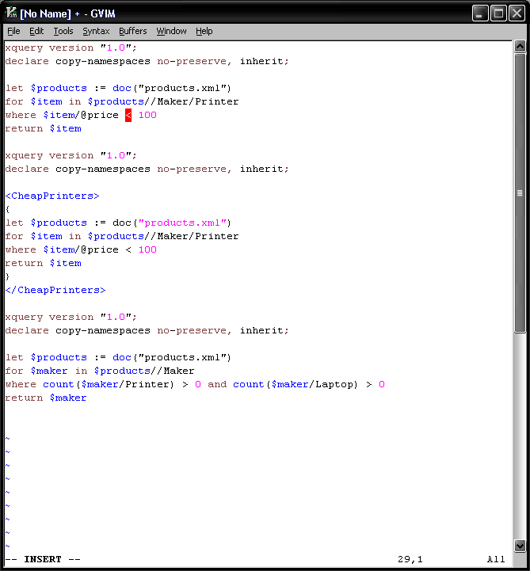
Code for Queries 12.2.1a-c

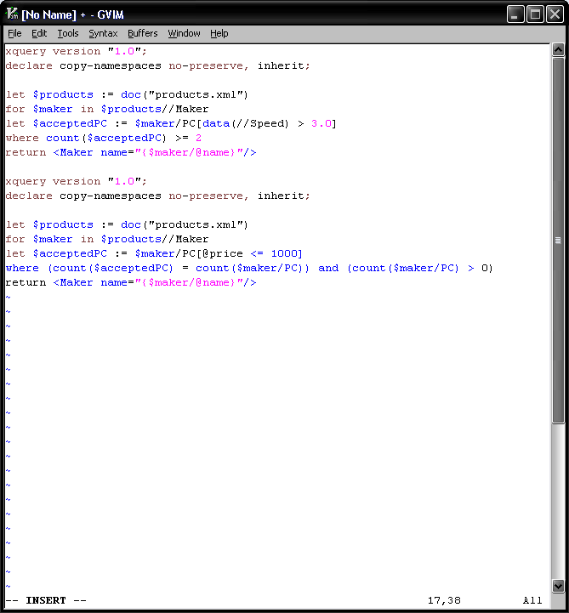
Code for Queries 12.2.1d-e

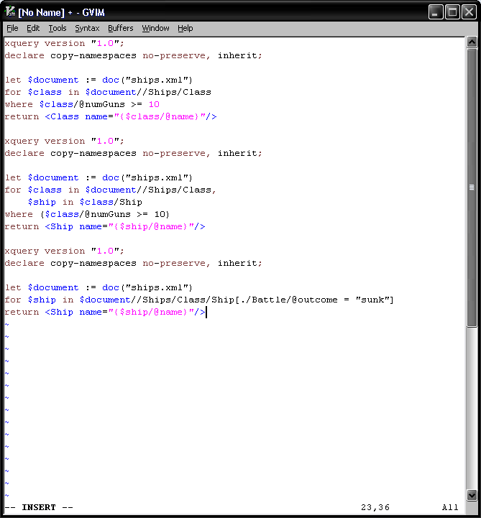
Code for Queries 12.2.2a-c

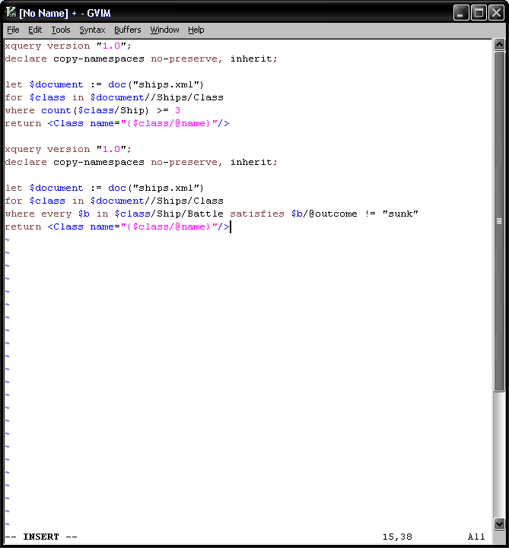
Code for Queries 12.2.2d-e

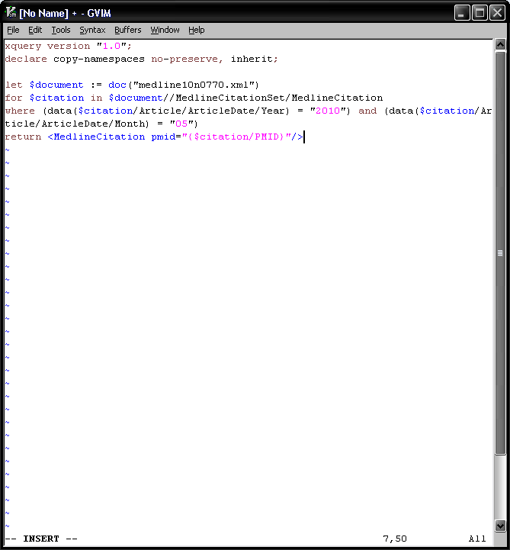
Code for Query with Medline File

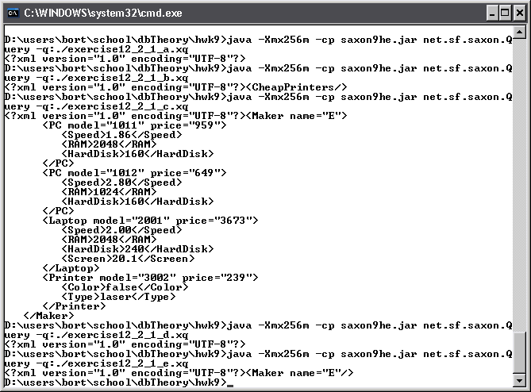
Results for Queries 12.2.1a-e
a, b, and d all return empty sets.
There are no printers in the source file that are under 100 dollars and there is no maker that sells at least 2 pc’s with speed >= 3.0

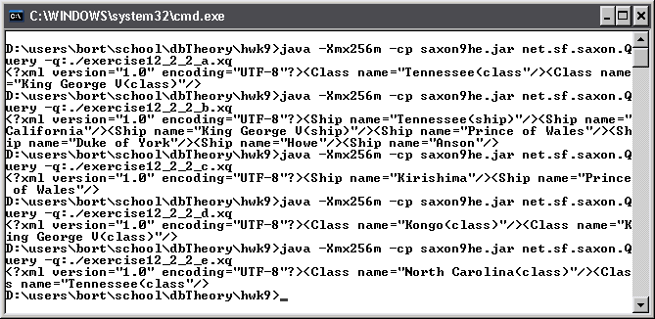
Results for Queries 12.2.2a-e
The phrase (class) or (ship) was added to the end of the strings “Kongo”, “Tennessee” etc to help distinguish the two

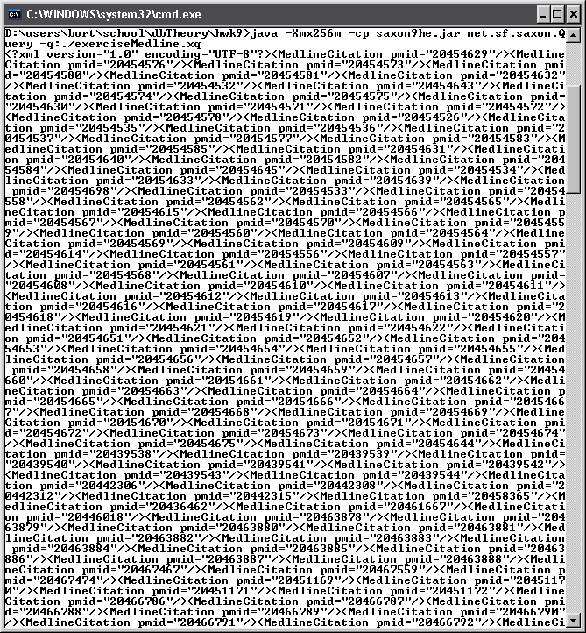
Results for Medline Query. Output is cutoff because it was so long.

