Table of Contents

Page 1 This Page
2 Project Description
3 Task List
4 Timeline
5 Effort Matrix
6 Design Diagrams
10 Statement of ABET concerns
11 Oral Presentation Slides
12 Gregory Baker Bio
14 Robert Koeninger Bio
16 Team Budget, Billable Hours
17 Team Contract
Encrypted Cell Phone Communication
Background:
Sensitive information is frequently transmitted over cellular communication networks as voice data. As voice recognition software improves, it will become more important for information such as social security numbers and credit card information to stay private between the parties. Encrypting voice communication more securely will provide more protection against eavesdroppers looking for information.
Problem Statement:
The current standard of secure communication, GSM, has been proven to be insecure. Current cellular phone systems do not provide sufficient privacy for sensitive information to be confidently transmitted over cellular networks. Our cellular encryption system will provide additional security for sensitive information to be transmitted during a call, while preventing an eavesdropper from deciphering the communication.
Team Members:
Greg Baker bakergo@mail.uc.edu
Robert Koeninger koeninrc@mail.uc.edu
Faculty Advisor:
Dr. Philip A. Wilsey
Goal:
Our goal is to modify a smart phone to encrypt voice packets before being sent, and decrypt them on the other end of the voice communication. If the receiving phone is incapable of decryption, the paranoid party will be alerted that the communication is insecure.
Subgoals:
Explore encryption techniques that are feasible for use in cellular communication.
- Develop software on the cellular phone to encrypt and decrypt voice communication during a call.
- Analyze the power and speed of various techniques to this goal.
Helpful Skills:
- Knowledge of encryption methods
- Some familiarity with host system (Google Android)
- Java and embedded programming skills

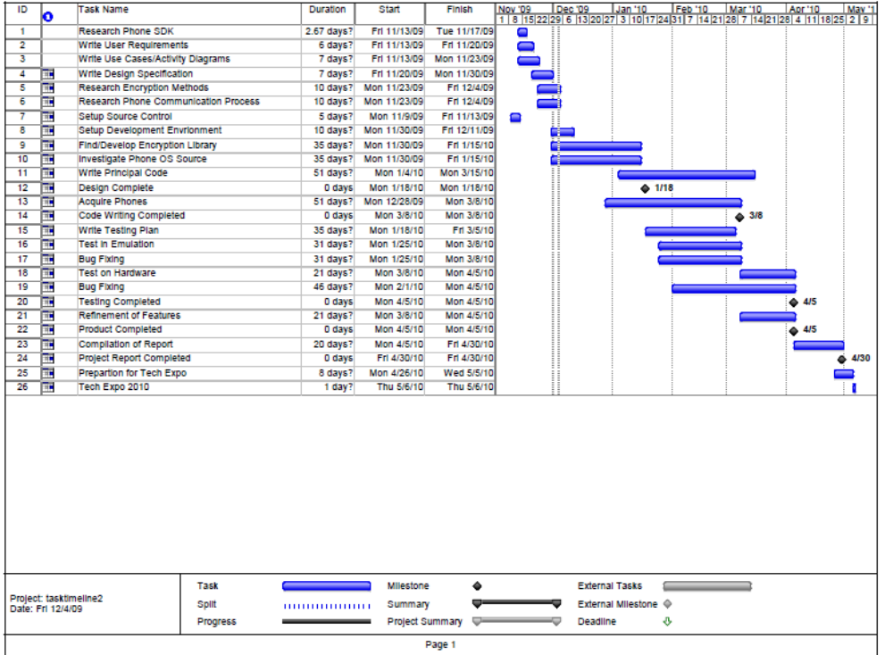

Design Diagrams
Level 0 shows the simple branch where the phone determines if the call is encrypted or not. If the call is encrypted, the diagram branches to the non-descript task of communicating with encryption.
Level 1 is expanded to show the encrypted/unencrypted conversion branch on both the sending and the receiving phone. Also included is a loop to illustrate the encryption process that occurs on both phones while the conversion is taking place.
Level 2 elaborates on the encryption key exchange process and the conversation encryption process. This diagram also mentions the on-screen indicator to the user warning them that the call will not be encrypted. The names of the processes in the “Both Phones” section describe the conversation process in more detail, stating each step between when the voice data is picked up by the microphone and sent to the antenna.

Conventions Used in Diagrams
In Design Level 1 and Level 2 Diagrams, the phone operations are divided into three groups: “Sending Phone”, “Receiving Phone” and “Both Phones” in order to separate activities that are unique to sender or receiver. The “Both Phones” section contains the process that encrypts the conversation as this is the same for both phones once the conversation has been established.
Several processes are enclosed in Predefined Process nodes in order to keep the phone’s normal operation out of the diagram. The “Continue Call Normally” process, for instance, is there as a place holder for the normal operation of a phone call, without leaving that step in the overall sequence vague.
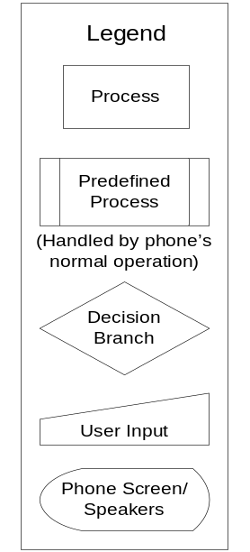
(Refer to the legend for the meaning of node shapes)
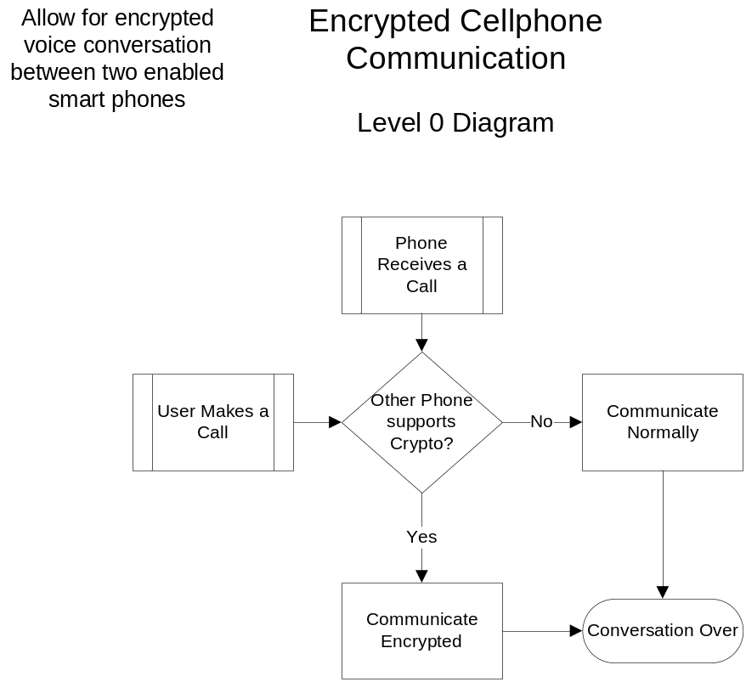
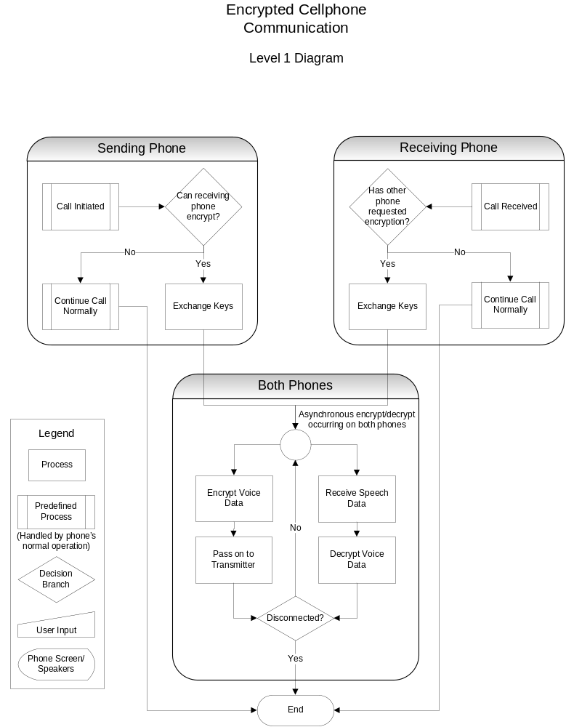
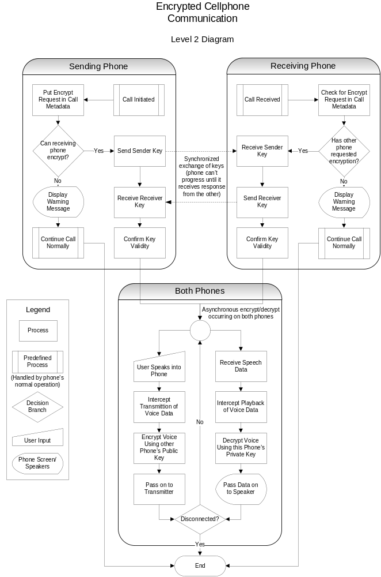
Statement of ABET Concerns
Economic constraints on the Skullduggery project are numerous. Since we are modifying the operating system in a smart phone, we need to consider costs between two phones. Each phone is expensive, between $200 and $425. Each phone requires a data plan with at minimum a $20/month contract, frequently with a set-length lock-in. The total cost of this project may be as high as $700 per person, or $1400. The software and development environment is the cheapest part of the project, each are free. We have no grants or sponsors for the project.
Ethical concerns of the Skullduggery project are common with any encryption-based project. The project may be used to conceal illegal activities. Testing the efficacy of the phone encryption may be difficult and illegal, and would require tapping into the phone conversation. Depending on the contract with the cell-phone provider, modification of the phone may cause a breach of contract. The goal of the project is to protect the privacy of the user. A successful project will be ethically sound by designing testing methods that do not breach laws or privacy of cellular users in the area and do not violate signed contracts.
Sustainability past the project scope is relatively bleak. The Skullduggery project is currently open source, which will assist in the long-term maintainability. It may be that the initial implementation of the project is not compatible between phones, or between different versions of the same phone. We do not plan on maintaining the project beyond the end-of-year deadline. However, the project will ideally be written in a manner that allows for fast maintenance and extensibility later. A successful project will be able to be extended to several different smart-phones with minimal changes to the code.
From a manufacturing standpoint, the Skullduggery project aims to be an implementation of an encryption system. A successful project will not necessarily be a stand-alone product that can be installed on any phone, but we should have a demonstrable encrypted conversation between two phones. There should be no barriers to turning the project into a product, but it will require additional work. As the project is not targeted to become a marketable product, there is no requirement to be portable across different phone systems. As a demonstrable project, there are requirements for an installation process and configuration.
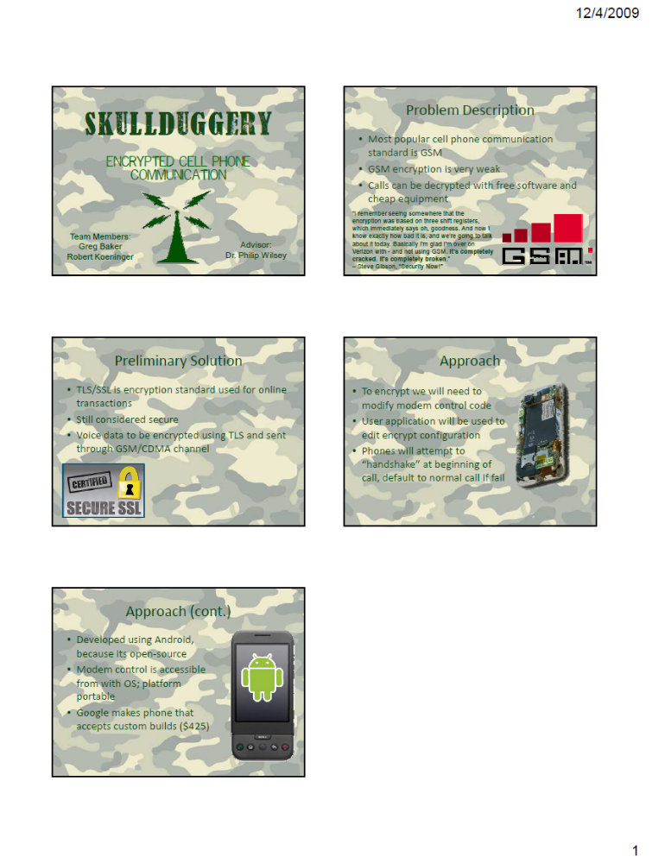
Oral Report Slideshow

Gregory Baker | bakergo@mail.uc.edu

co-op or other experience and responsibilities
- Software Development Co-op, WhatIfSports.com (1 quarter): Participated in a 5 person multidisciplinary team making the Football Survivor game for FoxSports.com. Added new features to the game simulation engine to track player-specific statistics on a game-by-game basis. Assisted with conversion of forums to a new, upgraded system.
- Web Development Co-op, UCit Web Development (4 quarters): Designed and implemented web applications with administrative functionality for various departments at UC. Maintained and debugged applications. Helped design and write new tools to reduce the cost and development time of writing new applications. Helped deploy new testing environments for UCit.
skills/expertise areas
- Familiar with C#, VB.NET, VB6, Python, PHP, C, C++, Java.
- Familiar with Linux, Windows and OS X
- Software design, testing, time estimation
- Familiar with usage of SQL databases, Source control and regular expressions.
areas of interest
- Programming
- Embedded systems
- Video Games
type of project sought
- I am interested in working on any of the L-3 projects.
- Programming on an embedded device or non-standard environment (such as a robot or low-power system).
- Programming with a unique application, analysis of music or visual systems.
- I'm very good at web development, but it is not preferred.

Robert Koeninger | koeninrc@email.uc.edu

co-op or other experience and responsibilities
- Web Developer and Tester, ITI Transcendata, Milford (3 quarters): Installed and maintained networked application on variety of machines and platforms, Performed regression testing and interface testing, developed web component to upload files
- Control Software Developer and Tester, Siemens Energy and Automation, Mason (2 quarters): Developed software packinge in C++ to store program state (all members in an object hierarchy), performed unit and regression testing
- Webmaster, UC Center for Community Engagement, Cincinnati (1 quarter): Maintained website content, worked with CMS, investigated web design
skills/expertise areas
- Software languages and paradigms: C/C++, Assembler, Java, OOP
- Software tools, Visual Studio, Eclipse, Clearcase, Previously maintained CVS on home server
- Web languages and technologies: HTML/CSS/JavaScript/AJAX, PHP, Java Servlets, SQL
- Web tools and software: Tomcat, Apache, MYSQL, Linux as a server, Macromedia MX Studio
- Operating Systems: Windows 4x and NT, various distrobutions of Linux, training with Mac OS X, Worked with other UNIX-style systems like Solaris, HP-UX and AIX
areas of interest
- Software development
- Multimedia - audio, video, image processing
- Custom web development
- Network programming
type of project sought
- Project involving manipulation or recognition of images, video, or audio
- Projects involving network communication
Self-Assessment Essay
Robert Koeninger
My project involves modifying the functionality of a commercial cell phone to encrypt it’s voice communication.
Classes I have taken to prepare me for this include Computer Science, Software Engineering, Network Communications and Algorithm Design. Some of the code will be written in C/C++, which I became fluent in while working at Siemens Energy and Automation. Other parts will be modules written in Java, which I became familiar with while working at ITI Transcendata and on my own in high school. Also during co-op, I had experience in reading other developer’s code, something that is a bit of a weakness for me. On the non-technical side, co-op and Software Engineering Lab taught me how to describe ideas to others as that is another weak point of mine. Most of the skills I will need to do this project I learned from classes and co-op experience.
Team Budget To-Date
To-Date, there have been no expenses and there were no expected expenses.

Billable Hours

