Fern-Ware: Natural-Language Houseplant Recommendation
DATA641 Final Project Report
Joseph Kutza, Rithvik Kommareddy, and Zachary Hamilton

1. Problem and Users
Fern-Ware addresses a decision that occurs before most plant-care advice becomes useful: choosing a houseplant that fits a living space and care routine. Species differ in their need for light, water, and humidity, but most resources explain care after a plant has already been purchased. Before Fern-Ware, a new grower might search several websites, ask a store employee or friend, or learn through trial and error. These approaches place most of the comparison and interpretation on a user who may have little experience.
The main users are prospective household plant owners, especially beginners who want practical guidance without learning botanical vocabulary first. Experienced growers can also validate the environmental factors and request more detailed information. The design goal was to accept an ordinary room description and return a small set of compatible plants.

2. Product
Fern-Ware combines a chat-style browser interface, a Flask API, a local language model, and a JSON plant database. JavaScript sends the user's description to /api/parse, where a fine-tuned BART-MNLI model classifies watering, sunlight, and humidity as low, medium, or high. The API returns each value with a model score and score margin. The browser asks about missing conditions, then compares complete preferences with genus_desc.json and ranks exact or partial matches.
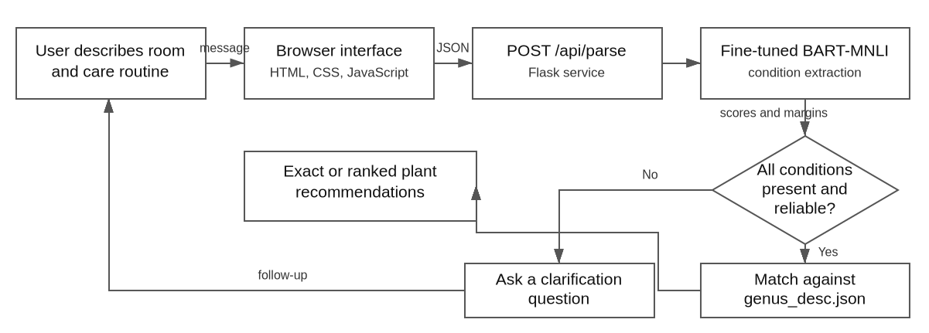
Figure 1. End-to-end processing and clarification flow.

3. NLP Method and Evaluation

Model and data
The starting model was facebook/bart-large-mnli. It performs natural-language inference by comparing a premise with a hypothesis and deciding whether the premise supports it. This helps with language variation: high sunlight may be described as bright, sunny, or next to a window. Fern-Ware treats the user's description as the premise and statements such as 'the room has high sunlight' as candidate hypotheses. The strongest candidate becomes the predicted class.
Synthetic training data were created by assigning low, medium, or high levels to each attribute and generating a natural description from those labels. Each description was expanded into nine premise-hypothesis pairs: three attributes multiplied by three candidate levels. The pipeline used 1,000 descriptions, producing 9,000 pairs. Descriptions were split 80/20 before expansion, yielding 7,200 training pairs and 1,800 validation pairs without placing the same premise in both sets. BART-MNLI was fine-tuned for one epoch and saved for reuse by Flask.

Metric, baseline, and results
Classification accuracy was the main metric. The original zero-shot model provided a 57 percent baseline, while the fine-tuned model reached 70.7 percent overall. Reported per-attribute accuracy was 75 percent for the first attribute, 78 percent for humidity, and 59 percent for sunlight. The presentation calls the first attribute temperature, although the deployed interface uses watering. This mismatch means the numbers support the general modeling approach but are not a final measurement of the exact deployed configuration.
Fine-tuning improved accuracy by about fourteen percentage points, but sunlight remained the weakest category. Accuracy does not reveal which levels are confused or whether a 70 percent model score represents a 70 percent chance of being correct. A stronger evaluation would add per-class precision and recall, macro F1, confusion matrices, and calibration on manually reviewed user descriptions.

Failure modes
The most important failure occurs when the model chooses low, medium, or high even though the user never mentioned an attribute. Short answers such as 'lots' also depend on the preceding question. The application therefore combines model output with mention detection, score and margin thresholds, conversation state, and normalized follow-up answers. These safeguards reduce unsupported recommendations but do not eliminate classification errors or calibrate the scores.

4. User Evidence
The project gathered qualitative feedback from University of Maryland plant science faculty and students and from friends and family. This provided both plant-experienced users and relative beginners. Experienced participants agreed that water, sunlight, humidity, and placement captured the core maintenance problem, while also requesting details about subspecies. Beginners valued low-maintenance options, fewer special instructions, and more guidance from the chatbot.
Users did not consistently provide complete, structured descriptions. Some supplied all three conditions, while others omitted humidity or sunlight. They also used ordinary phrases such as 'bright,' 'water often,' 'lots,' and 'a lot' rather than the model's class names. The original workflow could guess an omitted condition or repeat a question when an answer lacked the expected vocabulary.
The interface was changed to detect whether an attribute was mentioned, preserve accepted values across turns, and ask a targeted question for missing information. A pending-condition state gives context to short replies, and common phrases are normalized to low, medium, or high. Matching waits until all required conditions are available. Because the presentation reports no participant counts or standardized usability measures, this is formative qualitative evidence rather than a controlled study.

5. Ethics and Limitations
Data rights and provenance matter in both parts of the system. Synthetic language data reduce dependence on private messages but can reproduce the generator's phrasing and biases. Plant-care information may come from public agencies, reference works, or hobbyists, yet public availability does not remove the need to record sources and licenses. Because sources conflict over details such as watering intervals, the database should favor authoritative evidence and avoid presenting disputed values as universal facts.
The app does not require names, accounts, or addresses, but room descriptions may still reveal information about a home or routine. A deployed version should minimize logs, avoid retaining messages without consent, and explain where processing occurs. Testing was also limited to a university community and personal networks. Synthetic data and a narrow participant pool may underrepresent dialects, accessibility needs, housing conditions, and different ways of describing care.
When the model is wrong, the safest response is to expose uncertainty and ask rather than guess. Fern-Ware displays scores, identifies missing information, and labels partial matches. Users should be able to correct extracted conditions. Some plants are toxic to pets or children, so hazardous plants require warnings or removal from the local database. Even then, recommendations remain informational rather than guarantees of plant survival or household safety. The central limitation is the risk that an uncertain classification or disputed care record appears more authoritative than its evidence supports.

