FRIEND FINDER
ARCHITECTURE

TECHNICAL ARCHITECTURE:

J2ME
mobile
J2ME
mobile
BlueTooth
BTSPP Request
BTSPP Request
BTSPP Response
BTSPP Response

Bluetooth wireless technology is a short range communication system intended to replace cables connecting portables and/or fixed electronic devices. Its core system consists of an RF Transceiver, base band and protocols stack. The system offers services that enable the connection of devices and exchange of a variety of data classes between these devices.

FRIEND FINDER

The Bluetooth operates in the unlicensed ISM (Industrial Scientific Medicine) band at 2.4GHz. The system employs a frequency hop transceiver to combat interference and fading and provides many FHSS (Frequency Hopping Spread Spectrum) carriers.

Bluetooth devices can create dynamic ad hoc network to accomplish this, devices must be able to discover other near by devices, a process referred to as device enquiry. A discovered device is identified by its Bluetooth device address or friendly name.

BTSPP:
The Bluetooth serial port profile (BTSPP) is used for creating an
RFCOMM connection between two devices. The RFCOMM protocol emulates a serial port connection and provides support for flow control.

J2ME:

The Micro Edition of java2 platform provides an application environment in mobile devices that specifically addresses the needs of commodities in the vast and rapidly growing embedded space.

FRIEND FINDER

FUNCTIONAL ARCHITECUTRE

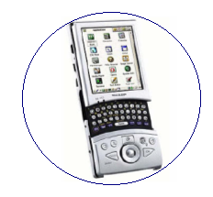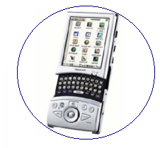
BlueTooth
Bluetooth
mobile
Bluetooth
mobile

Friend Finder is a Bluetooth application software which helps us to find new friend based upon the profile we enable. We can even find friend from our buddy list in the vicinity of the mobile.

1. After enabling Bluetooth select friend finder icon.

2. By selecting friend finder it asks us to register or search.

3. For the first use we have to register our profiles.

4. Later we have to enable one or more profiles.

5. After enabling the profiles search for the desired friend or our friends from the buddy list.

6. All the devices that match the profiles in the vicinity are displayed.
FRIEND FINDER

7. To communicate select one of the devices displayed.

8. After selection we can transfer data (text messages, pictures, or video’s).

9. We can even send our profiles to the desired devices.

