Technologies:

Java 17

Spring Boot Framework

Rest API

Maven Build Tool

Lombok PlugIn

Build command: mvn clean install

Test Coverage:

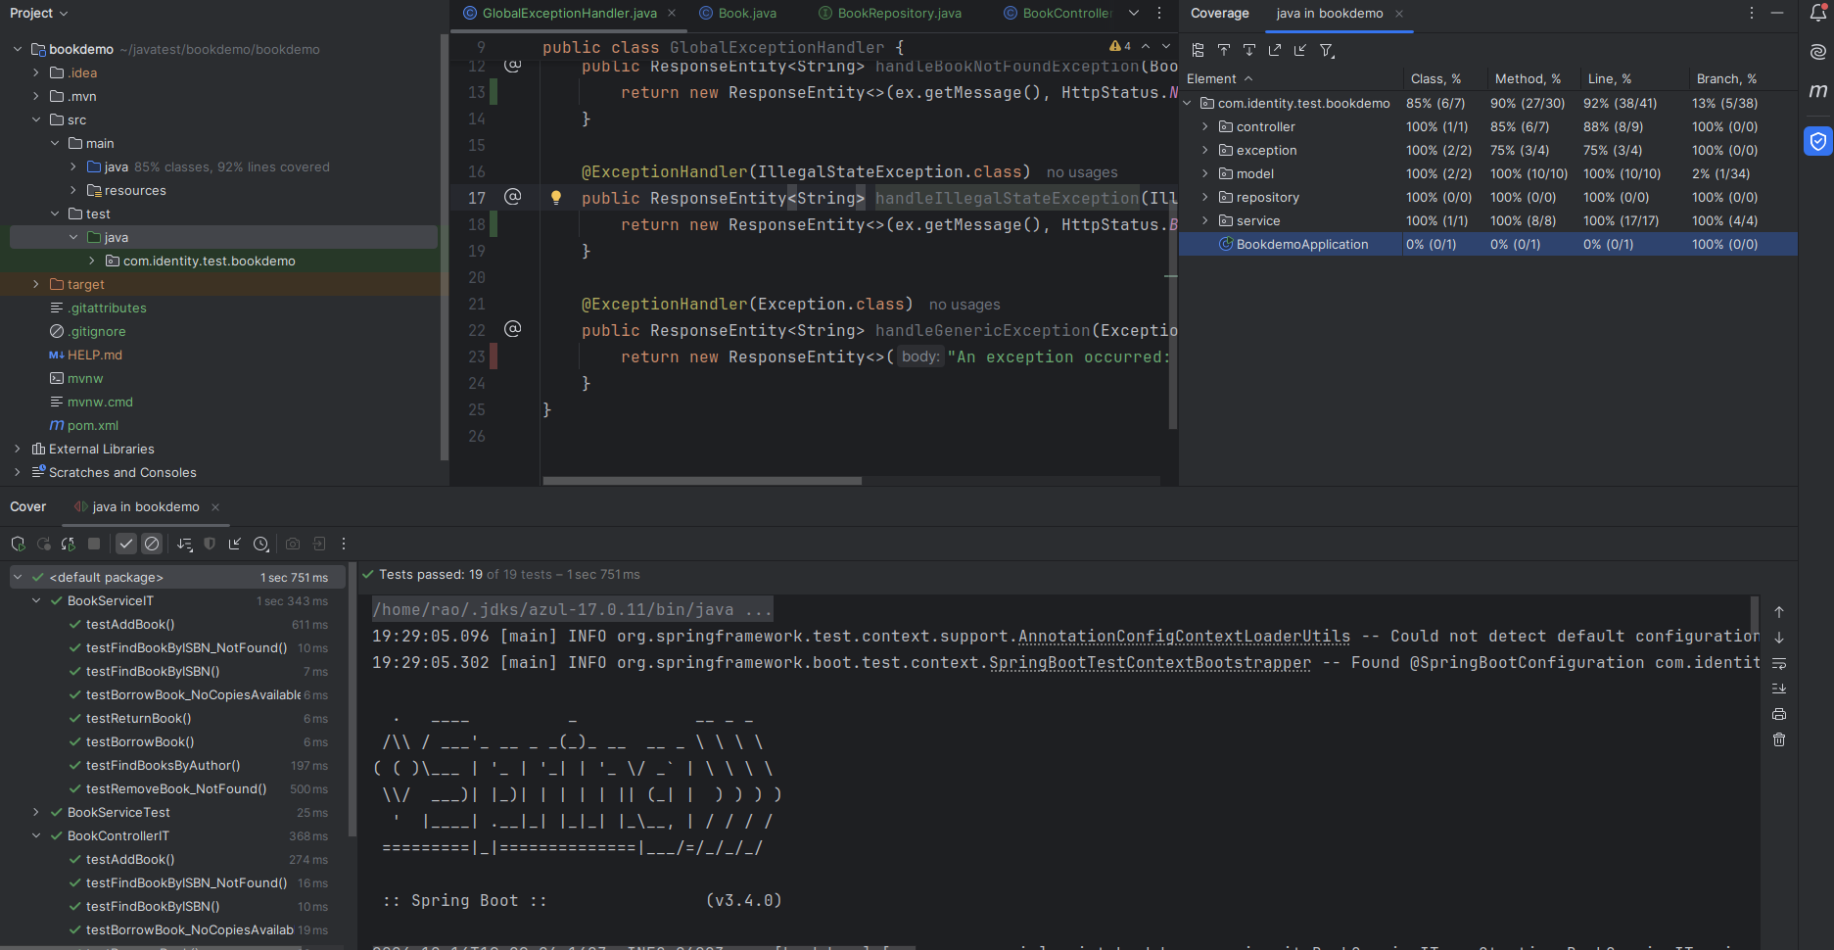

Build Screen Shot

