North Carolina State Archives

AXAEM: Summary of Finding Aids Issues

We have some issues with our current finding aids stylesheet, one of which we believe requires the need for a new stylesheet entirely.

Our current default finding aid—the one that Rusty Koonts developed for us—continues to have some issues that need resolution:

1. Missing banner and repository -- The banner and repository do not show up for records where containers are not linked to the top-level.
2. Bibliographic link issues when file level bibs have folders connected to boxes linked at the series level rather than the top level. Often we see that the container locations are not showing up in these stylesheets for boxes that are not attached at the top level. This might be an issue that requires resolution with the proposed new stylesheet below.

Based on issue 2 above, I think we need a second stylesheet that can handle records where containers are linked at various levels, not just the top level. A good example the Colonial Court Records at the recordgroup level, SR.401. As you can see in the screenshot of the finding aid below, box numbers are not populating for Files linked to Folders nested within top-level containers attached to Series-level bibs. This is part of the general problem with the limits on where we can export data to finding aids, but it’s also an issue for Record Group level finding aids where we want the containers for each Series to display with the Series bib info in DOC rather than as a long list at the Record Group level.

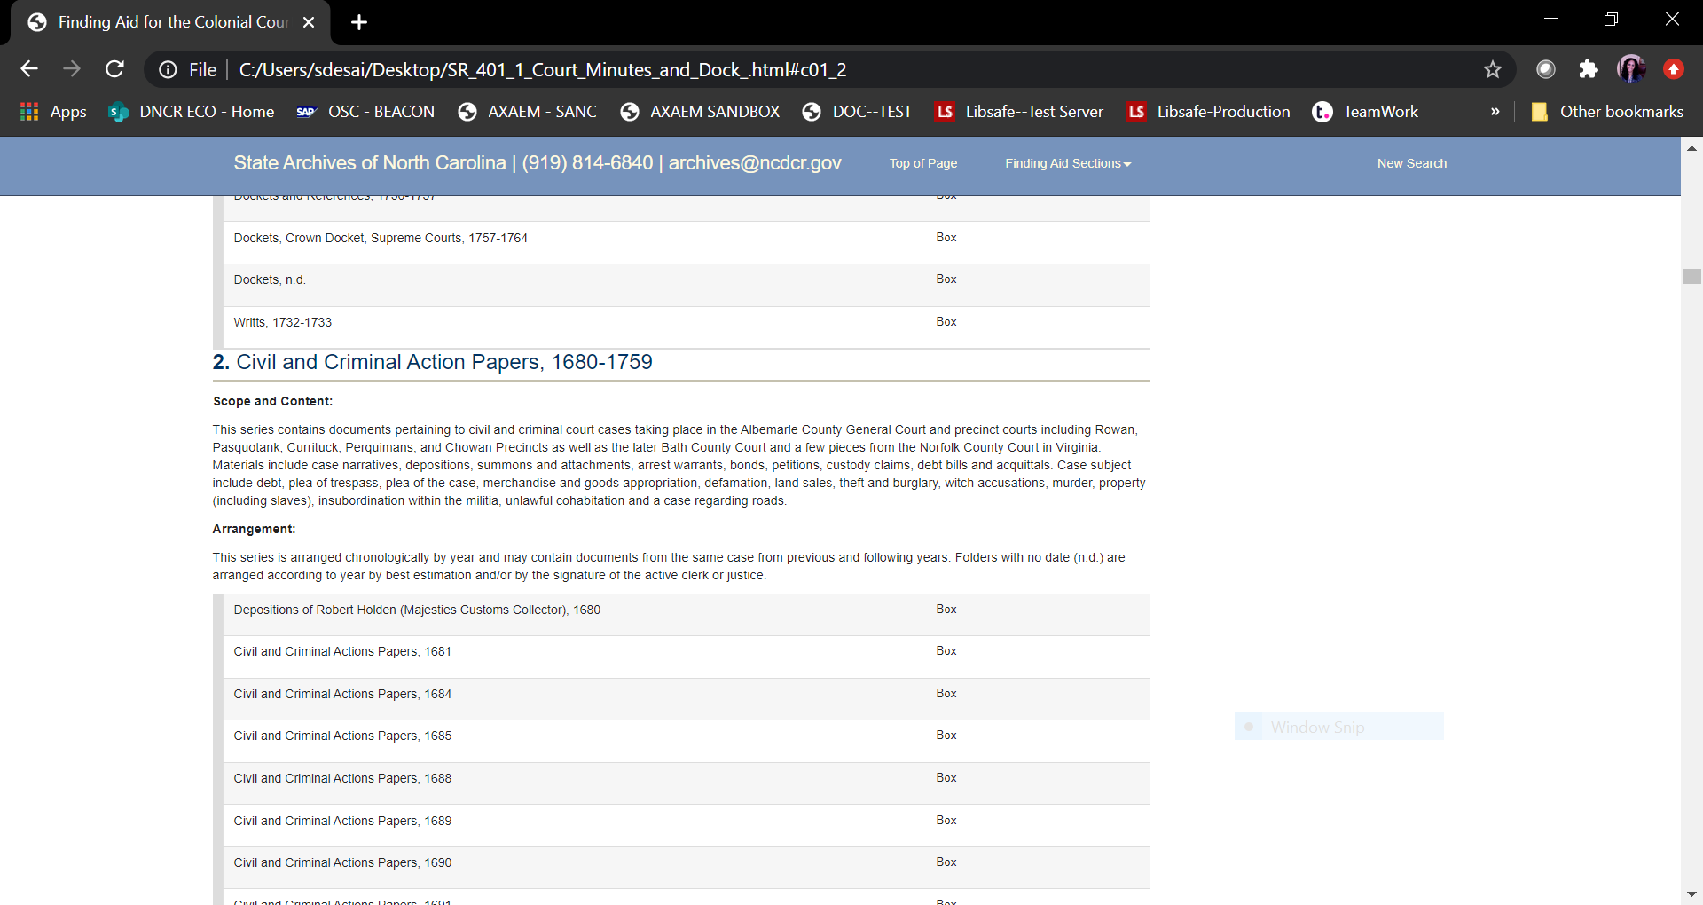

We believe this is our current default stylesheet is based off of the Medical Center Archives stylesheet which is designed to have the boxes linked at the top level bib record in order for the link between file to folder container to box to work accurately. Unfortunately, all of our State Records do NOT link boxes at the top level like the Medical Center. Therefore, we really need a stylesheet that is set up to recognize containers at different levels.

On a more minor note, we have also found that italics don’t seem to show up in our finding aids. Is there some code or something we need to render italics in the finding aids?

Thanks,

Sangeeta

​