ARDMS
  - Advanced Rescue & Disaster Management System
Project Report and User Manual

A. Abstract
The Advanced Rescue & Disaster Management System (ARDMS) is a complete digital solution designed to save lives during emergencies. It connects people in danger directly with nearby rescue teams and a central command center. By utilizing real-time GPS tracking, instant SOS alerts, and smart task grouping, ARDMS eliminates the confusion and delays typically seen during natural disasters or medical emergencies. This project provides a Web Admin Dashboard for operators, a Public App for victims to ask for help, and a Rescuer App for first responders to navigate exactly where they are needed.

B. Introduction
When a disaster strikes - like a flood, earthquake, or severe medical emergency - every single second matters. Unfortunately, traditional phone calls to emergency numbers can get jammed, and explaining your exact location can be difficult when you are in a panic.
ARDMS solves this problem by using the technology already in our pockets: smartphones. With ARDMS, a person just has to press a single SOS button. Instantly, their exact GPS coordinates, the type of emergency, and their details are sent to a live Web Dashboard. An operator immediately sees this on a map and dispatches a registered Rescuer to that exact spot. The system acts as a digital bridge between those who need help and those who can provide it.

C. Project Description
ARDMS is composed of three main pieces working together simultaneously:
- 1. The Public App: A mobile application for everyday people. It has large, easy-to-read buttons to trigger an SOS for different emergencies (like Medical, Flood, Fire).
- 2. The Rescuer App: A mobile application for emergency responders (paramedics, firefighters, volunteers). It acts like a delivery app, but instead of delivering food, they are delivering help. It gives them a map, routing, and details of the victim.
- 3. The Web Admin Dashboard: A website for the central command team. It shows a live map of all victims and all active rescuers, allowing the operator to play 'matchmaker' and assign the closest rescuer to a victim.

D. Technical Workflow & System Architecture
The system runs on a modern, real-time technology stack. It uses React Native for the mobile apps, React.js for the Web Dashboard, and a Node.js/SQLite backend for the database. Everything communicates instantly using WebSockets.

1. Master Full Image (System Overview)
Below is the complete animated flow of the system. It traces the signal from the Public App triggering an SOS, to the Admin Dashboard dispatching it, directly to the Rescuer App accepting it.
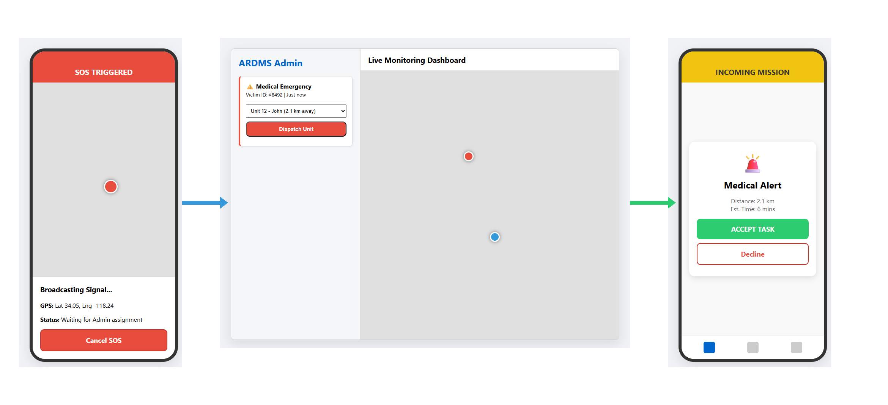

2. Public Mobile App Explanation
The Public App is designed to be extremely simple, as victims are usually in a state of panic.
- Home Screen: Contains clearly labeled emergency types (Medical, Flood, Fire).
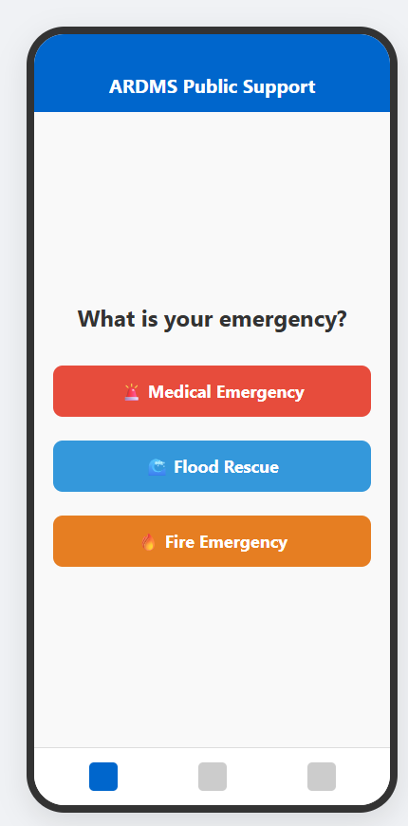
- SOS Trigger: When a category is tapped, it grabs the phone's GPS location and sends a 'Critical SOS'.
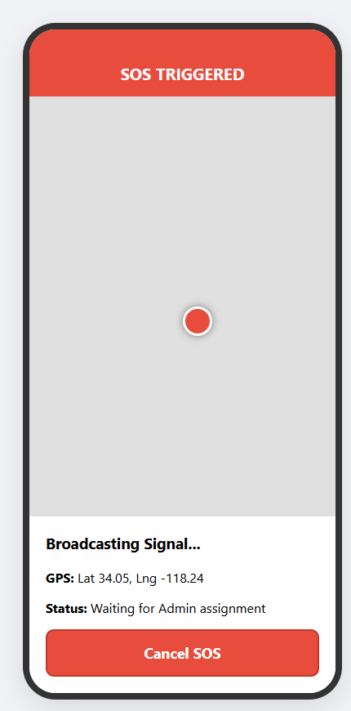

3. Web Admin System Explanation
The Web Admin is the 'brain' of the operation. It is a website that the emergency operators look at on their computer screens.
- Call Assign & Task Dispatching: The operator clicks an incoming SOS and assigns it to an available rescuer.
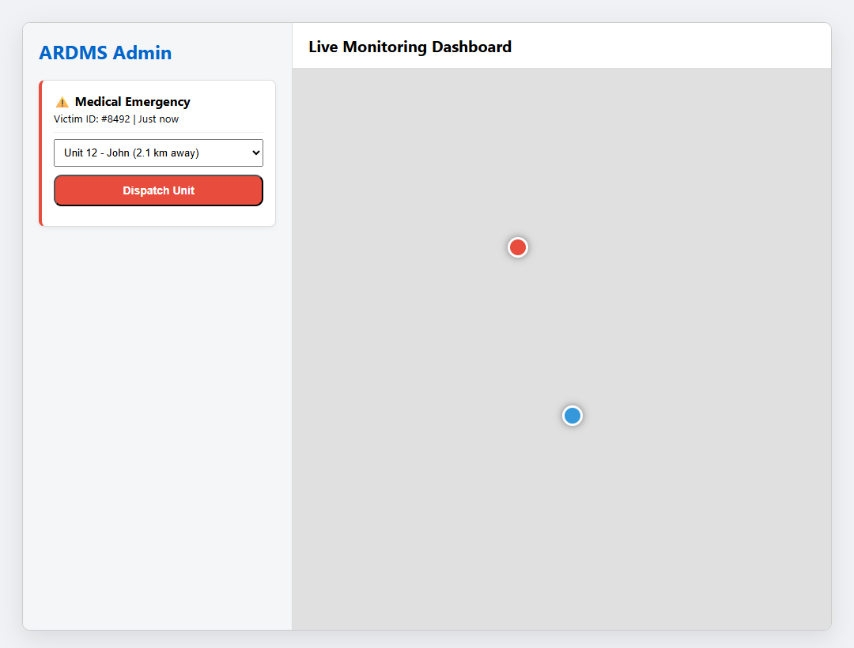
- Tactical Grouping (Public Details Grouped Supplies): If multiple people in a neighborhood trigger an SOS, the admin can group them into one task for efficient supply drop or rescue.
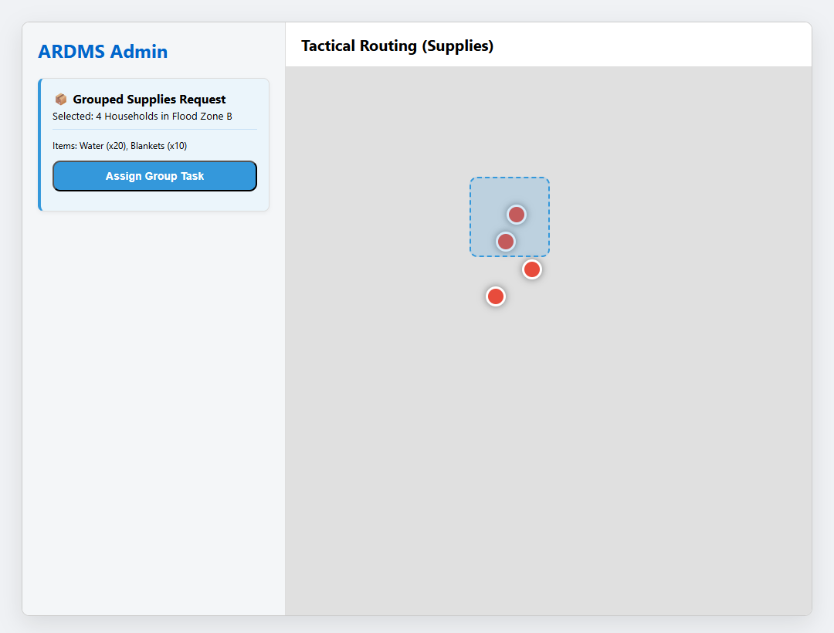

4. Rescuer Mobile App Explanation
The Rescuer App is built for action and navigation.
- Acceptance Functioning: When the Admin assigns a task, their phone rings with an incoming mission.
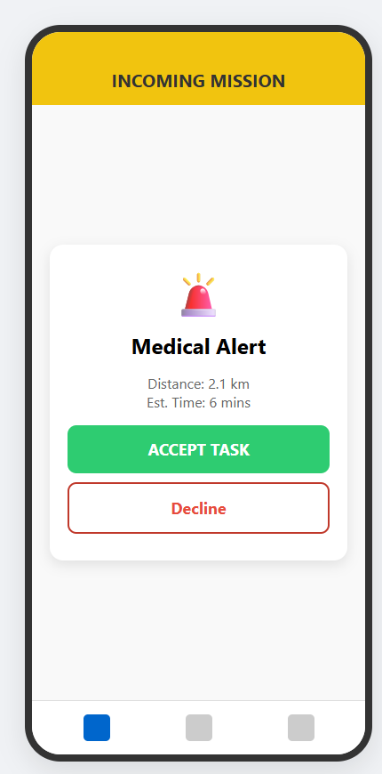
- Task Performance Navigation and Tracking: The app draws a routing line on the map from their current location to the victim. Live tracking updates constantly.
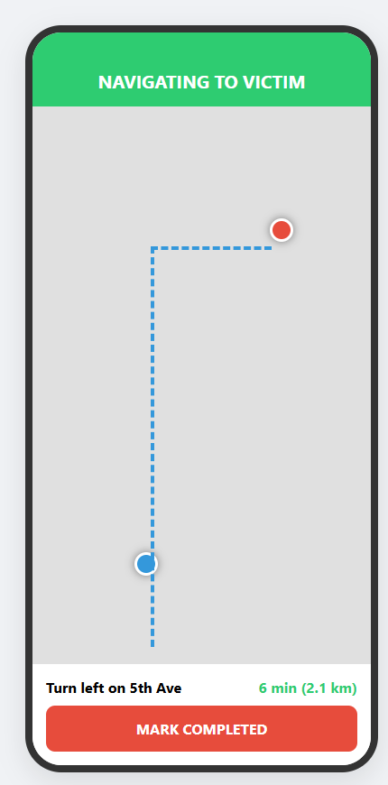
- History Pages: Once missions are completed, they are securely stored in the history log.
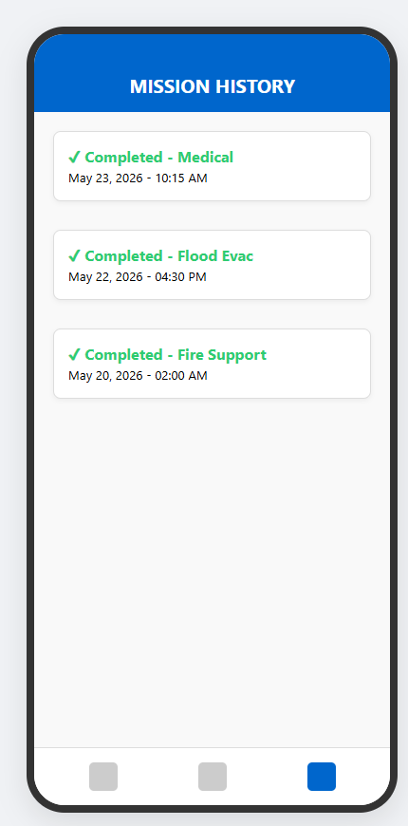

5. Detailed Operational Flow
Here is the step-by-step story of an emergency in ARDMS:
1. Victim opens Public App and taps 'Medical Emergency'.
2. App waits 3 seconds, captures GPS, and POSTs data to Server.
3. Server saves to Database and alerts Web Admin.
4. Admin sees a flashing Red Alert on their map.
5. Admin clicks the alert, selects Rescuer 'John', and clicks 'Assign'.
6. John's Rescuer App rings. John clicks 'Accept'.
7. John follows the blue navigation line on his map to the victim.
8. Victim sees John's vehicle icon moving toward them on their screen.
9. John arrives, helps the victim, clicks 'Complete', and the alert turns green on the Admin dashboard.

