
MOOC BASED SEMINAR REPORT

On

TITLE

Submitted in partial fulfillment of the requirement for Seminar in 1stSemester.

of

MBA (2nd SEMESTER)

By

Priyanka Singh

Under the Guidance of

Ms. SHILPA WADHWA

(Assistant Professor, School of Management)

DEPARTMENT OF MANAGEMENT

GRAPHIC ERA HILL UNIVERSITY

DEHRADUN

SESSION (2020-2022)


CERTIFICATE

THIS IS TO CERTIFY THAT PRIYANKA SINGH HAS SATISFACTORILY PRESENTED MOOC BASED SEMINAR ON THE COURSE TITLE INTRODUCTION TO BUSINESS MANAGEMENT IN PARTIAL

FULLFILLMENT OF THE SEMINAR PRESENTATION REQUIREMENT IN 2ND SEMESTER OF MBA DEGREE COURSE PRESCRIBED BY GRAPHIC ERA HILL UNIVERSITYDURING THE ACADEMIC SESSION

2020-2022.

Campus MOOCS -Coordinator and Mentor

Ms. SHILPA WADHWA

SIGNATURE


TABLE OF CONTENT

S. NO. CONTENT
- ACKNOWLEDGEMENT

- INTRODUCTION

- WEEK 1

- WEEK 2

- WEEK 3

- WEEK4

- CERTIFICATE OF REGISTERATION

- CERTIFICATE OF COMPLETION

PAGE NO.

1

2

3

4

5

6

7

8


ACKNOWLEDGEMENT

I take this opportunity to express my profound gratitude and deep regards to my guide

Ms. Shilpa Wadhwa for his exemplary guidance, monitoring and constant encouragement throughout the course.

The blessing, help and guidance given by him time to time helped me throughout the project. The Success and final outcome of this course required a lot of guidance and assistance from many people And I am extremely privileged to have got this all along the completion of my report. All that I have Done is only due to such supervision and assistance and I would not forget to thank them. I am Thankful to and fortunate enough to get constant encouragement, support and guidance from all the People around me which helped me in successfully completing my online course.

INTRODUCTION

Introduction to Business Management is about how to manage people, money and information, and gain confidence and insight into your own management style.

It is a 4 WEEK COURSE

Week 1: Managing yourself

Week 2: Managing money

Week 3: Managing people

Week 4: Managing information

WEEK-1

WEEK-2

WEEK-3

WEEK-4

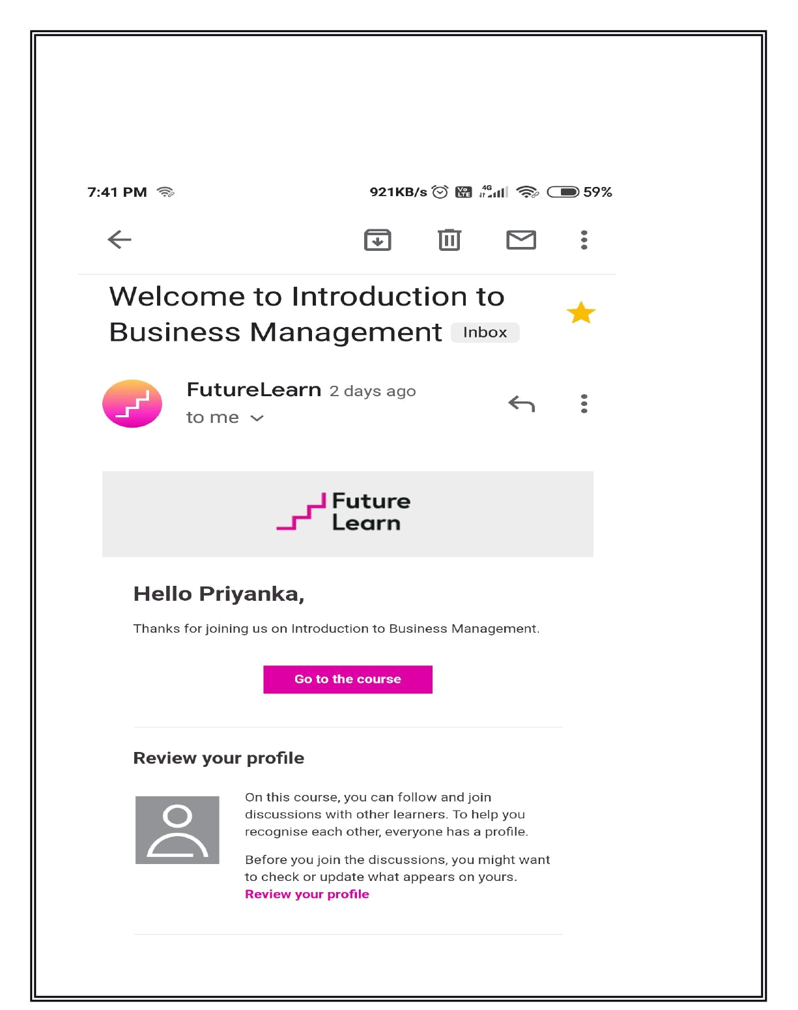
CERTIFICATE OF REGISTERATION
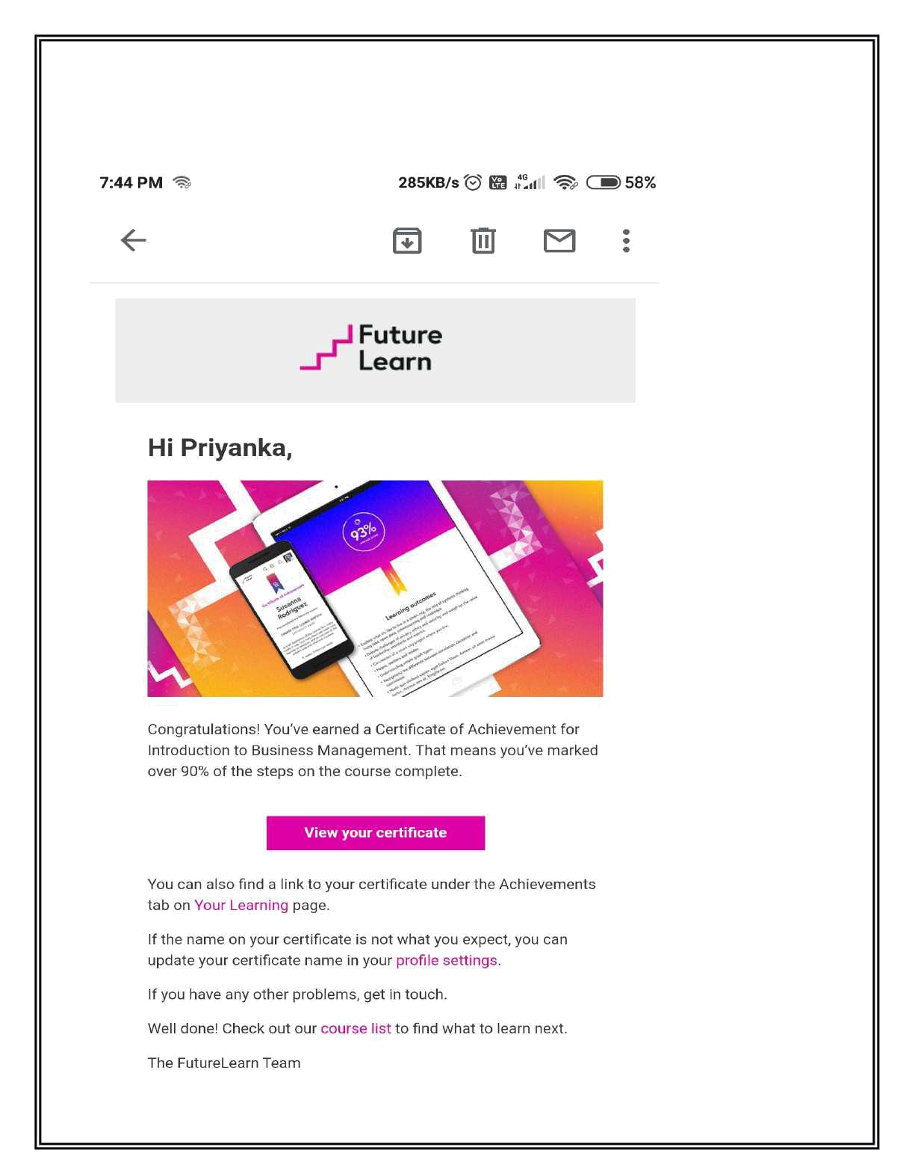
CERTIFICATE OF COMPLETION

