assignment1

Rohith chandra koyyala

30/01/2022

student id: 811191504

#Reference: <https://www.iplt20.com/stats/2021>

TOP RUN GETTERS IN IPL 2021

Below table shows the top five run scorers in Ipl 2021. The table explains the number of matches, runs, strickrate, not outs and high scores etc. In which ruturaj Gaikwad scored 635 and remained as top run scorer of 2021 edition.

data1 <- read.csv("C:/Users/kramr/Desktop/assign1.csv")  
data1

## S.NO PLAYER MATCHES INNINGS NOTOUT RUNS HIGH.SCORE AVERAGE  
## 1 1 ruturaj Gaikwad 16 16 2 635 101 45.35  
## 2 2 faf du Plessis 16 16 2 633 95 45.21  
## 3 3 kL Rahul 13 13 3 626 98 62.60  
## 4 4 shikhar Dhawan 16 16 1 587 92 39.13  
## 5 5 glenn Maxwell 15 14 2 513 78 42.75  
## BALLS.FACED STRICKRATE X100 X50 X4.S X6.S TEAM  
## 1 466 136.26 1 4 64 23 chennai super kings  
## 2 458 138.20 0 6 60 23 chennai super kings  
## 3 451 138.80 0 6 48 30 punjab kings  
## 4 471 124.62 0 3 63 16 delhi captails  
## 5 356 144.10 0 6 48 21 royal challengers banglore

mean(data1$RUNS) ##mean runs scored by all five batsmen

## [1] 598.8

table(data1$TEAM)

##   
## chennai super kings delhi captails   
## 2 1   
## punjab kings royal challengers banglore   
## 1 1

data1$RUNS_variance = sd(data1$RUNS) ##varience in there in runs  
  
##Below histogram represents the average of the five players  
  
hist(data1$AVERAGE)

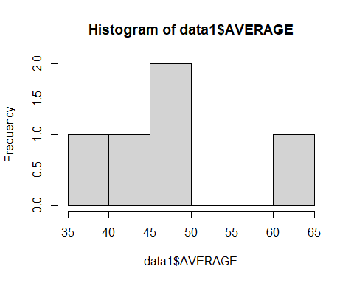

##Below scatter plot shows of runs scored  
x<- data1$RUNS  
y<- data1$S.NO  
plot(x,y,main="PLAYER AND NO OF RUNS SCORED", xlab ="RUNS", ylab = "S.NO")

