DFN Model Parameterisation Report
A123 26650 M1B LFP High-Power Cell

1. Introduction
This report documents the Doyle–Fuller–Newman (DFN) model parameterisation for the A123 26650 M1B lithium iron phosphate (LFP) cell with a nominal capacity of 2.5 Ah. All simulations were carried out using PyBaMM.

2. Initial Parameter Estimation
Initial parameter estimation was done through published literature and online resources. The supporting references are attached as Paper 1, Paper 2, and Paper 3.
The PyBaMM parameter spreadsheet (pybamm_parameters_classified.xlsx) contains the initial values taken from the literature, along with calculated values for volume fraction, maximum concentration, and density.
The Watzold (2025) paper provided a substantial number of geometric parameters including electrode thickness, current collector thickness, and separator thickness. The Scipioni (2018) paper supplied a reliable estimation of particle radius. These values were cross-checked against the Prada (2012) and Prada (2013) papers for consistency.

3. Task 1 — Baseline DFN Simulation
For the DFN simulation, the Prada electrolyte conductivity and electrolyte diffusivity functions were used. The electrode diffusivities and exchange current density values were retrieved from the Scipioni (2018) paper.
The reference OCV curve was obtained from the A123 26650 M1B datasheet, specifically the C/12.5 discharge curve (red curve below). A C/2 discharge curve was also used for additional validation.
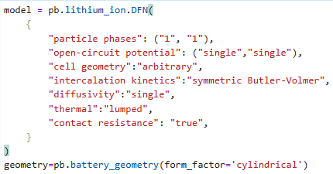
Figure 1: Reference OCV curves from the A123 26650 M1B datasheet.

3.1 Initial Simulation Results
The initial simulation results are shown below:
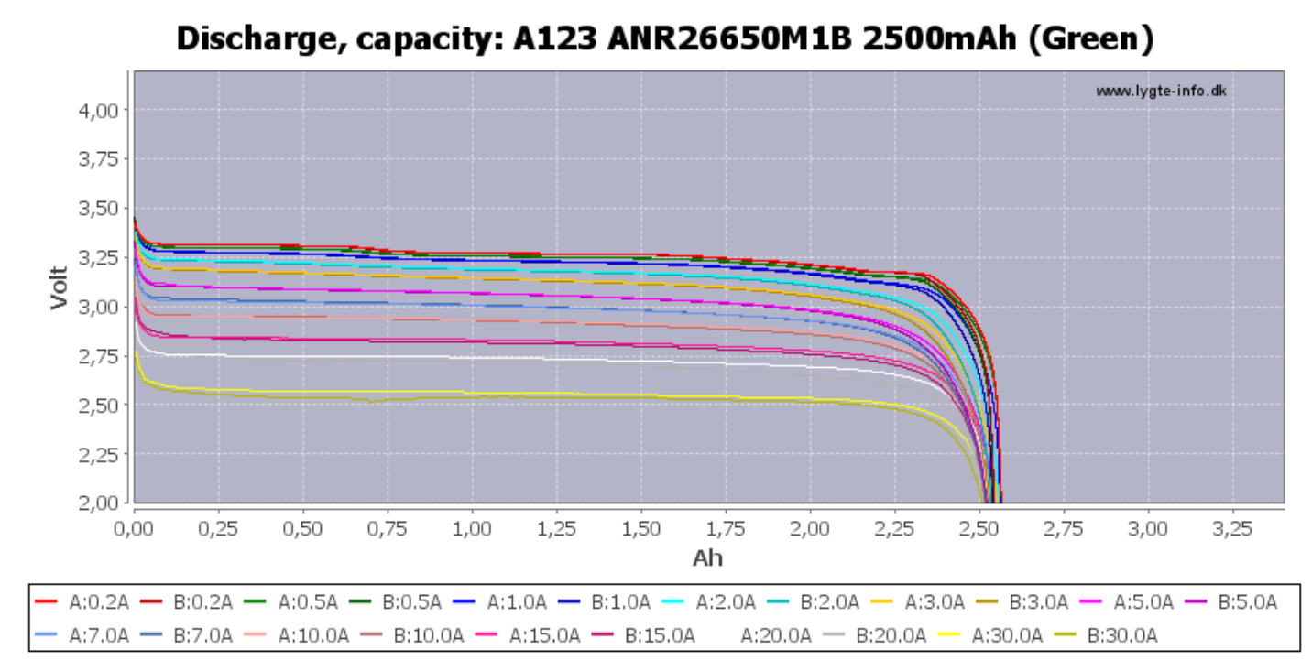
Figure 2: Initial DFN simulation result vs. experimental OCV.

3.2 Manual Parameter Optimisation
After manual optimisation of the parameters listed in the table below, the fit improved but the RMSE error remained significant due to the OCV function, which was initially taken from the Prada example in the PyBaMM documentation.
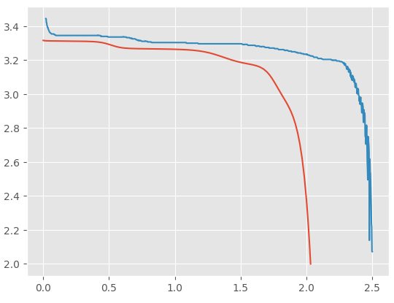
Figure 3: Result after initial manual optimisation.
Table 1: Parameters changed during manual optimisation.
Parameter | Old | New | Notes
Positive electrode thickness [m] | 0.0000627 | 0.0000624
Neg CC conductivity [S.m⁻¹] | 58,411,000 | 43,808,250 | ×0.75
Pos CC conductivity [S.m⁻¹] | 36,914,000 | 27,685,500 | ×0.75
Contact resistance [Ω] | Commented out | 0.006 | Added
Max conc. neg electrode [mol.m⁻³] | 28,985 | 30,985
Initial neg SOC fraction | 0.811 | 0.85
Neg particle radius [m] | 5.48e–7 | 5.38e–7
Neg particle diffusivity [m².s⁻¹] | 4.8e–15 (const) | graphite_diffusivity(sto, T) | Const → function
Neg AM volume fraction | 0.482 | 0.58
Neg electrode conductivity [S.m⁻¹] | 215 | 107.5 | ×0.5
Pos particle diffusivity [m².s⁻¹] | 2.4e–17 (const) | lfp_diffusivity(sto, T) | Const → function
Pos particle radius [m] | 3.80e–8 | 2.85e–8 | ×0.75
Pos electrode conductivity [S.m⁻¹] | 0.18 | 0.036 | ×0.2
Pos AM volume fraction | 0.37529 | 0.360529
Pos electrode porosity | 0.42 | 0.55
Cation transference number | 0.36 | 0.38
Electrolyte diffusivity [m².s⁻¹] | 2e–10 | 1e–10 | ×0.5
Upper voltage cut-off [V] | 3.65 | 5

4. OCV Optimisation with MSMR Model
To address the OCV mismatch, a custom Multi-Site Multi-Reaction (MSMR) model was employed for the optimised OCV function (see ocp_estimation.ipynb). The MSMR approach and its composite formulation are described in the Verbrugge (2017) paper.

4.1 Graphite OCV
The MSMR model was used to reconstruct the graphite negative electrode OCV:
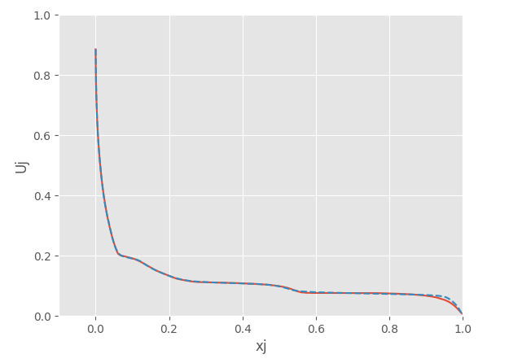
Figure 4: MSMR-reconstructed graphite OCV.

4.2 LFP OCV
For LFP, both lithiation and delithiation OCPs were initially considered to account for hysteresis, but the analysis proceeded with a single OCP curve.
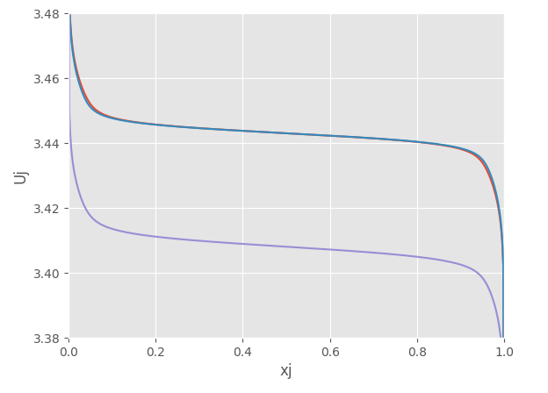
Figure 5: LFP OCV (lithiation and delithiation curves).

4.3 Improved OCV Fit
After applying the MSMR-based OCV, the simulation results improved substantially:
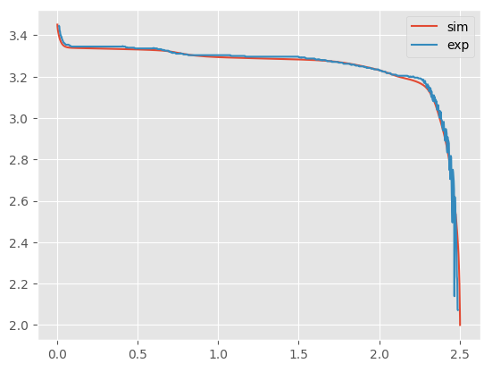
Figure 6: Improved OCV fit after MSMR optimisation.
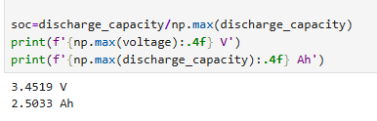
Figure 7: RMSE after OCV optimisation.
Finding the graphite phases properly using the MSMR model proved to be effective in reducing the OCV error.
Table 2: Parameters adjusted after OCV optimisation.
Parameter | Before OCV Opt. | After OCV Opt.
Positive electrode thickness [m] | 0.0000624 | 0.0000625
Initial neg SOC fraction | 0.85 | 0.76
Initial pos SOC fraction | 0.035 | 0.01

5. C-Rate Validation
High C-rate charge–discharge simulations were run at 1C, 2C, 3C, and 4C to validate the parameterised model against experimental data.

5.1 1C Charge–Discharge
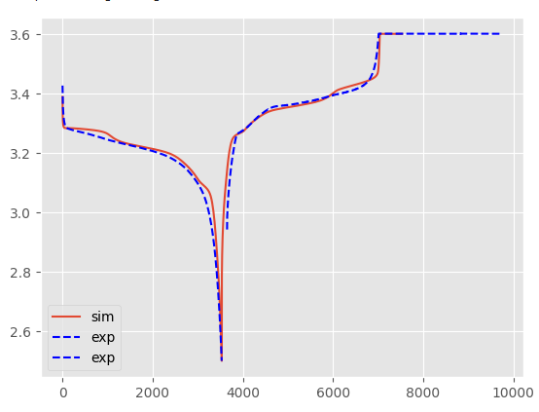
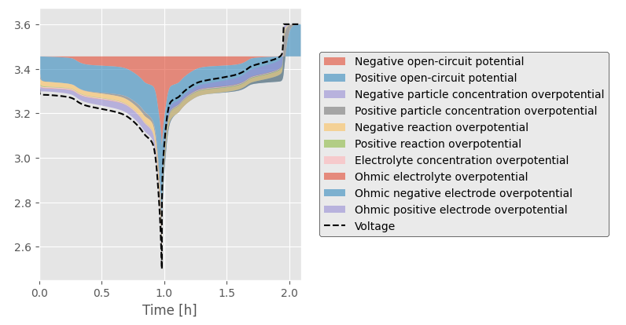
Figure 8: 1C charge–discharge comparison (experiment vs. simulation).

5.2 2C Charge–Discharge
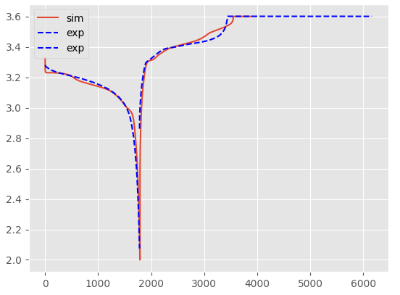
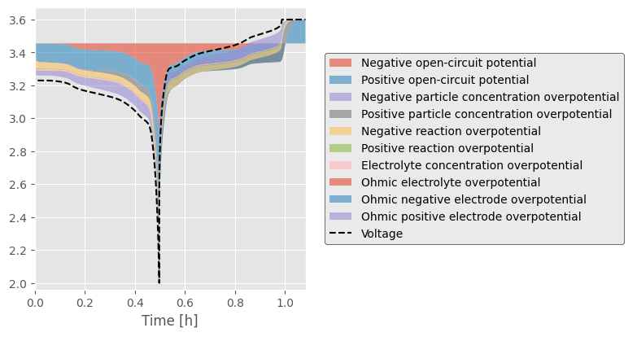
Figure 9: 2C charge–discharge comparison.

5.3 3C Charge–Discharge
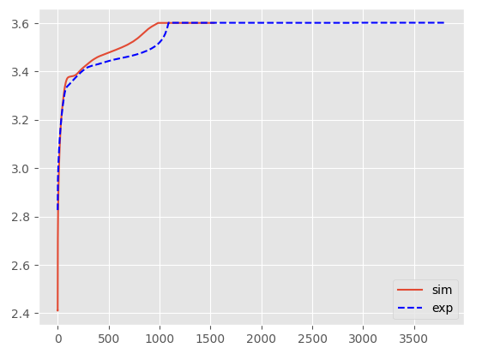
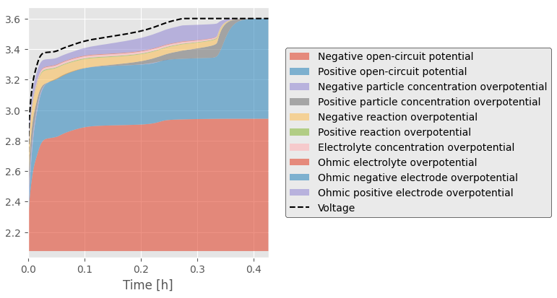
Figure 10: 3C charge–discharge comparison.

5.4 4C Charge–Discharge
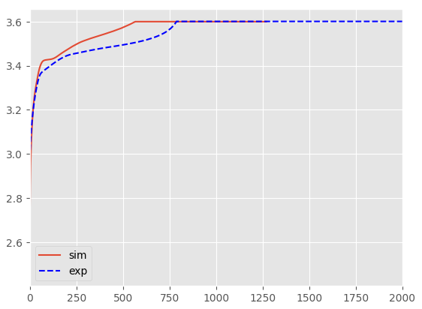
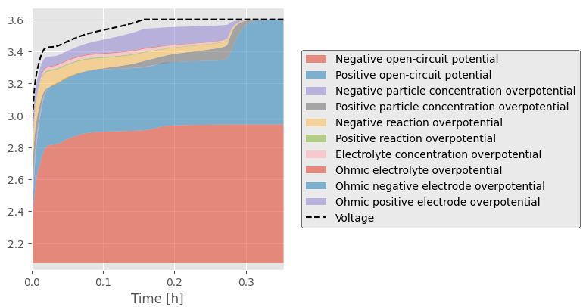
Figure 11: 4C charge–discharge comparison.

5.5 HPPC Result (Pre-Optimisation)
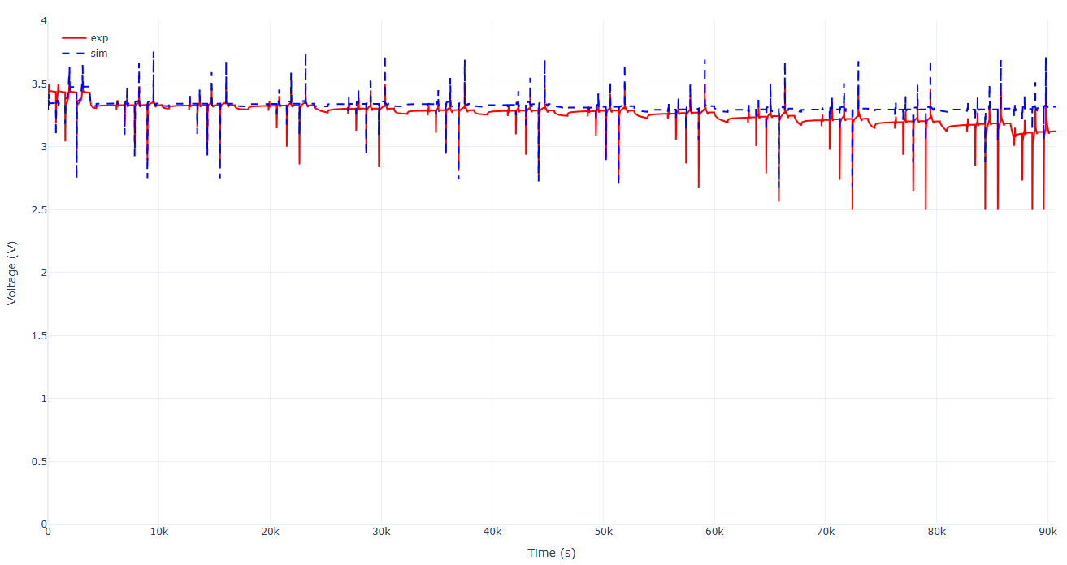
Figure 12: HPPC simulation result before automated optimisation.

5.6 Error Analysis
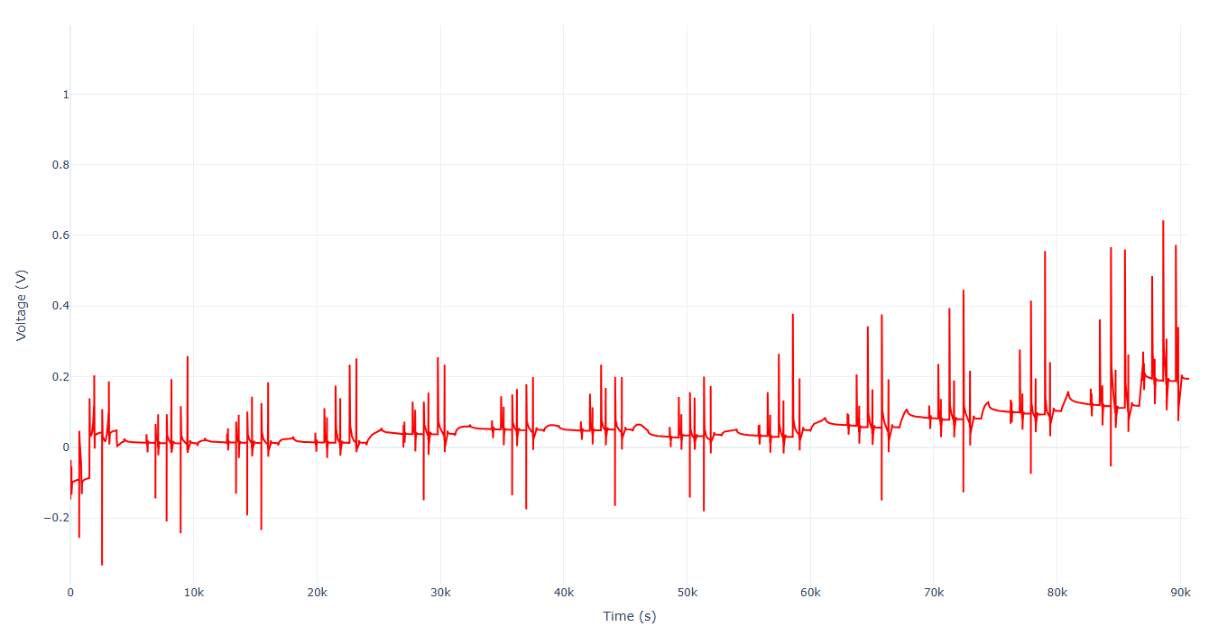
Figure 13: Error analysis across C-rates.
High C-rate charging consistently placed the simulated voltage on the higher side, resulting in a slow, gradual departure from the experimental voltage trajectory.

6. Automated Parameter Optimiser

Layer 1 — Data Loading
The script loads experimental voltage-vs-time curves for five C-rates (1D, 1C, 2C, 3C, 4C) from the interpolated Excel file, sub-sampled to approximately 400 points each for speed. It also loads the graphite OCP lookup table from Hunan_interpolated.xlsx. The LFP positive electrode OCP is hard-coded as the Afshar (2017) analytical function and is not optimised.

Layer 2 — Parameter Vector (55 Unknowns)
All tunable physics is flattened into a single 55-element array with named bounds. This covers geometry (8 parameters), negative electrode properties (6), positive electrode properties (6), separator/electrolyte/thermal (5), exchange current density and activation energies (4 each for neg/pos), solid diffusivities (4), electrolyte conductivity scaling (1), the MSMR gallery for graphite OCV (21 parameters: 7 each for U₀, X, and ω), and initial SOC stoichiometries (4: separate for discharge and charge start).

Layer 3 — Simulation Engine
For each C-rate evaluation, build_pybamm_params takes the 55-element vector and: (a) reconstructs the graphite OCV from the MSMR gallery parameters using a stable logistic/tanh formulation, (b) creates Python closures capturing the current kinetic and diffusivity parameters, and (c) assembles the full PyBaMM ParameterValues dictionary. It then builds a fresh DFN model (lumped thermal, symmetric Butler–Volmer, single-phase) and solves using the IDAKLUSolver. The experiment definitions differ per rate — 1D is a simple CC discharge, while 1C–4C are CC–CV charge protocols.

Layer 4 — Cost Function
The simulated voltage curve is interpolated onto the experimental time grid using interp1d, and RMSE is computed over the overlapping time window. If a simulation fails (solver crash or unphysical parameters), a penalty of 1.0 V RMSE is returned. The total objective is the weighted sum of RMSE across all five C-rates (currently equal weights of 1.0 each).

Layer 5 — Two-Phase Optimiser
Phase 1 (Powell):
A fast local optimiser starts from the nominal (hand-tuned) parameter values. It is gradient-free and bounded, so it quickly refines the neighbourhood of the initial guess. This acts as a “warm start” — it finds a reasonable local minimum at low computational cost.
Phase 2 (Differential Evolution):
A global stochastic optimiser that explores the full bounded parameter space. It is seeded with the Phase 1 result via x0=p_local, so the initial population already includes a good solution. With popsize=8 and maxiter=80, it balances exploration against compute cost.
Feedback Loop:
Each optimiser evaluation calls the objective function, which runs all five PyBaMM simulations, computes five RMSEs, and returns the total cost. The optimiser then proposes a new parameter vector, and the cycle repeats. The best parameters are saved to JSON, and comparison plots are generated at the end.

7. Optimised Results
After automated optimisation, the RMSE for every C-rate came under 25 mV:
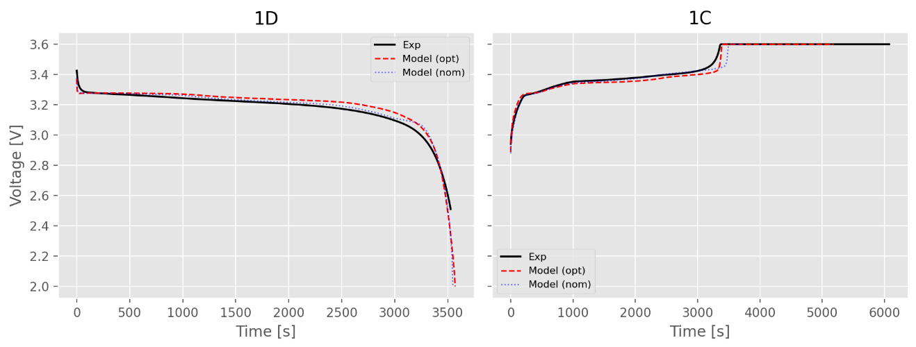
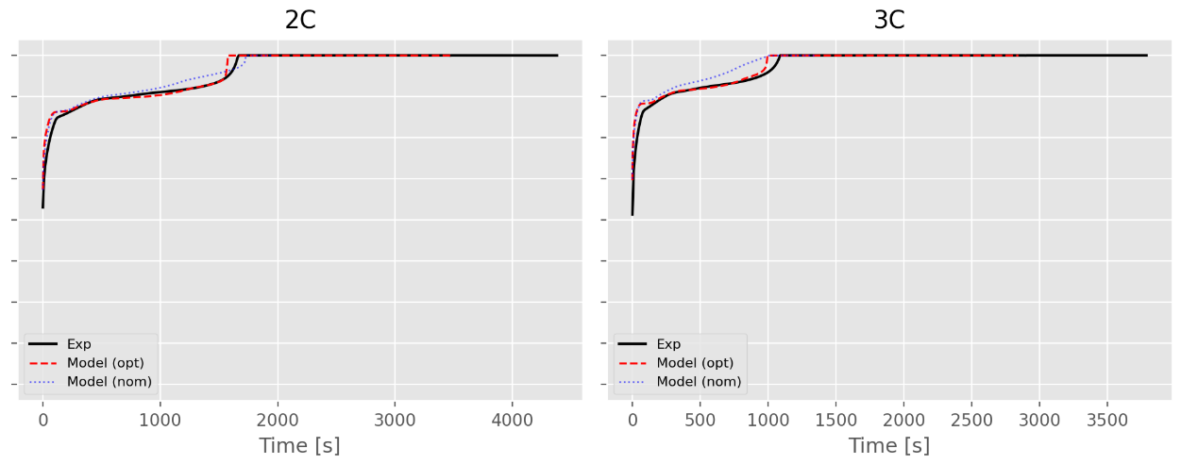
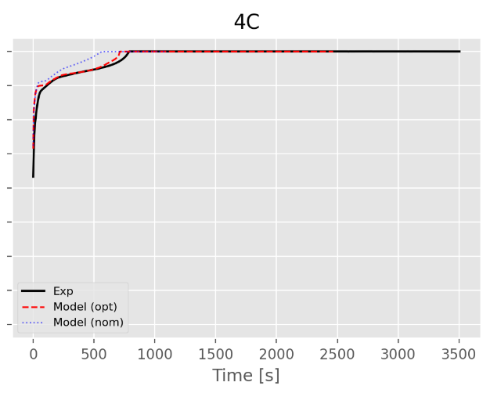
Figure 14: Optimised simulation results across all C-rates (≤ 25 mV RMSE).
The updated OCV capacity converged to approximately 2.57 Ah, which is very close to the reported OCV capacity:
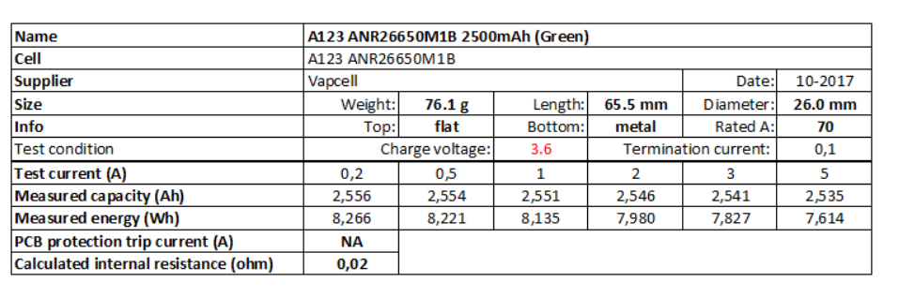
Figure 15: website OCV capacity result.
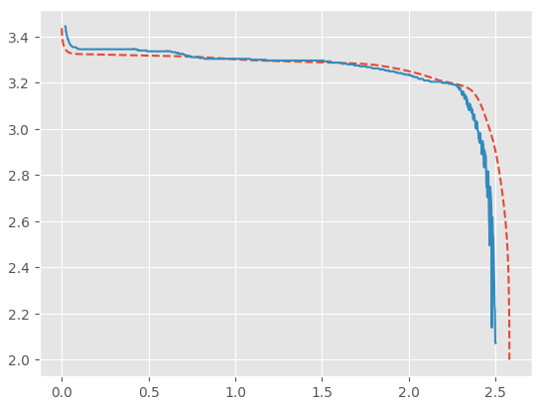
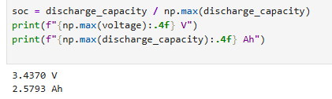
Figure 16: OCV fit and RMSE after full optimisation.

7.1 HPPC Result (Post-Optimisation)
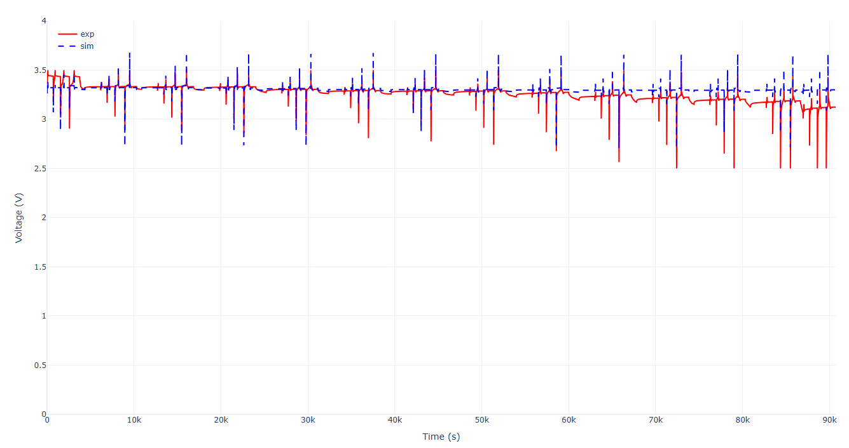
Figure 17: HPPC result after automated optimisation.

8. Remaining Issues and Next Steps
The HPPC result still exhibits the same systematic error, although the magnitude in the initial segment has been reduced. Low C-rate simulations show good validation, but the model at high C-rates like after 4C remains problematic with respect to electrolyte transport and thermal effects.
The discrepancy persists even after incorporating SOC-dependent diffusivity and electrolyte properties as functions of concentration and temperature.
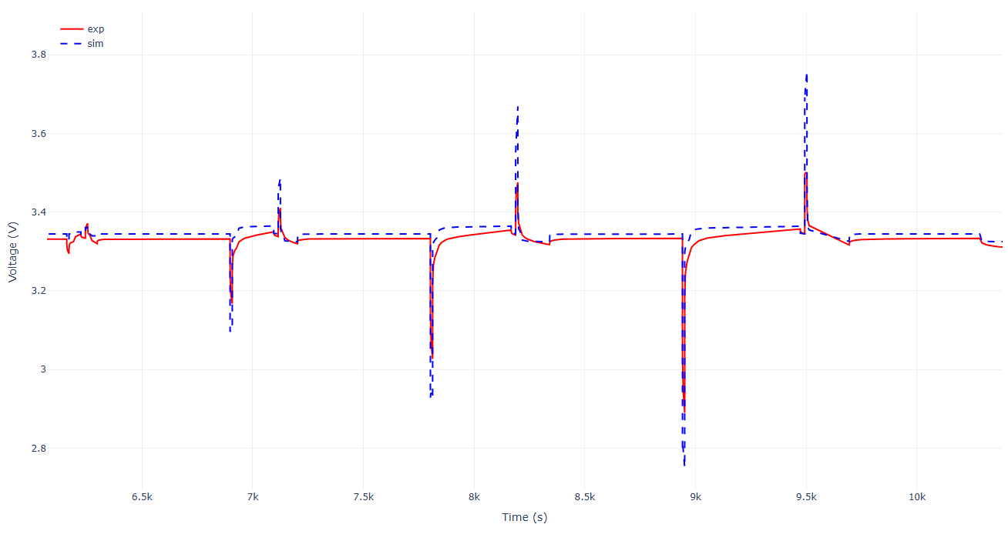
Figure 18: Remaining high C-rate discrepancy.
Next steps:
• Further validation of high C-rate discharge and charge profiles, particularly beyond 4C.
• Continued optimisation of electrolyte transport and kinetic properties.
• Investigation of additional thermal coupling effects at elevated C-rates.

