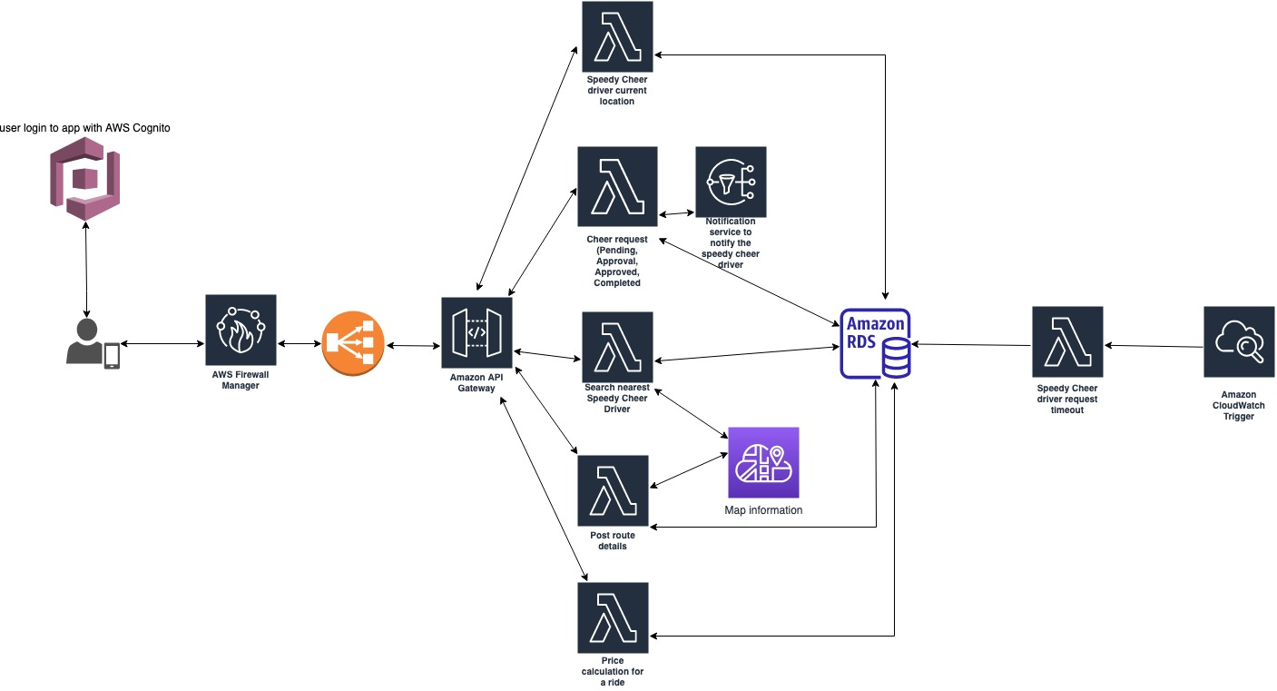

1. User login to app with AWS Cognito service
2. All requests are routed through the AWS Firewall Manager -> Load balancer -> AWS API Gateway
3. There are 5 lambda functions which handles all the requests coming from API Gateway
4. The first lambda function is for locating the Speedy Cheer driver.
5. The second lambda function handles all the user’s cheer requests and there is an SNS service for which the speedy cheer driver will be notified
6. The third lambda function is for searching the nearest Speedy Cheer driver and this is associated with the map information service
7. The fourth lambda function is for showing the route information to the user and this is associated with the map information service
8. The fifth lambda function is calculating the price for each Speedy Cheery driver visit to the user.
9. There is a possibility of request not being accepted and the request keeps going on and times out by the AWS cloudwatch trigger through a lambda function.

All the lambda functions above store the specific task information in the RDS preferably MySQL database