|  |  |
| --- | --- |
| **Student name:** | Rahulkumar Kalidas Patel |
| **Student email:** | [rkpatel52@myseneca.ca](mailto:rkpatel52@myseneca.ca) |
| **Course Information** | WEB700NII - Web Programming |
| **Assessment Name** | Assignment 3 |
| **Date** | 10/06/2025 |

**Honesty Statement**

I declare that the attached assessment is wholly my own work in accordance with Seneca Academic Policy. No part of this assignment has been copied manually or electronically from any other source (including web sites) or distributed to other students.

1. **Created Folders and Files**

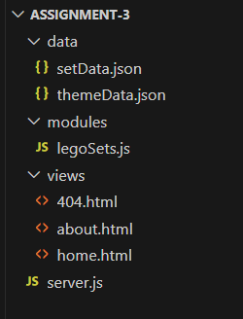

1. **Copy the content of html and json files from lab instructions link**
2. **Write server.js code as per lab instructions**

1. **Run “npm init -y”**

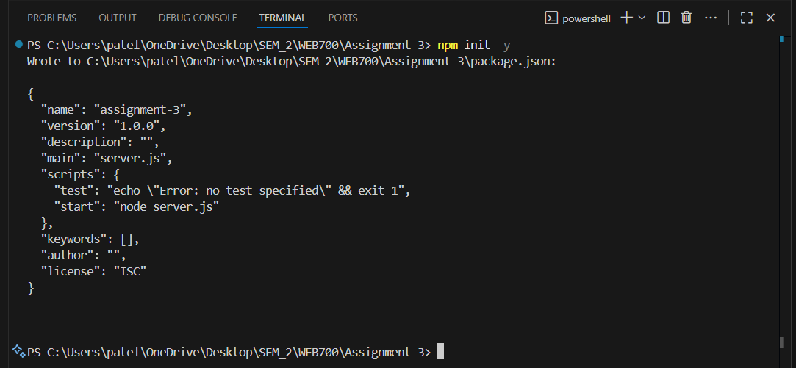

It creates **package.json** so npm can track scripts

1. **Run “npm install express”**

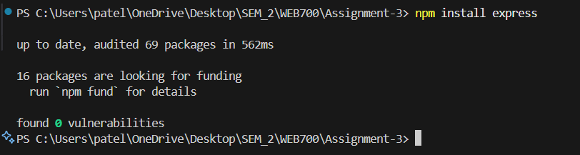

Express is the web framework your server uses.

1. **Run “node server.js” in your terminal**

1. **Copy the link** [**http://localhost:8080**](http://localhost:8080) **and open it into the browser and check the following linnks**

* **Home Page :** <http://localhost:8080/>
* **About Page :** <http://localhost:8080/about>
* **Lego sets :** <http://localhost:8080/lego/sets>
* **404 Page :** [http://localhost:8080/a](http://localhost:8080/a%20)

**Home Page (**<http://localhost:8080/>**)**

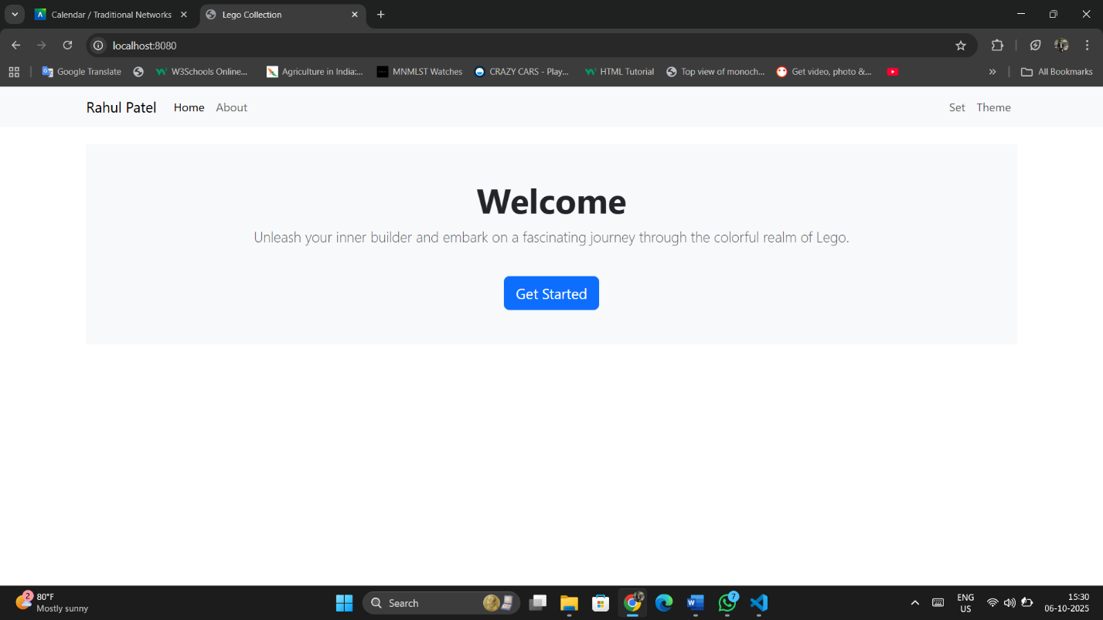

Displays the main page to introduce the website.

**About Page (**<http://localhost:8080/about>**)**

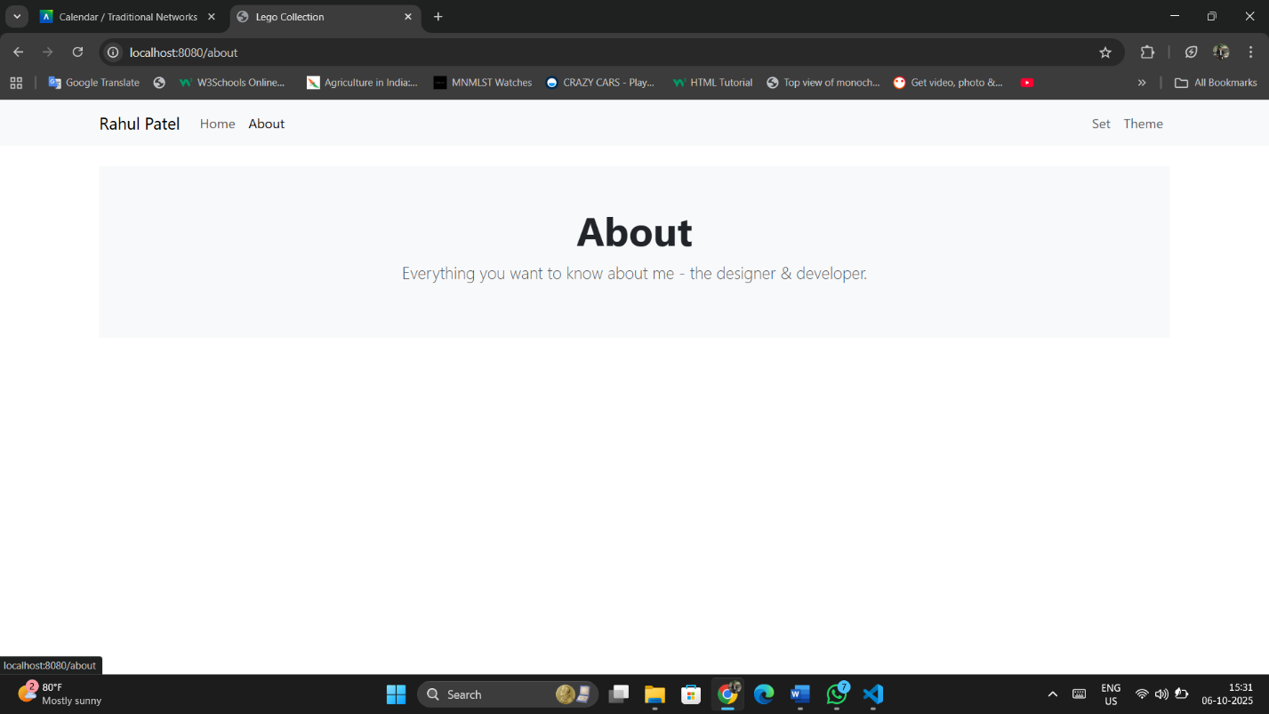

Shows Abou page information

**All sets (**<http://localhost:8080/lego/sets>**)**

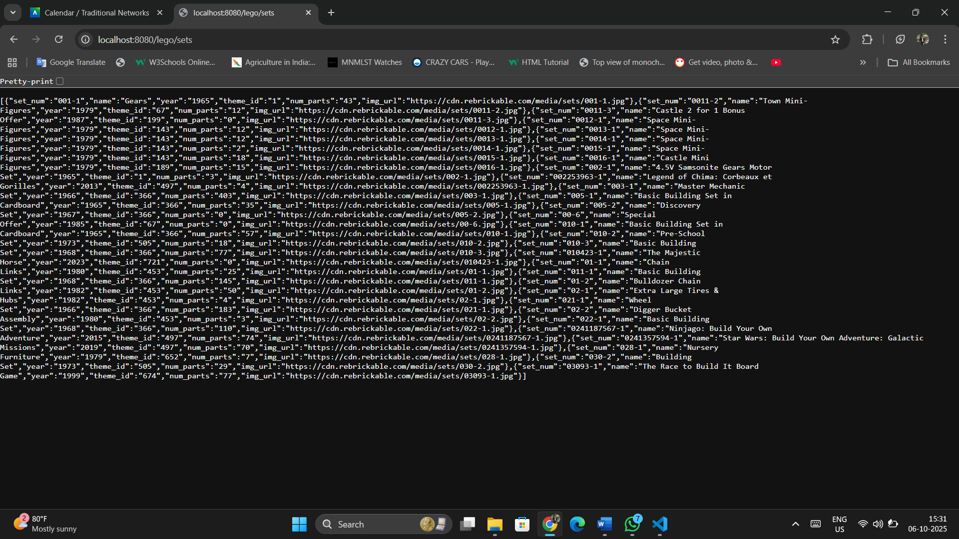

List all available Lego sets

**Filter by theme (**<http://localhost:8080/lego/sets?theme=tech>**)**

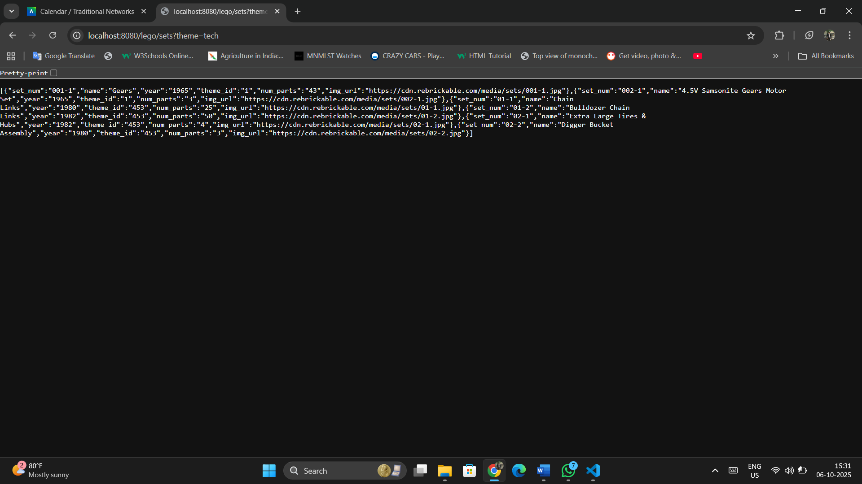

Displays Lego sets of a chosen theme.

**Single set (**<http://localhost:8080/lego/sets/0013-1>**)**

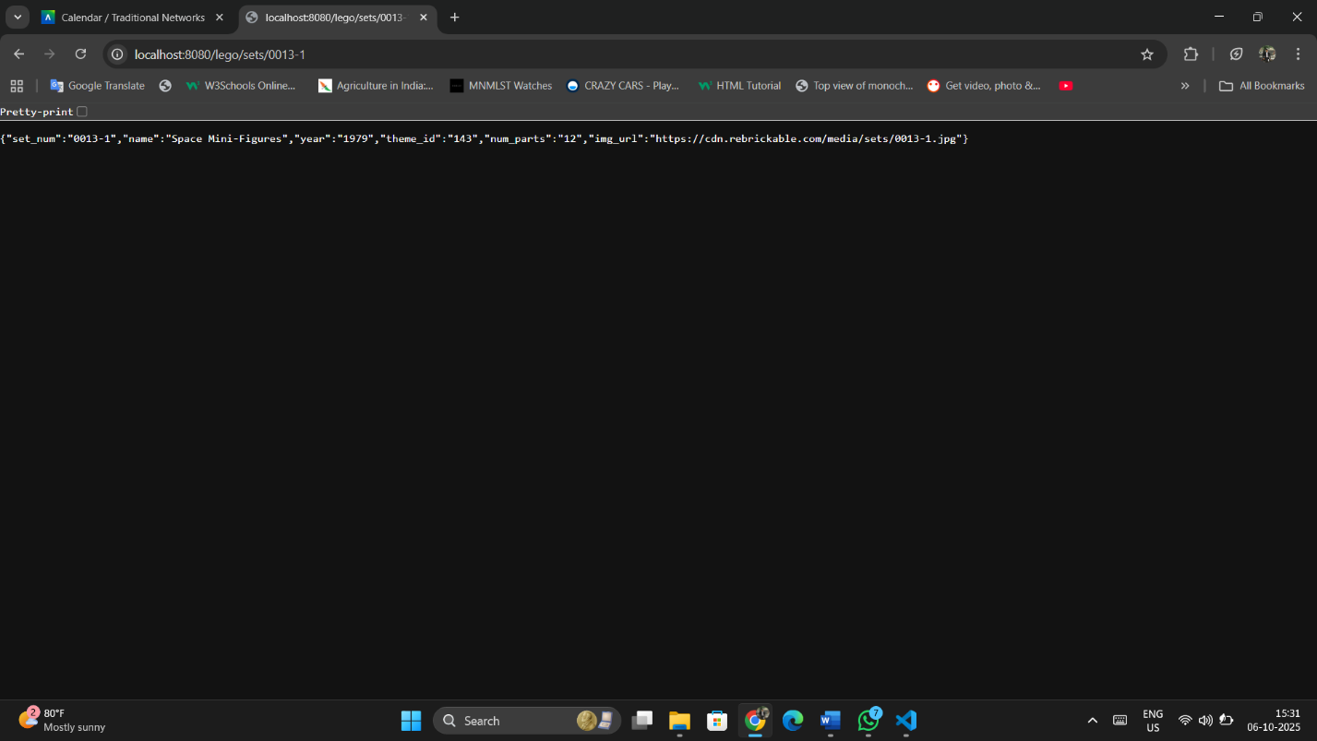

Shows details of one specific Lego set

**404 Page (**<http://localhost:8080/error>**)**

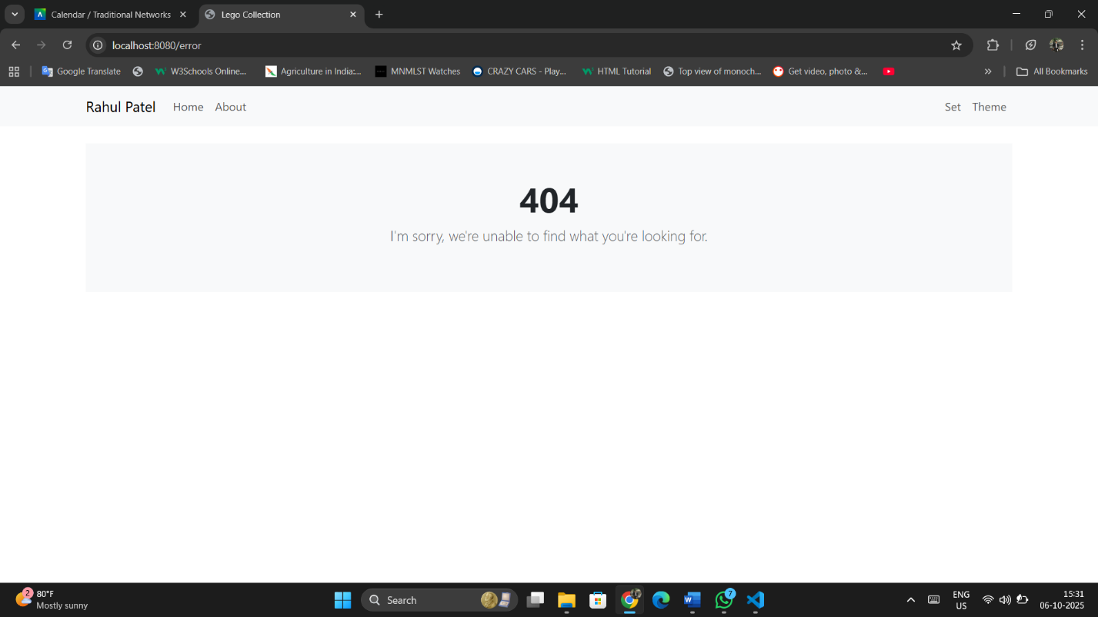

If you enter wrong file name or information that doesn’t exist, then it is called 404.html by default.