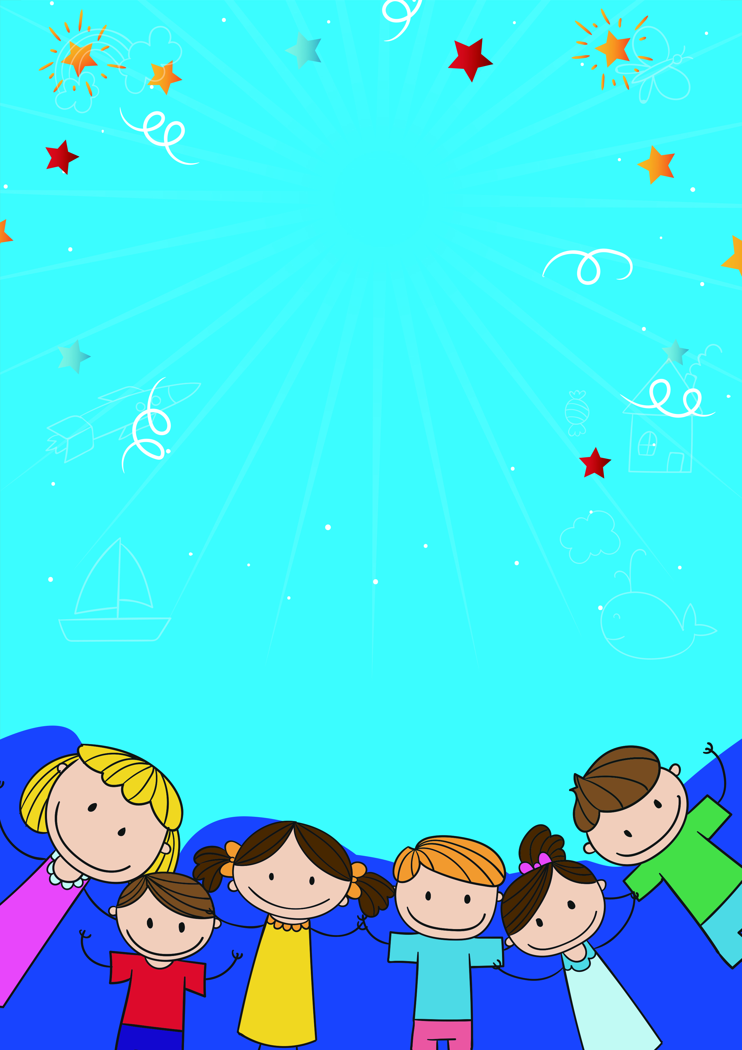

**Introduction to Erb's Palsy**

Erb's palsy is a condition affecting the nerves which leave the spinal cord (brachial plexus) at the neck and supply the muscles and skin of the arm and hand. Erb's Palsy in children usually results from damage to the brachial plexus nerves from a traumatic delivery in babies by excessive pulling. Damage to these nerves can cause muscle and sensation problems.

Physiotherapy can help aid recovery from Erb's palsy by providing strengthening exercises in a fun and engaging way for your baby and also provide advice on positioning to maintain range of movement in the arm while the nerve is recovering.

In infants

https://youtu.be/V3KxSsZp_6c

https://youtu.be/U7umR9sPUqs