**Clear Your Skin at Home with These 7 Remedies**



When pimples are popping up or you're about to lose it over dry skin and dark spots, your first instinct might be to reach for your wallet. But what if the secret to glowing skin could be found in your kitchen? Seriously, you’d be surprised at all the magical skincare elixirs you can concoct with a few simple pantry ingredients, like lemon juice, aloe vera, and turmeric.

Whether you’re looking for an anti-inflammatory product, a DIY exfoliant, or a blackhead eliminator, we’ve got the lowdown on all the best home remedies. There’s no need for a lab coat or beakers when it comes to these skincare solutions. They’re as easy to whip up as a bowl of cereal—check them out below.

**Home Remedy #1**: **Oatmeal, Lemon Juice, and Honey**

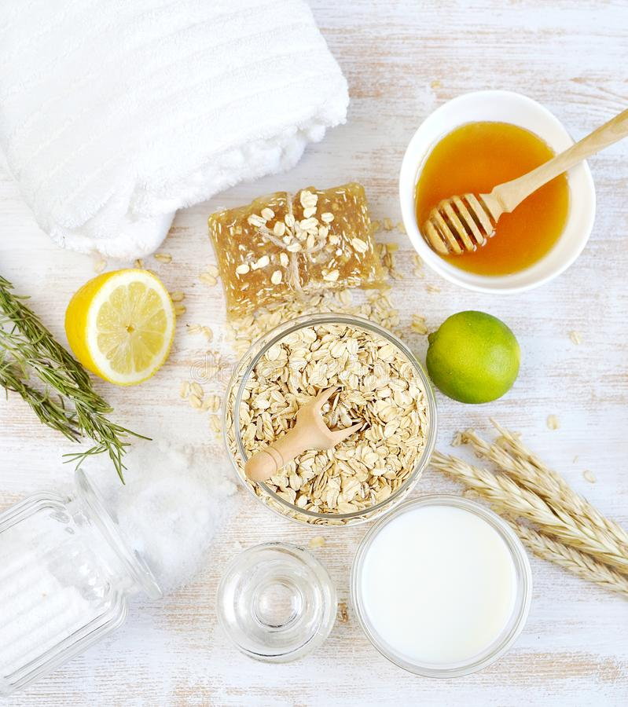

Oatmeal might be a breakfast champion, but this humble grain is WAY more than a healthy snack. Oatmeal’s natural properties make it a skincare wizard, especially for acne-prone skin. Reach for this grain when you’re looking for an exfoliant, a natural oil absorber, or a clean way to treat blemishes.

On the hunt for a natural blackhead treatment? Tart lemon is the perfect addition to your natural skincare party. With citric acid and vitamin C, along with a host of antibacterial properties, a few drops of lemon is all you need to brighten skin. Honey is the sweet mediator between oatmeal and lemon, binding the two together to create a gentle anti-inflammatory exfoliant and skin brightening mask.

The combo of all three make for a beauty treatment that’s gentle enough to use on sensitive skin. Mix a handful of oats, a few drops of honey, and a few squeezes of lemon together in a bowl. Blend well and then apply to your face. Gently rub the oats into your skin, moving your fingers in a circular motion all over your face as you exfoliate. Give a little extra love to any areas prone to blackheads, like your nose and chin, and any dark spots and acne scars. Allow the face mask to rest on your face for a few minutes before you wash off with warm water.

If you’re not in the mood for a DIY, snag an oatmeal mask like the THANN Oatmeal Face Scrub to give your skin a weekly pick-me-up. This formula uses the naturally exfoliating texture of oatmeal and apricot seeds to gently remove dead skin cells while also infusing a blend of antioxidants and vitamins A, B, and C into the skin to create a soft, smooth, and even complexion.

**Home Remedy #2:** **Yogurt**

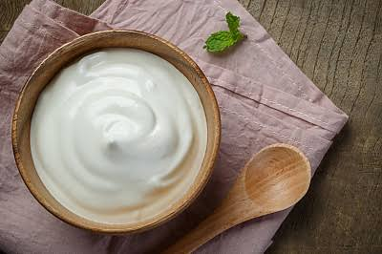

Yogurt has long been championed by nutritionists (and moms around the world) as a healthy way to start your day, but it’s also a natural skincare solution. Thanks to its probiotics and vitamin D properties, yogurt is a multitasking champ, delivering moisture while targeting pesky pimples. For your DIY adventures, skip the flavored fruit yogurts and instead reach for natural yogurt. Apply a small amount to your pimples and leave it on for 30 minutes; once you wash it away, prepare to be amazed by how it’ll dry your pimples out and soothe your oily skin.

For days when your fridge is full of takeout and leftovers, load up on HEY HONEY’s Sweet Treat mask. This mask has our favorite natural ingredients—honey and yogurt—and promises to improve skin elasticity and amp up your skin’s protection against the natural elements.

**Home Remedy #3:** **Tea Tree Oil**

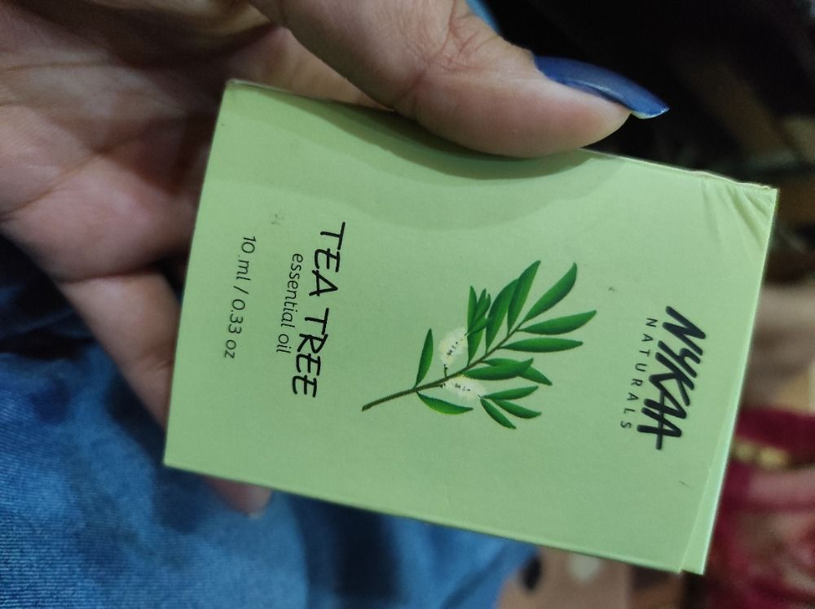

Tea tree oil is the dream natural sanitizer because it doesn’t leave you smelling like an antiseptic dentist’s office. You can find this oil in the leaves of the Australian tea tree, but there’s no need to trek into nature to source this acne fighter, as most natural grocery stores stock this natural cleanser. Apply a few drops of tea tree oil directly to a small cotton ball. Gently press the cotton ball over your well-cleansed face, taking special care to apply on any breakouts.

If you have sensitive skin, it's always a good idea to dilute tea tree essential oil before you use it on your skin. A good rule of thumb is to use about one to two drops of tea tree oil for every 12 drops of carrier oil. If you're not up to creating your own diluted blend, it’s easy to find tea tree oil a hero ingredient in pre-formulated skincare products. One of our faves is THE ORGANIC PHARMACY Peppermint, Tea Tree, Eucalyptus Face Wash. This is a great everyday essential for acne-prone skin, as it helps to promote clear skin by balancing oil and purifying pores without ever overdrying.

**Home Remedy #4:** **Witch Hazel**

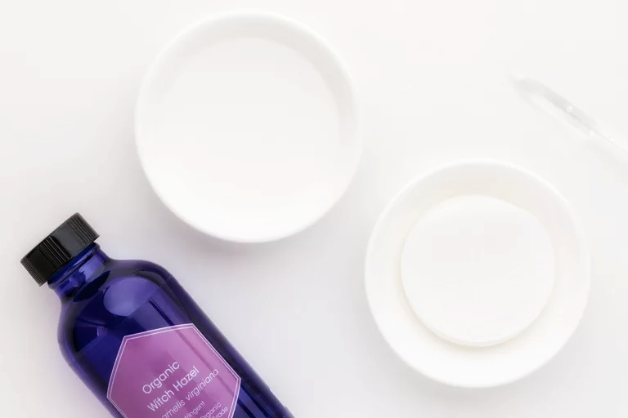

Witch hazel has long been one of dermatologists’ favorite natural remedies, as well as one of our go-to skincare solutions. As the ultimate astringent, you can rely on this simple plant extract to target excess oil, clear your pores, and reduce any acne inflammation. Witch hazel is also gentle enough to apply raw to your face as a toner. Pour a few drops over a cotton pad until it’s moist, and then pat over your face to cleanse and brighten your skin.

This natural ingredient can also make for an excellent spot treatment when paired with other acne fighters. For a potent, ready-made option, we love using ORIGINS Super Spot Remover™: Acne Treatment Gel. The clean formula pairs witch hazel with 1.5% salicylic acid to unclog pores and keep skin clear.

**Home Remedy #5:** **Aloe Vera Gel**

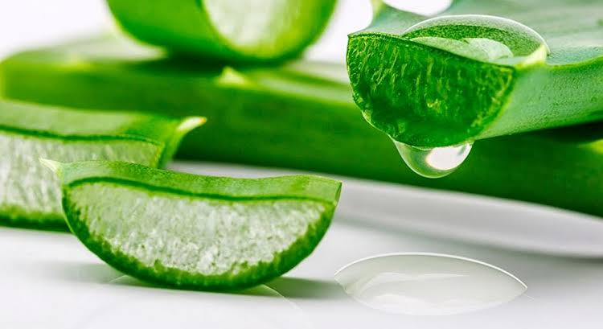

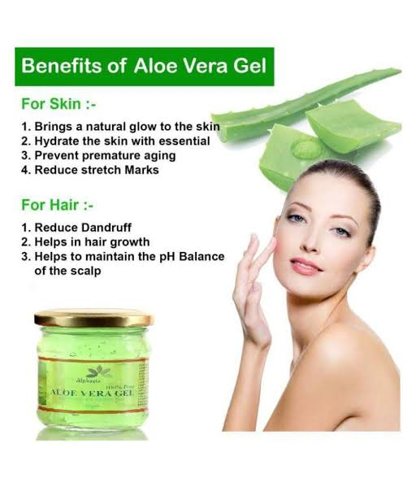

Your sunburn savior is more than just a summer staple—aloe vera gel deserves a regular spot in your skincare routine because of its amazing anti-inflammatory properties. If it can dramatically tame sunburns, just think of the wonders it’ll do for your pimples.

There are a handful of ways you can use aloe to treat breakouts, and one of the easiest is to use a small amount directly on a pimple as a spot treatment. Another option is to swap out your moisturizer for raw aloe, giving you a potent dose of the ingredient’s naturally moisturizing and anti-inflammatory benefits. Still want more aloe? Try incorporating a serum like TAHNYC Vegan Hyaluronic Acid in Aloe VeraMolecular Serum into your a.m. and p.m. skincare routine as a daily hydration booster and redness reducer.

**Home Remedy #6:** **Rose Water & Lemon Juice**

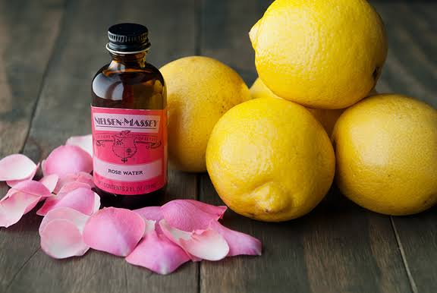

One surefire way to indulge self-care is with rose water, a powerful exfoliator that will help you nix dead skin cells and pollutants from your gorgeous face. Simply mix rose water with a few drops of lemon juice and apply all over your skin with a cotton pad. Then—this is our fave part—cue up your favorite Netflix show and let the mask sit for 30 mins. Rinse off with warm water and apply your favorite lotion.

FEEL Harmony Rose Petal Facial Mask combines roses (including actual rose petals) with vitamin E and vitamin C, creating a moisturizing skin mask that’s gentle on the environment, too—it’s 100% vegan. Swap this in between your full-strength peeling masks to maintain bright skin.

**Home Remedy #7:** **Turmeric & Olive Oil**

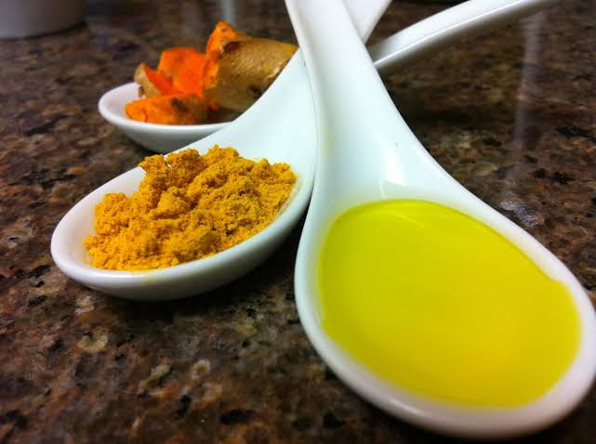

You might reach for turmeric when you’re stirring up your favorite curry, but this powerful spice doesn’t just belong in the kitchen. Turmeric’s natural anti-inflammatory properties make it a solid pick for evening out your skin tone and keeping your glow going. But just to warn you, turmeric is mighty yellow—so make sure to mix it with a thickening component in order to avoid accidentally dyeing your skin! We love mixing it with olive oil, which works similar to aloe vera, to moisturize and repair sun damage.

If you’re mixing ingredients, add just enough turmeric to olive oil so that you get a bold yellow color, but keep the consistency closer to an oil than a paste. Leave the mixture on as a mask for 10 to 15 minutes, then wash thoroughly with lukewarm water. If you’d prefer not to play chef and esthetician, load up on APTO SKINCARE’s Healing Mask with Turmeric after an exfoliating session. This mask is balanced with azelaic acid, giving an extra boost to turmeric’s power in reducing skin redness and breakouts.