SCHOOL OF COMPUTER AND INFORMATION SCIENCES

IGNOU, MAIDAN GARHI, NEW DELHI – 110 068

Enrolment No.: ………………………

Project Proposal No :…………………..
(for office use only)
Study Centre: ……………….……….

Regional Centre:…… RC Code:……
E-mail: ………….………..…………...
Mobile/Tel No.: …..………………….
1. Name and Address of the Student ………………………..…………………………………….
………………………………………………………………
2. Title of the Project .………..…………………………………………………….
3. Name and Address of the Guide …..………………………………………………………….
………………………………………………………………
Ph.D* M.Tech.* B.E*/B.Tech.* MCA M.Sc.*
4. Educational Qualification of the Guide

(Attach bio-data also)
(*in Computer Science / IT only)
5. Working / Teaching experience of the Guide** …………………………………………………………… ……………………………………………………………………………………………………………….
(**Note: At any given point of time, a guide should not provide guidance for more than 5 MCA students of IGNOU)
6. Software used in the Project ……………………………………………………………..
7. If already pursued BCA/BIT from IGNOU, mention the title of the project (CS-76) and the s/w used……………………………………………………

8. Project title of the Mini Project (MCS-044) and the s/w used………………………………………………
9. Is this your first submission? Yes No

Signature of the Student Signature of the Guide
Date: ………………… Date: …………………….

For Office Use Only Name:……………………………..............
…………………………………………….

Signature, Designation, Stamp of the Project Proposal Evaluator
Approved Not Approved Date: …………………….
Suggestions for reformulating the Project:

Index

- Abstract
- Objectives of the project
- System Requirements
- Problem Definition, Requirement Specifications
- Scope of solution
- System analysis
- Detailed structure of Project
- Future enhancements

Virtual Class Room System

INTRODUCTION

Developing a virtual classroom system to promote a greater count of students to splurge into the field of Education. It integrates the benefits of a physical classroom with the convenience of a ‘no-physical-bar’ virtual learning environment, minus the commuting hazards and expenses. It will usher in the immense flexibility and sophistication in the existing learning platform structures, with the perfect blend of synchronous and asynchronous interaction. It provides a means of collaborative learning for the students.
If you’re a teacher or student, you probably know that Virtual Class Room designed to help professors and instructors create and teach courses online or use online technology to help run classes. In educational software circles, it’s also often called an e-learning system, a learning management system, or a virtual learning environment.
In the recent era of globalization, technological advancement has increased dramatically in every sphere including mainstream education. These advances have introduced new educational nomenclature i.e. “virtual classroom”. Profound investments in technology in this decade have given rise to a worldwide explosionof information. Many educational institutions have been mystified by this information chaos. They are driven by the goal to use newly found access to global data communication. This step will increase enrolment and will award a vast range of degrees through massive investments in distance education programmes. There has been much talk among educators that these acts begin to modify the students’ worth to the academic world, as the students begin to assume both the tangible and intangible characteristics associated with those of a “Customer” as opposed to the characteristics of a student. Marketing strategies abound that beseech the “students-customer” to take advantage of “fast, universal access”, “earn a degree in a short period of time”, and other creative approaches that guarantee satisfaction and quick delivery of the degree-of-choice. Moreover, in the fast growing competition in the job market, there have been increasing demands for specialists, professionals over population, increasing awareness as well as demand for higher education, shortage of qualified teachers and infrastructure facility. Virtual classroom has taken a lead role in the teaching-learning process. Generically, the virtual classroom is a teaching and learning environment located within a computer mediated communication system. It consists of asset of group communication and work “spaces” and facilities that are constructed in software. Virtual Class Room System allows you to incorporate dynamic, interactive training into your learning landscape and manage it across the enterprise. This reduce training costs while increasing impact, scope, and frequency of training to keep pace with your business-using only a Web browser. Ensure customers, partners, and employees are always up-to-date on new product releases, corporate initiatives, and soft skills. Train the widest audience possible with anytime, anywhere access to recorded training sessions.

System Analysis

Purpose of the System:
This system provides an online solution to provide teaching and learning environment located within a computer mediated communication system. It consists of asset of group communication and work “spaces”.
Existing System:
- Existing system is not providing the information about faculty’s achievements.
- Existing system doesn’t provide online exams.
- Existing system doesn’t have the facility to send the mails to other students.
- Existing system is not having the facility for faculty to upload the assignments.
- The Existing System doesn’t provide the facility for the students to download the assignments.
Proposed System:
- Students can choose courses, attend lectures, take exams, view their attendance records, progress reports etc as per their convenience.
- Registration for multiple courses.
- Attend lectures either at the scheduled time or on request view lecture at a later time.
- Faculties can take lectures, upload assignments, announcements, evaluate answer sheets and also can upload lectures and other discussions in various formats as in videos, power point presentation etc.
- Upload and Download of various assignments, college notices, student's notices, journals, videos.
- There can be forums, blogs etc to discuss various queries and to put up suggestions posted both by students and teachers.
- Administrator can generate reports, log files, backup/recovery of data at any time.
- Shared documents and media library that can help in active learning of a student.
- Users must have valid User ID and password to login thus creating their individual profiles.
Students can take up various quizzes which can help them to realize their inbuilt talents in various fields.

Feasibility Study

TECHNICAL FEASIBILITY:

Evaluating the technical feasibility is the trickiest part of a feasibility study. This is because, at this point in time, not too many detailed design of the system, making it difficult to access issues like performance, costs on (on account of the kind of technology to be deployed) etc. A number of issues have to be considered while doing a technical
analysis.
- Understand the different technologies involved in the proposed system:
Before commencing the project, we have to be very clear about what are the technologies that are to be required for the development of the new system.
- Find out whether the organization currently possesses the required technologies:
  - Is the required technology available with the organization?
  - If so is the capacity sufficient?
For instance –

Operational Feasibility:
Proposed project is beneficial only if it can be turned into information systems that will meet the organizations operating requirements. Simply stated, this test of feasibility asks if the system will work when it is developed and installed. Are there major barriers to Implementation? Here are questions that will help test the operational feasibility of a project:
Is there sufficient support for the project from management from users? If the current system is well liked and used to the extent that persons will not be able to see reasons for change, there may be resistance.
Are the current business methods acceptable to the user? If they are not, Users may welcome a change that will bring about a more operational and useful systems.
Have the user been involved in the planning and development of the project? Early involvement reduces the chances of resistance to the system and in general and increases the likelihood of successful project. Since the proposed system was to help reduce the hardships encountered. In the existing manual system, the new system was considered to be operational feasible.

“Will the current printer be able to handle the new reports and forms required for the new system?”

Economical Feasibility:
Economical feasibility attempts 2 weigh the costs of developing and implementing a new system, against the benefits that would accrue from having the new system in place. This feasibility study gives the top management the economic justification for the new system.
A simple economic analysis which gives the actual comparison of costs and benefits are much more meaningful in this case. In addition, this proves to be a useful point of reference to compare actual costs as the project progresses. There could be various types of intangible benefits on account of automation. These could include increased customer satisfaction, improvement in product quality better decision making timeliness of information, expediting activities, improved accuracy of operations, better documentation and record keeping, faster retrieval of information, better employee morale.

System Requirement Specification

Overview:
Developing a virtual classroom system to promote a greater count of students to splurge into the field of Education. It integrates the benefits of a physical classroom with the convenience of a ‘no-physical-bar’ virtual learning environment, minus the commuting hazards and expenses. It will usher in the immense flexibility and sophistication in the existing learning platform structures, with the perfect blend of synchronous and asynchronous interaction. It provides a means of collaborative learning for the students.
- Students can choose courses, attend lectures, take exams, view their attendance records, progress reports etc as per their convenience.
Registration for multiple courses.
- Attend lectures either at the scheduled time or on request view lecture at a later time.
- Faculties can take lectures, upload assignments, announcements, evaluate answer sheets and also can upload lectures and other discussions in various formats as in videos, power point presentation etc.
- Upload and Download of various assignments, college notices, student's notices, journals, videos.
- Real Time collaboration among – A/B via chat rooms.
- There can be forums, blogs etc to discuss various queries and to put up suggestions posted both by students and teachers.
Administrator can generate reports, log files, backup/recovery of data at any time.
- Shared documents and media library that can help in active learning of a student.
- Availability of voice mail box to allow faculties to get the descriptive messages left by the students.
- Users must have valid User ID and password to login thus creating their individual profiles.
- Students can take up various quizzes which can help them to realize their inbuilt talents in various fields.

Modules Description

No of Modules:
The system after careful analysis has been identified to be presented with the following modules:
The Modules involved are
- Student
- faculty
- Administrator
- Security And Authentication
- Reports
Description for Modules:
Student: Students can choose courses, attend lectures, take exams, view their attendance records, progress reports etc as per their convenience. Students can take up various quizzes which can help them to realize their inbuilt talents in various fields.
Faculty: Faculties can place the lectures, upload assignments, announcements, evaluate answer sheets and also can upload lectures and other discussions in various formats as in videos, power point presentation etc.
Administrator: Administrator can generate reports, log files, backup/recovery of data at any time. Shared documents and media library that can help in active learning of a student. Administrator will provide users valid User ID and password to login by creating their individual profiles.
Security and Authentication:
- Student Registration.
- Login as student or faculty and Administrator
- Change password
- Forgot Password
Reports:
In this module, different actors can generate the different types of reports according to their responsibilities.

SOFTWARE REQUIREMENT AND
HARDWARE REQUIREMENT

Software Requirements :
Operating System : Windows XP/2003 or Linux
User Interface : HTML, CSS
Client-side Scripting : JavaScript
Programming Language : Java
Web Applications : JDBC, Servlets, JSP
IDE/Workbench : My Eclipse 6.0
Database : Oracle 10g
Server Deployment : Tomcat 5.x
Frame Work : Struts 1.x

Hardware Requirements:
Processor : Pentium IV
Hard Disk : 40GB
RAM : 512MB or more

System Design

Data Flow Diagrams

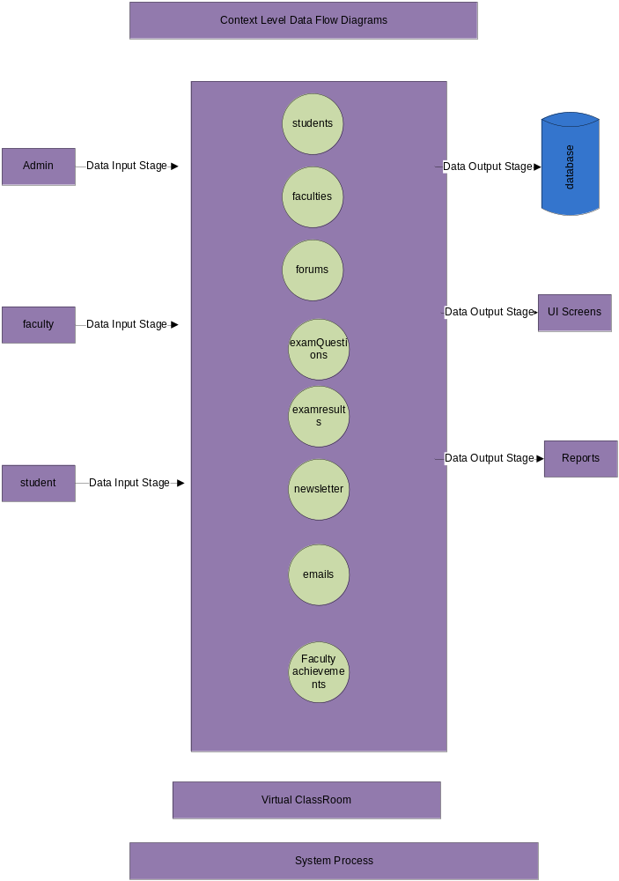

Login DFD Diagram:
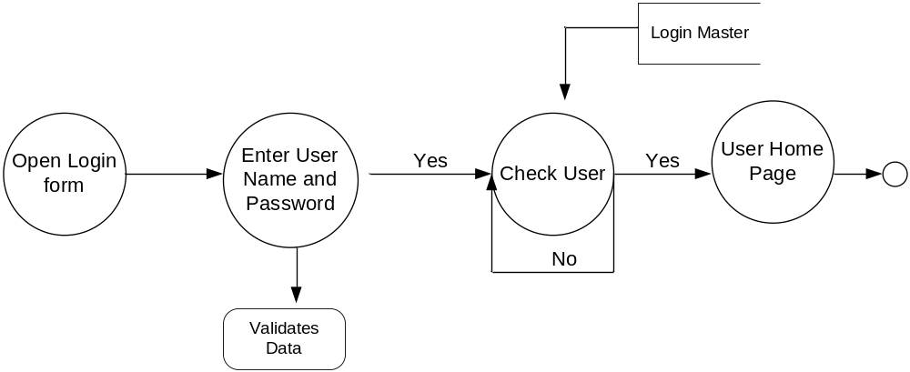

Admin Level1 Data Flow Diagram:

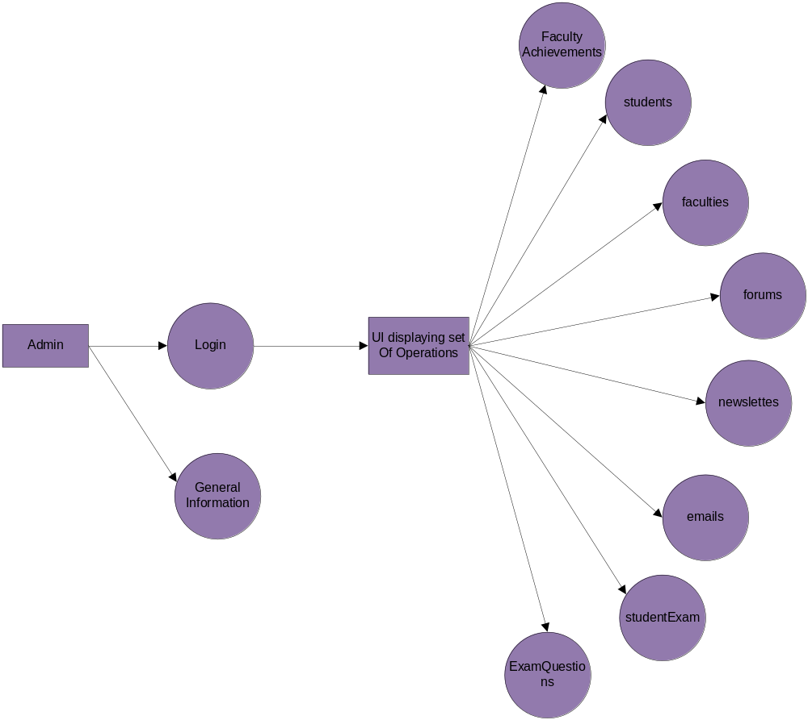

Admin Level1 Data Flow Diagram:

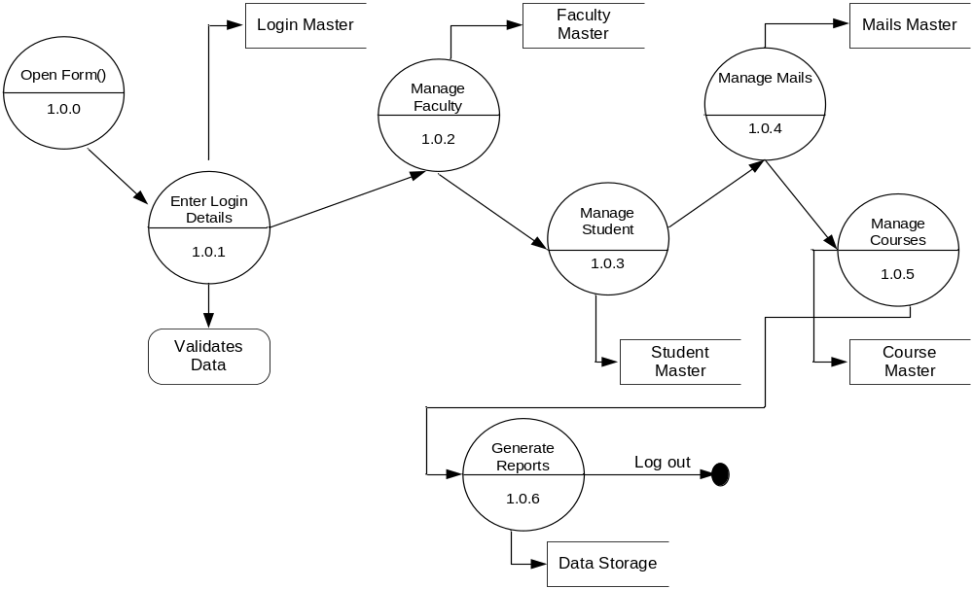
Level 2 Data Flow Diagram for Admin:
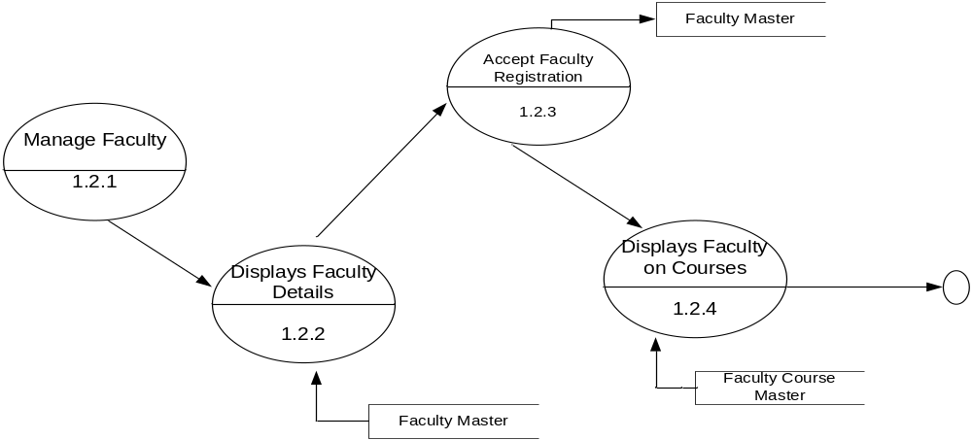
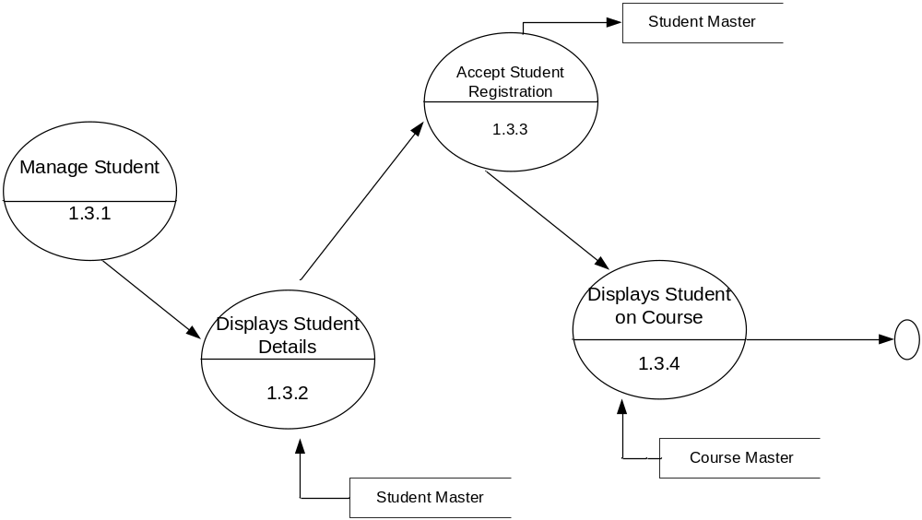

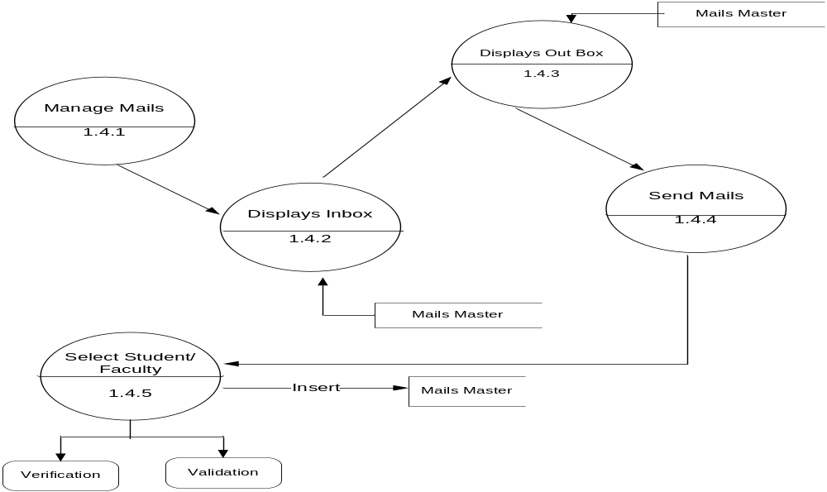

Faculty Level1 Data Flow Diagram:

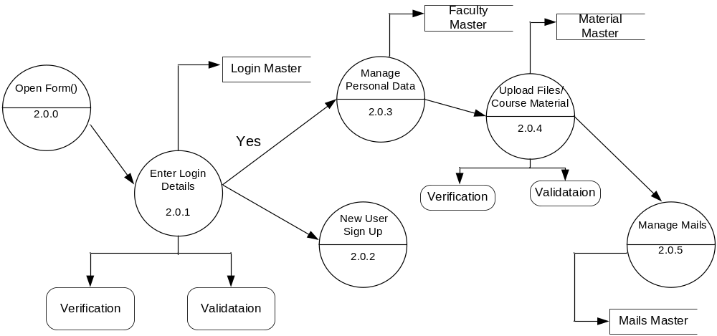
Faculty Level2 Data Flow Diagram:
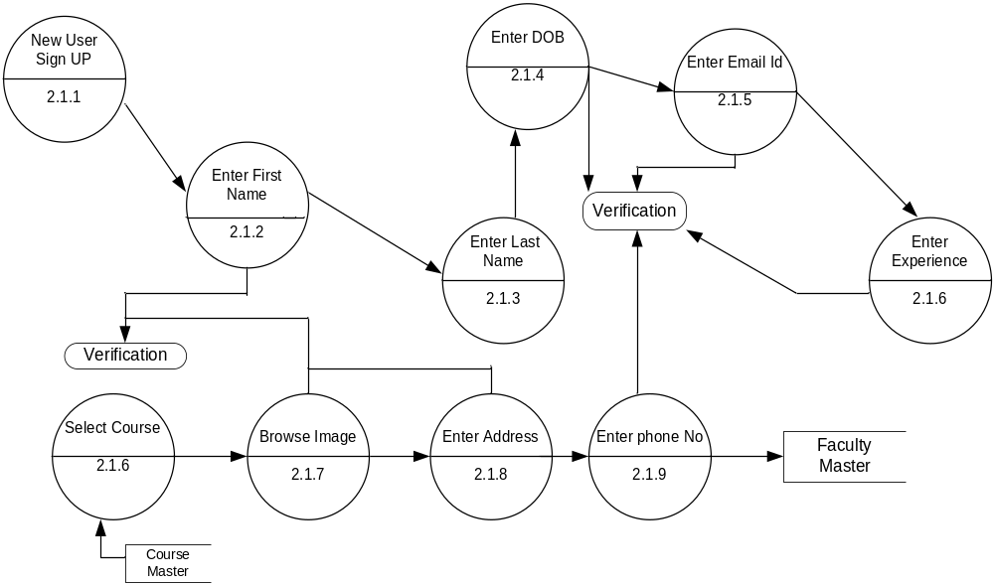
Student Level1 Data Flow Diagram

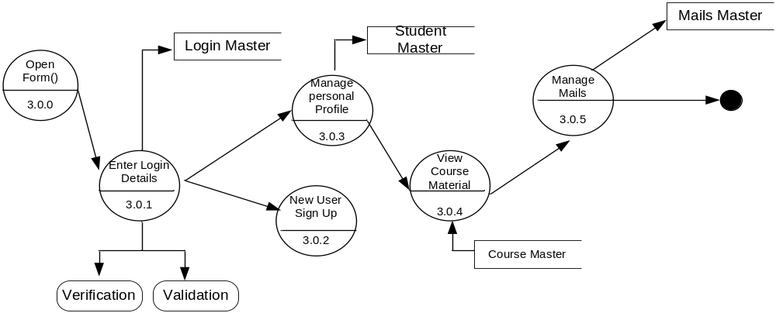

E-R Diagram

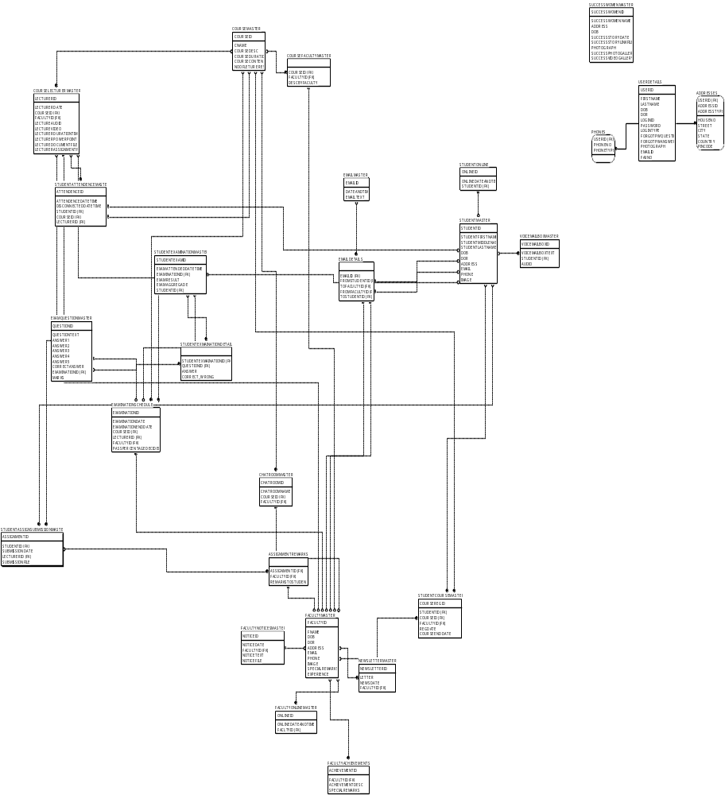

UML Diagrams
(Unified Modeling Language)

Class Collaboration Diagram

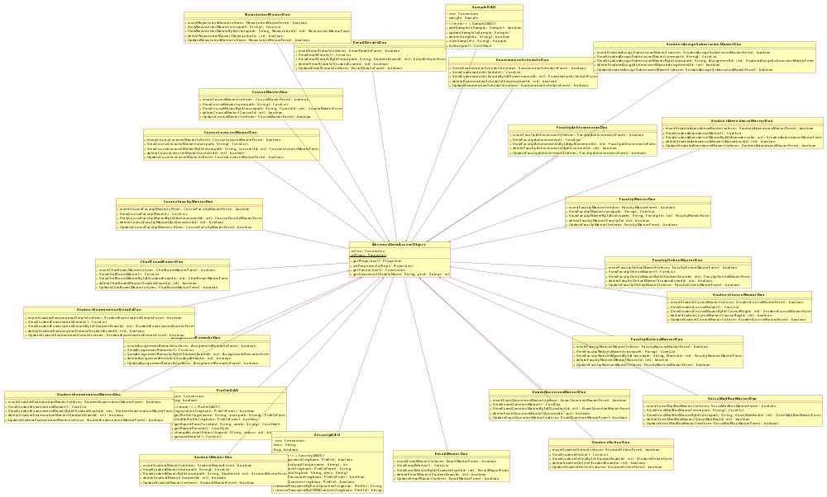

Use-case Diagrams

System Use Case Diagram:

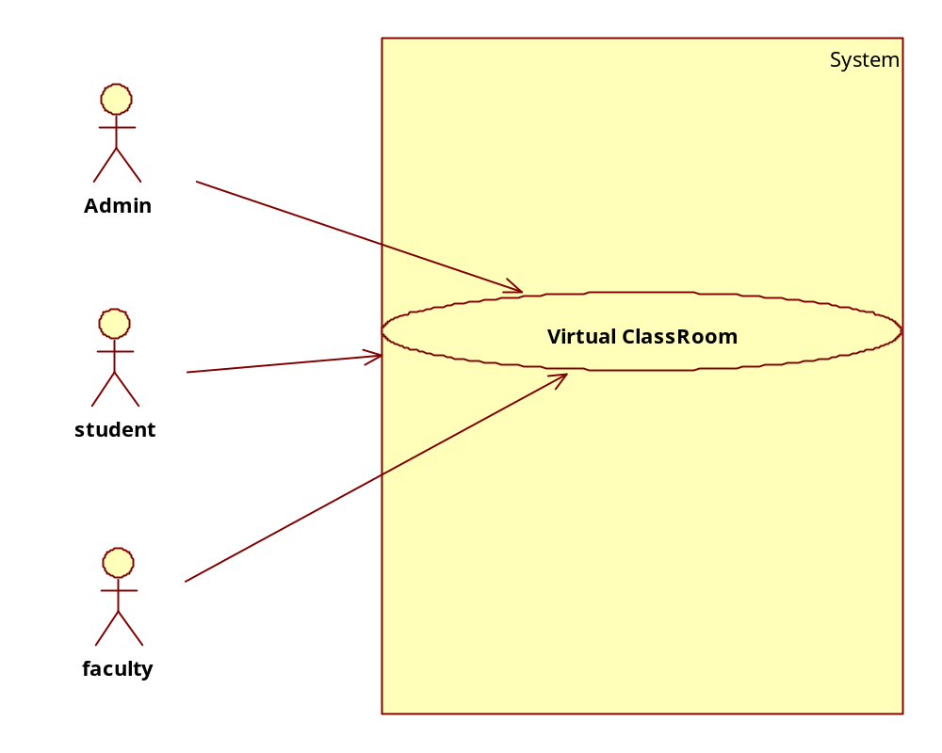

Admin Use Case Diagram:
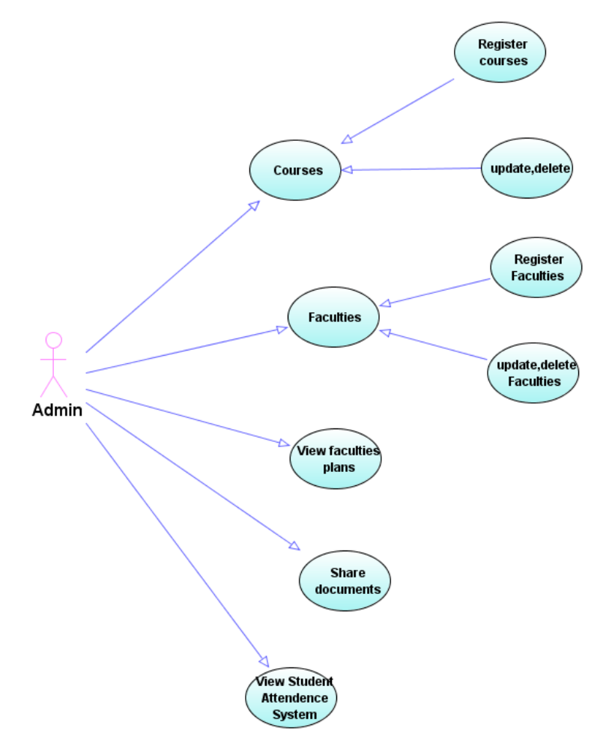

Faculty Use Case diagram:
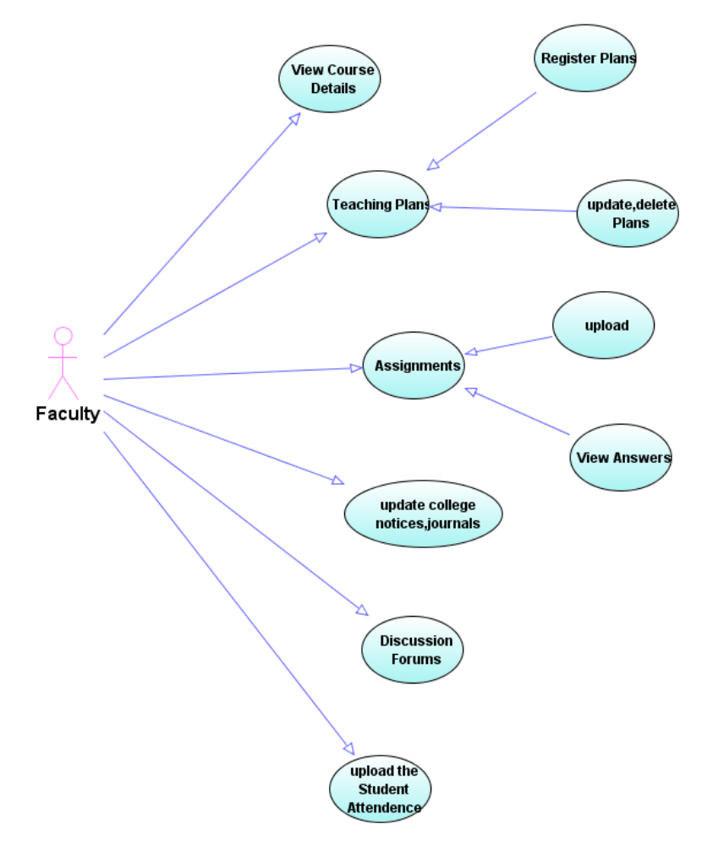

Student Use Case Diagram:
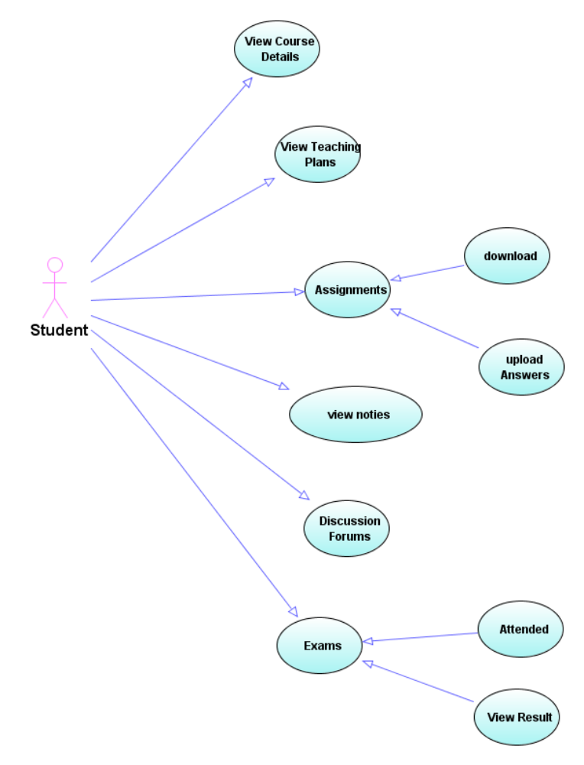

Sequence Diagrams

Admin Sequence Diagram:

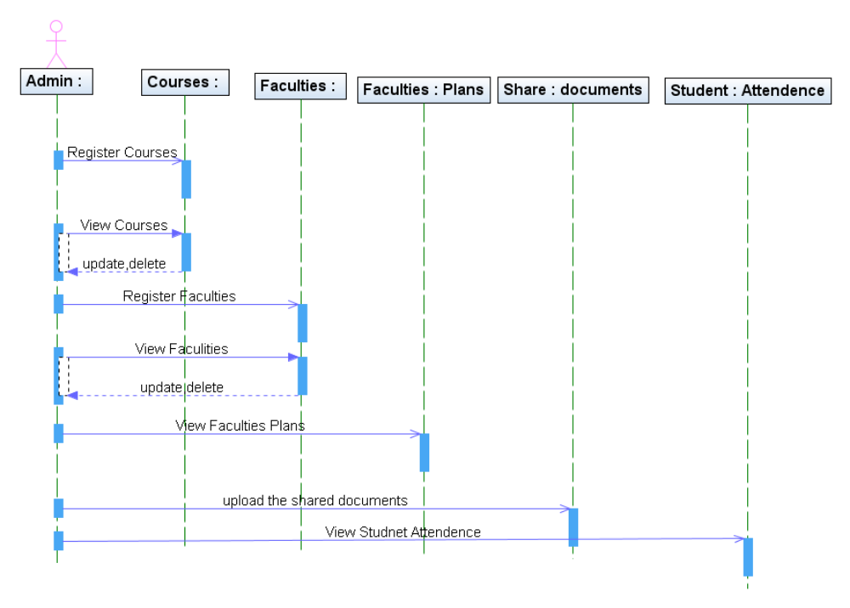

Faculty Sequence Diagram: 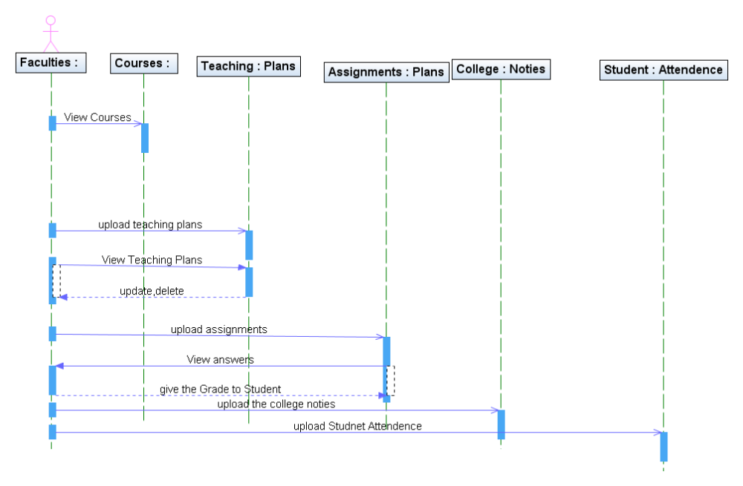

Student Sequence Diagram:
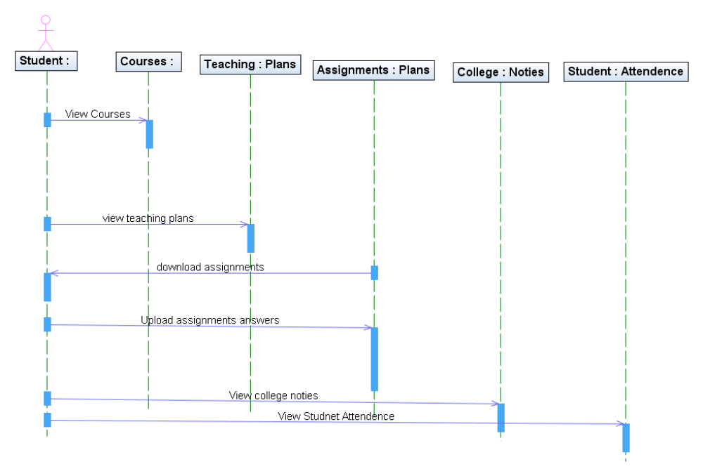

Collaboration Diagrams

Collaboration Diagram for Admin:
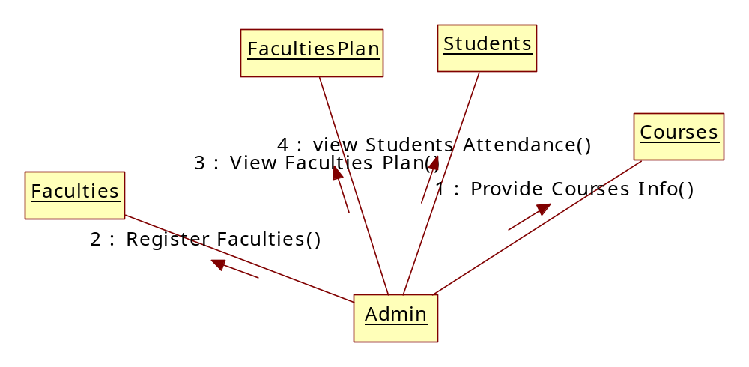

Collaboration Diagram for Faculty:
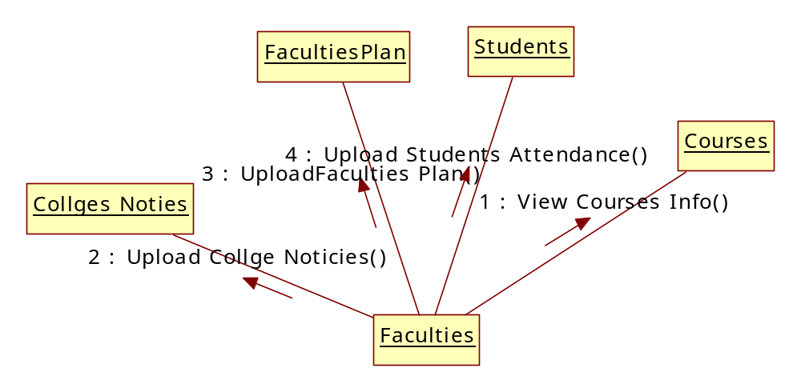

Collaboration Diagram for Students:

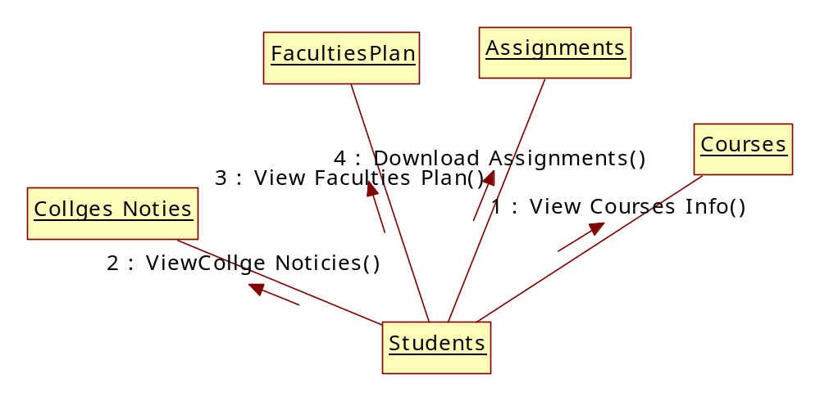

Operational Level Sequence Diagrams

Login sequence Diagram:
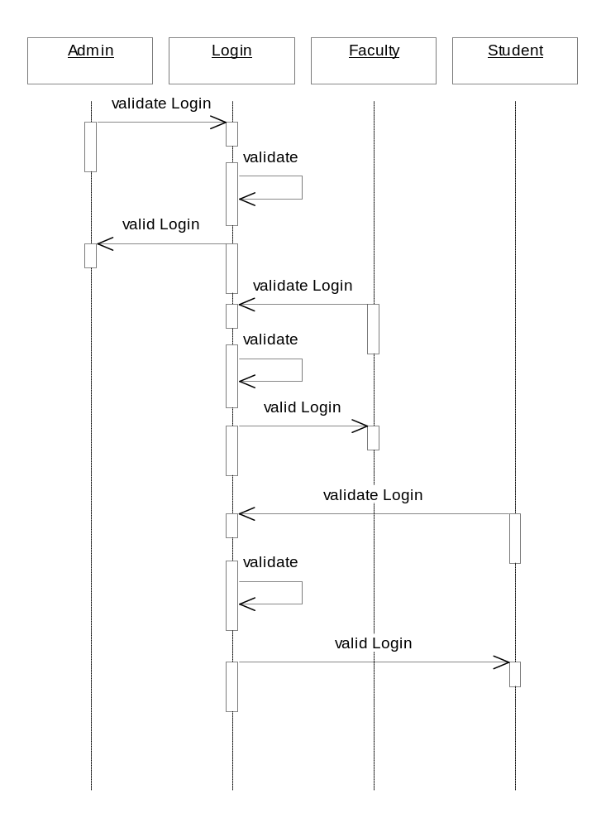

Faculty adding Sequence Diagram:
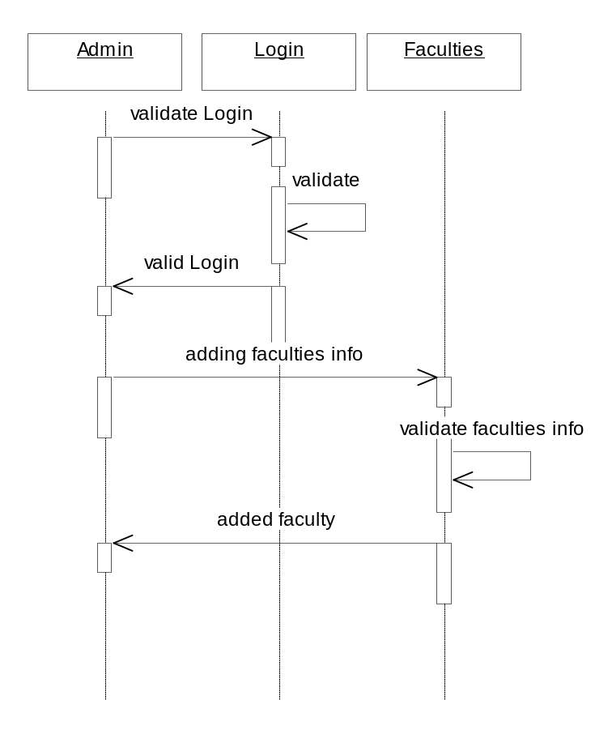

Add & View Course Sequence Diagram:
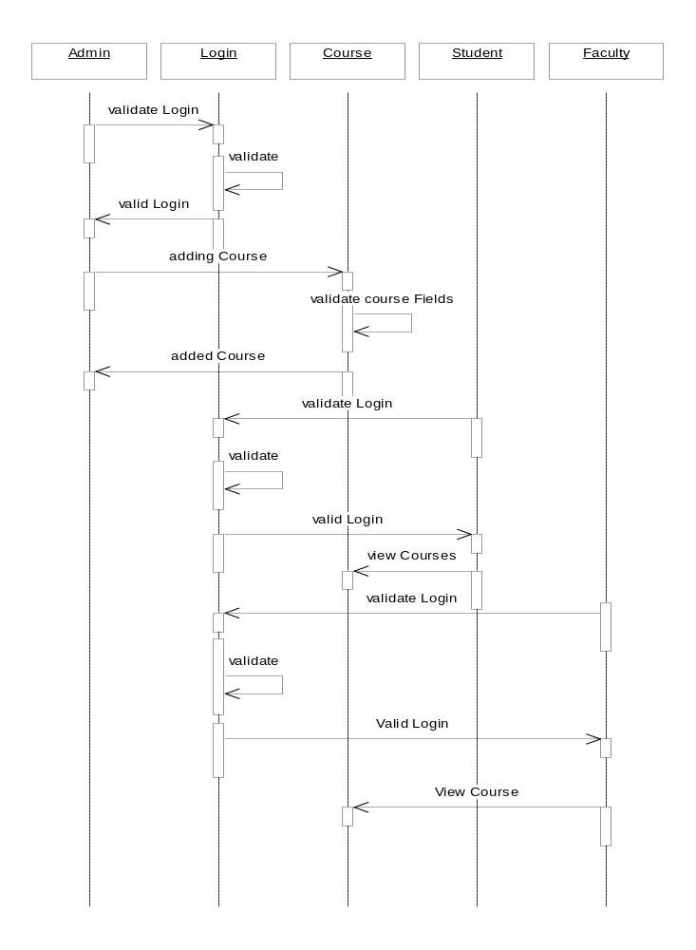

Operational Level Collaboration Diagrams

Login Collaboration Diagram:

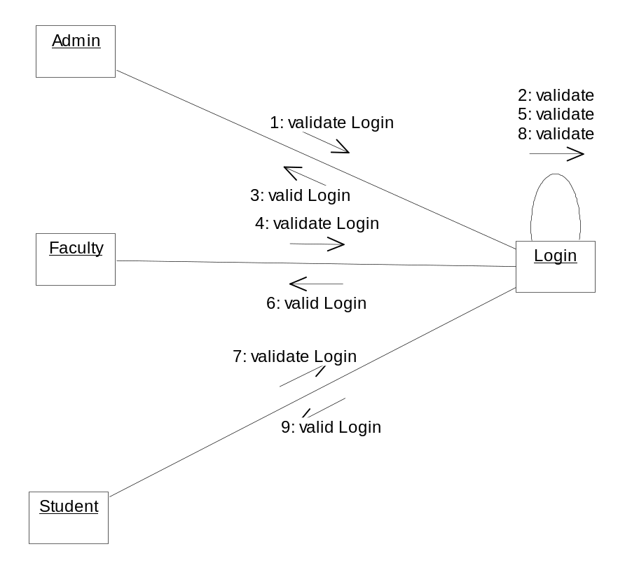

Faculty Adding Collaboration Diagram:
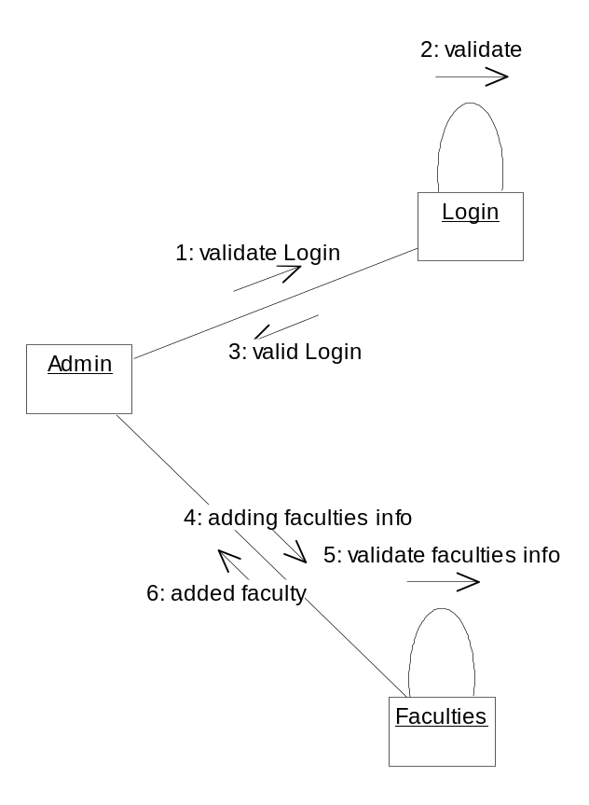

Add & View Collaboration Diagram:
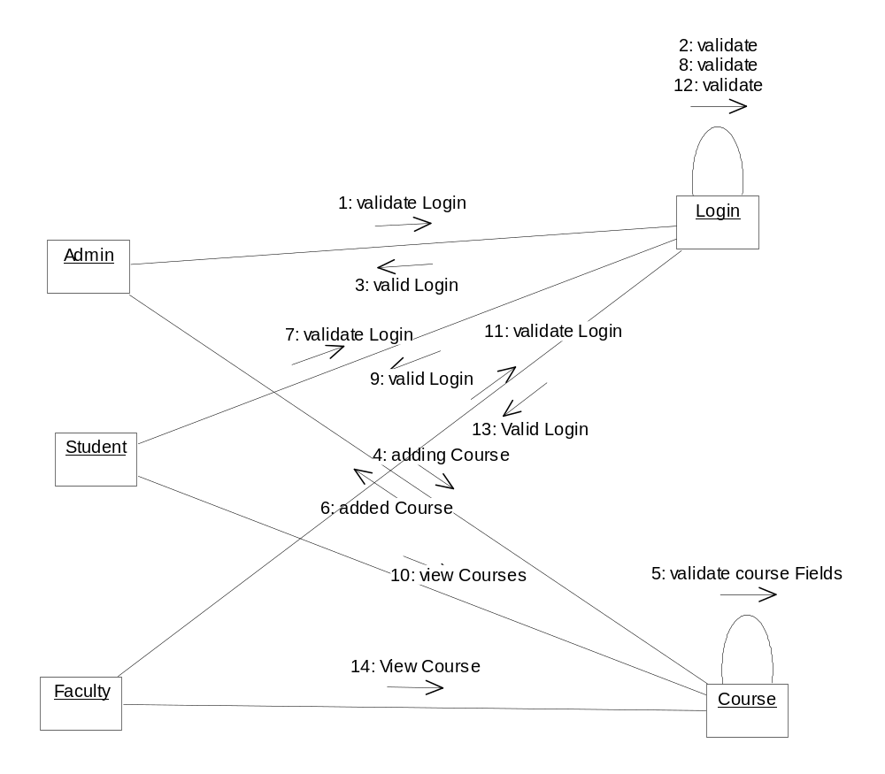

Activity Diagrams

Admin Activity Diagram:

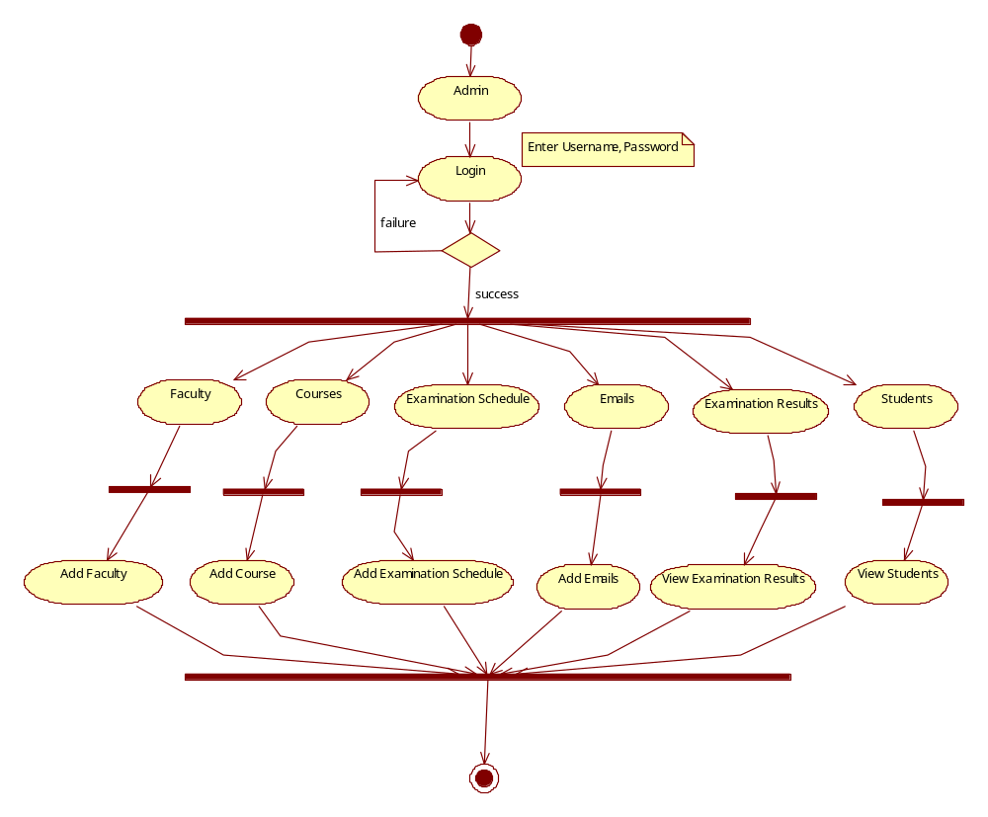

Student Activity Diagram:

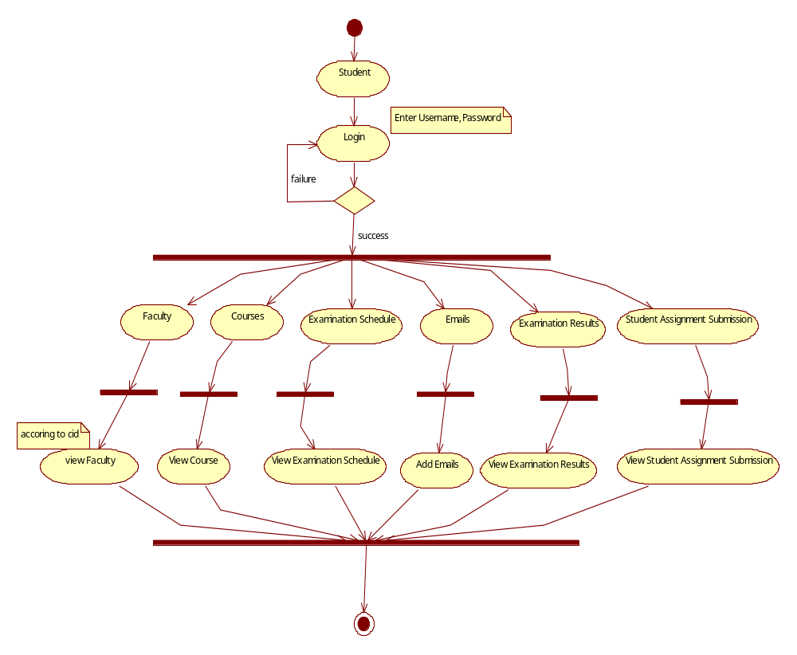

Faculty Activity Diagram:

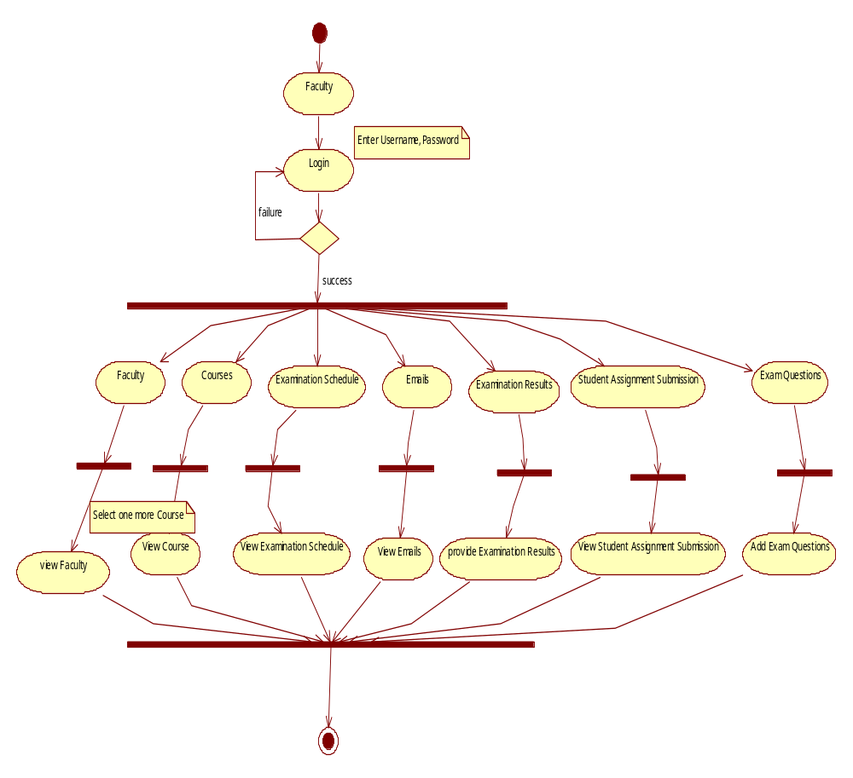

Component Diagram

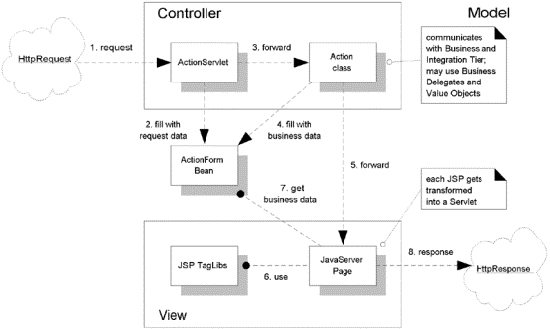

Deployment Diagram

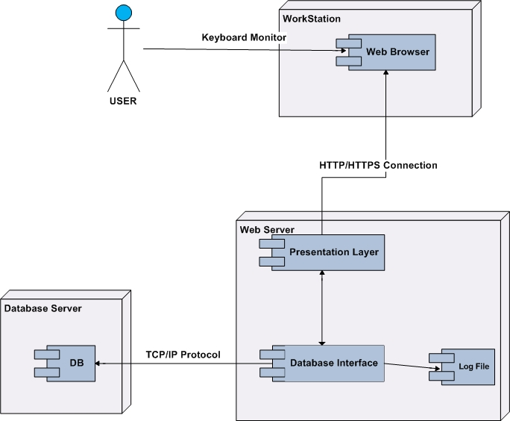

Data Dictionary

USERDETAILS:

Column name | Data Type | Constraint
USERID | Number | Primary key
FIRSTNAME | Varchar
LASTNAME | Varchar
DOB | Date
DOR | Date
LOGINID | Varchar | Not null
PASSWORD | Varchar
LOGINTYPE | Varchar
FORGOTPWQUESTION | Varchar
FORGOTPWANSWER | Varchar
PHOTOGRAPH | Blob | Not null
EMAILID | Varchar
FAXNO | Varchar

ADDRESSES:
Columnname | DataType | Constraint
USERID | Number | Foreign key
ADDRESSID | Number | Not null
ADDRESSTYPE | Varchar | Not null
HOUSENO | Varchar
STREET | Varchar
CITY | Varchar
STATE | Varchar
COUNTRY | Varchar
PINCODE | Varchar

ASSIGNMENTREMARKS:

Columnname | DataType | Constraint
ASSIGNMENTID | Number
FACULTYID | Number
REMARKSTOSTUDENT | Varchar

CHATROOMMASTER :

Columnname | DataType | Constraint
CHATROOMID | Number | Primary key
CHATROOMNAME | Varchar
COURSEID | Number
FACULTYID | Number

COURSEFACULTYMASTER:
Columnname | DataType | Constraint
COURSEID | Number
FACULTYID | Number
DESCBYFACULTY | Varchar

COURSEMASTER:
Column name | Data Type | Constraint
COURSEID | Number
CNAME | Varchar
COURSEDESC | Varchar
COURSEDURATION | Varchar
COURSECONTENT | Blob
NOOFLETURERES | Number

EMAILDETAILS:

Column name | Data Type | Constraint
EMAILID | Number
FROMSTUDENTID | Number
TOFACULTYID | Number
FROMFACULTYID | Number
TOSTUDENTID | Number

EMAILMASTER:

Column name | Data Type | Constraint
EMAILID | Number | Primary key
DATEANDTIME | Date
EMAILTEXT | Varchar

EXAMINATION SCHEDULE :

Column name | DataType | Constraint
EXAMINATIONID | Number | Primary key
EXAMINATIONDATE | Date
EXAMINATIONENDDATE | Date
COURSEID | Number
LECTURERID | Number
FACULTYID | Number
PASSPERCENTAGEDECIDED | Number

EXAMQUESTIONMASTER:

Column name | Data Type | Constraint
QUESTIONID | Number | Primary key
QUESTIONTEXT | Varchar
ANSWER1 | Varchar
ANSWER2 | Varchar
ANSWER3 | Varchar
ANSWER4 | Varchar
ANSWER5 | Varchar
CORRECTANSWER | Varchar
EXAMINATIONID | Number
MARKS | number

FACULTY ACHIEVEMENTS:

Column name | Data Type | Constraint
ACHIEVEMENTID | Number | Primary key
FACULTYID | Number
ACHIEVEMENTDESC | Varchar
SPECIALREMARKS | Varchar

FACULTY MASTER :

Column name | Data Type | Constraint
FACULTYID | Number | Primary key
FNAME | Varchar
DOB | Date
DOR | Date
ADDRESS | Varcahr
EMAIL | Varchar
PHONE | Varchar
IMAGE | Blob
SPECIALREMARKS | Varchar
EXPERIENCE | Varchar

FACULTYNOTICESMASTER:

Column name | Data Type | Constraint
NOTICEID | Number | Primary key
NOTICEDATE | Date
FACULTYID | Number
NOTICETEXT | Varchar
NOTICEFILE | Blob

FACULTYONLINEMASTER:

Column name | Data Type | Constraint
ONLINEID | Number | Primary key
ONLINEDATEANDTIME | Date
FACLTYID | Number

NEWSLETTERMASTER:

Column name | Data Type | Constraint
NEWSLETTERID | Number | Primary key
LETTER | varchar
NEWSDATE | Date
FACULTYID | Number

PHONES:

Column name | Data Type | Constraint
USERID | number | Foreign key
PHONENO | Varchar | Not null
PHONETYPE | Varchar | Not null

STUDENT ASSIGNSUBMISSIONMASTER:

Column name | Data Type | Constraint
ASSIGNMENTID | Number
STUDENTID | Number
SUBMISSIONDATE | Date
LECTURERID | Number
SUBMISSIONFILE | Blob

STUDENT ATTENDENCE MASTER:

Column name | Data Type | Constraint
ATTENDENCEID | Number | Primary key
ATTENDENCEDATETIME | Date
DISCONNECTEDDATETIME | Date
STUDENTID | Number
COURSEID | Number
LECTURERID | Number

STUDENTCOURSEMASTER :

Column name | Data Type | Constraint
STUDENTID | Number
COURSEID | Number
FACULTYID | Number
COURSEREGID | Number | Not null
REGDATE | Date
COURSEENDDATE | Date

STUDENTEXAMINATION MASTER:
Column name | Data Type | Constraint
STUDENTEXAMID | Number | Primary key
EXAMATTENDEDDATETIME | Date
EXAMINATIONID | Number
EXAMRESULT | Varchar
EXAMAGGREGADE | Number
STUDENTID | Number
STUDENTEXMAINATIONDETAILS:

Column name | Data Type | Constraint
STUDENTEXMAINATIONID | Number
QUESTIONID | Number
ANSWER | Varchar
CORRECT_WRONG | Varchar

STUDENTMASTER:

Column name | Data Type | Constraint
STUDENTID | Number | Primary key
STUDENTFIRSTNAME | Varchar
STUDENTMIDDLENAME | Varchar
STUDENTLASTNAME | Varchar
DOB | Date
DOR | Date
ADDRESS | Varchar
EMAIL | Varchar
PHONE | Varchar
IMAGE | blob

STUDENTONLINE :

Column name | Data Type | Constraint
ONLINEID | number
ONLINEDATEANDTIME | Date
STUDENTID | Number

SUCCESSWOMENMASTER:

Column name | Data Type | Constraint
SUCCESSWOMENID | Number | Primary key
SUCCESSWOMENNAME | Varchar
ADDRESS | Varchar
DOB | Date
SUCCESSSTORYDATE | Date
SUCCESSSTORYLINKFILE | Blob
PHOTOGRAPH | Blob
SUCCESSPHOTOGALLERY | Blob
SUCCESSVIDEOGALLERY | Blob

VOICEMAILBOXMASTER:

Column name | Data Type | Constraint
VOICEMAILBOXID | Number | Primary key
VOICEMAILBOXTEXT | Varchar
STUDENTID | number
AUDIO | blob

BIO-DATA

Full Name: Krishna Murthy SVG
Date of Birth: 27 Jul 1984
Address:
Office:
Cognizant Technology Solutions,
Ground floor, DLF IT Park,
Gachibowli, Hyderabad – 500081
Phone Number: 040 – 44513850.
Home:
Flat No: 201, Raghavendra Apts,
Venkateswara Nagar, Malkajgiri,
Hyderabad – 500047
Phone Number: 040 – 27052602
Mobile number: +91 – 9959690575
Email: svgkrishnamurthy@gmail.com

Academic Qualification:
MSc. – Computer Science – 2006 Passed out
BSc. - Computer Science, Electronics and Maths – 2004 Passout
BIE – Maths – 2001 Pass out
SSC – 1999 pass out
Experience Details:
Having 5+ Years of experience in developing web based and desktop based Rich Internet Applications using Adobe Flex and along with Java and J2EE technologies. Presently working as Team lead for Cognizant Technology Solutions.
Certifications:
- Sun certified Web Component Developer(SCWCD)
- Adobe Certified Expert in Flex Development
Experience Summary:
- Overall 5+ years IT experience in Desktop applications and web based applications using Adobe Flex and Java/J2EE.
- Proficiency in developing web based/desktop applications Rich Internet Applications using Adobe Flex 1.5, Flex 2, Flex 3 and Flash Builder 4.
- Strong Experience in developing Java and J2EE Applications
- Strong expertise on various flex frameworks: Cairngorm, PureMVC, Mate, Swiz , FEET(custom framework) and XOA.
- Proficiency in developing web based database driven applications, experience programming on Core Java, Swings, JSP/Servlet, Struts,XML and MsSQL Database.
- Strong software developing expertise including designing/modeling, programming/coding of server side components.
- Having build configuration and management using Apache Ant and Maven.
- Having the experience in unit testing and component testing.

