Machine Learning

* Machine derives weights for each predictor to predict target
* Initialize a random weight for each predictor then try to reduce error
* Using Gradient Descent w/Learning Rate α
  + Minimizing Error
  + 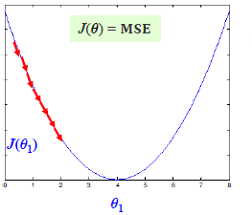 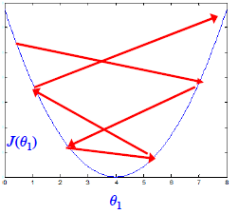

Linear Regression

* Building a model by learning coefficients Θ as ŷ = ΘTX
* Verify ŷ against Y

Avoid Over-Learning?

* w/ simpler model but still preserve good prediction accuracy by identifying really “important” attributes for prediction.
* Lasso (And Ridge) regularization
  + Balance error <> λ X model complexity
* 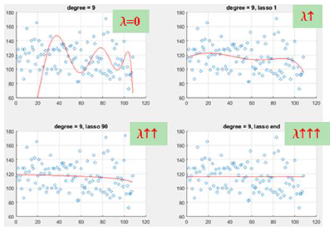

Interpreting Lasso and Ridge

* Need to balance out between increasing MSE and increasing regularizer (penalty)
* Lasso

Linear Regression PPT

Root Mean Square Errors (RMSE)

* All machine learning methods are based on measuring some kinds of error
* Measure square sum of error (SSE) or Residuals
* Fitlm() function in matlab
  + If p value derived from t test for xi is very small 🡪 good predictors to y
  + If p Value > 0.01 🡪 Not a good predictor to y.

A model with too many predictors 🡪 overfitting