ADAS User Help Manual ver 0.9

Table of Contents
1. Introduction 4
1.1 Purpose 4
1.2 Acronyms and Terminology 4
2. Product Overview 5
2.1 FCM Features 5
2.2 FCM Static Architecture 6
2.3 Physical Structure 8
3. High-level FCM Feature Descriptions 9
3.1 Lane Departure Warning (LDW): 9
3.2 Forward Collision Warning (FCW): 9
3.3 Following Distance Indicator (FDI) 9
4. FCM General Operation 10
4.1 FCM Interactions 10
5. FCM Operating States 11
5.1 FCM Sleep State 11
5.2 FCM Normal State 11
5.3 FCM Diagnostic Failed State 11
5.4 FCM Reprogramming EyeQ2 State 11
5.5 FCM Reprogramming S12 State 11
6. LDW Operating States 12
6.1.1 LDW Sleep State 12
6.1.2 LDW Normal State 12
6.1.3 LDW Diagnostic Failed State 12
6.1.4 LDW Reprogramming EyeQ2 State 12
6.1.5 LDW Reprogramming S12 State 13
6.2 LDW Warnings 13

7. FCW Operating States 14
7.1.1 FCW Sleep State 14
7.1.2 FCW Normal State 14
7.1.3 FCW Diagnostic Failed State 14
7.1.4 FCW Reprogramming EyeQ2 State 14
7.1.5 FCW Reprogramming S12 State 14
7.2 FCW Warnings 16

8. FCM Block Diagram 17

8.1 Software 17
8.1.1 CANoe(FCAN_restbus2) 17
8.1.2 EYEQCLIENT 7.8.0 18
8.1.3 IVIEWLAUNCHER 19
8.2 Hardware ……………………………………………….………………………….20

1. Introduction
This document provides a high level specification of Magna’s Front Camera Module (“FCM”) with its functional descriptions.

1.1 Purpose

The purpose of this document is to define the high level specifications for FCM and its following functions:
- Vehicle Detection
- Lane Detection

1.2 Acronyms and Terminology

Term | Description
AHBC | Automatic High Beam Control
LDW | Lane Departure Warning
TSR | Traffic sign recognition
FCW | Forward Collision Warning
FDI | Following Distance Indication
ILR | Intelligent Light Ranging
NHTSA | National Highway Traffic Safety Administration
TAC | Target Alignment Calibration
SPC | Service Point Calibration
FOE | Focus of Expansion
RTA | Ready To Assist
NRTA | Not Ready To Assist
CIPV | Closest In- Path Vehicle
S12x | Star 12 x Microprocessor

2. Product Overview

The FCM is a multi-functional, monocular, one-box camera system providing various driver assistance features. The FCM must be mounted in the interior of the vehicle windshield, near to the rear view mirror.

2.1 FCM Features

- Lane Departure Warning (LDW)
- Forward Collision Warning (FCW)
- Following Distance Indication (FDI)

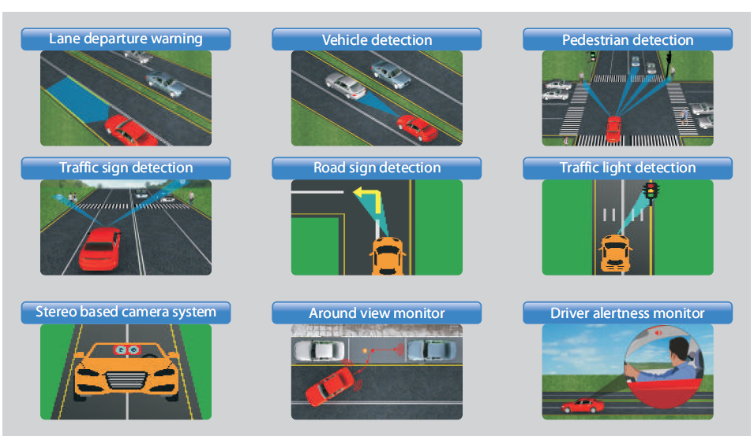
Fig: Advance Driver Assistance Features

- Lane departure warning: Detects different types of lane indications and extrapolates unmarked lane with single lane marking.

- Vehicle detection: Detects and tracks the course of a vehicle to calculate the time to collision, thus preventing one.

- Pedestrian detection: Detects pedestrians in different postures, and tracks their path, to avoid accidents.

- Traffic sign and traffic light detection: Detects traffic signs and traffic lights mounted on poles. Road signs detection: Detects traffic signs painted on roads.

- Depth map generation: The stereo based camera system helps generate depth maps using dense and sparse stereo matching algorithms with distance measurements.

- Around view monitor: Offers a 360 degree view to enable blind spot detection and provide parking assistance.

- Driver alertness monitor: Vision and infra-red (IR) based solution detects inattentive drivers

2.2 FCM Static Architecture

The following diagram shows the peripherals which are not part of the FCM:

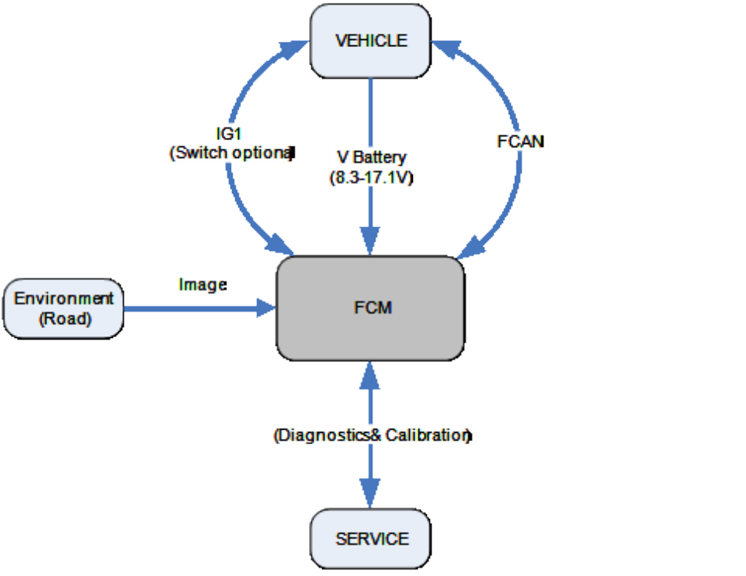
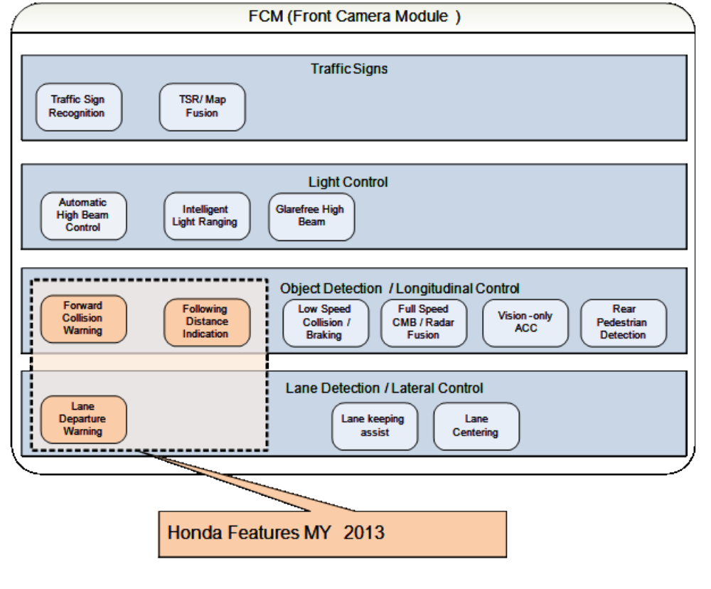

2.3 Physical Structure

- The following block diagram is provided for reference, but does not establish any requirements:

: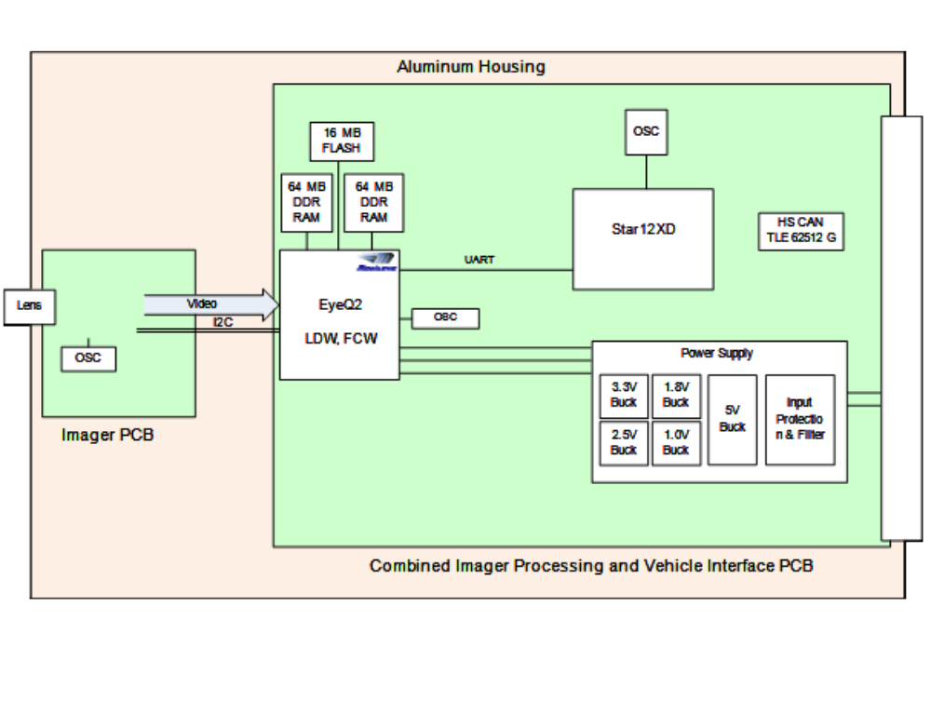
Fig : Internal Architecture of FCM Module

3. High-level FCM Feature Descriptions

3.1 Lane Departure Warning (LDW):

Lane Departure Warning warns the driver when unintentionally drifting out of the marked driving lane. Lane Departure Warning is a passive system and does not take any active measures to prevent lane departures. The FCM LDW feature utilizes a forward looking camera and image processing software to detect lane boundaries and analyze vehicle and customer inputs to determine unintentional lane drift. The FCM LDW feature provides CAN signals to the vehicle indicating a lane departure event. Typically the vehicle will then issue an audible and/or visual warning to the driver.

3.2 Forward Collision Warning (FCW):

The Forward Collision Alert (or Warning) feature is designed to warn drivers of a potential collision with an object in the host vehicles forward path. The FCM meets NHTSA FCW test requirements.

3.3 Following Distance Indicator (FDI)

The following distance indicator informs the driver that they are potentially following a target vehicle too closely.

4. FCM General Operation

4.1 FCM Interactions
The FCM shall communicate with the vehicle via the following schematic Vehicle to FCM connection diagram.

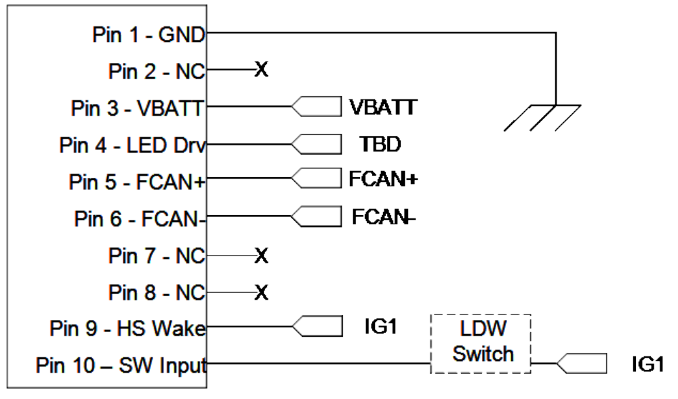
Fig: Vehicle to FCM connection diagram

The LDW switch must have a minimum debounce time of 50ms. Once the module is woken and all module diagnostics have passed, the Star 12 will read the switch input every 10 ms. When the switch A/D value indicates that the switch has been pressed, the Star 12 will begin a debounce timer. The next 5 readings must also be outside the open voltage range. If one of the readings is not outside the open voltage range, the debounce timer is canceled until the next reading outside the open range. If all six readings are outside the open voltage range, the six readings are then averaged and compared to the voltage range for the LDW switch. If these readings are within the LDW switch range, the Star 12 will determine that the LDW switch has been pressed and toggle the switch value inside the software (on -> off, off -> on).

5. FCM Operating States

The FCM is a battery powered module. Wake up (Pin 9) and sleep (Pin 5) are based on ignition (IG1) input. The FCM has the five (5) following operating states:
- Sleep
- Normal Operation
- Reprogramming EyeQ2
- Reprogramming S12x
- Diagnostics Failed

5.1 FCM Sleep State

In the SLEEP state the FCM shall cease all CAN communication. The FCM shall recognize and react to the wake up signal as shown in Operating States.

5.2 FCM Normal State

In the NORMAL state the FCM shall execute the FCW and LDW features as per LDW State Machine and FCW State Machine. The FCM shall enter and exit this state per Operating States.

5.3 FCM Diagnostic Failed State

In the DIAGNOSTIC FAILED state the FCM shall execute the FCW and LDW features as per LDW State Chart and FCW State Chart. The FCM shall enter and exit this state per FCM Operating States.

5.4 FCM Reprogramming EyeQ2 State

In the REPROGRAMMING EYEQ2 state FCM features shall be unavailable to the driver. This state is used for the TAC and SPC processes as well as software updates to the image processing software. The FCM shall enter and exit this state per FCM Operating States.

5.5 FCM Reprogramming S12 State

In the REPROGRAMMING S12 state FCM features shall be unavailable to the driver. This state is used for reprogramming the flash memory including functional software and calibrated values. The FCM shall enter and exit this state per FCM Operating States.

6. LDW Operating states

Lane Departure Warning warns the driver when unintentionally drifting out of the marked driving lane. Lane Departure Warning is a passive system and does not take any active measures to prevent lane departures. The FCM LDW feature utilizes a forward looking camera and image processing software to detect lane boundaries and analyze vehicle and customer inputs to determine unintentional lane drift.

The FCM has the five (5) following operating states:
- LDW OFF State
- LDW NRTA State
- LDW RTA State
- LDW BLOCKED State
- LDW DISABLED State

6.1.1 LDW OFF State

In this state the customer has disabled the feature through the LDW Switch. Warnings are not issued. Signal states are noted in the Off block above and transitions are also shown.

6.1.2 LDW NRTA State

In this state the LDW I on and enabled, but has not detected lane markings with sufficient confidence and or the proper conditions have not been met (e.g. vehicle speed).

6.1.3 LDW RTA State

In this state, the FCM has sufficient confidence in the lane markings and the vehicle is operating within enabling parameters to issue the warnings. In this state warnings may be active but are not necessarily active at any point in time.

6.1.4 LDW BLOCKED State

In this state the FCM has detected a full blockage of the imager, marking lane detection impossible. Once a blockage has been detected, the FCM must remain in a blocked state until the blockage has been gone for 5 minutes continuously at the speeds of 20 KPH or higher in this driving cycle. If the vehicle is turned off and the camera has transitioned to sleep mode, it is necessary to maintain the memory of the blocked state.

6.1.5 LDW DISABLED State

The LDW disable state encompasses 3 unique scenarios that move the FCM to a disabled state.

1. The first is an over temperature condition that causes the FCM to go into a load shedding mode, where the EyeQ2 and its supplies are shut down to allow the FCM to cool down and protect the hardware from abnormal behavior or damage.

2. The setting DTC codes will transition the module to the Disabled state.

3. Inhibit bits from various modules indicates that a signal is not valid and should not be used. During this period, the FCM shall transition to the disabled state without setting a DTC. Normal operation is returned after meeting specific criteria outlined in the DTC table.

6.2 LDW Warnings

Only within the Ready to assist state it is possible to issue a warning to the driver indicating an unintentional lane departure. When a warnings is issued by the EyeQ2 to the Star12 and there are no inhibiting conditions present.

For more information regarding LDW Status transition refer State Chart for LDW (S12 Statecharts LDW FCW updated disabled state.pdf)

7. FCW Operating states

The FCM has the five (5) following operating states:
- FCW OFF State
- FCW NRTA State
- FCW RTA State
- FCW BLOCKED State
- FCW DISABLED State

7.1.1 FCW OFF State

While in the OFF state the FCW feature is unavailable except to transition to another state.

7.1.2 FCW NRTA State

While in the NRTA state the FCW feature shall not issue any warnings but will continue to search for targets.

7.1.3 FCW RTA State

While in the RTA state the FCW features shall actively track a CIPV and any targets if interest, issuing a warnings if an imminent collision is detected.

7.1.4 FCW BLOCKED State

In this state the FCM has detected a full blockage of the imager, marking lane detection impossible. Once a blockage has been detected, the FCM must remain in a blocked state until the blockage has been gone for 5 minutes continuously at the speeds of 20 KPH or higher in this driving cycle. If the vehicle is turned off and the camera has transitioned to sleep mode, it is necessary to maintain the memory of the blocked state.

7.1.5 FCW DISABLED State

The LDW disable state encompasses 3 unique scenarios that move the FCM to a disabled state.
1. The first is an over temperature condition that causes the FCM to go into a load shedding mode, where the EyeQ2 and its supplies are shut down to allow the FCM to cool down and protect the hardware from abnormal behavior or damage.
2. The setting DTC codes will transition the module to the Disabled state.
3. Inhibit bits from various modules indicates that a signal is not valid and should not be used. During this period, the FCM shall transition to the disabled state without setting a DTC. Normal operation is returned after meeting specific criteria outlined in the DTC table.

7.2 FCW Warnings
The FCW warning is a combination of a following distance alert and imminent collision alert. Either or both can be true to issue the warning. When neither is true, the warning is not issued.

For more information regarding LDW Status transition refer State Chart for LDW (S12 Statecharts LDW FCW updated disabled state.pdf)

8. FCM Block Diagram

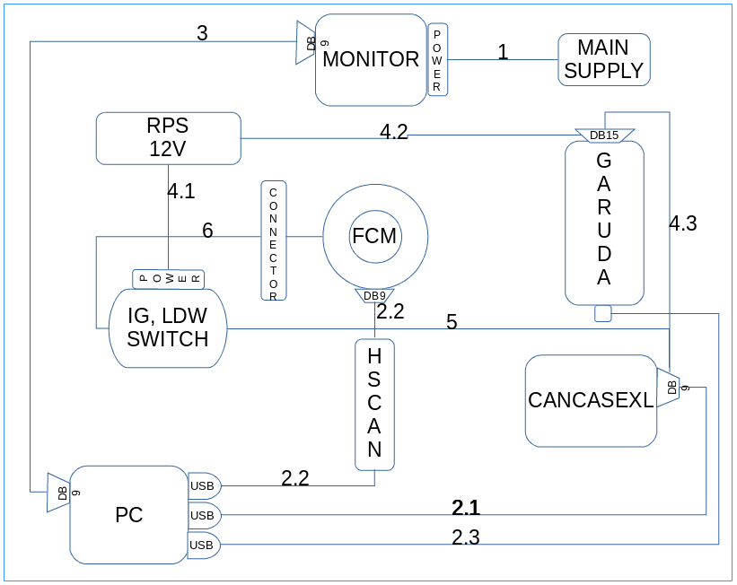

Fig : Block Diagram of ADAS bench setup

8.1 SOFTWARE

8.1.1 CANOE (ver 8.0.49).
8.1.2 EYEQCLIENT 7.8.0 (CAN-KVASER).
8.1.3 IVIEWLAUNCHER.

8.1.1 CANOE(FCAN_restbus2)

Windows OS :
Go to Start → Search for Canoe from Programs menu → Click on CANoe → configuration → Load the Configuration(.cfg) file (FCAN_restbus2).

Steps to Start CANoe.

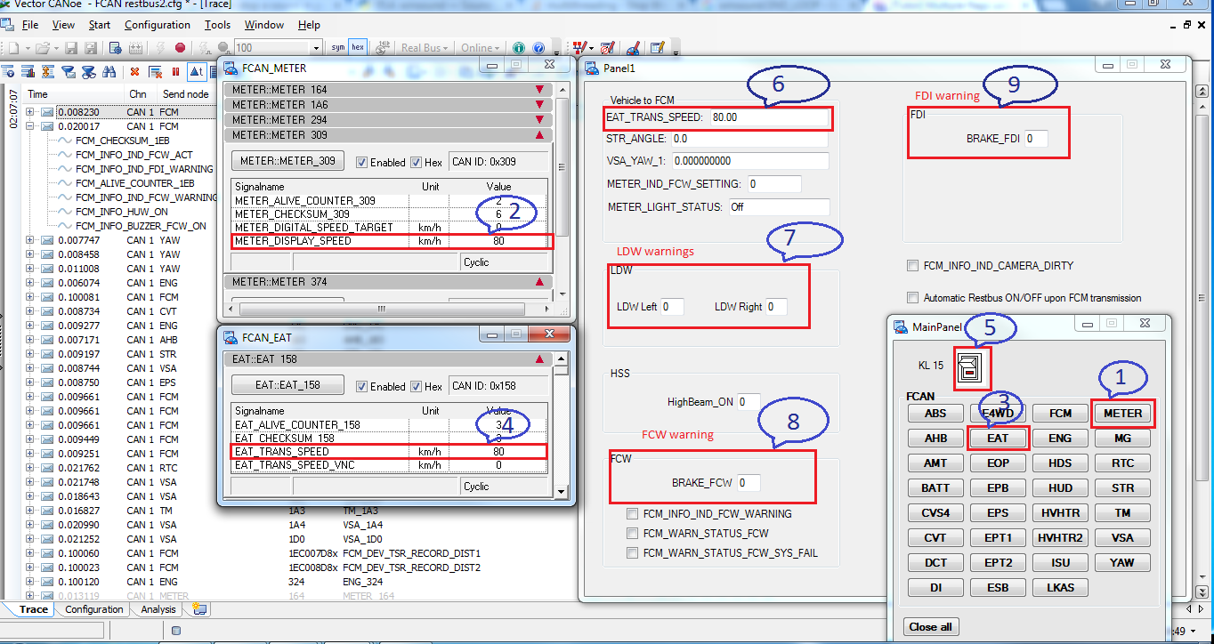
Fig : CANoe tool configuration settings for FCM
Step1: Go to Menu → view → All Panels → MAIN Panel → METER.

Step2: Set Speed minimum or Greater Than 47 kmph.(METER_DISPLAY SPEED).

Step3: In MAIN Panel click on EAT.

Step4: Set Speed minimum or Greater Than 47 kmph.(EAT_TRANS_SPEED).

Step5: Now click on KL-15 in the MAIN Panel.

Step6: Check EAT_TRANS_SPEED signal in Panel1 to confirm that the given speed has been
taken by the FCM or not.

Step7: Check LDW_Left and LDW_Right signal in Panel1 to confirm the LDW warning.

Step8: Check BRAKE_FCW signal in Panel1 to confirm the FCW warning.

Step9: Check BRAKE_FDI signal in Panel1 to confirm the FDI warning.

8.1.2 EYEQCLIENT 7.8.0(CAN-KVASER)

EYEQCLIENT is used to know that our FCM is calibrated and set correctly or not. Whether it is detecting the Lane and whatever the speed is given whether it is taken or not.

To Start EYEQCLIENT 7.8.0

1. Click on EYEQCLIENT 7.8.0.

2. Check for the communication in the KvaserControl Window, if the message is coming
continuously then it is connected properly.

3. Click on Start.

4. After Playing the Video related to LDW you will see the Lane markings in the EYEQCLIENT.

------------------------------- Todo EyeQClient image for playing video -------------------------------

8.1.3 IVIEWLAUNCHER

IVIEWLAUNCHER is used to Play the video or to simulate the different road conditions.

1. Click on IVIEWLAUNCHER.

2. Select any video you want to Play.

3.Click on LAUNCH button.

8.2 Hardware
8.2.1 FCM.
8.2.2 CANCASEXL.
8.2.3 BREAKOUT BOX(IGNITION & LDW SWITCH BOX).
8.2.4 CAN KVASER LEAF LIGHT HS.
8.2.4 GARUDA.
8.2.5 DC POWER SUPPLY.
8.2.6 EXTENDED MONITOR.

