ADAS Library API Manual ver 2.0

Table of Contents
1. Introduction 3
1.1 Library Files 3
2. Lib_Garuda_Api file 3
3. Lib_General_file 5
4. Lib_Meter_EAT file 5
5. Execution of testcases using robotframe work 5
6. References

1 Introduction :
This document provides information on functionality of each function in the library file.
The file Lib_Garuda_API has API used to communicate with Garuda device,

file Lib_General includes function to provide paths to all images used in testcase and functions to log and display messages and

file Lib_Meter_EAT includes functions to send messages of Meter and Eat nodes

Library files

The Library files used are :
- Lib_Garuda_API
- Lib_General
- Lib_Meter_EAT

- Module Lib_Garuda_API :
The Lib_Garuda_API is a library file which provide API to communicate with the Garuda device like connectind , disconnecting ,adding and blocking filters etc.

Class PassThru_Msg :

This class defines the message Structure.

Class conversions :

This Class Helps in Converting the bytes of data into an single integer and vice versa.

Methods :

expand_Id() :
Input arguments : Message Identifier (Ex: 0x18DAF1B1)
Returns : List containing Message Id divided into 4 separate
Bytes (Ex: [0x18, 0xDA, 0xF1, 0xB1])

expand_data() :
Input arguments : Message Data of 8 byte length
Returns : List containing Message Data divided into 8 separate Bytes.

merge_id_data() :
Input arguments : Instance of PassThruMsg structure
Returns : List containing Message Id and Data

Class Garuda :

This class provide API to communicate with Garuda device

Methods :

destroy() :
Input Arguments : None
Returns : None
Description : This Function will Disconnect and Close the Garuda

add_pass_filter() :
Input Arguments : MsgId
Returns : pFilterID on Successfull Call else returns -1.
Description : This function starts filtering of incoming messages.
Only Allows Messgages with ID equal to 'MsgId'to pass.
On successfull function call, The FilterID will be returned to Calling Function

add_block_filter() :
Input Arguments : MsgId
Returns : pFilterID on Successfull Call else returns -1.
Description : This function starts filtering of incoming messages.
Only Allows Messgages with ID not equal to 'MsgId'to pass. On successfull function call, The FilterID will be return to Calling Function

send_msg() :
Input Arguments : MsgId, Data, Dlen, Timeout
Returns : None
Description : This Function will send the message based on the input parameter.

read_msg() :

Input Arguments : Timeout, flag_extented, return_list
Returns : On successful call, it returns the pointer pointing to first byte of msg.
Description : This Function will read the meassage and will give byte by byte information.

clear_buffer () :
Input Arguments : Id_list(ex:7 to clear transmission buffer, 8 to clear receive buffer,9 To clear Periodic buffer and 10 is to clear Message Filter buffer)
Returns : None
Description : This Function will clear all buffers. Which buffer it have to clear will depend on Id_list parameter

send_periodic_msg () :
Input Arguments : func,period
Returns : Handler
Description : This Function will start sending messages periodically.
Period of sending the message can change message to message.

3 . Module Lib_General :

The Lib_General is a library file which provide paths to all the images which are being used in the testcases and also provide functionalities to display the user messages and log the same.

Class Constant :
Constant class is used to provide path of the all Images and videos used in the test cases from the provided folder

Class General :
General class contains User Messagebox and Logging the test case(s)

Methods :

infomessagebox() :
This method used displaying the user message on Screen for perticular intervals of time. Usage : infomessagebox(self,<Any Message is apear on message box>, Interval = <integer>)

logInfo () :
logInfo() function is used for logging the test case
Usage : logInfo("Log will dump in info.log file")

4 . Module Lib_Meter_EAT :

The Lib_Meter_EAT is a library file which is used to send messages from garuda instead of sending it from node METER and EAT .

Methods :

CalcAliveCntr() :
input parameter : none
return : Current value of Alive_Cntr of particular message Id
Description : This function is used to increment Alive_Cntr of particular
message Id and to make it zero if the same becomes 4 .This
function is to tell the user that message frame being sent are
different

Calc_Checksum () :
input parameter : none
returns : Calculated checksum value for a particular message Id
Description : This function is used to calculate checksum value for particular message Id . It is achieved by adding each byte of the identifier and each nibble of the data.

Send_Msg () :
input parameter : none
returns : On successfull function call, The FilterID will be returned to Calling Function else it will return -1.
Description : This function is used to send message of particular Id on to the CAN bus.This function internally Calls Calc_Checksum function

5. Execution of test cases using Robot Frame Work :

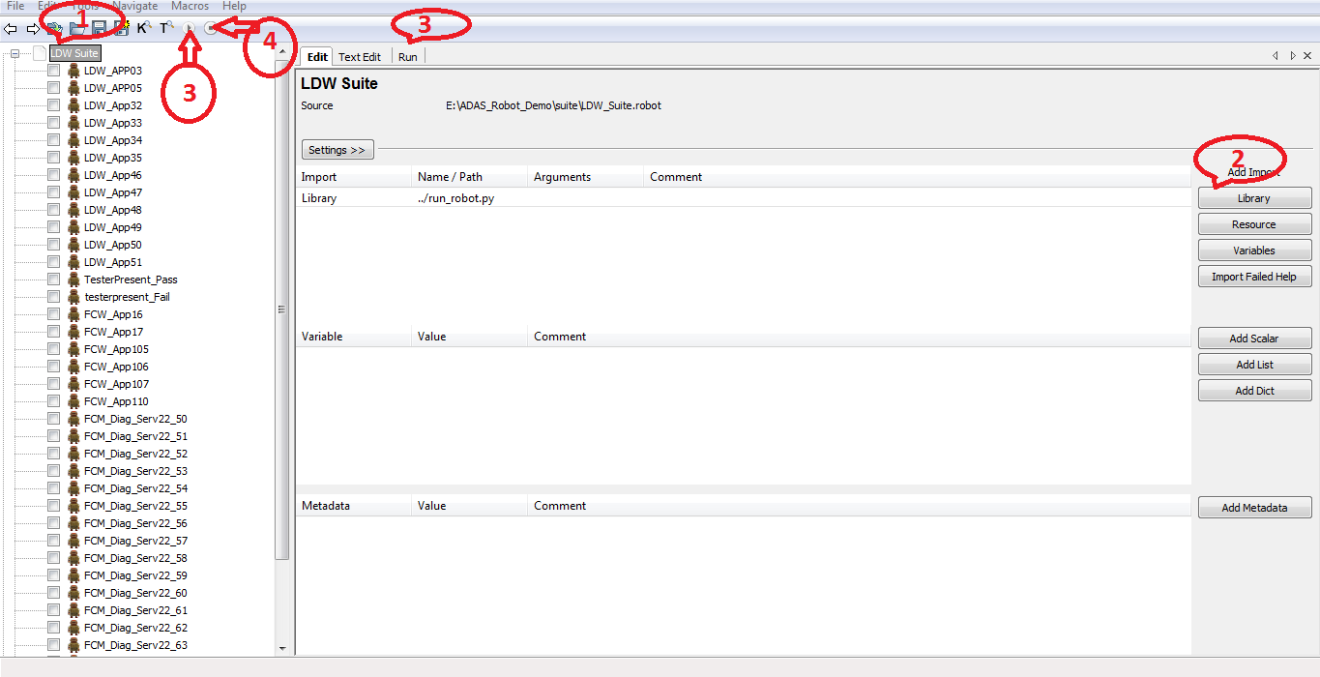

1 . Open the test suite whose testcases has to be executed
2 . Add the path of the library where the library files are present by clicking on library as shown above
3. To run the test cases press on buttons pointed as 3
4 . To stop the execution of testcases press on button pointed as 4

Reports and logs are generated after the execution of testcases and it is shown below

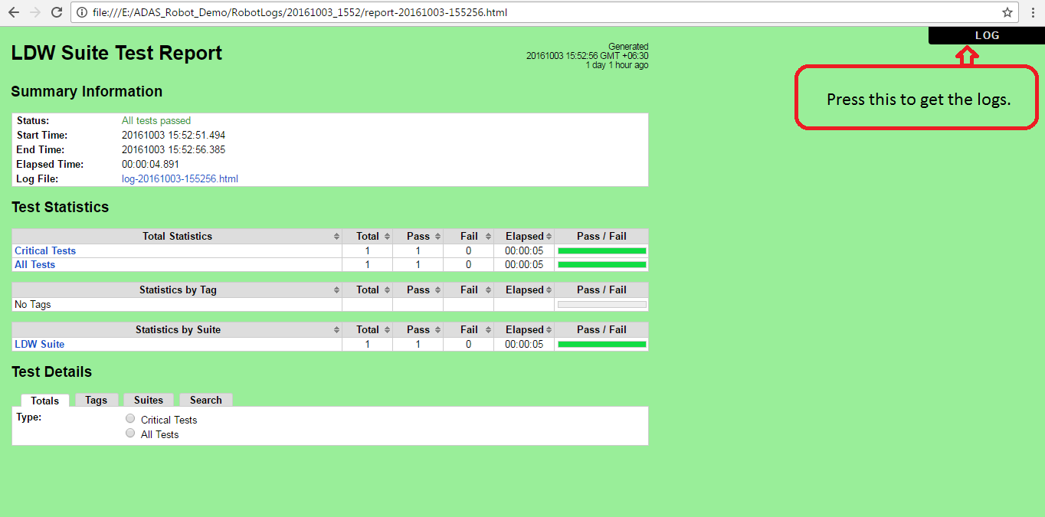

6 . References

1 . For GARUDA API refer : J2534 API document
2. For Robot Framework help : https://pypi.python.org/pypi/robotframework

