Drone Propellers and Its Type

What’s A Propeller?
Propellers, also known as props, are the unsung heroes of an FPV drone. They play a crucial role in generating thrust that lifts the quad off the ground and enables it to move in different directions. However, many drone pilots often overlook the importance of choosing the right propellers, leading to issues such as increased noise, reduced flight time, or even motor failure.

Types of Drone Propellers
There are two main types of drone propellers
Fixed pitch and variable pitch
Fixed pitch propellers are the most common and simplest type and do not have a single adjustable angle.Variable-pitch propellers, on the other hand, have adjustable blades that allow you to change the angle of attack, giving you more precise control over your drone. Fixed pitch propellers are the most common and simplest type and do not have a single adjustable angle .
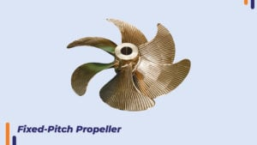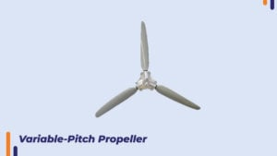
There are several other important types of propellers
• 3" to 7 inch
• 8" to 10 inch
• Triblades Propellers
3 inches to 7 inches
3-inch to 7-inch propellers is a range of propeller sizes commonly used on drones of various sizes and operations. Lower propellers add dexterity and throw, while larger propellers producemore thrust for heavier loads and harsher conditions. The choice of propeller size depends on thespecific operating conditions of the drone. increase.
8 inches to 10 inches
8-inch to 10-inch propellers are popular for small to medium-sized drones and model aircraft. They are lightweight and efficient, making them ideal for long flights and precise manoeuvres. However, it may not be powerful enough for large or heavy aircraft. Triblades
The Triblade Propellers features a unique blade design that reduces vibration and noise, making it ideal for applications that require smooth, quiet flight. Adding blades increases lift, reduces turbulence, and improves handling and control.
They are also less susceptible to damage than two-blade propellers, reducing the risk of accidents and accidents. However, triblades are not suitable for all aircraft types or applications. Increased lift and thrust can destabilize a light or small aircraft, and increased propeller weight and size can affect aircraft speed and maneuverability. Mainly Used in Small Project related Drone Making. 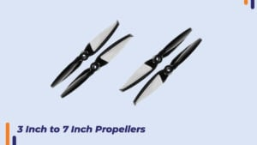 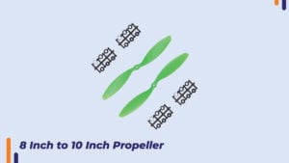 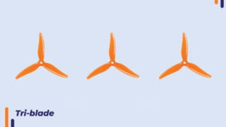
Propeller size and pitch: The size and pitch of a drone's propellers are important factors that affect the flight characteristics of the drone. Propeller size is measured in inches and describes the diameter of the circle the blades make as they rotate. Pitch, on the other hand, refers to the angle of the blades and determines the power the propeller can produce.
Higher-pitch propellers produce more thrust but require more power, while lower-pitch propellers produce less thrust but require less power. number of blades
Drone propellers come in a variety of blade configurations, from 2 to 6 blades. In general, propellers with more blades produce more lift and are more stable, but also require more power to operate. 2-blade propellers are the most common type and are suitable for most drone applications. However, 4-blade propellers are growing in popularity due to their improved stability and manoeuvrability.
Material:Drone propellers can be made from a variety of materials, including plastic, carbon fiber, and wood. Plastic propellers are affordable and most common, but they can easily break if the drone crashes. Carbon fiber propellers are more durable and lighter than plastic, but more expensive. Wooden propellers are the least common and are used only for specific applications. Thrust:
Thrust is measured in grams. For your drone to hover, the propeller needs to produce at least 1 gram of thrust for every gram that your drone weighs. To perform stunts, or even just to take off or fly forward, your drone needs more than 1 gram of thrust per gram of weight.
Propellers produce more thrust when they spin faster and less when they spin slower. The speed of the drone also affects the amount of thrust produced. Some props perform well when the drone is stationary, but not so well during a cruise, while others perform well at high speeds but poorly when hovering. You want a prop that balances these factors and can create a good amount of thrust at different speeds.

To find the best prop for your drone, look up motor thrust tests to see what prop size work best with your motor. Keep in mind that props perform wildly differently when strapped to a thrust stand in a static setting compared to when they’re actually flying through moving air. Props can produce 20-30% less thrust in the air than on the ground. Speed:
A propeller that creates lots of thrust with high pitch doesn’t necessarily make a drone faster than a lower pitch propeller that generates less thrust. As the propeller’s speed increases (which is measured in rotation per minute – RPM), so does the drag, requiring more torque from the motor to turn.
The theoretical maximum speed of an aircraft can be calculated using the equation:
Max Speed (in inch per second) = Max RPM * Propeller's Pitch / 60
In real life, factors such as air resistance, head wind, and angle of attack etc can all affect a drone’s speed.
Thrust affects acceleration and angle of attack, while RPM affects top speed. To achieve the best speed for our drone, we need a balance between thrust and RPM.
Price of Propeller:1147 Carbon Nylon CW/CCW Propeller Pair 209TK.Plastic Propeller 10 inch/8 inch (2pcs)- Multi color 105TK.180 motor with carbon propeller paddle set DC high speed RC 3v-7.4v (1 Pair)349.00Tk.1pair 4-blade Propeller Outer Dia 60mm Aperture 5mm Ducted Screw for RC Pattern Trawler Vessel Fishing Bait Boat 420.0Tk.2*75mm 75mm 7.5cm Props High Speed Propellers Blades Props A B For 2mm Shaft R/C Spare Parts Access Small Mini Quadcopter Drone123Tk. 2.0mm RC Aluminum Bullet Propeller Adapter Holder for Brushless Motor Prop 110TK
2PCS 30mm 3cm Props Mini Propellers Blades For 0.8mm Motor Shaft 69Tk.
Conclusion:
In conclusion, drone propellers are a critical component of a drone's flight system, and their size, pitch, number of blades, and materials all play a significant role in the drone's performance. Understanding the different types of drone propellers and their characteristics can help drone pilots select the right propellers for their specific needs and ensure a safe and stable flight experience

What is an ESC for drones?
ESC stands for Electronic Speed Controller. It is an electronic circuit that connects the motor, the battery, and the flight controller, whose primary purpose is to change the speed and direction of the drone.

Due to the difference in motor technology, the flight controller of drones with brush and brushless motors cannot communicate directly with the motors. ESC helps them to establish a co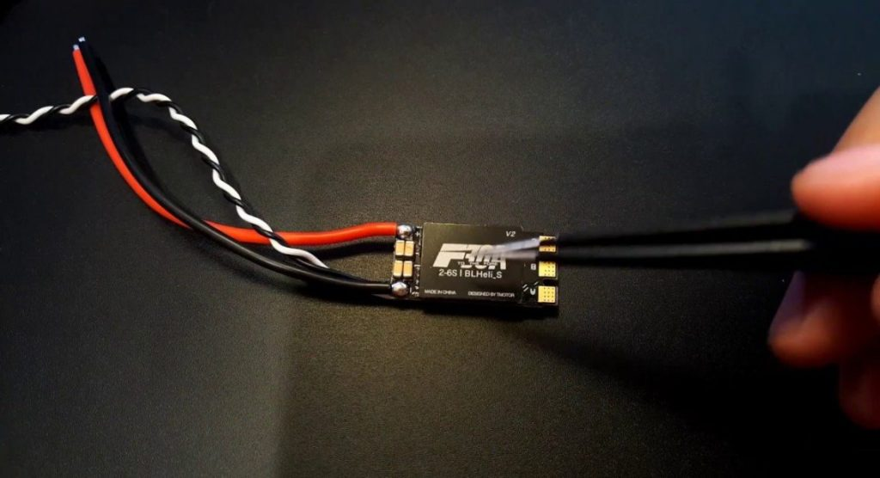nnection, thus allowing the drone to control and regulate the speed of the motors in flight. Types of ESC for drone
There are two types of drone electronic speed controllers, brushed and brushless. Brushed ESCs are used in brushed motors and brushless ESCs are used in brushless motors.
Brushed ESCs have been around for quite some time. They are very affordable and ideal for use in a variety of ready-to-use (RTR) RC vehicles. Brushless ESCs are an advanced version of drone speed controllers. Although they can be a bit expensive, they have more high performance and are more durable compared to brushed electronic speed controllers.

How does an ESC work?
Whether brushed or brushless ESCs, they both work on basically the same principle. ESCs control the rotation of the motor by transmitting a timed electrical signal that is translated into a change in speed.
First, the pilot transmits a signal from a radio transmitter, which is received by a radio receiver fixed to the UAV, and thenfurther sends that signal to the flight controller board, which generates an appropriate signal and forwards it to the BEC/ESC, which speeds up the motor depending on the strength of that signal.
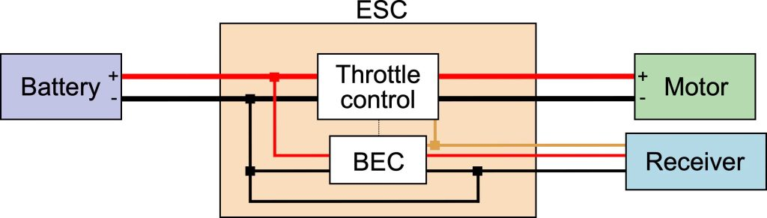
How to choose ESC for drones?
Using a good quality ESC means you should have a reliable and smooth flying experience, but of course, there are other factors to consider. Here's a guide on how to choose the best ESC for quadcopter and FPV drones：

1. ESC current rating
When you choose an ESC for UAVs, the first thing to consider is the current rating, which is the amount of current it can handle. The ESC is measured in Amps, therefore sometimes referred to as amp rating.
It is recommended that you decide on the current rating of the ESC after you have selected the proper motor size. Because the motor draws current as it spins, and if your ESC handles too much current, it will begin to overheat and eventually break down.
In general, the ESC should be rated 10-20% higher than the motor's maximum current at 100% throttle. For example, if your motor produces 10A at full throttle, you should use a 12A or 15A ESC.
For safety reasons, you can also choose some ESCs that are equipped with temperature sensors. These sensors not only monitor their temperature and adjust to prevent overheating, but also prevent damage if your drone hits somethingsharp or flies too close to an object with high thermal conductivity.

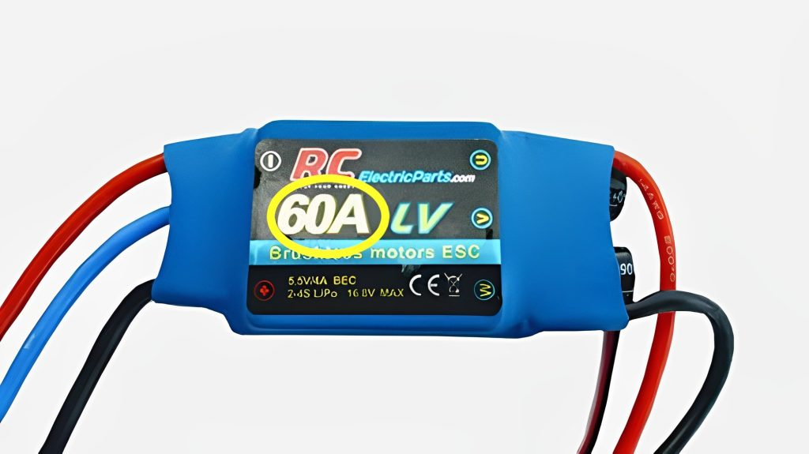

2. Input voltage rating
In addition to the amperage, ESCs have a maximum amount of voltage that they support, which is the voltage rating. Some ESCs are rated for 3S-4S, while others can handle up to 6S. It largely depends on what battery voltage you want to run on your drone, too high a voltage used to power your ESC will destroy both the ESC and the motor.
The power of a motor can be measured in watts, which is voltage multiplied by amperage (volts x amps = watts). Therefore, as the voltage increases, the amperage may decrease to keep the engine's total power equal. This means that a higher voltage battery can provide the same engine output power at a lower current draw.
Moreover, when the voltage of the ESC is increased, the pilot will tend to choose to give more throttle. This increases the amperage and the total power (watts) of the motor increases. This is why a high-voltage drone will fly faster compared to a low-voltage drone.
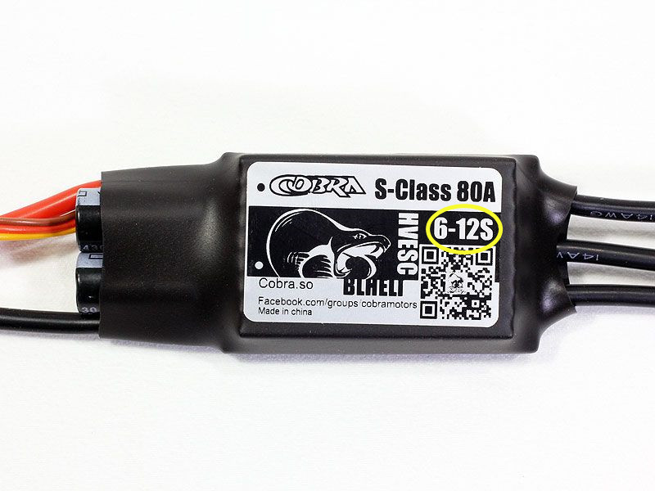

3. Weight and size
Typically, the weight and size of an ESC are determined by its current rating and are proportional to it. Most ESCs on the market today are similar in size and weight, with single ESCs weighing between 4-6 grams and quad ESCs weighing around 12 grams to 15 grams.
Lighter ESCs are better suited for racing drones, they allow the drone to have a faster spin and deceleration and produce a faster speed change. But the lighter the ESC, the lower the heat dissipation, raising concerns about overheating.

4. ESC firmware
As the software that runs on each ESC, the ESC firmware provides information about the protocols and configuration interfaces it supports and determines the performance of the ESC. Most ESCs are running the following 3 types of ESC firmware.

5. With or without BEC
Another important thing you may want to know before buying an ESC is what BEC means and do you need it. BEC stands for Battery Elimination Circuit. An ESC with a BEC can power devices on the flight platform such as a receiver, rudder, or flight controller.
Whether you need a BEC or not depends on your flight controller. Most drones now have a separate power module to power the flight controller, in which case you will not need an ESC with a BEC. For example, JOUAV's CW-40 VTOL drone has batteries designed to power the flight controller, payload, and engine electric start. However, if you want or need to power other devices such as servos and receivers, then an ESC with BEC will be necessary, which will allow you to get rid of the extra receiver battery pack.

Tips for choosing an ESC with BEC
There are two main types of BECs: switched and linear (sometimes called "LDO"). Which type you choose depends on your budget. The linear BEC is the cheapest and most common type of BEC, but it runs with only 25% of the power used for useful work and 75% of the power is converted to heat. The switched BEC is more efficient but moreexpensive. In practice, the highest efficiency of switched BEC is about 85%, with only about 15% being converted to heat.
Also, you must double-check the current limits of their BECs and make sure that the total current of all servos/receivers, etc. does not exceed this amount. In general, for small models, 1.5 to 2 amps is sufficient; for medium-sized models, 3 amp types need to be considered. For large models, the BEC must provide 5A or more.
6. ESC protocols
ESC protocols are the "language" in which the flight controller and ESC talk and determine how fast the signal is sent from the FC to the ESC. Here are all the ESC protocols currently available for UAVs and how long it takes them to send a packet.
- Standard PWM (1000us – 2000us)
- Oneshot125 (125us – 250us)
- Oneshot 42 (42us – 84us)
- Multishot (5us – 25us)
- Dshot• Dshot150 (106.8us)
- Dshot300 (53.4us)
- Dshot600 (26.7us)
- DShot1200 (13.4us)

• ProShot

ESC processors

There are three main families of processors (MCUs or microcontrollers) that you need to know about multiplexing. Most of the ESC multiplexers on the market today use these processors: Atmel, Silabs e ARM Cortex.

7. Capacitor:
A typical 5 FPV drone draws between 150-190 A at full throttle. This huge current draw strains the battery and causes what is called a voltage spike. If the spike is too strong or occurs for a longer period, voltage regulators, capacitors, and field effect tubes can be damaged and fail.
Capacitors can help protect electronics by absorbing the energy of these spikes before they penetrate your drone and cause damage. In addition to this, capacitors eliminate electronic noise in FPV video signals and can also greatly improve the performance of our drone.
The most commonly used capacitor is the low-ESR capacitor. Adding a low-ESR electrolytic capacitor with a nominal value of at least 440 μF at 25 volts (v) PDB to the battery's cable can immediately improve performance.

How do we calibrate the ESCs?
The most common type of ESC calibration for small electric aircraft is the maximum throttle/minimum throttle method.
To perform this type of calibration,we must be able to control the power to the motor separately from the power to the autopilot. If we do not have a separate power source, then we can temporarily power the autopilot from a USB cable for this type of calibration.
Steps on how to calibrate the drone:
- Start on autopilot without the motor connected to the battery or turn off the propeller
- Switch to manual flight mode
- Set the throttle lever on the remote control to the maximum position
- Connect the battery
- At this stage, the ESC/motor should beep to indicate it is in ESC calibration mode. Usually, this is 2 or 3 quick beeps, but the motor will not turn.
- Now quickly lower the throttle lever to zero.
- The ESC should beep to indicate that it has accepted the new calibration range. Now slowly increase the throttle and check that the motor is responding properly.

Bonus tips: How do I connect an ESC with a motor?
Step 1: For this step, we will need the four ESCs.
Step 2: From one end of the ESC, there are two cables that must be connected directly to the power cables that come out of the PDB.
Two details must be taken into account:
- Match the polarity (color) of the wires.
- Arrange the wiring so that it is contained between the red separators.
Step 3: This is how all the wiring should look. Observe what we have discussed in the previous point, the cables are mounted inside the separators.
Step 4: From one side of the ESC there are three cables that will be connected to the motor.The arrangement of these cables defines the rotation of the motor. So there are two positions.. With

any of the cables crossed with a central one, (see photo). 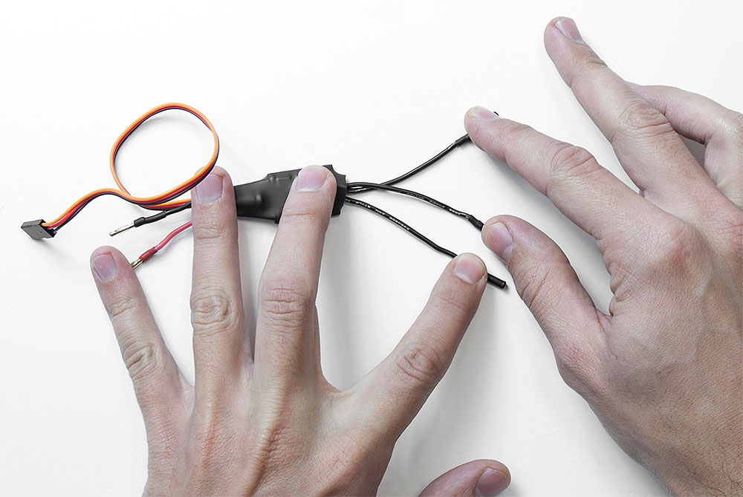
Step 5: And the other position, with the cables without crossing. (view photo).
It's hard to see if the wires are coming out of the ESC crossover, the heat shrink wrap on this component doesn't make it easy to see how the wires are coming out.
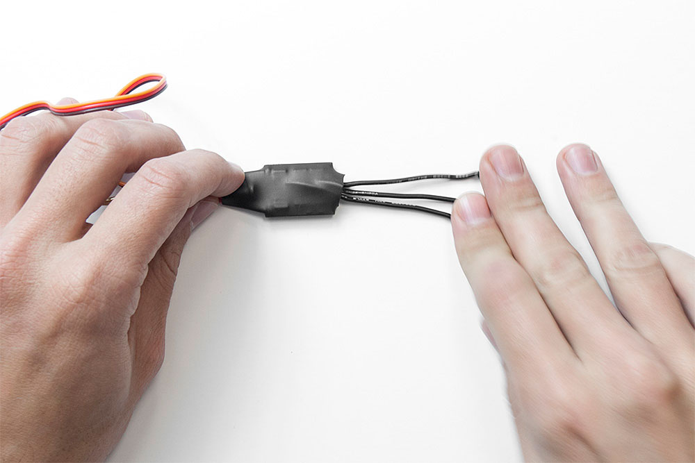

- Step 6: Each of the ESCs must be connected to each motor. Cross the wires that go to the silver motors, and leave the ones that go to the black motors in their normal position.
- Step 7: In the photo, we can see an ESC already installed, in this case, as it is connected to a black motor, the cables go without crossing.
- Step 8: If any of the connectors look like in the image, apply some tape to cover the connection, so we will avoid any electrical problems in our drone.
- Step 9: We are going to place the ESC cables so that they are tight to the leg. Look at the image to do it correctly.
- Step 10: Perform this action for each of the ESCs.
- Step 11: Put a flange on each ESC to fix it to each leg.
- Step 12: We have to be careful that the cables do not interfere with the rotation of the motor.
- Step 13: This is how your drone should look once all the ESCs are installed.
- The part closest to the motor has loose wiring, during the configuration of the controller, it is possible that we have to modify the connection. Therefore, we will fix these parts later.
- Step 14: We will connect each ESC in order according to the diagram, to each connector on the controller.
- We will place the connector so that the yellow wire goes toward the front of the drone.
- Step 15: This is how the connections should look.
- Step 16: The last thing in this phase, put a flange to capture the wiring correctly.

