**Abstract**

The need for medical assistive technology has become increasingly prevalent in the last decade, fueled by the high cost and difficulty finding trusted in-home nursing services. More recently, growth in robotic technology has been expedited by intelligent computer vision, latest battery technology, and energy efficient parts. However, little has been done to bridge robotics, computer vision, and medical assistance in a consumer-grade and economical manner. In this paper, we propose an affordable indoor Unmanned Aerial Vehicle (referred to as a Baymax) equipped with an Intel RealSense depth sensing camera to detect an incurring stroke on a patient. In particular, this study highlights the hardware necessary to implement the technology, and the computer vision tasks involved in identifying a facial palsy from the images supplied by the camera. Our use of Fisher Discriminant Analysis for the classification of facial palsy will also be compared to other methods of classification –such as support vector machines, and the convolution neural network-.

**Introduction**

The two primary issues Baymax will attempt to mitigate are the cost of home health care nurses, and the safety hazards of family members acting as an informal substitute for Registered Nurses. The Centers for Medicare & Medicaid Services (CMS) estimates over 10,800 home health agencies providing care for over 3.4 million elderly or disabled patients[1]. Unfortunately, the eligibility for Home Health Benefit from Medicare is only limited to patients requiring part-time or non-continuous patient care for fewer than 21 contiguous days [2]. To those who are not covered by the Medicare program, the approximate cost of a home health aide is $21 per hour without extra charges for additional services [3]; this leaves the option for full-time nurses unaffordable for those needing intermittent care.

One of the more affordable alternatives to having an in-home nurse is the use of an Assisted Living Facility, which provides a one-bedroom unit for approximately $3,000 per month [3]. However, the Centers for Disease Control and Prevention (CDC) estimates 66% of people hospitalized for stroke are over the age of 65 years [4], and the American Association of Retired People (AARP) reports the vast majority of Americans (89%) of ages 50+ want to remain in their own homes as long as they can [5], which leaves an Assisted Living Facility inconvenient for the majority of stroke victims.

The latter issue, and the more common alternative to Medicare and Assisted Living Facilities, is the use of family members and untrained caregivers helping their loved ones at home. Although there are over 34 million family care-givers in the United States [5] who practice this, there is a lack of oversight, prompt response, and experience that would otherwise be offered by a formal Registered Nurse [6].

Our solution, Baymax, is an assistive drone that will aid recovering stroke victims who require frequent monitoring for facial palsy. Although our solution is novel to home health care and medical assistance, there are a number of non-trivial computational challenges outlined in this paper.

**Mechanical Apparatus**

Although the intrinsic of the electrical and mechanical components of the quadcopter will not be discussed within this paper, it is important to understand the nature of the images that are taken from the quadcopter and the apparatus that we use to gather this data. As shown in Figure 1, the quadcopter consists of a carbon fiber frame with an Android phone connected via a USB OTG cable to an Intel RealSense 3D depth-sensing camera. The Android phone then uses the linux libUVC framework to receive the image in YUV format and perform the necessary processing described in the later portions to classify the object as a normal face or one with palsy. The drone is capable of flying to eye-level height and taking a picture of the patient’s face.

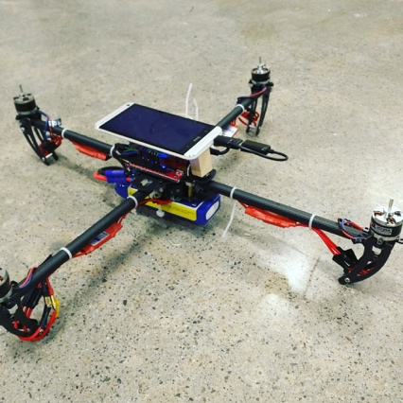

figure 1. Quadcopter to receive images for processing.

**Classification Method**

The binary classification of human faces is not a relatively new problem, and has been approached in a variety of methods to solve a number of different issues, including the classification of gender among a set of images. However, there are a number of optimizations which could be learned from research in face classification to be applied towards classifying stroke victims. Namely, this project focuses on the use of Gabor filters and Fisher Discriminant Analysis –as proposed by [1] towards the classification of Bell’s Palsy.