NOTES-PINN

Step 1
Create a neural network class in pinn_model.py that takes input (x,t)(x, t)(x,t) and predicts the solution u(x,t)u(x, t)u(x,t) of the 1D heat equation.
Component | Purpose
tf.keras.Model | Allows custom architecture and training
Dense layers | Hidden layers with tanh activation
call() | Forward pass: takes [x, t] → returns u
What is tanh activation

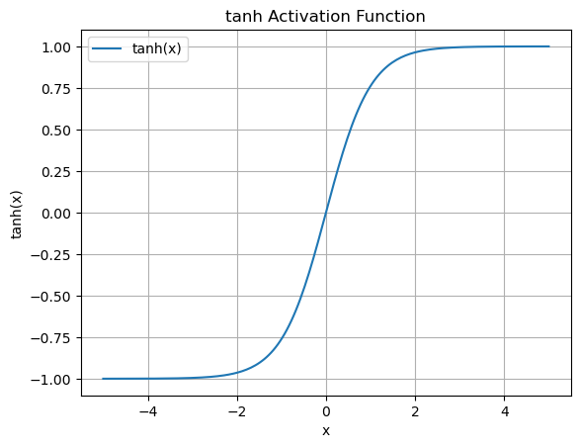
- Zero-centered output: Its range is [-1, 1], so outputs are centered around zero. This helps gradients flow better and can lead to faster convergence compared to functions like sigmoid (which outputs between 0 and 1).
- Non-linearity: It introduces non-linearity, allowing neural networks to learn complex patterns.

