Data Visualization:

Clearly there are three different areas:

We can cluster the data before running optimization

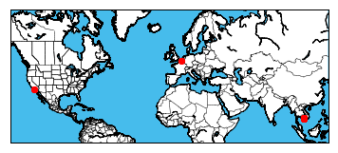

Cluster 0

Number of locations: 1598

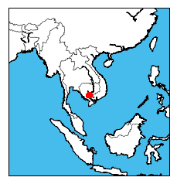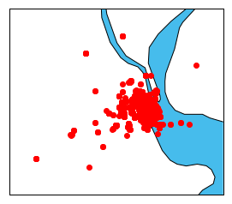

Cluster 1

Number of locations: 3

1187 33.778968 -118.189823

1188 33.778968 -118.189823

1563 33.778722 -118.198508

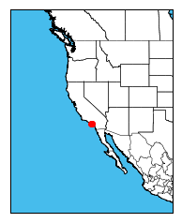

Cluster 2

Number of locations: 2

897 50.690189 3.161406

898 50.690189 3.161406

