Technical Test Report

Ravi Kumar Tiwari

**Data Visualization:** Visualization of the delivery locations on the map

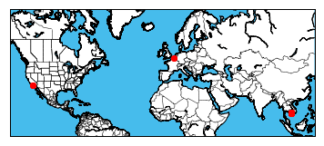

Fig 1: Location of delivery points on the world map

We can see that there are three different clusters. The distributions of points in the three clusters are as follows:

|  |  |
| --- | --- |
| Cluster ID | Location Count |
| 0 | 1598 |
| 1 | 3 |
| 2 | 2 |

Cluster 0 which in which almost all the locations are situated are in Cambodia. Cluster 1 and Cluster 2 which has only 3 and 2 points are situated are in US and France, respectively.

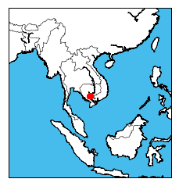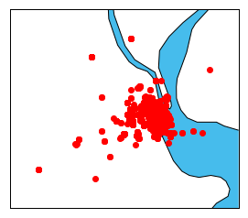

Fig 2: Points in Cluster 0

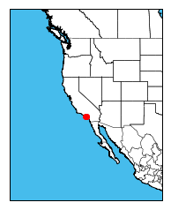

Fig 3: Points in Cluster 1

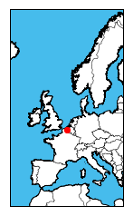

Fig 3: Points in Cluster 2

**Method**:

For the optimization, I have chosen to find the route that corresponds to shortest distance travelled by all the delivery boys. In calculating the distance travelled, I assume that all the delivery boys start from the central locations and they go back to central location after delivering all the parcels. To find the shortest path I have used multi-chromosomal genetic algorithm . As there are very few points in the clusters 1 and 2 which are located very far away from points in cluster 0, I have chosen to minimize the total distance travelled by delivery boys in cluster 0 only. Since we need 1 delivery boy to cover locations in cluster 1 and 2, I have optimized the total distance travelled in cluster 0 using only 24 delivery boys.

**Results:**

From the figure below, we see that the even after 20000 iterations, the solution is not fully converged. We can get even better solution simply by increasing the number of iterations. However, I feel that aim of the technical test is to evaluate the methodologies and its implementation. I have, therefore, chosen to report the un-converged result in the interest of time. Figure 4 and 5 depict the total distance travelled by all the delivery boys and time taken to find the optimal route as a function of iteration number

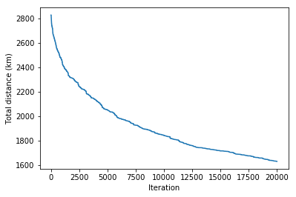

Fig 4: Total distance covered by the delivery boys for the optimal route obtained after n iterations

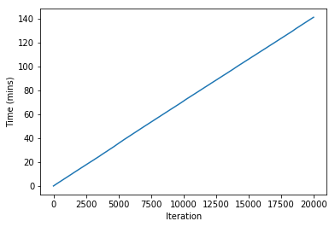

Fig 5: Time taken to complete n iterations

Figure 6 and 7 show the delivery route (both zoomed in and out version) for a few delivery boys

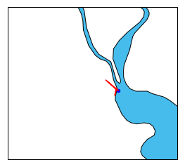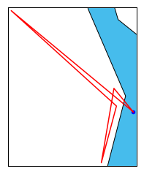

Fig 6: Delivery Route for delivery boy 4. The figure on the right is zoomed version of the figure on the left

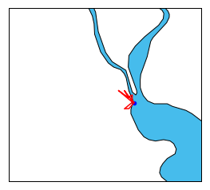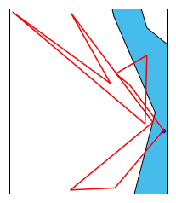

Fig 7: Delivery Route for delivery boy 12. The figure on the right is zoomed version of the figure on the left

**Ideas on Scaling :**

We can use parallel genetic algorithm that consists of multiple populations that evolve separately most of the time and exchange individuals occasionally. In case there are multiple warehouses then we can first create cluster of delivery location with warhouses as their centres and then minimize the distance travelled

Also, with parameter optimization such as population size, or with different types of mutations the algorithm can be made to converge faster.

**Problem Statement:**

There could be multiple constraints to reflect the actual conditions. Some of them are

* Instead of geometrical distance, we need to optimize the total path distance. The two points might be close to each other on the map but if there no direct path connecting these two points then the delivery boy needs to cover much more than their geometric distance.
* There might be an upper limit on the number of locations a delivery boy can go to.
* The objective function might be to minimize the total cost/time taken for delivery rather than the total distance travelled
* Instead of assuming that after delivering all the packages the deliveryboys go back to the warehouse, we can also assume that after delivering their last package they go back to their home