**LSTM: Long Short-Term Memory networks**

LSTM are a type of recurrent neural network capable of learning order dependence in sequence prediction problems. Capable of learning long term dependencies in data.

RNN are different from traditional feedforward neural networks.

LSTMs are designed to avoid the long-term dependency problem.

LSTM has feedback connections inside the neural network to learn temporal patterns and overcomes the problem of vanishing or exploding gradients caused by RNNs.

Can look to use de-noise algorithm

Can look to apply wavelet transformation to pre-process input prices

Gunduz and Uhrig-Homburg, 2011 – Forecasting cds with Merton structural models

LSTM networks overcome the vanishing gradients problems and learn long-short term dependencies more easily than vanilla RNNs.

Combine neural network with macroeconomic and financial conditions to enhance the forecasting accuracy.

FRED can give us 2s10s Treasury Constant Maturity Rate which represents slope.

Probabilistic computing will soon be able to make decisions with less amounts of data.

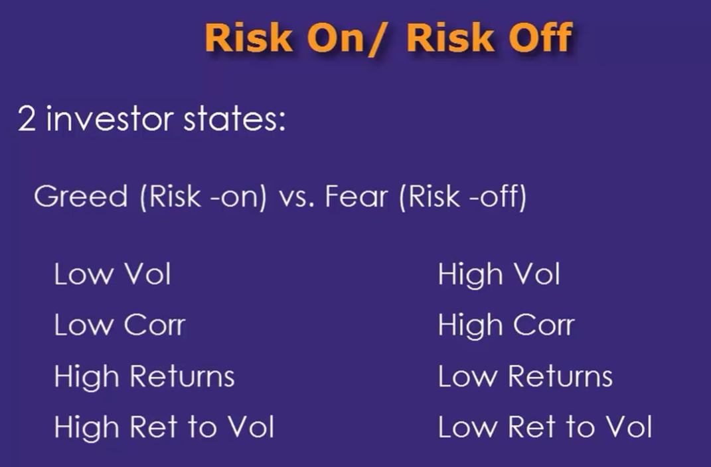

Unlike stocks VIX is mean-reverting.

Gallup poll in August 22 found the 37 per cent of Americans held negative views of airline industry compared to 27 per cent who held a favourable impression.

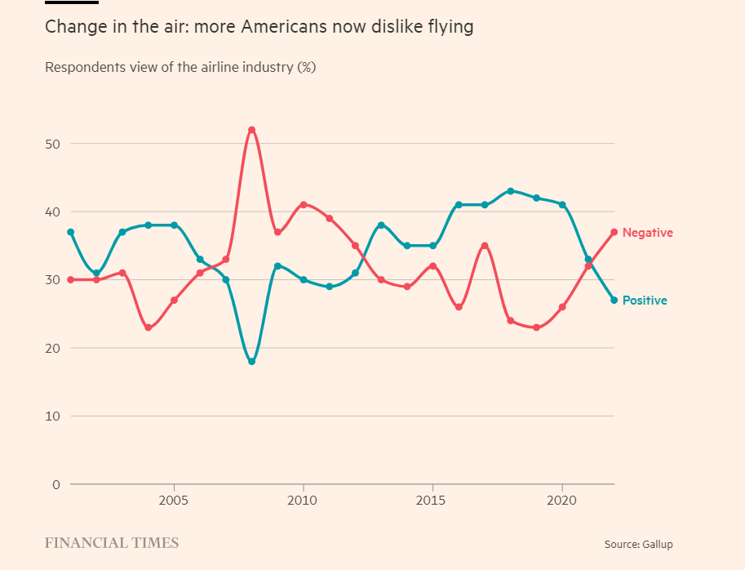

Total US Call Option Volume

OPCVTOTC Index

The authors used various factors to define the Black Swan events, among them the Jarque-Bera statistics.

We used the Bayesian Optimization algorithm for choosing the best hyperparameters for our trading strategies.

<https://research.macrosynergy.com/the-predictive-superiority-of-ensemble-methods-for-cds-spreads/>

**Hurst and CDS**

<https://ipe.ro/rjef/rjef1_2022/rjef1_2022p106-121.pdf>

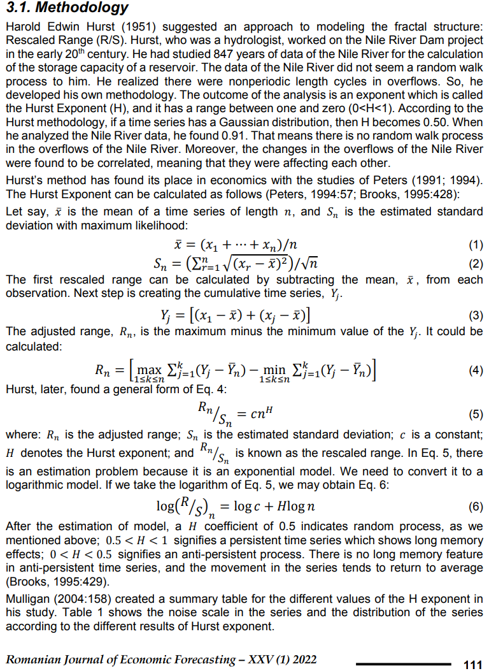

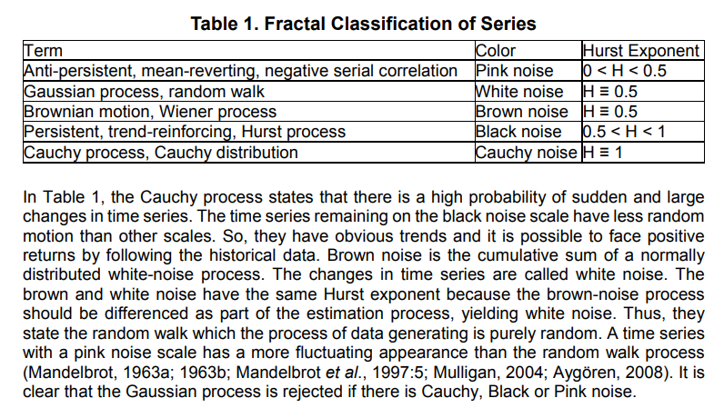

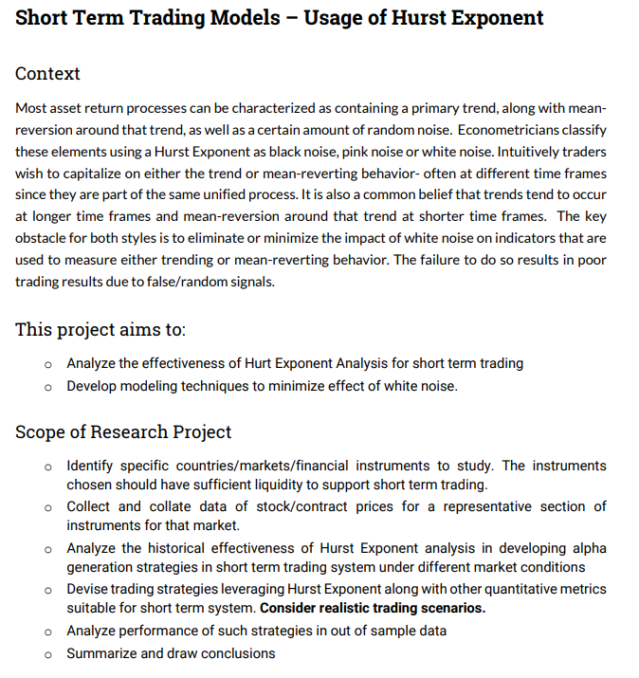

IG

Lookback = 1

Good tutorial on LSTM

<https://lilianweng.github.io/posts/2017-07-08-stock-rnn-part-1/>

Check the references on this page

<https://link.springer.com/article/10.1186/s40537-021-00430-0>

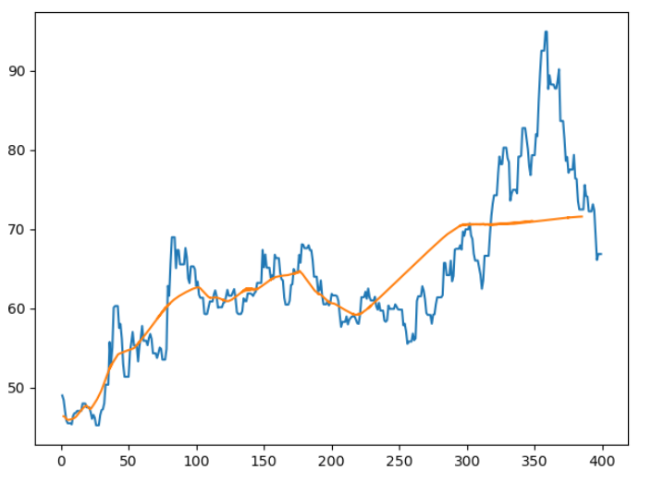

**Support Vector Machines**

<http://www.quantstart.com/articles/Support-Vector-Machines-A-Guide-for-Beginners/>

Predicting equity moves in the modern era of fast trading has been nothing but vexing, not least when it comes to the threats posed by technical forces like dealer positioning. Oft-dreaded crashes typically fail to ensue, or break out in unexpected ways, making life harder for professional forecasters.

ARIMA

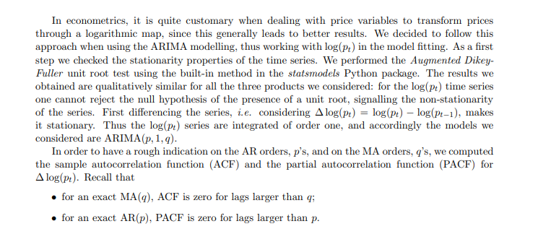

LSTM

Predicting the increment of the quantity of interest instead of the quantity itself is a well-known way to improve performance when training multivariate machine learning models.

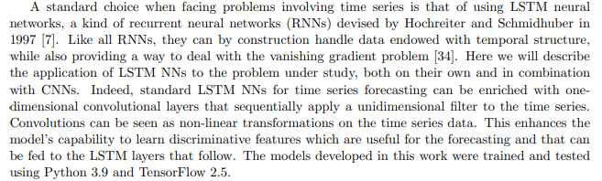

Given that the influence of financial and macroeconomic variables on the CDS market is usually long-lasting and far-reaching (Balcilar et al., 2018; Hkiri et al., 2016; Wang et al., 2019), incorporating LSTM with the Merton determinants model could improve the forecast accuracy by identifying the long-term impact of financial and macroeconomic variables on the CDS indices. (may be use this when incorporating the hurst component time series).