MScFE Capstone Project

Group: 1157

Rajneesh Kumar Singh – singhrajneesh@gmail.com

Abstract The purpose of an abstract is to summarize the key information in your report, including the research goals, design, and major findings of your research. This section should be as concise as possible (typically no longer than 300 words) and give the reader a clear understanding of what to expect in the report. Introduction An introduction should establish the context and purpose of your report. In this section, you should pose the question or hypothesis that is going to be investigated in the following sections, as well as discuss the theoretical background and rationale of the report to the reader. Theoretical Framework This section provides a more comprehensive, critical discussion of the existing research and literature on the topic of your report. It is important to only include relevant literature that provides context to your research question or hypothesis. MScFE 690 Capstone –Capstone Project Report Guidelines ©2019 - WorldQuant University - All rights reserved. 3 Methodology Use this section to outline how you conducted your research study. This includes the specific techniques and tools you used to collect and analyze your data, any constraints you encountered as well as how you were able (or unable) to manage these constraints. Results The Results section is where you will present your data. Use figures, tables, and graphs to clearly represent information in a logical order. Only include the data that is most relevant to your report in this section. If you want to include additional or non-essential data for context or clarity, you can add an appendix at the end of your report. Discussion In this section, you will analyze the data you presented in your results and interpret this data in light of your research question or hypothesis. Use this section to explain what your results mean and how they relate to, or contribute to, existing research and knowledge in the field. Conclusion The conclusion is where you will provide a concise summary of your results and findings. It is very important that no new ideas or data are introduced in your conclusion. Make sure you include all the key information that was presented in the results and discussion. References This section is a comprehensive list of the literature and research you cited in your report. This list should be alphabetical and formatted correctly according to the referencing style you have used in your report. Appendix The appendix is an optional section at the end of the report that can be used to include additional information or data for clarity or interest. You can refer to the appendix throughout your report.

# Project Track

**Short Term Trading Models – Usage of Hurst Exponent in credit derivatives**

The project is more of a practical type where Hurst Exponent and Machine Learning techniques will be used to build a macro credit trading strategy.

# Problem statement

Applications of machine learning in the area of macro credit is not that common yet. This project aims to bridge this gap in application of recent machine learning techniques and Hurst Exponent to the area of credit derivatives and credit ETFs.

# Goals and Objectives

**Goal:** In this project we intend to analyse the effectiveness of Hurt Exponent Analysis for short term trading of global macro credit derivative index, CDX.NA.IG. The goal of the project is to build a long/short strategy for systematic trading of global macro credit over short to medium term horizons. We also explore modelling techniques to minimize the effect of white noise.

**Objectives:**

* Use Hurst Exponent to identify trending and mean-reverting time series of credit default swaps
* Explore and compare time series forecasting techniques vs machine learning based prediction techniques like Support Vector Machine and Long Short-Term Memory (LSTM) (Vukovic, 2022)
* Backtesting of the formulated strategy

# Literature Review and Competitor Analysis

In his debut non-fiction book titled “The Greatest Trade Ever: How One Man Bet Against the Markets and Made $20 Billion”, American journalist Gregory Zuckerman narrates behind the scenes story of how John Paulson had pulled off the greatest trade in financial history. “By piling into complex "credit default swaps" against mortgages – in effect, insurance policies that would pay out if homeowners defaulted – his fund made an unthinkable $15bn (£9.8bn) in a year, $4bn of which he took home himself (Stewart, 2010)” and that dwarfed George Soros's billion-dollar currency trade in 1992. The 2015 movie “The Big Short” is based on the same trade.

Credit default swap (CDS) is a credit derivative instrument which is basically like an insurance on the default of the underlying reference entity. The reference entity could be a corporate or any sovereign. These are instruments which protects the buyer in case of default. In return the protection buyer pays a quarterly fee to the protection seller. Many such credit default swaps can be bundled together and form an index swap. For example CDX.NA.IG is one such portfolio of single-name credit default swaps on the 125 most liquid investment grade corporates in North America. European and other regional equivalents also trade actively. Further there are options and tranched products on these macro credit indices (Markit, 2021). For a more detailed understanding of the credit default swaps readers are referred to the Federal Reserve Board’s discussion paper on the same (Bomfim, 2022).

Credit derivative products gained immense notoriety and have largely been blamed for the Great Financial Crisis of 2008-2009. These markets had largely been unregulated before that and is still opaque to many market participants. In an IMF working paper (Elliott, 2009) the authors highlight how credit derivative markets can increase systemic risk due to the inter-connectedness of large financial institutions and how policy makers need to be aware of the “blind-spots” in this market.

Recently the CDS of Russian Federation came into focus as it launched a full-fledged war against Ukraine in early 2022. In the below figure we can see how the premium on the CDS sky-rocketed as the war progressed and there were fears that the Russian state would not honour the coupon payments on their outstanding bonds. Also notice the volatility around this CDS price.

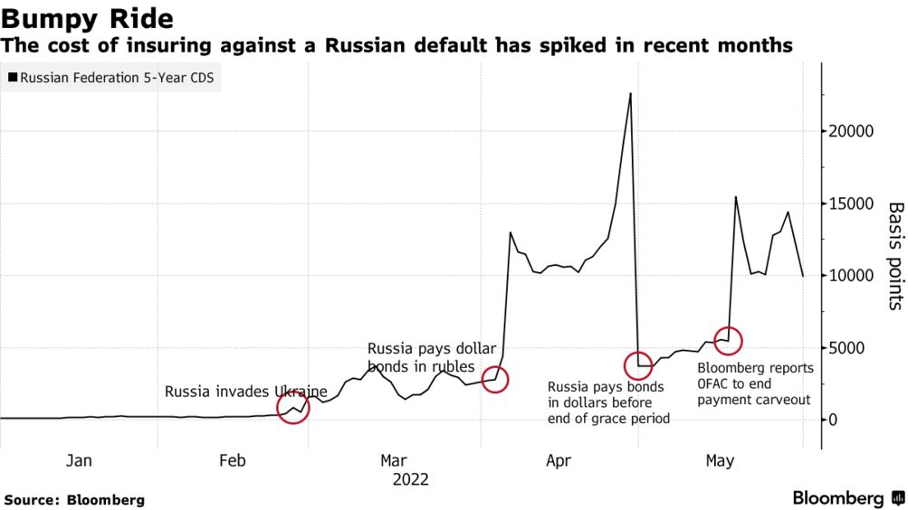

To implement a hedging and/or a trading strategy, the accurate forecasting of CDS spreads becomes important. Similar to the VIX index, credit indices have become important barometer of overall credit risk of whole economy. While other asset classes like equity, bond and foreign exchange get lot of attention with regards to new forecasting techniques, work on credit derivative asset class looks minimal in comparison.

While a lot of studies has been done on the determinants of CDS spreads, the literature is sparse on price forecasting. (Avino, 2014) did an analysis of two linear forecasting models, ordinary least squares and an AR(1) model as well as a Markov regime-switching approach and found some evidence of statistical predictability. His instrument of choice was the iTraxx CDS index and the data covered the 2008 financial crisis. iTraxx index is a pool of CDS on 125 investment grade corporates in Europe. They found the Markov switching model underperforming the linear models under study.

With the advent of machine learning models researchers have begun to apply them to the credit derivative markets. Support Vector Machines were applied by (Gündüz, 2011) to single-name CDS prices and were found to outperform the Merton model. (Zhang, 2018) expands on this study by predicting the returns rather than the CDS prices and also adds a few features.

In an IMF working paper by (Hu, 2019) ensemble machine learning methods were applied on firm level accounting-based, market-based and macroeconomic variables to generate CDS spreads which can be helpful for arriving at CDS spreads for companies who don’t have an active CDS market. The ensemble methods used were Bagging, Gradient Boosting and Random Forest.

Are CDS spreads predictable? And does efficient market hypothesis apply to the credit derivatives markets? With this dual goals (Vukovic, 2022) investigated the daily CDS spreads for 513 leading US companies over the time-period 2009-2020. The study splits the period as pre and post Covid-19 to check if there were changes in the market efficiency. The forecasting tools they used were Support Vector Machines, Group Method of Data Handling, Long Short-Term Memory and Markov switching autoregression. The results show the prediction results are not very different before and during Covid-19. But they did find that the market became less efficient during the pandemic. The GMDH and MSA models outperformed SVM and LSTM.

As we can see the latest machine learning and deep learning models for time series forecasting of credit default swaps spreads has been able to provide better results compared to traditional methods. This is consistent with the findings in other asset classes where researchers have been reporting superior results. This also means that efficient market hypothesis may not hold for CDS price movements and the moves may not be mere random walks. Fractal Market Hypothesis (FMH) could be an alternative for CDS prices especially during periods of market turbulence.

FMH studies have been conducted on various markets using a variety of methods to establish the fractal properties of the time series. Using the CDS spreads of Turkey, Russia, South Africa and Brazil, (Günay, 2016) examine the long-memory dependency in its volatility. Hurst Exponent Analysis was used by (Balkan, 2022) on the CDS spreads for 34 OECD countries between March 2003 and February 2020. Using rescaled range analysis with four different frequencies the researchers were able to show persistency in all CDS spreads and therefore upholding the FMH.

The pricing of CDS under Generalized Mixed Fractional Brownian motion has been considered by (He, 2014) and they provide a closed-form analytical expression for the CDS under risk-neutral assumption. The long memory in highly volatile time series of cryptocurrencies is examined using Hurst exponents of log returns in (Sheraz, 2022) as this nascent market has demonstrated sufficient divergence from normal distribution assumption.

Our literature survey has thrown evidence of long-term memory in CDS prices from two independent approaches that researchers have taken: fractal markets and deep learning model like LSTM. This motivates us to combine the two approaches and see if better forecasting results can be achieved. In this study we focus on Hurst Exponent Analysis for short term trading of CDX.NA.IG. We will use Hurst Exponent to classify our time series as trending or mean-reverting. Mean-reversion occurs over shorter timeframes and since our focus is short term trading we expect to do more work identifying the mean reversion signals. We might use other signals and indicators like moving average or RSI indicators to enter into a trade and test alpha generating trading strategies. We also explore machine learning and deep learning models for comparison with our Hurst model. To our knowledge there are no study using Hurst Exponent and machine learning/deep learning at the same time.

# Design

1. Use the feedback you received for your previous submissions to **Design your project** by specifying your approach, methodology, desired outcomes, and intended working plan.

No ‘single best; forecasting model in quantitative finance and quantitative modelling of markets.

We constructed a new technical indicator MH (Moving Hurst) based on Hurst exponent that describes chaotic properties of time series. We can compare the returns generated with other popular technical indicators like MACD. We tested and evaluated our proposal using hypothesis testing.

Another promising approach has been presented in (Selvaratnam and Kirley, 2006), (Qian and Rasheed, 2004) where Hurst exponent is used as an input parameter in neuronal networks applied to predict time series.

https://www.scitepress.org/papers/2018/66670/66670.pdf

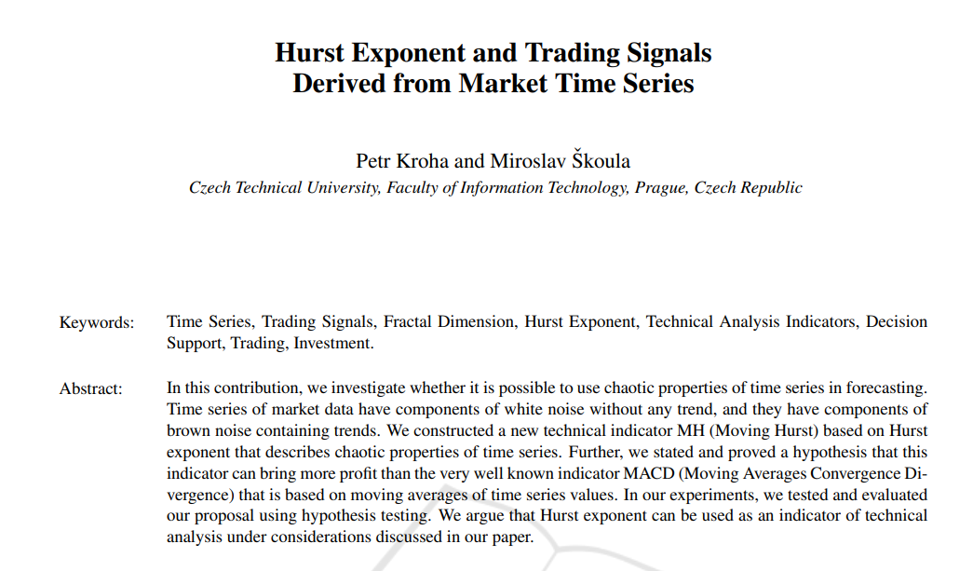

https://c.mql5.com/forextsd/forum/170/hurst_exponent_and_financial_market_predictability.pdf

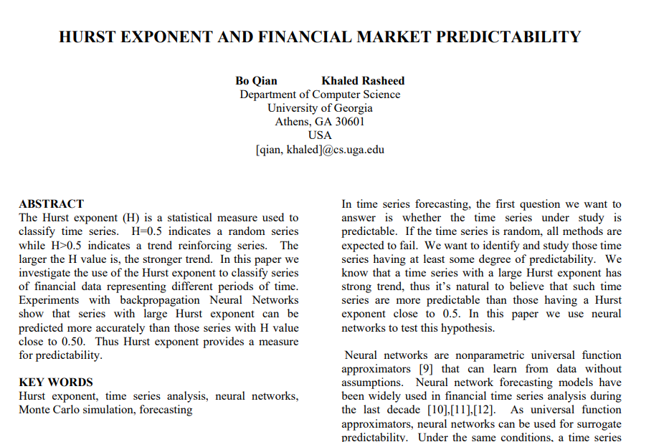

# GitHub Repository

An online repository for the current project is publicly available at the below GitHub address.

<https://github.com/rks972633/MScFE_Capstone>

The plan is to provide all the files and working codes to the online repository.

# Pseudo code

Below algorithm for calculation of Hurst Exponent is motivated from (Sheraz, 2022).

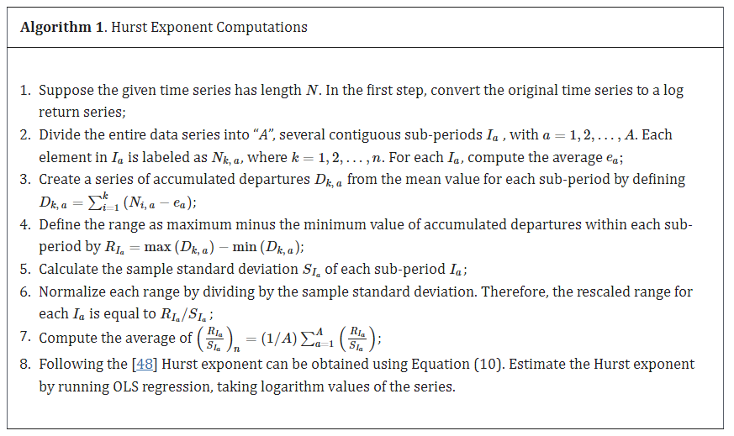

# References

Avino, D. a. (2014). Are CDS spreads predictable? An analysis of linear and non-linear forecasting models. *International Review of Financial Analysis 34*, 262-274.

Bomfim, A. N. (2022). Credit Default Swaps. *Finance and Economics Discussion Series 2022-023*. Retrieved from https://doi.org/10.17016/FEDS.2022.023

Elliott, M. J. (2009). *Credit derivatives: systemic risks and policy options?* International Monetary Fund.

Günay, S. a. (2016). Long-memory in volatilities of cds spreads: evidences from the emerging markets. *ournal for Economic Forecasting 1*, 122-137.

Gündüz, Y. a.-H. (2011). Predicting credit default swap prices with financial and pure data-driven approaches. *Quantitative Finance 11.12*, 1709-1727.

Gupta, R. G. (2020). Retrieved from https://streetfins.com/analyzing-bill-ackmans-2-6-billion-cds-trade/

Hu, N. J.-C. (2019). *Completing the Market: Generating Shadow CDS Spreads by Machine Learning.* International Monetary Fund.

Markit, I. (2021). Retrieved from https://cdn.ihsmarkit.com/www/pdf/1221/CDS-Indices-Primer---2021.pdf

Stewart, H. (2010, March 07). Retrieved from https://www.theguardian.com/books/2010/mar/07/the-greatest-trade-ever-by-gregory-zuckerman-review-heather-stewart

Vukovic, D. B. (2022). Are CDS spreads predictable during the Covid-19 pandemic? Forecasting based on SVM, GMDH, LSTM and Markov switching autoregression. *Expert systems with applications* .

Zhang, T. Y. (2018). Predicting Credit Default Swap (CDS) Returns with Machine Learning. *Available at SSRN 3152143*.