

“-: Software Engineering II:-”

-:“Final Documentation:-”

SUBMMITED TO:-*
-:” Sir Yasir Hafeez”:-

SUBMMITED BY:-*

-:M.Usman Manzoor:-
(13-ARID-1165)
-:Abu Muhammad Haris:-
(13-ARID-1121)
-:Shan elhi:-
(13-ARID-1214)
-: Muhammad Fasial:-
(13-ARID-1177)

Project Name:-

“Hostel Management System”

Brief use case
Use case:get information
Actor: Admin
Description: Admin gets all the essential information of students to get them enrolled in hostel.

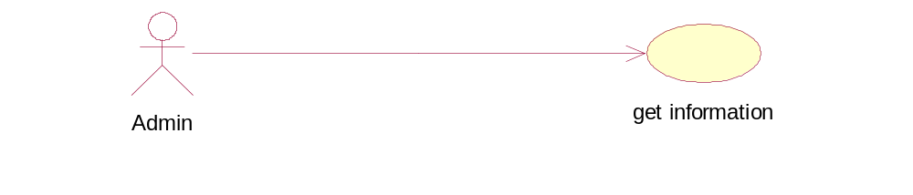
Fully dresses use case:

Use case name | Get Information
Scope | Get the essential Information from student wants to take admission in hostel.
Primary actors | Admin.
Actor’s goal | To get the essential detail of student.
Precondition | Student must get the form.
Post condition | Student has submitted the form with valid information.
Success scenario | Student gets enrolled in hostel.
Extension | If all the required information is not fulfilled.
Miscellaneous | Admin should handle all the issues.
Extended usecase
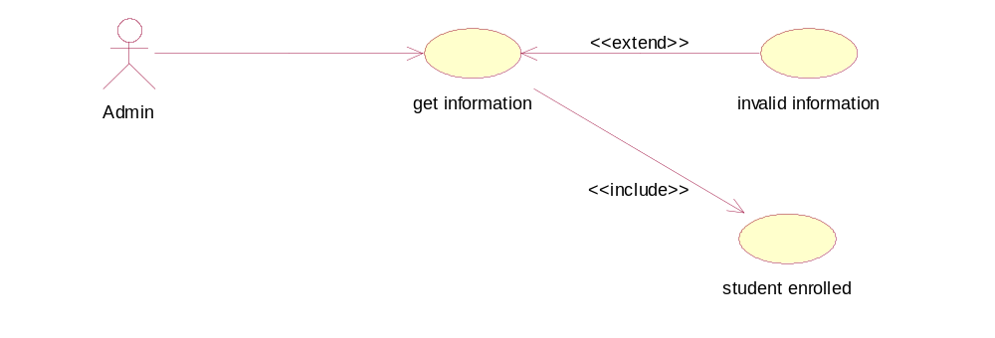
Brief use case:

Use case:allocate room.
Actor: Admin.
Description: Admin allocate room to students, get enrolled in hostel after fulfil the requirements needed by admin.
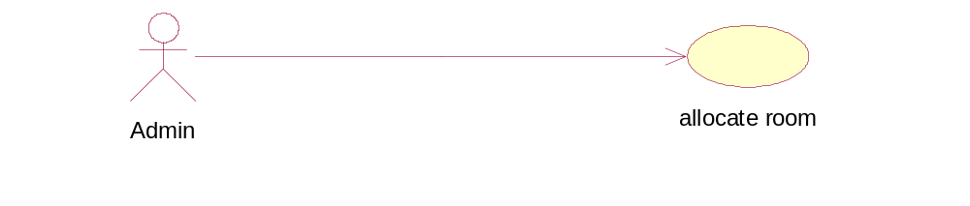
Fully dressed use case:

Use case name | Allocate room.
Scope | Allocation of room to enrolled student.
Primary actors | Admin.
Actor’s goal | To get the essential detail of student.
Precondition | Student must give valid information to admin.
Post condition | Student information is verified.
Success scenario | Student gets enrolled in hostel and room is allocated.
Extension | If all the required information is not fulfilled.
Miscellaneous | Admin should handle all the issues.

Extented Usecase:
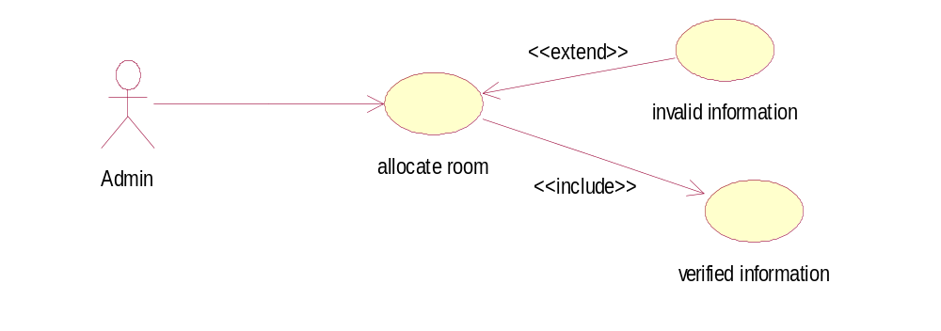

Brief use case:

Use case:manage information.
Actor: Db Manager.
Description: Db manager manages the information given by student in the database.
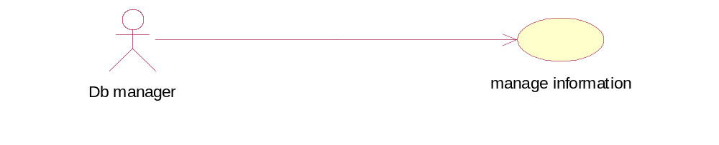

Fully dressed use case:
Use case name | Manage information.
Scope | Management of info given by students in database.
Primary actors | Db manager.
Actor’s goal | To manage the information given by student in database.
Precondition | Db manager must gets the information from admin.
Post condition | Db manager has inserted all the valid information in database of hostel.
Success scenario | Information is managed properly by Db manager.  New information is inserted in database for new student enrolled and updated.
Extension | If all the required information is not fulfilled.
Miscellaneous | Db manager should handle all the issues related to database.

Extended usecase:
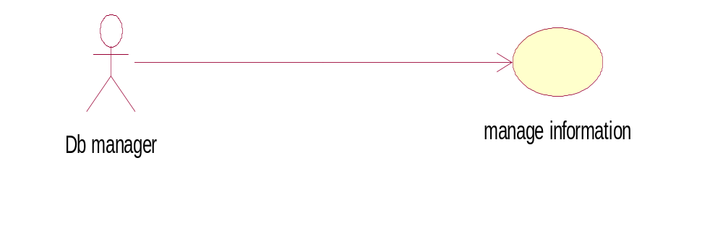

Brief use case:

Use case:update attendance.
Actor: Db Manager.
Description: Db manager updates the attendance of students present in the hostel on daily basis.
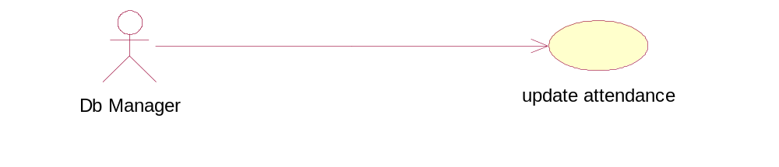

Fully dressed use case:

Use case name | Update attendance.
Scope | Update attendance of students on daily basis.
Primary actors | Db manager.
Actor’s goal | Updating of attendance on daily basis
Precondition | All the students information enrolled in hostel must be entered in database.
Post condition | Database system must work properly.
Success scenario | Student attendance is updated successfully.
Extension | If all thestudent enrolled are not entered in database.
Miscellaneous | Db manager handles all the issues related to database.

Extended Usecase:
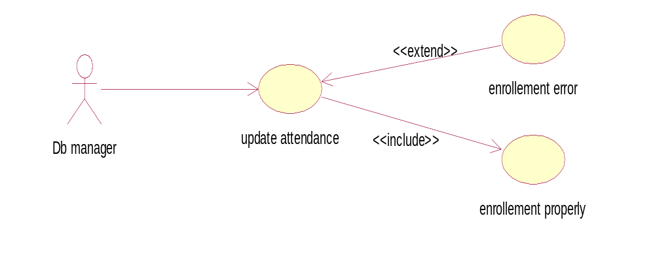

Brief use case:

Use case:manage mess.
Actor: Clerk.
Description: Clerk manage the mess system after getting attendance list from Db Manager.
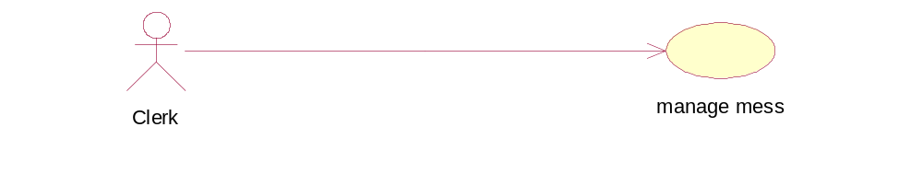
Fully dressed use case:
Use case name | Manage mess.
Scope | Manage the mess for students present in hostel.
Primary actors | Clerk.
Actor’s goal | Manage the mess for students present in hostel.
Precondition | Clerk should get the attendance list of students present in hostel.
Post condition | Get the report when food is ready.
Success scenario | Manage the mess system successfully.
Extension | If clerk do not gets the attendance list of students.
Miscellaneous | Clerk handles all the issues related to mess.

Extended Usecase:-
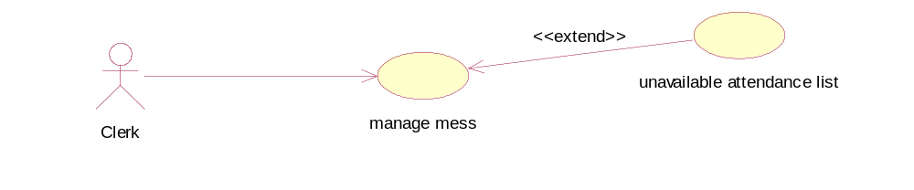

System-Level diagram
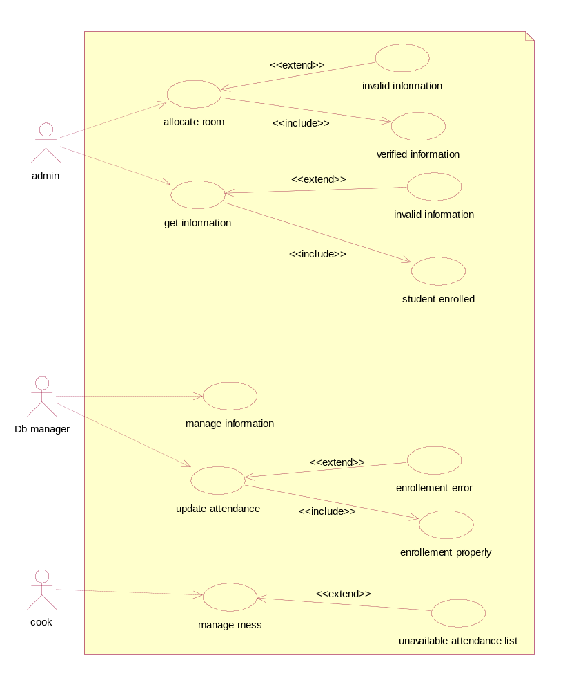

System Domain Model:
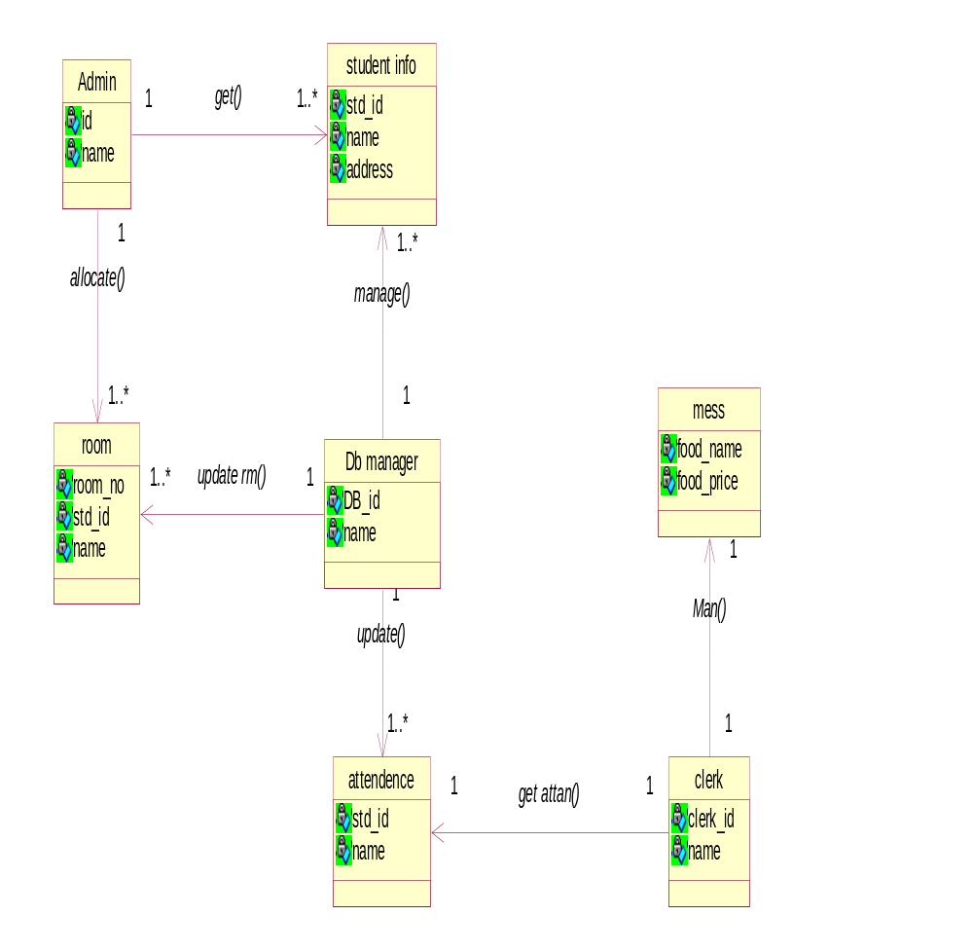

Over All Sequence Diagram:

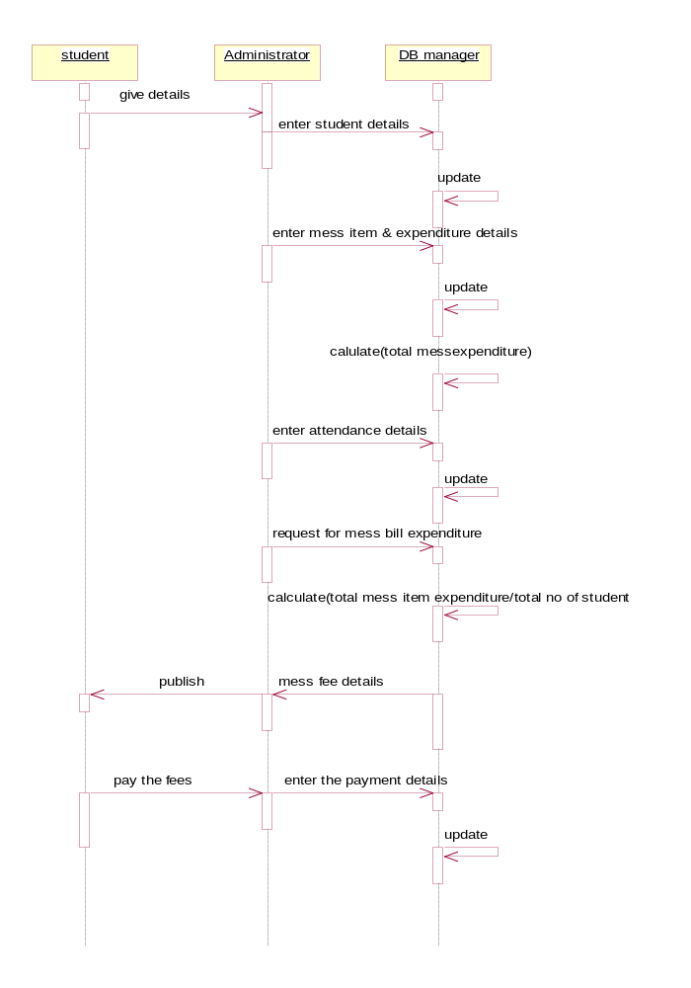

Sequence Digrams:-
1-
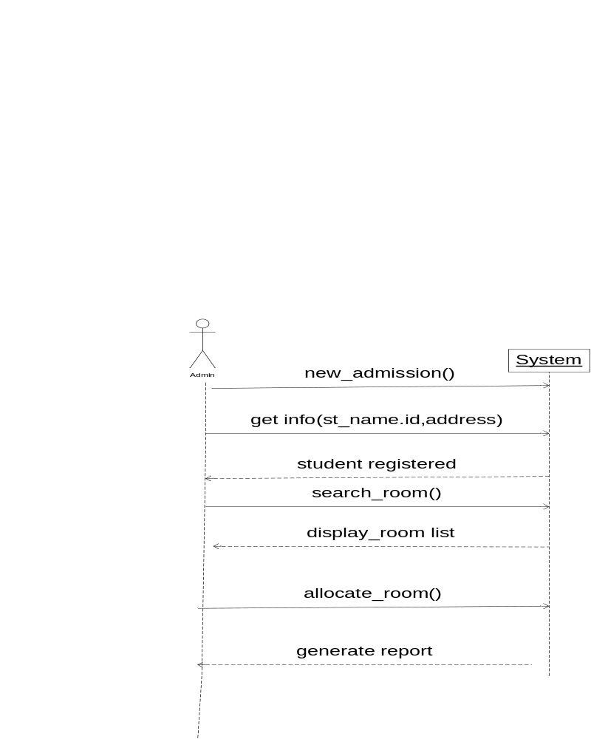

2-

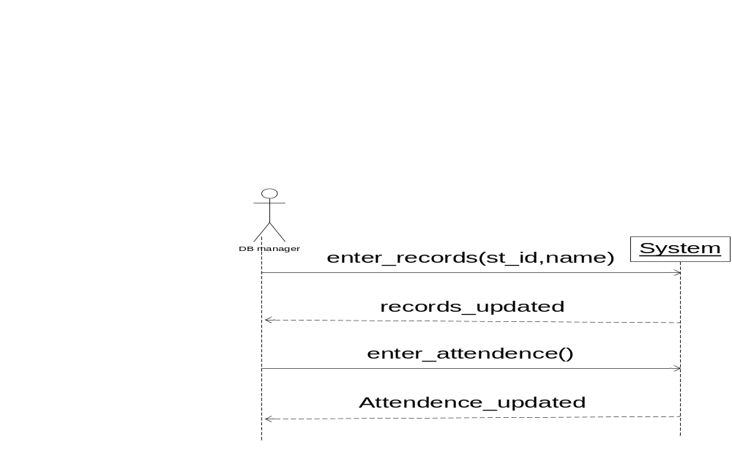

3-

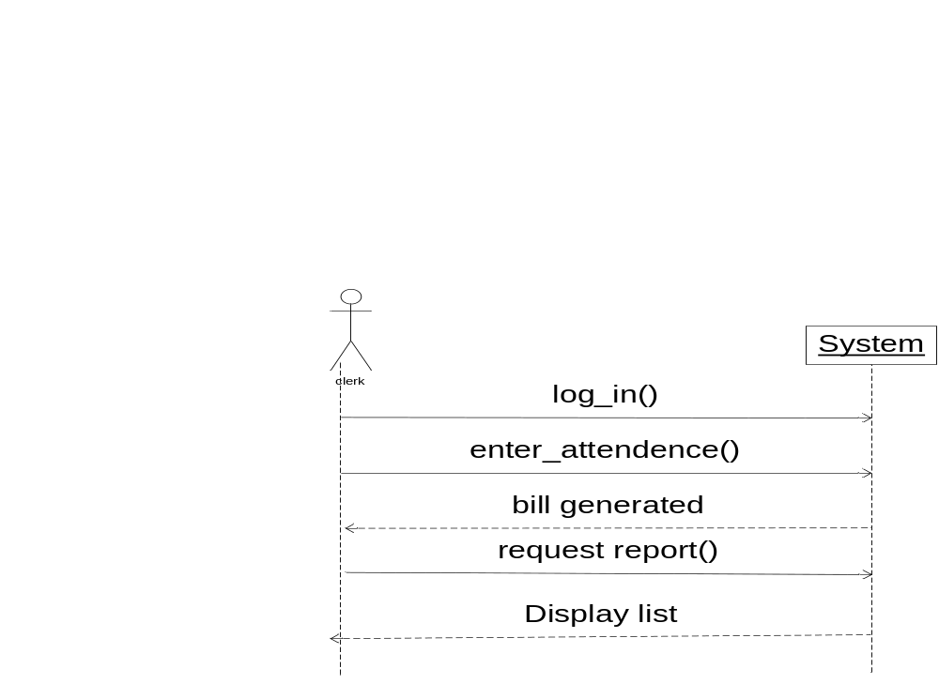

Class Diagram:

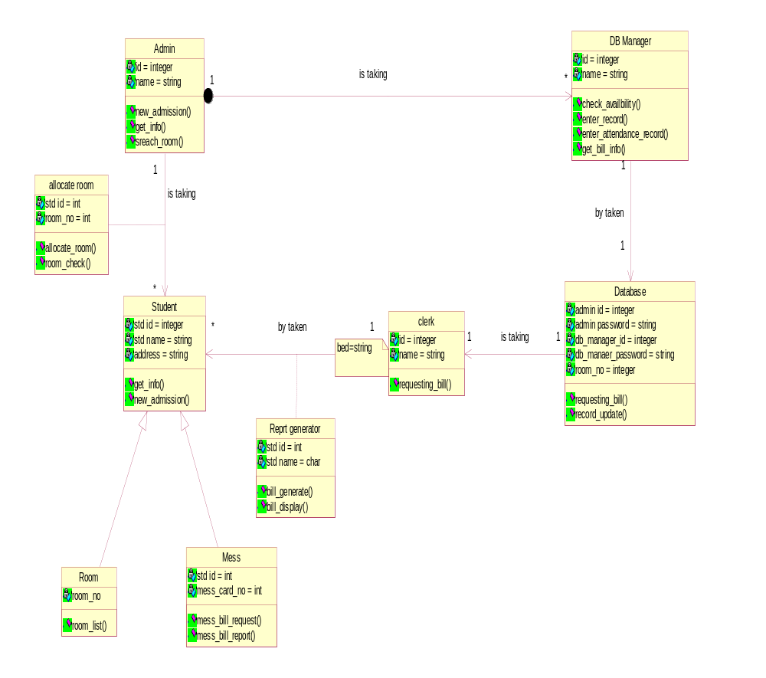

Collaboration Diagrams:-

Get_Info():
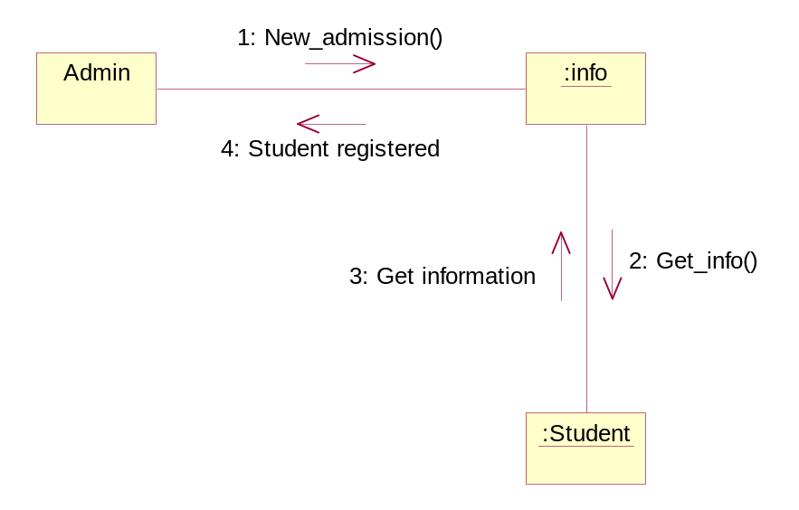

Allocating_room():
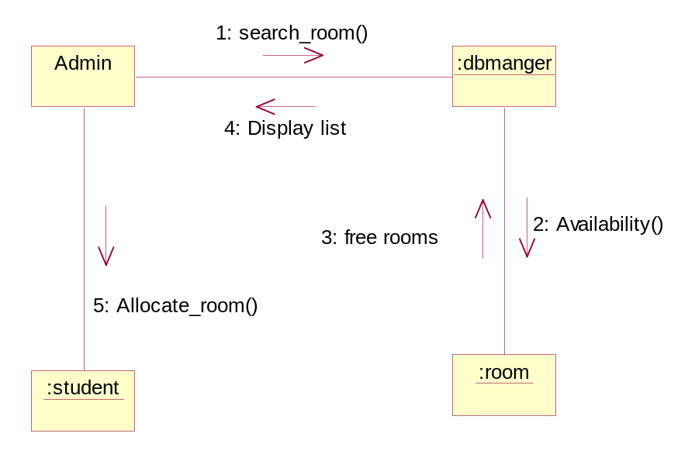

Manage_records():

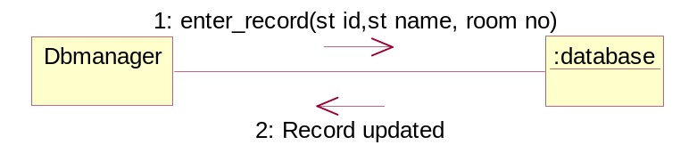

Update_attendance():

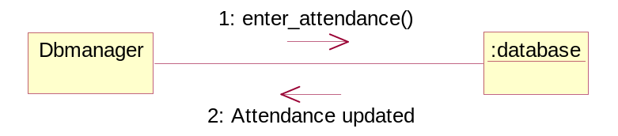

Bill_generating():

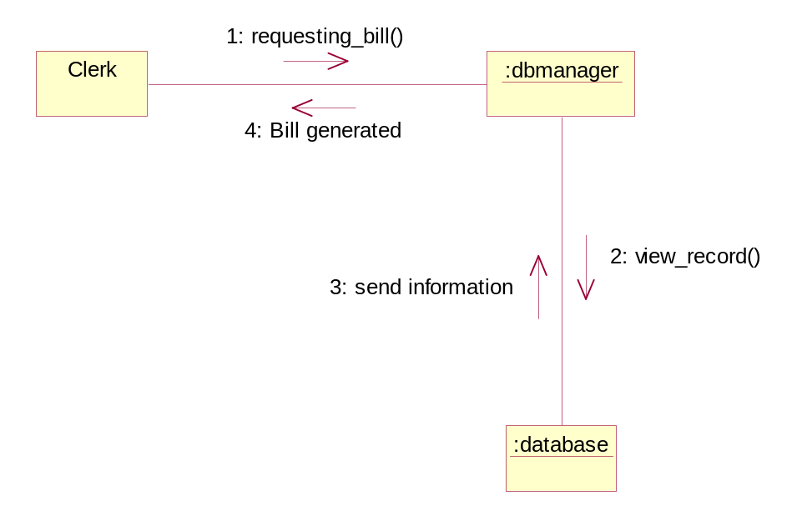

Activity diagrams
1.Get information: 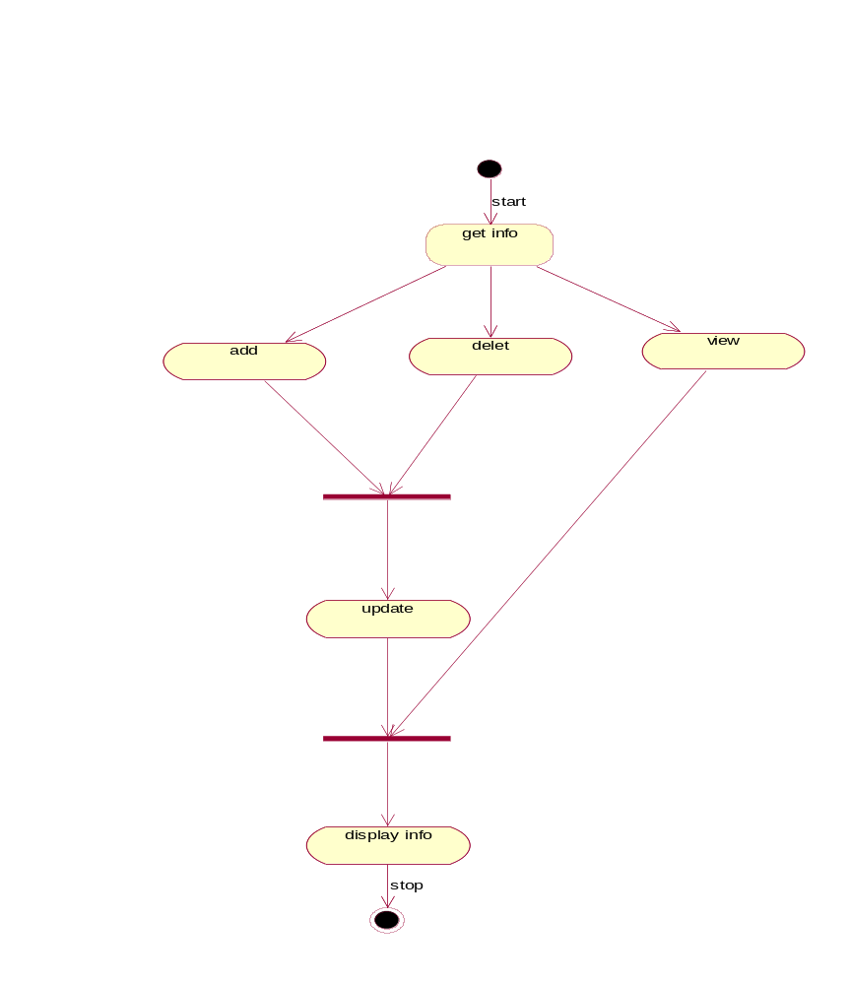
2.Attandance update: 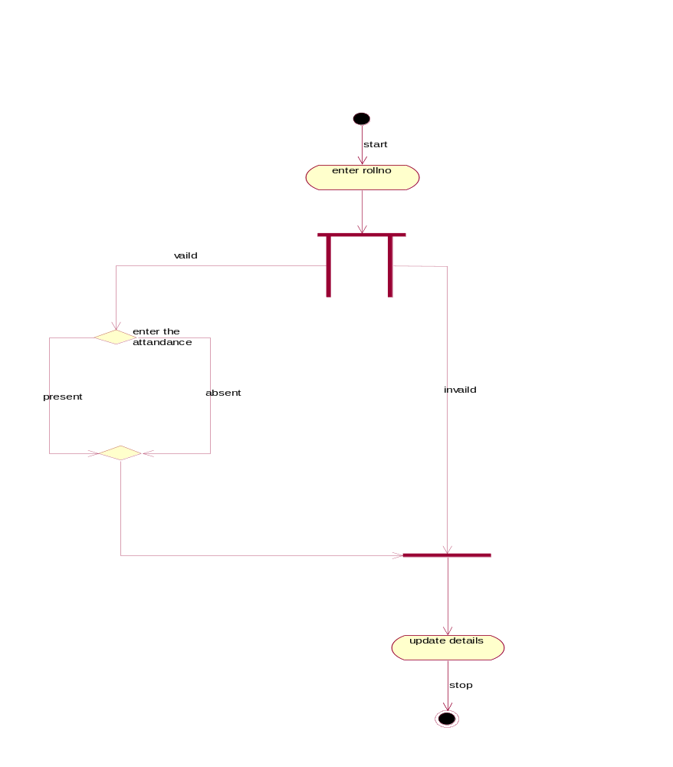
3.Room details: 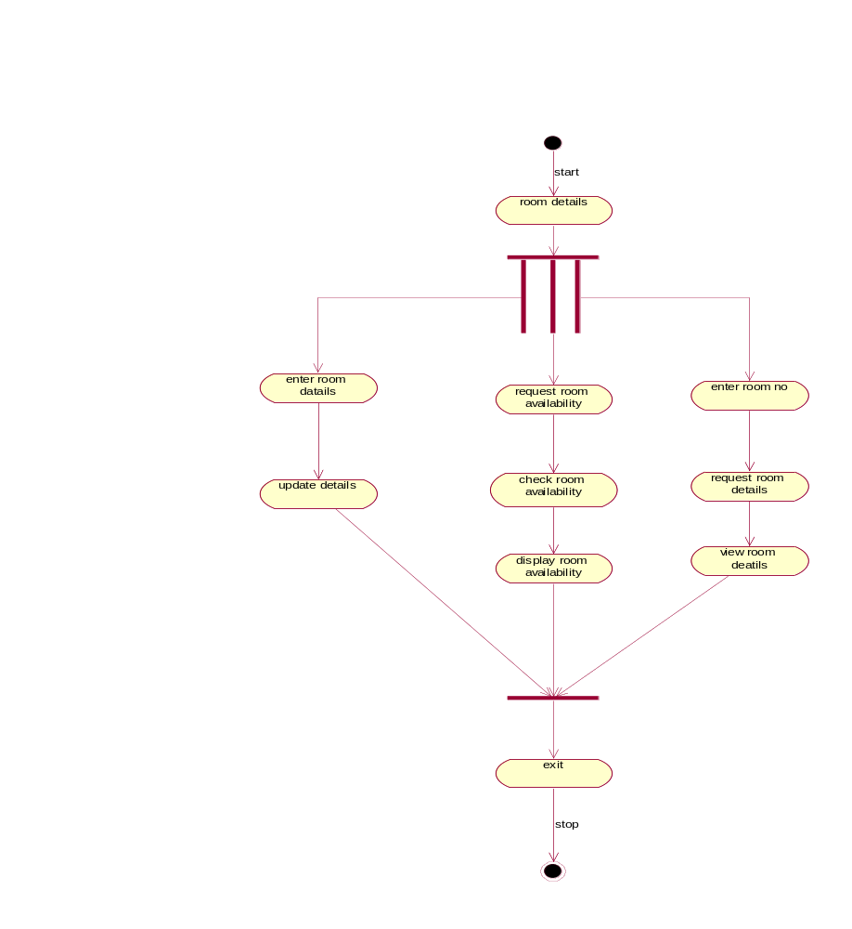

4.Mess details:

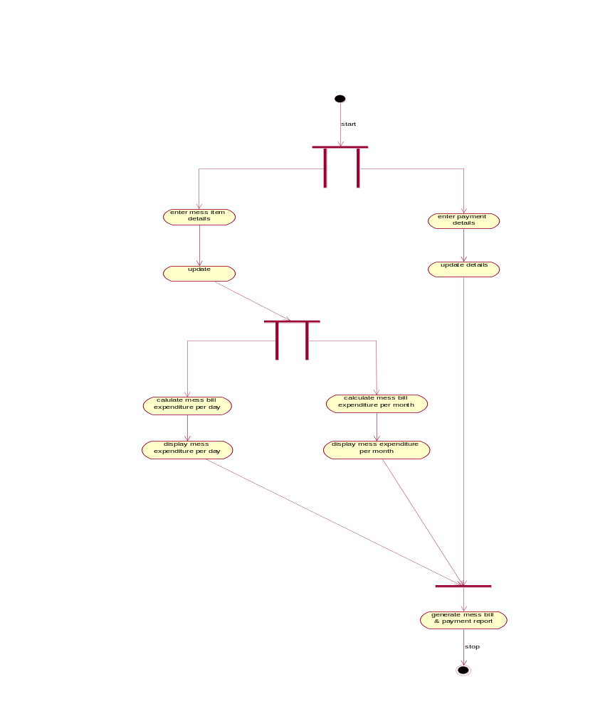

State chart diagrams

1.Get information:
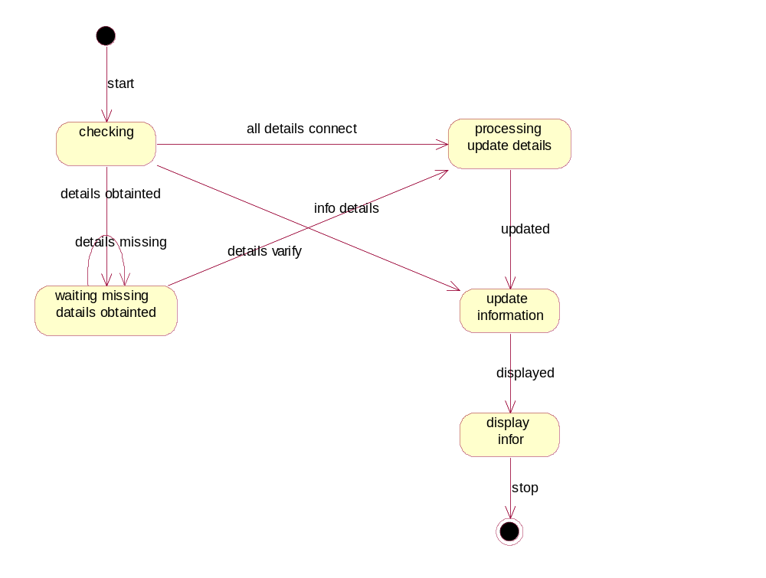

2.Attendance details:

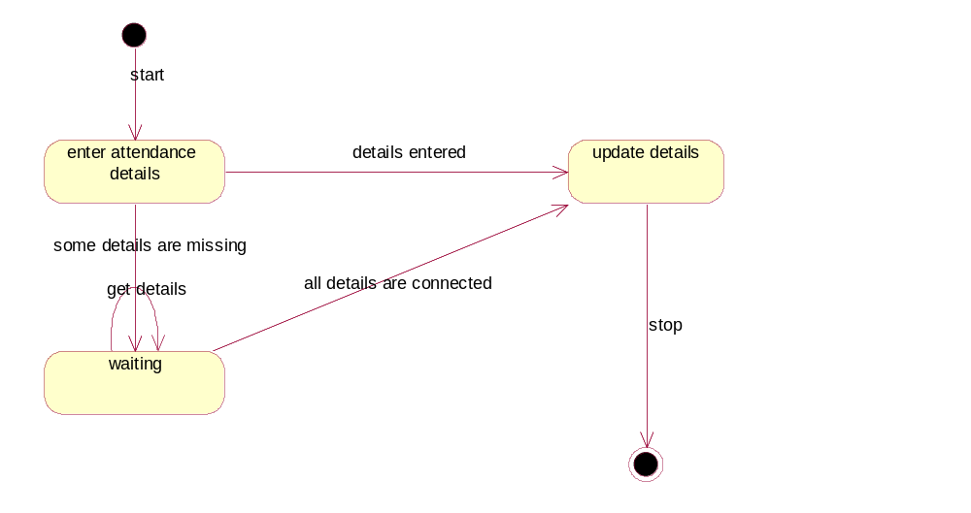
3,Room details:
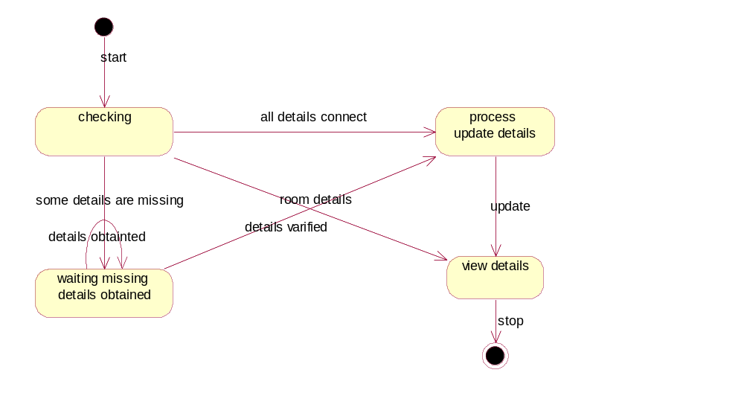

4.Mess details:
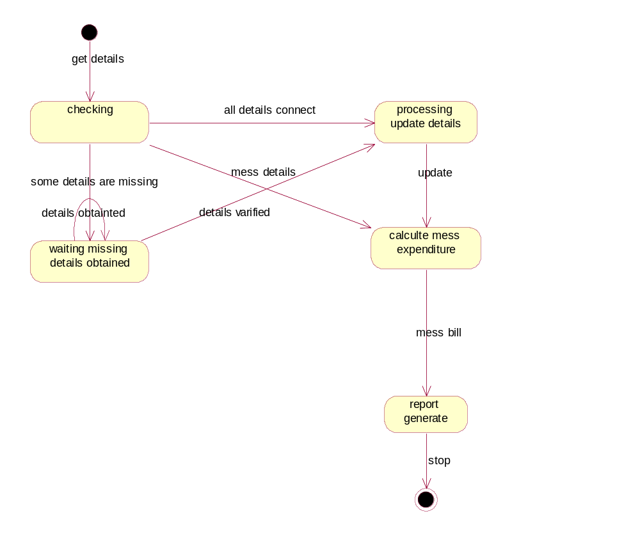

Component Diagram:

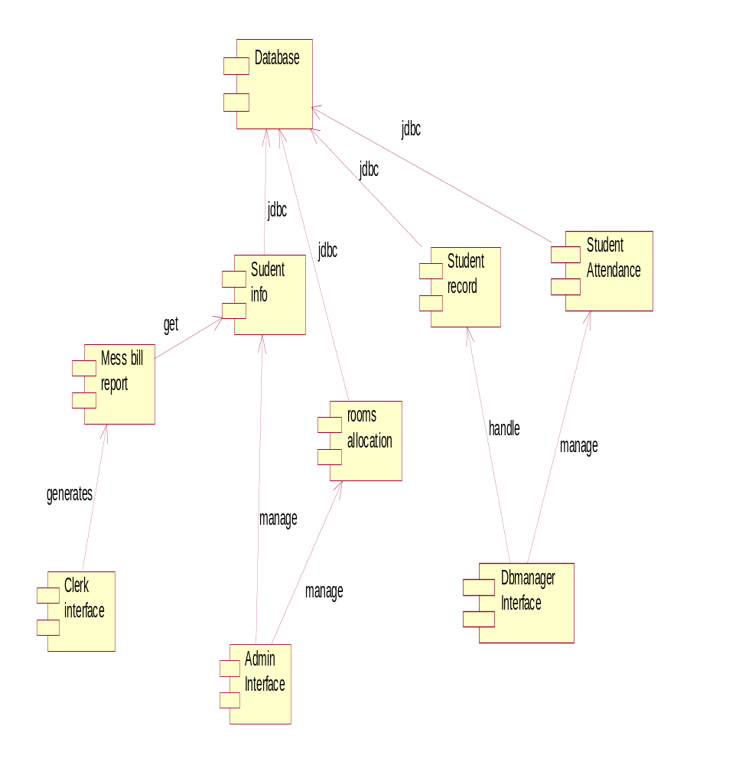

Deployment Diagram:

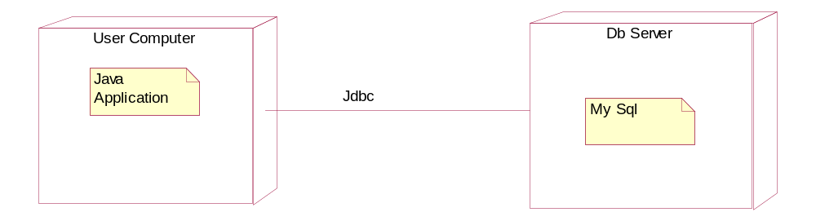

Thanks

