Report: Optimising NYC Taxi Operations
This report presents an Exploratory Data Analysis of 2023 New York City Yellow Taxi trip records. The goal of the exercise is to use the 2023 taxi trip data to uncover insights that can inform strategic decisions to improve service efficiency, maximise revenue, and enhance passenger experiences, that could help optimize taxi operations by analyzing patterns in the data.

Data Preparation

Loading the dataset
    - Sample the data and combine the files
The dataset consists of data collected and provided to the NYC Taxi and Limousine Commission (TLC) by technology providers like vendors and taxi hailing apps (https://www.nyc.gov/site/tlc/about/tlc-trip-record-data.page). The dataset used for the analysis consists of 12 files in parquet format, each for one month of data from the year 2023. Each file contains approximately 3 million records.
Combining the data for all twelve months would result in a dataframe of over 36 million records. Using this large dataframe for the analysis is not computationally feasible. One way to overcome this problem, is to take a small percentage of entries for pickup in every hour of a date. Using the column `tpep_pickup_datetime` for this, date and hour from the datetime values are separated, and then for each date, and each hour of each date, 5% of the records are sampled at random.
This sampled data will contain 5% values selected at random from each hour of each date. The sampled data from each file is concatenated into a single dataframe and stored separately onto a new parquet file. Reading this new parquet file into a new dataframe shows that it contains 1896420 records, which is approximately 5% of the total number of records. This ensures the dataset remains computationally manageable.
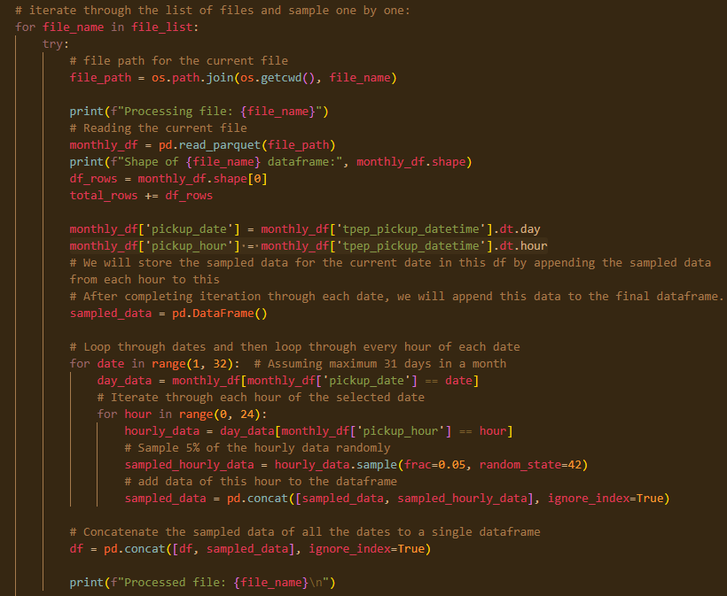

Data Cleaning

Fixing Columns
    - Fix the index
The sampling process randomly picks out records from the source, which includes the index, which results in the dataset not having an ordered index. Resetting the index re-orders the records with a new index, starting from 0.

    - Combine the two airport_fee columns
There are two airport fee columns. This is possibly an error in naming columns. These can be combined into a single column, and the extra column can be dropped from the dataframe.

Handling Missing Values
    - Find the proportion of missing values in each column
Missing data may be present in the dataset due to data entry errors, mismatched data-types, etc. Analysis shows that a few columns are missing 3.42% of the values.
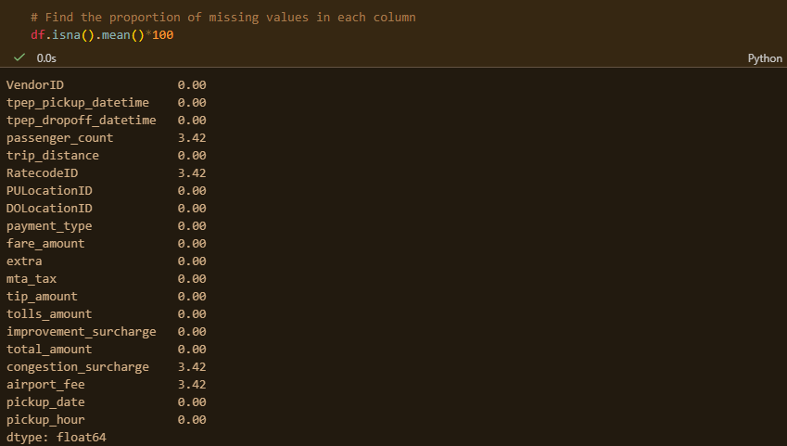
    - Handling missing values in passenger_count
`passenger_count` column shows 3.42% missing data from the previous analysis. These missing values can be imputed using the most occurring value in the column, or by assuming that the driver may have forgotten to enter the value as it was just one passenger.
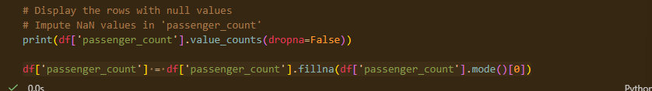
    - Handle missing values in RatecodeID
Missing values in the `RatecodeID` column can be imputed using the most occurring value in the column, which would be the Standard Rate.
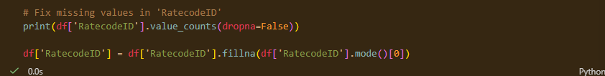
    - Impute NaN in congestion_surcharge
Missing values in `congestion_surcharge` column can be assumed to be $0.0, assuming there is no charge applied.
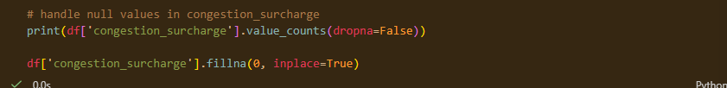

Handling Outliers and Standardising Values
    - Check outliers in payment type, trip distance and tip amount columns
Performing an outlier analysis by describing the dataframe shows if there are any potential outliers present. In a general sense, there are potential outliers in columns where the mean and median are further apart.
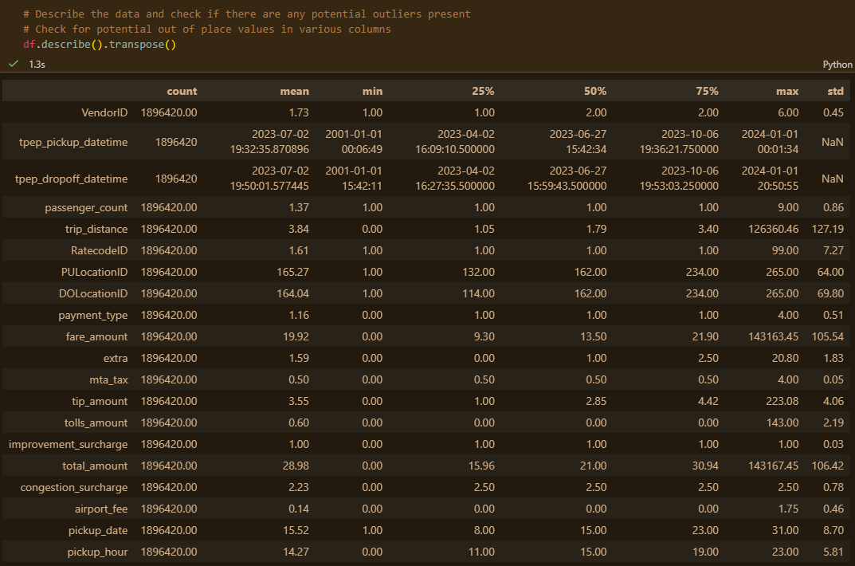
Based on the above analysis, it seems that some of the outliers are present due to errors in registering the trips.
- Entries with `passenger_count` more than 6.
- Entries where `trip_distance` is nearly 0 and `fare_amount` is more than 300
- Entries where `trip_distance` and `fare_amount` are 0 but the pickup and dropoff zones are different (both distance and fare should not be zero for different zones)
- Entries where `trip_distance` is more than 250 miles.
- Entries where `payment_type` is 0 (there is no `payment_type` 0 defined in the data dictionary).
- Entries where `RatecodeID` is 99 (there is no RatecodeID 99 defined in the data dictionary).
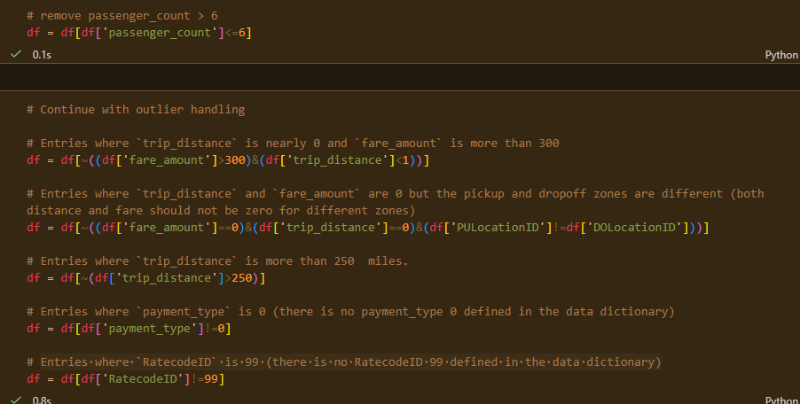

Exploratory Data Analysis

General EDA: Finding Patterns and Trends
    - Classify variables into categorical and numerical
Categorical Columns – 'VendorID', 'tpep_pickup_datetime', 'tpep_dropoff_datetime', 'passenger_count', 'trip_distance', 'RatecodeID', 'PULocationID', 'DOLocationID', 'payment_type'
Numerical Columns – 'fare_amount', 'extra', 'mta_tax', 'tip_amount', 'tolls_amount', 'improvement_surcharge', 'total_amount', 'congestion_surcharge', 'airport_fee'
    - Analyse the distribution of taxi pickups by hours, days of the week, and months
Hourly Trends: The demand curve shows a peak starting during morning commute (8:00 AM) and peaking during the evening rush (18:00 – 19:00). The lowest activity is consistently observed between 3:00 AM and 5:00 AM.
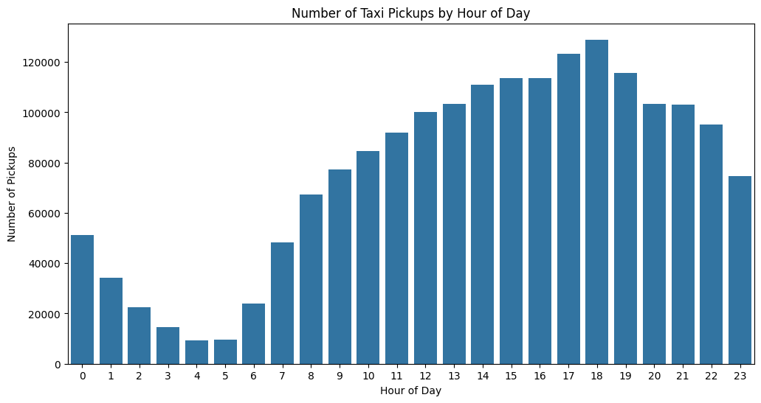
Weekly Trends: Wednesdays and Thursdays are the busiest days, and Sundays show the lowest trip volume.
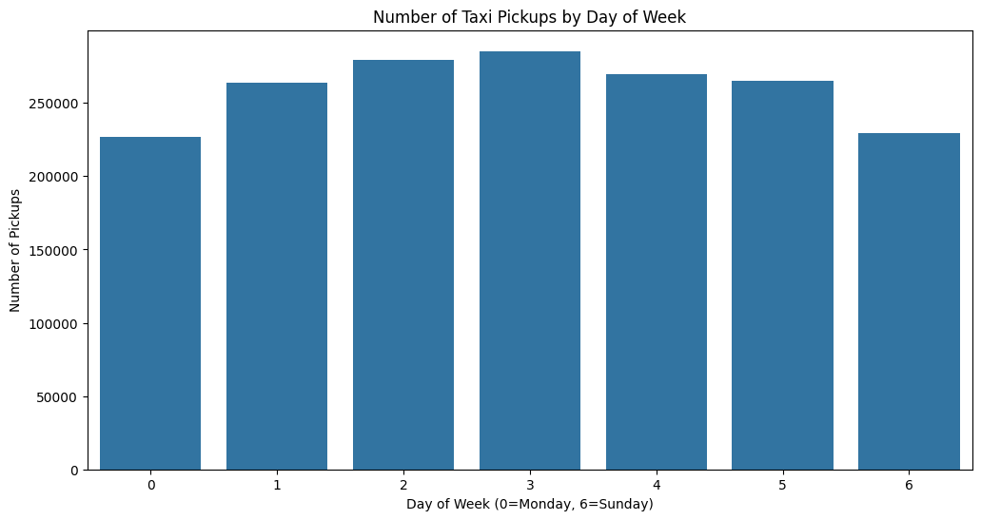
Monthly Trends: Activity dips slightly during January and February before rising again, and falls again in the months of July, August and September and rises in the fourth quarter.
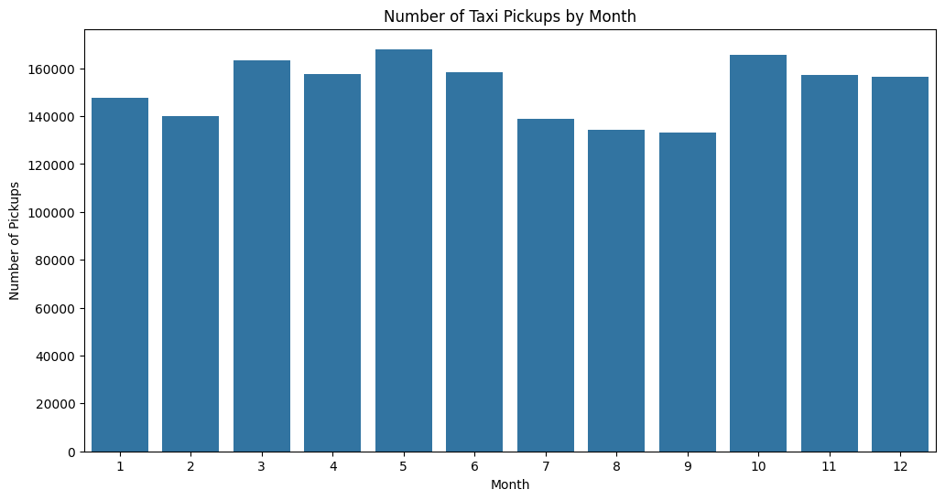
    - Filter out the zero/negative values in fares, distance and tips
Viewing the distribution of records of columns - `fare_amount`, `tip_amount`, `total_amount`, and `trip_distance` shows a large concentration of records with 0 values.
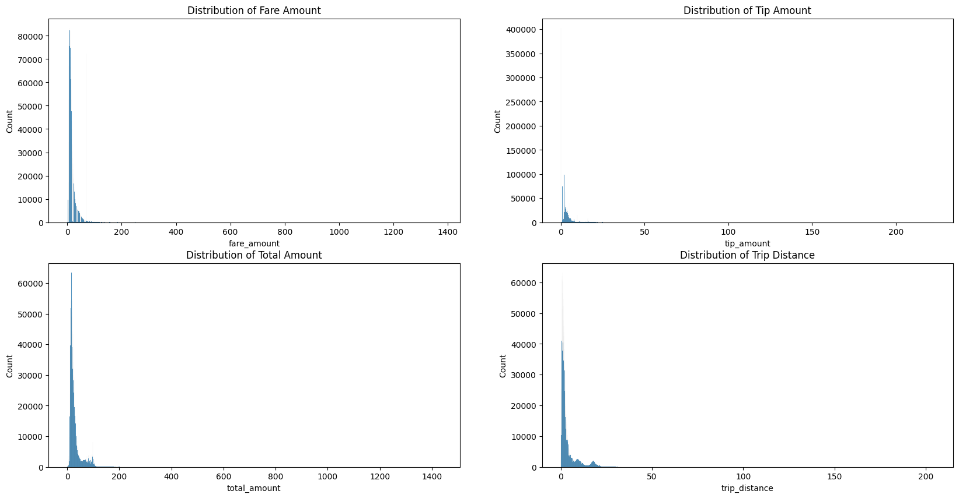
A new dataframe is created, excluding the zero values from the above columns to draw more accurate analyses from the data.

    - Analyse the monthly revenue trends
Upon plotting the total month-wise revenue, it is observed that there is a high revenue in the months of May and October. The revenue appears to drop in the 3rd Quarter.
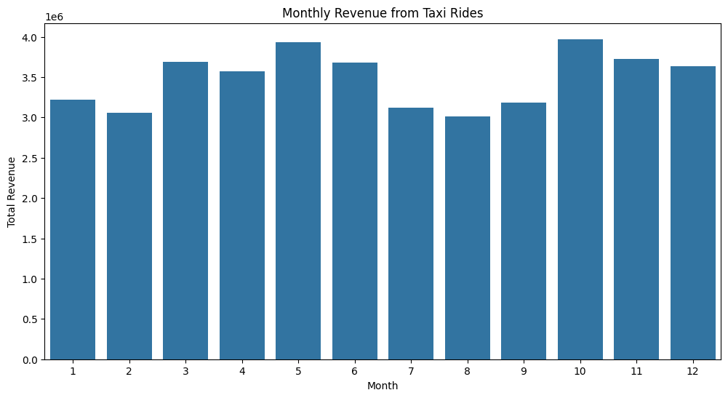
    - Find the proportion of each quarter’s revenue in the yearly revenue
The second and fourth quarters show periods of high revenue. A lower revenue is observed in the third quarter.
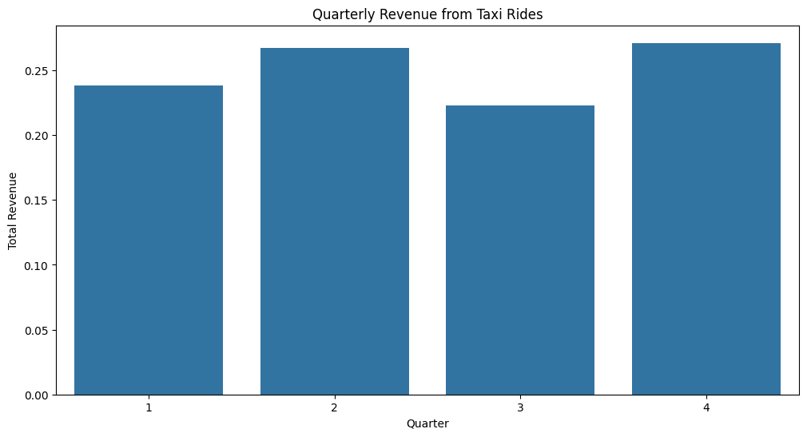

    - Analyse and visualise the relationship between distance and fare amount
A strong positive correlation is observed between the trip distance and fare amount. Farther the trip distance, the higher the fare amount.
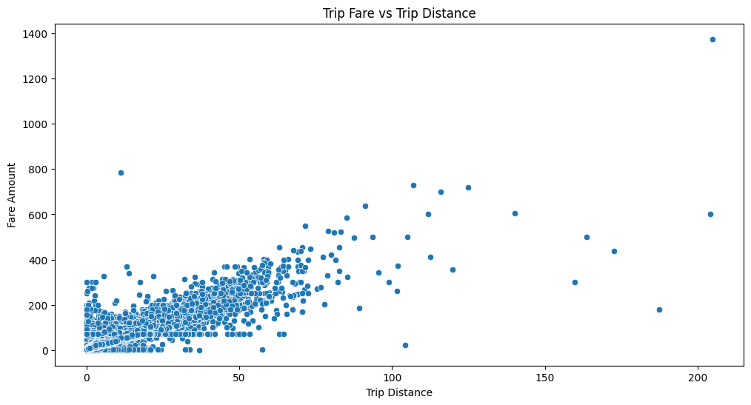
    - Analyse the relationship between fare/tips and trips/passengers
Trip duration has a weaker correlation with fare, indicating that time spent in traffic does not proportionally increase revenue.
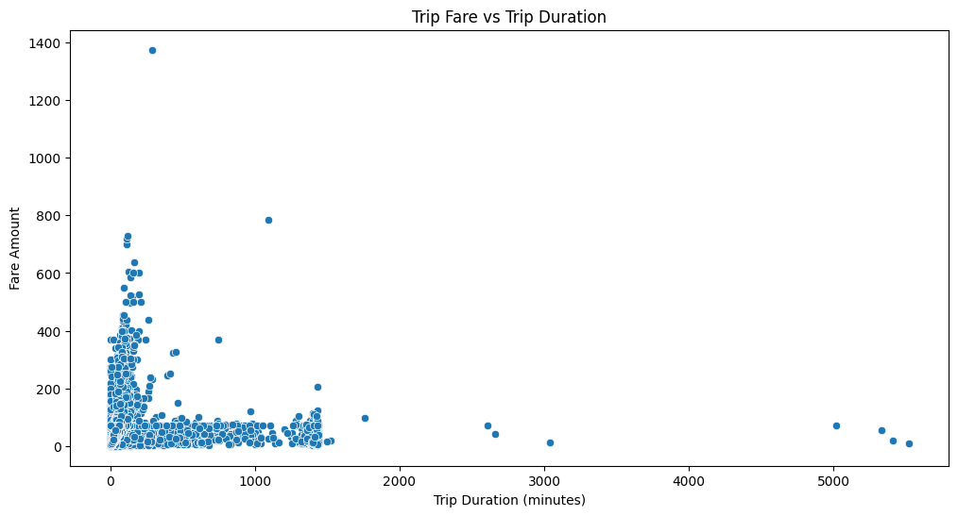

    - Analyse the distribution of different payment types
Credit Cards appear to be the most preferred mode of payment, followed by cash.
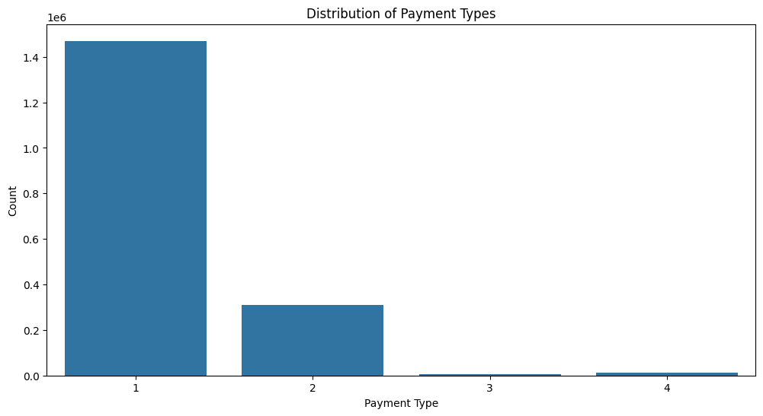
    - Load the taxi zones shapefile and display it
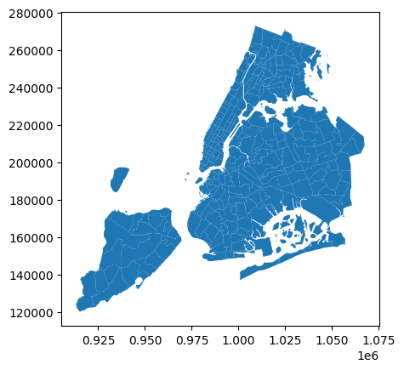
    - Merge the zone data with trips data

    - Find the number of trips for each zone/location ID
JFK Airport, followed by Upper East Side South and Midtown Center appear to have the highest frequency of trips.
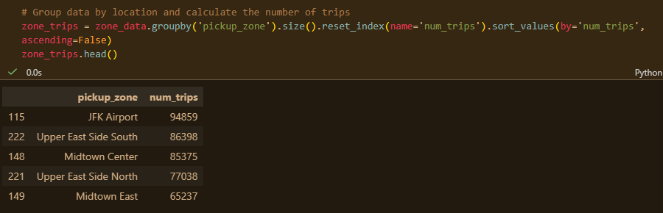
    - Add the number of trips for each zone to the zones dataframe
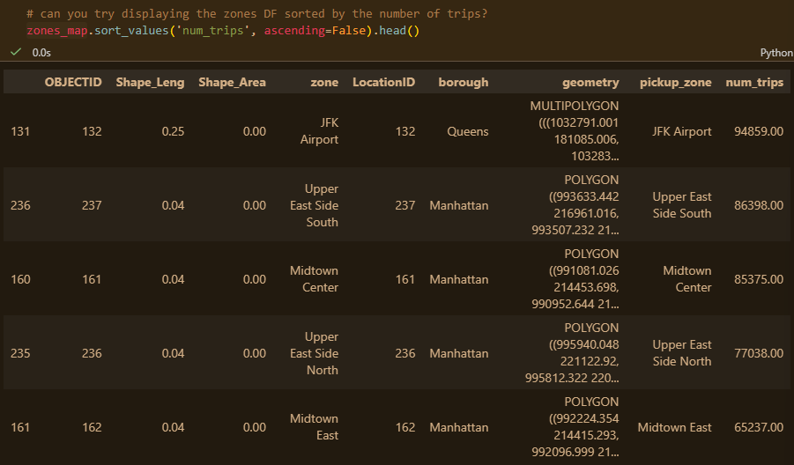

    - Plot a map of the zones showing number of trips
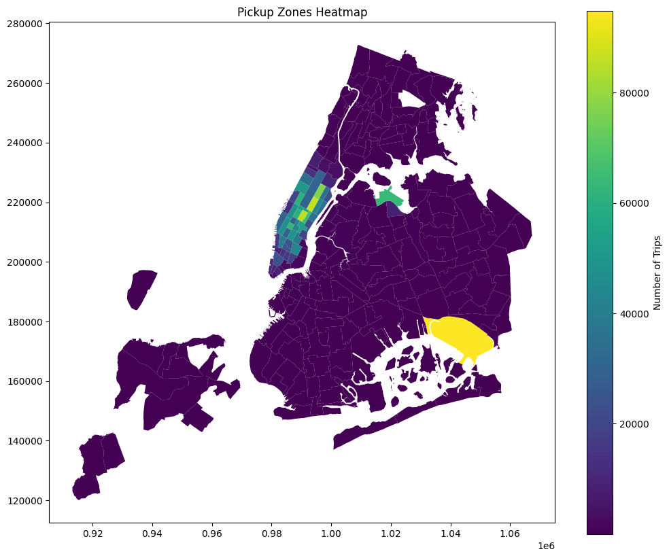
    - Conclude with results
Busiest hours, days and months –
The demand curve shows a minor peak during morning commute (8:00 AM) and a major peak during the evening rush (18:00 – 19:00). The lowest activity is consistently observed between 3:00 AM and 5:00 AM.
Wednesdays and Thursdays are the busiest days, while Sundays show the lowest trip volume.
Activity dips in January and February and rises to its highest in the fourth quarter.

Trends in revenue collected –
High revenue is observed in the months of May and October. The revenue appears to drop in the third quarter, before rising to the highest in the months of October and November.

Trends in quarterly revenue –
The second and fourth quarters show periods of high revenue. A lower revenue is observed in the third quarter
How fare depends on trip distance, trip duration and passenger counts –
There is a strong positive correlation between trip_distance and fare_amount. However, trip_duration has a weaker correlation with fare, indicating that time spent in traffic does not proportionally increase revenue as effectively as covering distance does.

Busiest zones –
JFK Airport, followed by Upper East Side South and Midtown Center appear to have the highest frequency of trips.

Detailed EDA: Insights and Strategies
    - Identify slow routes by comparing average speeds on different routes
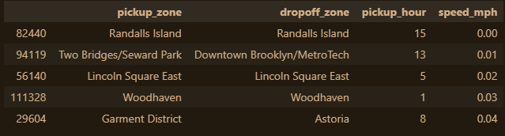
    - Calculate the hourly number of trips and identify the busy hours
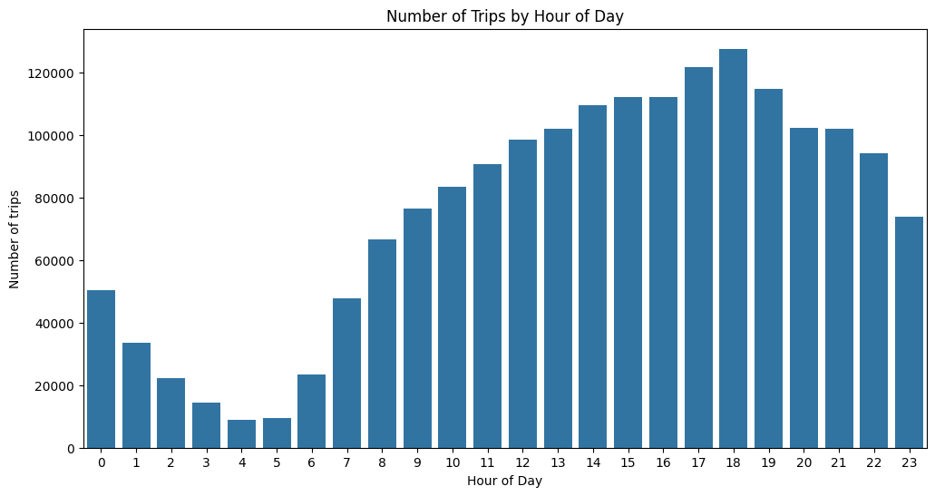
    - Scale up the number of trips from above to find the actual number of trips
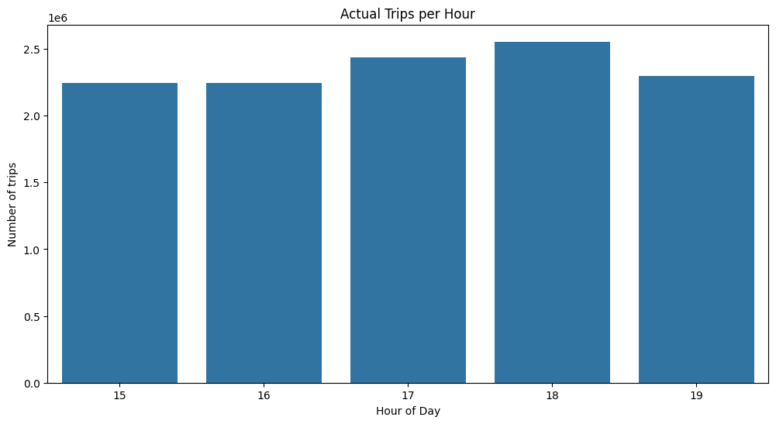

    - Compare hourly traffic on weekdays and weekends
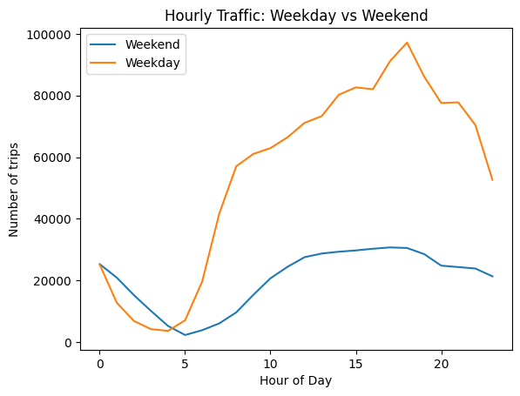
    - Identify the top 10 zones with high hourly pickups and drops
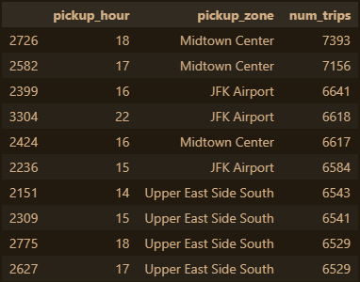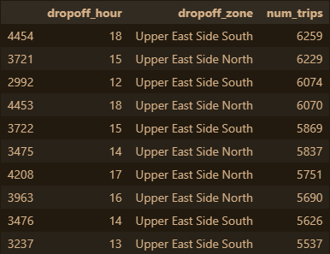

    - Find the ratio of pickups and dropoffs in each zone
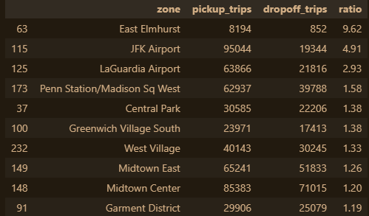
    - Identify the top zones with high traffic during night hours
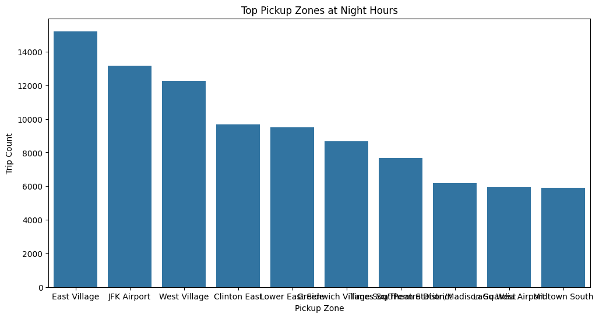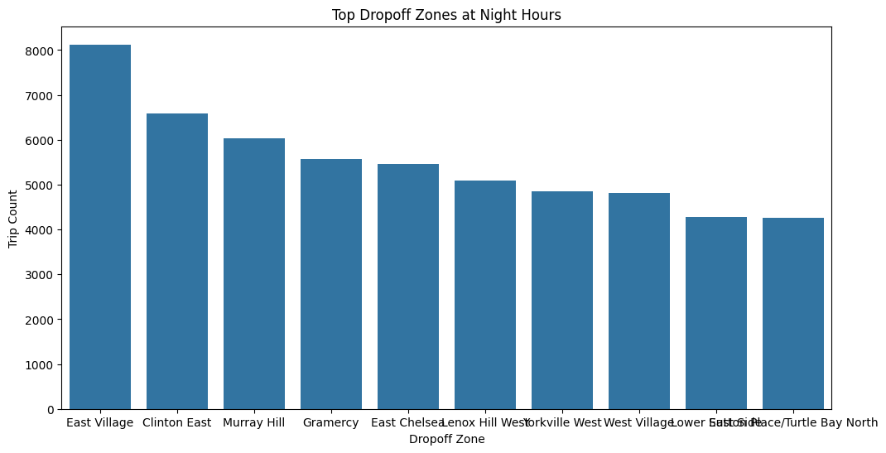
    - Find the revenue share for nighttime and daytime hours
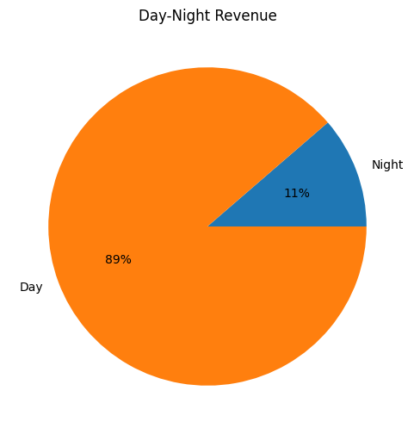
    - For the different passenger counts, find the average fare per mile per passenger
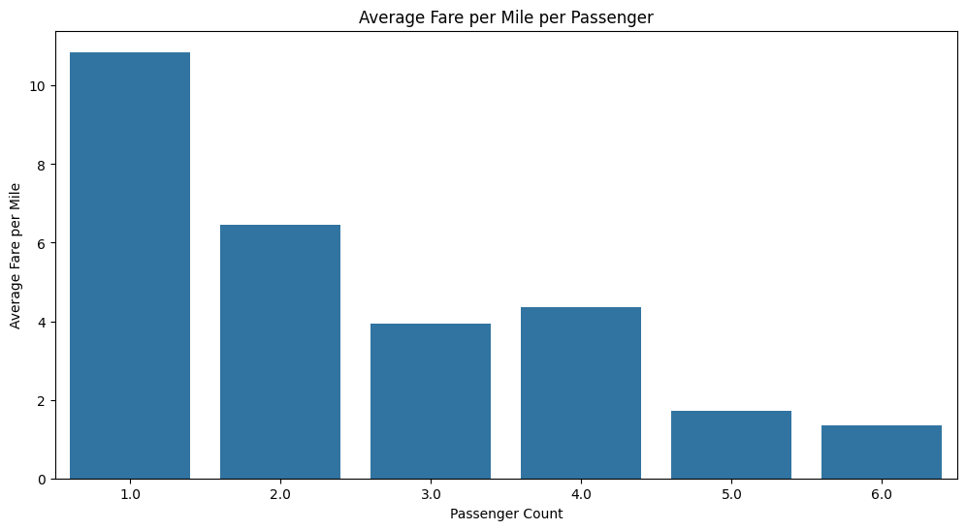
    - Find the average fare per mile by hours of the day and by days of the week
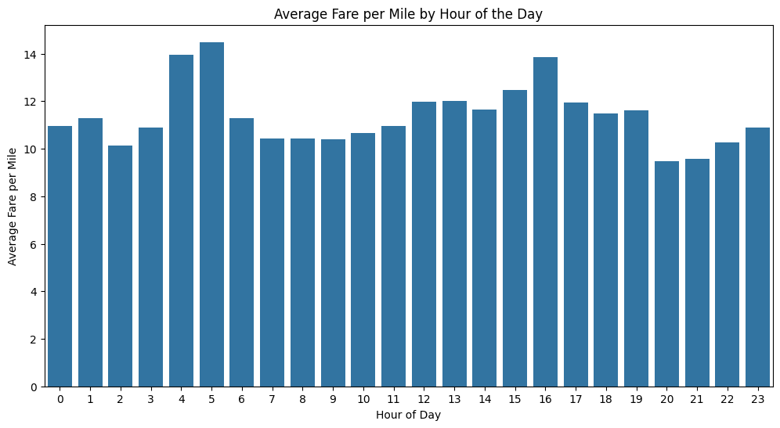
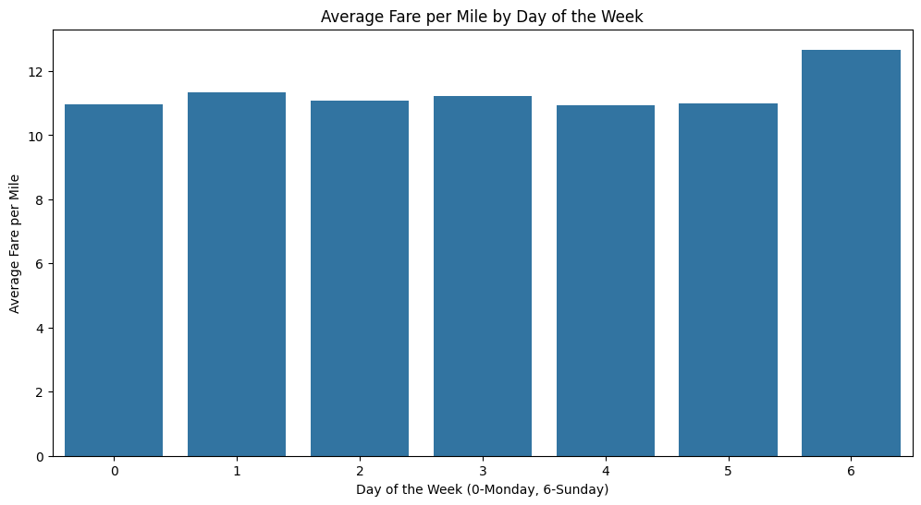

    - Analyse the average fare per mile for the different vendors
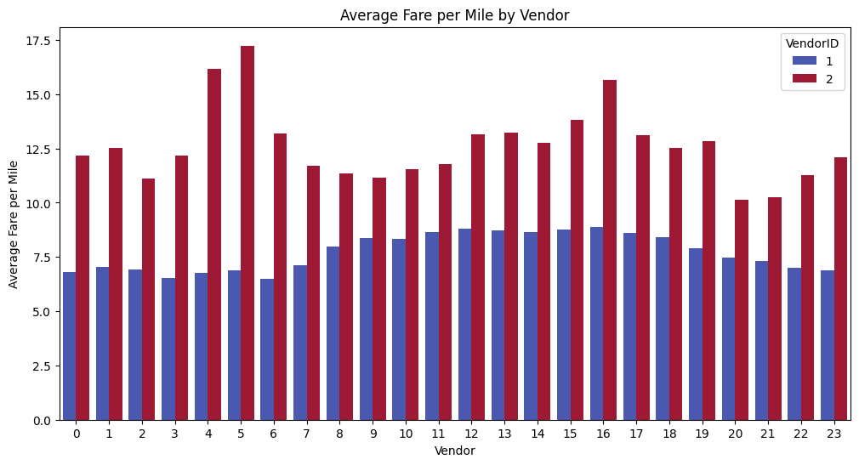
    - Compare the fare rates of different vendors in a distance-tiered fashion
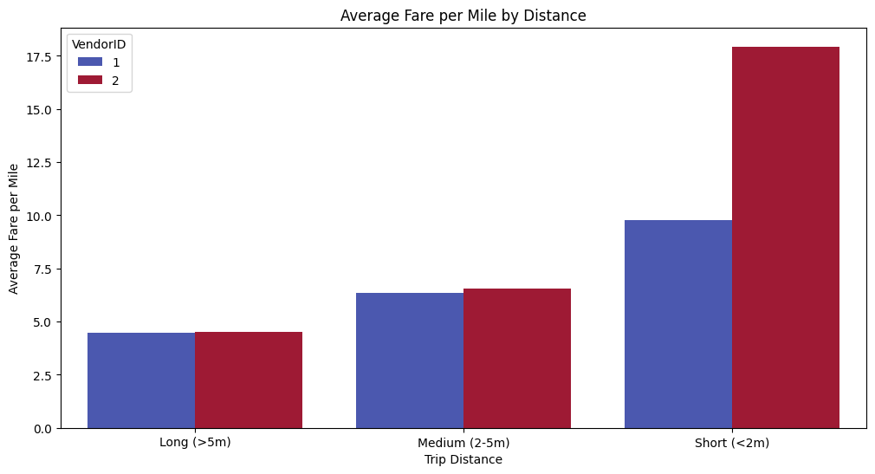

    - Analyse the tip percentages
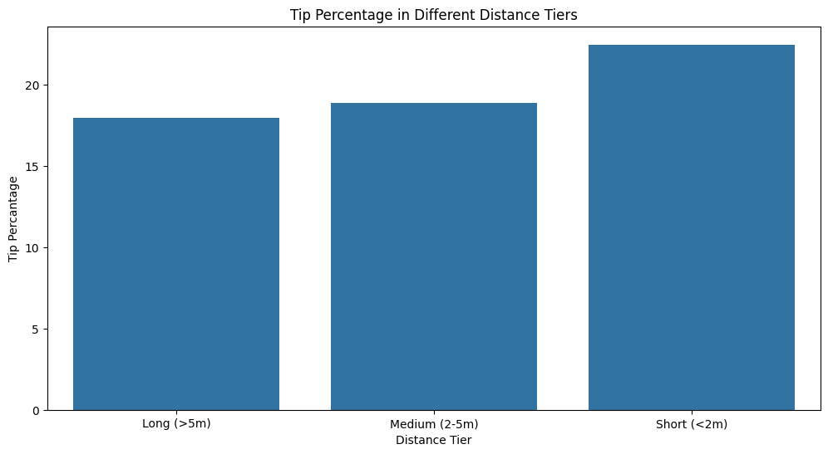
    - Analyse the trends in passenger count
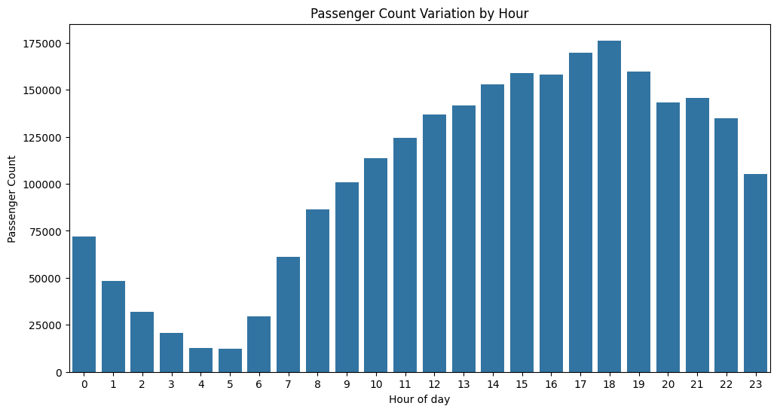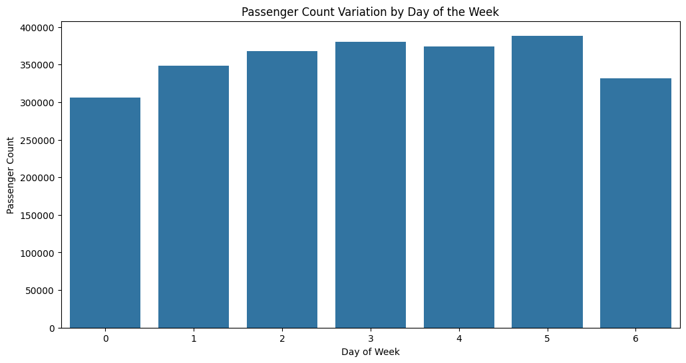
    - Analyse the variation of passenger counts across zones
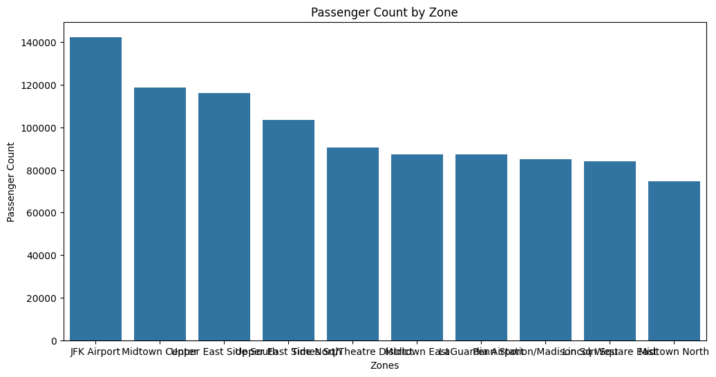
    - Analyse the pickup/dropoff zones or times when extra charges are applied more frequently.
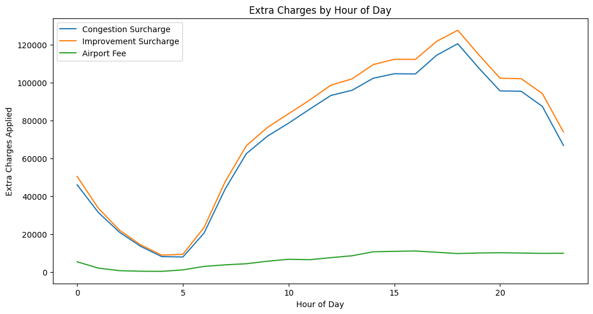

Conclusions

Final Insights and Recommendations
    - Recommendations to optimize routing and dispatching based on demand patterns and operational inefficiencies.
Analysis shows that the hours between 3pm and 7pm, with the number of trips peaking at 6pm. We see high number of pickups from Midtown Center and JFK Airport in the same time frame.
Deploying a higher number of taxis in these areas 30 minutes prior to the evening rush could meet the demand surge. Also, suggesting alternative routes could help mitigate traffic congestions during this period.
    - Suggestions on strategically positioning cabs across different zones to make best use of insights uncovered by analysing trip trends across time, days and months.
JFK Airport and Midtown Center are high-revenue zones and likely have a high wait-time. Maintaining a dedicated fleet at airports on during Thursday evenings and Sunday evenings could mitigate this.
During off-peak weekday mornings, drivers/taxi fleets could be deployed in residential zones, instead of airport queues.
Pickup hotspots shift to late-night on weekends. Fleet concentration can be shifted to entertainment districts like East Village and Clinton East starting 9 PM on Fridays and Saturdays to capture the "night out" crowd.
    - Propose data-driven adjustments to the pricing strategy to maximize revenue while maintaining competitive rates with other vendors.
Short trips can be prioritized over long distance during low-demand hours (11 AM to 3PM) as short trips often have higher fare-per-mile yields. Deploying fleets in high-density residential areas like Upper East Side to perform volume-based short trips, accumulate revenue faster than a single long trip.
Cabs can be equipped with a system that suggests default tips when passengers pay with credit cards.

