Docker Sandboxes and OpenShell: architecture deep dive
Oct 22, 2026 · @Rohith S

Summary
Docker Sandboxes and OpenShell can be combined, and the combination is better than either alone: Docker supplies a hypervisor boundary, an inner Docker Engine and an OCI packaging format headed to the CNCF; OpenShell supplies per-binary network policy, credential brokering and a fleet control plane that NVIDIA's reference architecture puts on every Vera CPU. The one architectural difference that drives everything else is where each draws its line. Docker draws it at the hypervisor and leaves the agent unconstrained inside; OpenShell draws it around the process and takes sockets, files and keys away from the agent one by one. Almost every layer is complementary. Two are not: both terminate TLS, and both inject credentials, which is the most plausible mechanism behind the interference an OpenShell engineer reported internally on 12 Oct.
Of the two couplings Michael asked about, the loose one (OpenShell's supervisor outside the VM, the Docker microVM as a compute target reached over vsock or mutual TLS) keeps one policy owner and fits the contract OpenShell adopted in September; it needs a new extension driver from NVIDIA and a guest kernel, a launcher hook, a channel and a local API from Docker. The native one (OpenShell's stock Docker driver running inside the VM on the inner daemon) needs no new NVIDIA code for a spike and is the right two-week experiment, but it runs two proxies in series, and today Docker's forward proxy refuses credentials it did not issue on requests to managed provider hosts, so OpenShell-injected keys survive only on Docker's transparent path. A Kit that carries OpenShell policy helps both, and a Docker Sandboxes fleet on Vera with OpenShell as the governance plane is the story worth building toward. Technical odds are high; organisational odds are fair, because Docker's upstream presence is one engineer, Docker is absent from NVIDIA's partner lists, and both companies sell the policy layer.
What this study changes relative to the two-slide brief:
- The reference architecture was announced on 21 Oct at GTC Berlin. GTC Washington, D.C. is 30 Nov to 3 Dec with the keynote on 1 Dec.
- Eric Curtin's two architectural PRs (the OCI compute driver and the containerd shim) were closed unmerged in July; maintainers asked for an out-of-process driver instead. No Docker agent provider for Docker Hub or Model Runner could be found in OpenShell or NemoClaw; treat that claim as unconfirmed.
- Enhanced Container Isolation is not a Docker Sandboxes issue. It blocks OpenShell's own Docker driver on Docker Desktop, where the seccomp probe still fails under ECI.
- The numbers have owners: Modal's "up to 2x" is Modal's test against an Intel Granite Rapids box; the 3x startup and 11,000 environments per 128-CPU rack are CoreWeave's; 22,500 is NVIDIA's 256-CPU rack figure with no footnote, about one environment per core. NVIDIA names CoreWeave and not Docker, Modal, E2B or Daytona.
- Daytona's proposal to run OpenShell natively has no public source; it stays internal.
- Docker Sandboxes already run on arm64 Linux with KVM, and Cloud Sandboxes offer linux/arm64; Arm is not the obstacle.
For tomorrow: hear Docker's roadmap, propose the split (Docker owns the boundary, packaging and the laptop; OpenShell owns runtime policy, credentials and the fleet), offer the native spike as the first joint experiment, and ask the kernel, channel and API questions listed at the end. The GTC DC mention stays an opportunity, not a promise.

How a Docker Sandbox runs
Docker Sandboxes is a virtual machine product. Each agent session gets one microVM with its own Linux kernel and its own private Docker Engine, and every control (network policy, credentials, MCP access) is enforced on the host side of the hypervisor, where the agent cannot reach it. The CLI is the standalone sbx binary; the Docker Desktop plugin era ended on 29 Jun 2026 when 4.80.0 removed it (architecture, isolation layers).
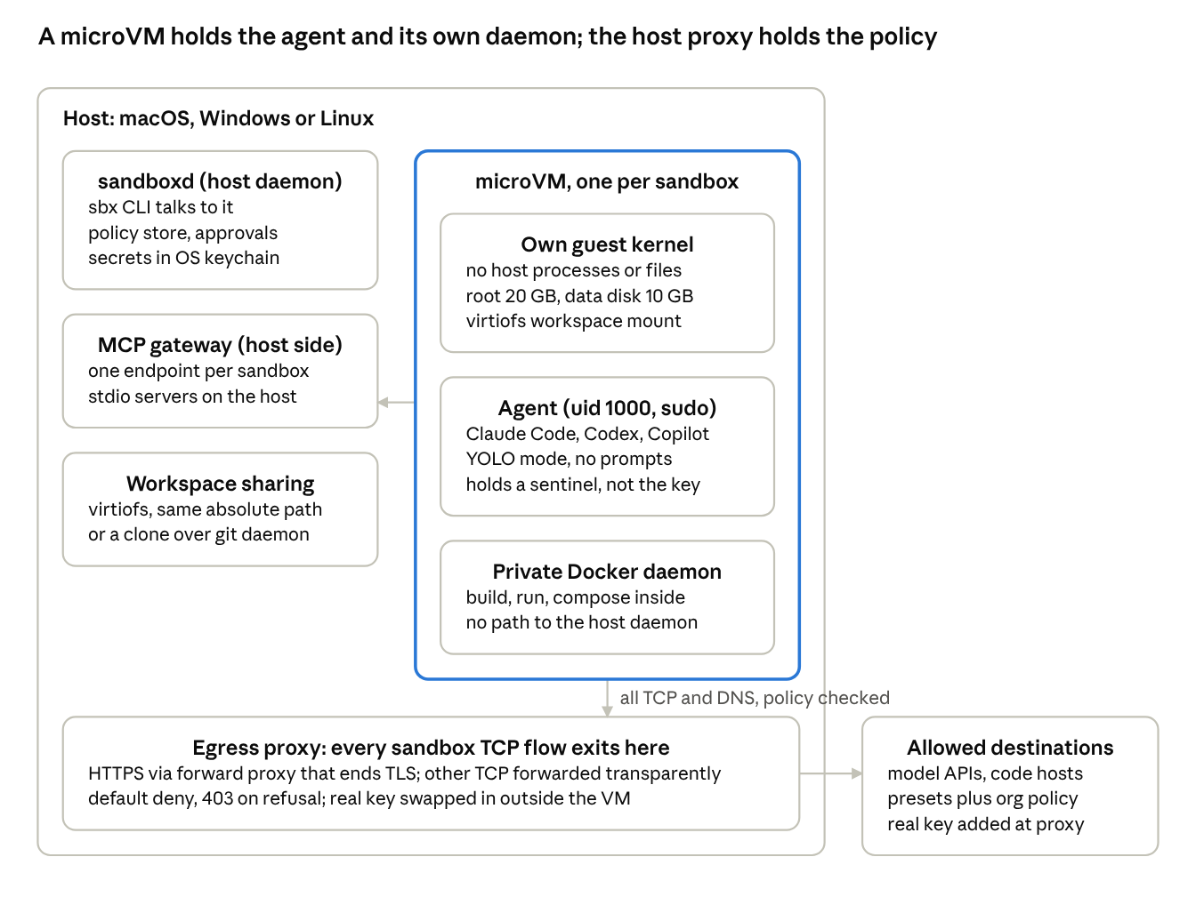
Docker Sandboxes (sbx) runtime: host services, microVM, egress proxy
The hypervisor is the control. Inside the VM the agent is deliberately unconstrained (non-root with sudo, no permission prompts), because Docker treats in-VM privilege separation as irrelevant to the boundary.
Runtime. Docker says it wrote its own VMM rather than adopt Firecracker, calling Apple Hypervisor.framework on macOS, Windows Hypervisor Platform on Windows and KVM on Linux from one codebase (Why microVMs). Docker never names the VMM, but the evidence points at containerd with the Apache-2.0 nerdbox shim and libkrun: the GPU bundle is literally nerdbox-nvidia-bundle.erofs, the daemon reports containerd schema versions and erofs page sizes, and nerdbox credits Docker as its original developer (GPU passthrough, containerd/nerdbox). Treat that as inference, but note it: OpenShell's own microVM driver is built on libkrun too. Inside the VM: a Docker-built guest kernel, the agent as agent (uid 1000) in /home/agent/workspace, a private dockerd with a 10 GB data disk, a 20 GB root. CPUs default to all host cores (capped at 16 on Linux arm64), memory to half the host clamped between 512 MiB and 32 GiB. Docker publishes no boot time or overhead figures.
Filesystem. Three workspace modes: a direct mount, which is a virtiofs passthrough at the same absolute path, read-write, with host-side caching on by default; clone mode, where the repo is read-only at /run/sandbox/source and the agent works on a private clone published back over a localhost git daemon as a sandbox-<name> remote; and mountless. Everything else in the VM persists until sbx rm. Host ~/.claude is deliberately not imported; a shared skills store mounts read-only. Secrets live in the OS keychain and are never written into the VM. Docker documents its own holes: hard links, hooks and scripts the host will later execute, and .env files readable in clone mode.
Network and credentials. All TCP leaves through a host proxy with a deny-by-default policy. HTTPS goes through a forward proxy that terminates TLS with a per-install CA (exposed inside as PROXY_CA_CERT_B64), which is what allows per-request method and path rules and header rewriting; other TCP is forwarded transparently with connection-level decisions, and an L7 rule on an uninspectable connection fails closed. DNS is answered by an in-sandbox resolver that enforces policy; UDP is experimental; ICMP is always blocked. Presets are Open, Balanced and Locked Down, with an approval flow and organisation governance that overrides local allows (governance, credentials). The agent holds a sentinel such as proxy-managed; the proxy replaces it with the real key after the request has left the VM, and OAuth token endpoints are intercepted so even session tokens stay on the host. MCP servers are brokered by a host-side gateway with its own policy; stdio MCP servers run on the host, outside isolation.
Kits. A v3 Kit is an ordinary OCI image whose manifest annotation vnd.docker.sandbox.kit.descriptor carries its declarations: kinds workload, mixin and set, built with a BuildKit frontend (# syntax=docker/sandbox-kit:3), with about 22 typed capabilities such as network-policy@2, credential@1, volume@1 and resources@1. Any widening of the permission surface must stop for approval, and a kit-tck conformance suite tests both Kit artifacts and runtimes (13 adapter verbs). The spec is Apache 2.0, labelled experimental with a final version targeted for Q4 2026, and Docker says it is bringing it to the CNCF; no formal submission status is published (spec repo, CNCF post).
Cloud Sandboxes. Announced 24 Sep 2026 and still labelled experimental: the same microVM on Docker-managed compute, sbx move between local and cloud, sizes from 1 vCPU/2 GiB at $0.07/h to 16 vCPU/32 GiB at $1.12/h, --platform linux/amd64 or linux/arm64, one-hour default TTL up to 24 h, a 58-operation HTTP API. Cloud policy is network-only; L7 method and path rules are not supported there yet, and central governance is "coming soon" (Cloud Sandboxes, local vs cloud).
Date | Milestone
21 Oct 2026 | sbx v0.49.2
13 Oct 2026 | 0.48.0 CLI refactor, --format json
28 Sep 2026 | v0.46.0, Linux arm64 CPU cap of 16 per sandbox
24 Sep 2026 | Cloud Sandboxes and Kit spec v3 announced, CNCF intent
21 Sep 2026 | v0.45.0: Kits v3, sbx --cloud, DNS fail-closed
29 Jun 2026 | Docker Desktop 4.80.0 removes the docker sandbox plugin
31 Mar 2026 | standalone sbx with Linux packaging (v0.21.0)
26 Jan 2026 | microVM sandboxes ship in Docker Desktop 4.58.0
Dec 2025 | experimental container-based docker sandbox plugin
What is open and what is not. The Kit spec, conformance suite and BuildKit frontend are Apache 2.0; the sbx distribution is proprietary (binaries only in docker/sbx-releases); nerdbox and libkrun are open but Docker has not said it ships them. Local sandboxes are free for commercial use; organisation governance and cloud compute are paid.
Enhanced Container Isolation. No Docker source links Sandboxes to ECI. ECI hardens containers inside the shared Docker Desktop VM with Sysbox; sbx runs its own per-agent VMs with no Docker Desktop requirement, and sandboxes never use host networking. The two are orthogonal. ECI does bite OpenShell's own Docker driver on Docker Desktop: the driver's seccomp notification probe still fails under the ECI runtime even after bridge-mode support landed (PR #4016, 16 Oct 2026). That is the friction the earlier brief had in mind, and it does not touch sbx.

How OpenShell runs
OpenShell is a policy runtime, not a virtual machine. Its unit of isolation is a pair: a trusted supervisor placed outside the agent, and a capability-free launcher placed beside it. The agent gets no network path, no real credential and no vote on policy; everything it wants to reach is requested through the supervisor.
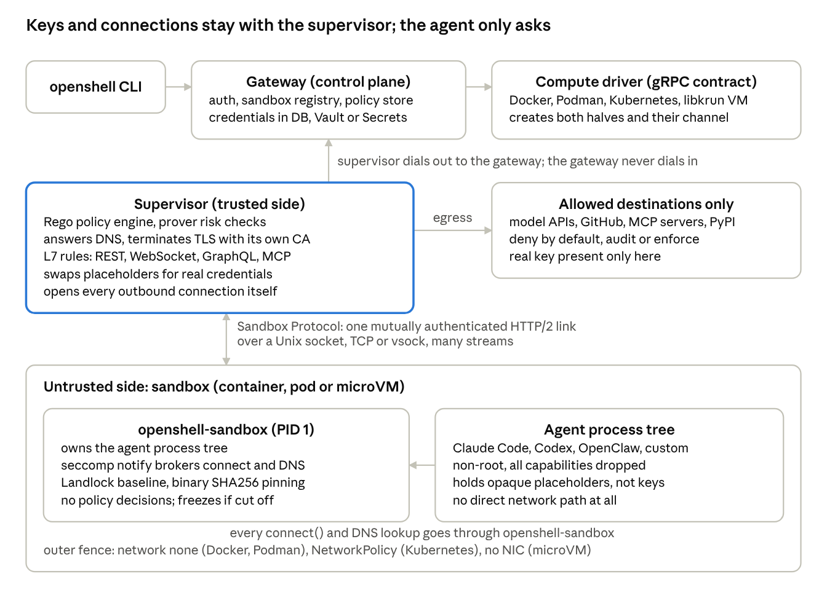
OpenShell 0.1.x runtime: gateway, supervisor, sandbox
The compute driver builds both halves and the channel between them. The gateway never dials the supervisor; the supervisor connects outbound to the gateway for policy and credentials. If the supervisor's link to the sandbox drops, the sandbox freezes the agent, and only the same supervisor process can resume it.
Control plane. A long-running gateway (openshell-gateway) is the auth boundary and system of record: it stores sandboxes, policies and provider credentials, in SQLite on a workstation or Postgres active-active on Kubernetes. The CLI and SDKs speak gRPC to it. Compute drivers implement one gRPC contract: Docker, Podman and Kubernetes are linked into the gateway (Kubernetes through the agents.x-k8s.io Agent Sandbox controller), the libkrun microVM driver and any extension driver run as separate processes over a Unix socket, and a Windows MXC driver is marked coming soon (architecture, drivers).
Admission. The driver provisions the workload and a separate supervisor, builds the channel and the outer fence. The supervisor confirms the boundary before any agent code runs: attach, Bound, confirm, Ready, start_agent, Running. A restart issues fresh tokens and certificates, and only the same supervisor process can resume a frozen sandbox (RFC 0012).
What enforces inside the sandbox.
- Landlock ABI 3 or newer (Linux 6.2+) for filesystem rules, with a mandatory baseline that hides the private /.openshell directory. Startup fails closed without it.
- seccomp user notification intercepts connect() and DNS. The sandbox runtime brokers the notification and installs a loopback relay socket with SECCOMP_IOCTL_NOTIF_ADDFD, while the supervisor opens the upstream connection and relays, so the workload never holds a socket to the destination.
- One non-root UID, every capability dropped, no-new-privileges, loopback-only socket binding through SO_BINDTODEVICE, and a fixed syscall denylist (mount, ptrace, bpf, io_uring, user namespaces and more).
- Binary identity: each binary allowed on the network is pinned to its first-seen SHA256. A changed digest is denied.
- These kernel features are required even inside containers or microVMs, which is the first thing to check on any host that is not a stock Linux kernel (support matrix, security best practices).
What the supervisor does. It evaluates every TCP open and DNS query against policy (Rego through regorus), answers DNS with placeholder addresses, and terminates TLS with a per-sandbox ephemeral CA injected into the sandbox trust stores. On the decrypted stream it applies L7 rules for REST, WebSocket, GraphQL, MCP and JSON-RPC, runs any middleware, swaps credential placeholders for real values only at profile-authorized endpoints, and opens the upstream connection itself. Loopback, link-local and cloud metadata addresses are always blocked.
Policy. One YAML document, version: 1, five sections (schema).
Section | Governs | Enforced by | Changes after start
filesystem_policy | read-only and read-write paths, include_workdir | Landlock in the kernel | locked; recreate the sandbox
landlock | best_effort or hard_requirement | sandbox runtime | locked
process | run_as_user, run_as_group (root rejected) | driver at creation | locked
network_policies | per-binary rules to host, port, path, protocol; audit or enforce; credential binding | supervisor | hot reload; open connections under old rules close
network_middlewares | up to 10 inspection or transform steps on allowed traffic | supervisor | hot reload
Precedence runs: a global gateway policy, then the sandbox's saved policy, then a policy shipped inside the sandbox image, then the restrictive default that allows no network at all. That image-carried slot is the natural hook for a Docker Kit. A prover checks a policy against a boundary with an SMT solver and flags risky proposals; an opt-in advisor lets an agent propose a rule for a person to approve (prover).
Credentials and inference. Providers hold credentials in the gateway's store (encrypted DB by default, Vault, or Kubernetes Secrets). The sandbox sees a placeholder such as NVIDIA_API_KEY; the supervisor rewrites it into the real header, request body or SigV4 signature, only for that profile's endpoints. The managed inference router was removed in 0.1.0 on 25 Sep 2026; workloads now call native endpoints such as integrate.api.nvidia.com, api.anthropic.com, or a local model through host.openshell.internal (inference, 0.1.0 upgrade). Docker Model Runner appears nowhere in the repository or docs.
Where the pieces land per runtime (sandbox runtimes, Docker driver, VM driver).
Runtime | Supervisor runs | Channel | Outer fence | Caveats
Docker (Engine or Desktop 28+) | its own companion container, host network by default | Unix socket on a driver-owned volume | workload network_mode=none | Docker Desktop needs host networking enabled in Settings; bridge mode via host.docker.internal is the fallback; GPU needs CDI before the gateway starts
Podman 5.x | companion container | Unix socket | network=none | rootless, cgroups v2, podman.socket running
Kubernetes 1.29+ | its own pod | mutual TLS over TCP | NetworkPolicy admitting only the supervisor | CNI must enforce NetworkPolicy; Agent Sandbox controller and Helm chart required; Kata via RuntimeClass
MicroVM (libkrun) | a process on the host | authenticated vsock | guest has no network device | experimental; KVM or Hypervisor.framework; first boot 10 to 30 s; 3 virtiofs mounts on x86_64
Windows MXC | CONNECT proxy inside the driver on the host | MXC network.proxy redirect | MXC container | RFC 0013 in review, no OpenShell binary inside the sandbox
Status. Apache-2.0, about 10k GitHub stars, 13 maintainers (10 NVIDIA, 3 Red Hat), weekly Tuesday stable releases with N-1 support. v0.1.5 shipped 20 Oct 2026; 0.1.0 on 25 Sep 2026 was a breaking release that cannot be upgraded in place. The README still calls the project alpha and flags Kubernetes, VM, GPU and Windows as experimental, while NVIDIA's 28 Sep announcement calls it broadly available. Two architecture generations circulate: pre-0.1.0 material (supervisor inside the sandbox, veth and nftables, CONNECT proxy) still appears on parts of the security page; the diagram above is the 0.1.x design.

Side by side
The two systems solve the same problem from opposite ends. Docker buys isolation with a hypervisor and keeps the agent unconstrained inside; OpenShell leaves the kernel shared and takes capabilities, sockets and credentials away from the process one by one. Almost every layer below is complementary rather than duplicated, with two exceptions: both terminate TLS, and both inject credentials.
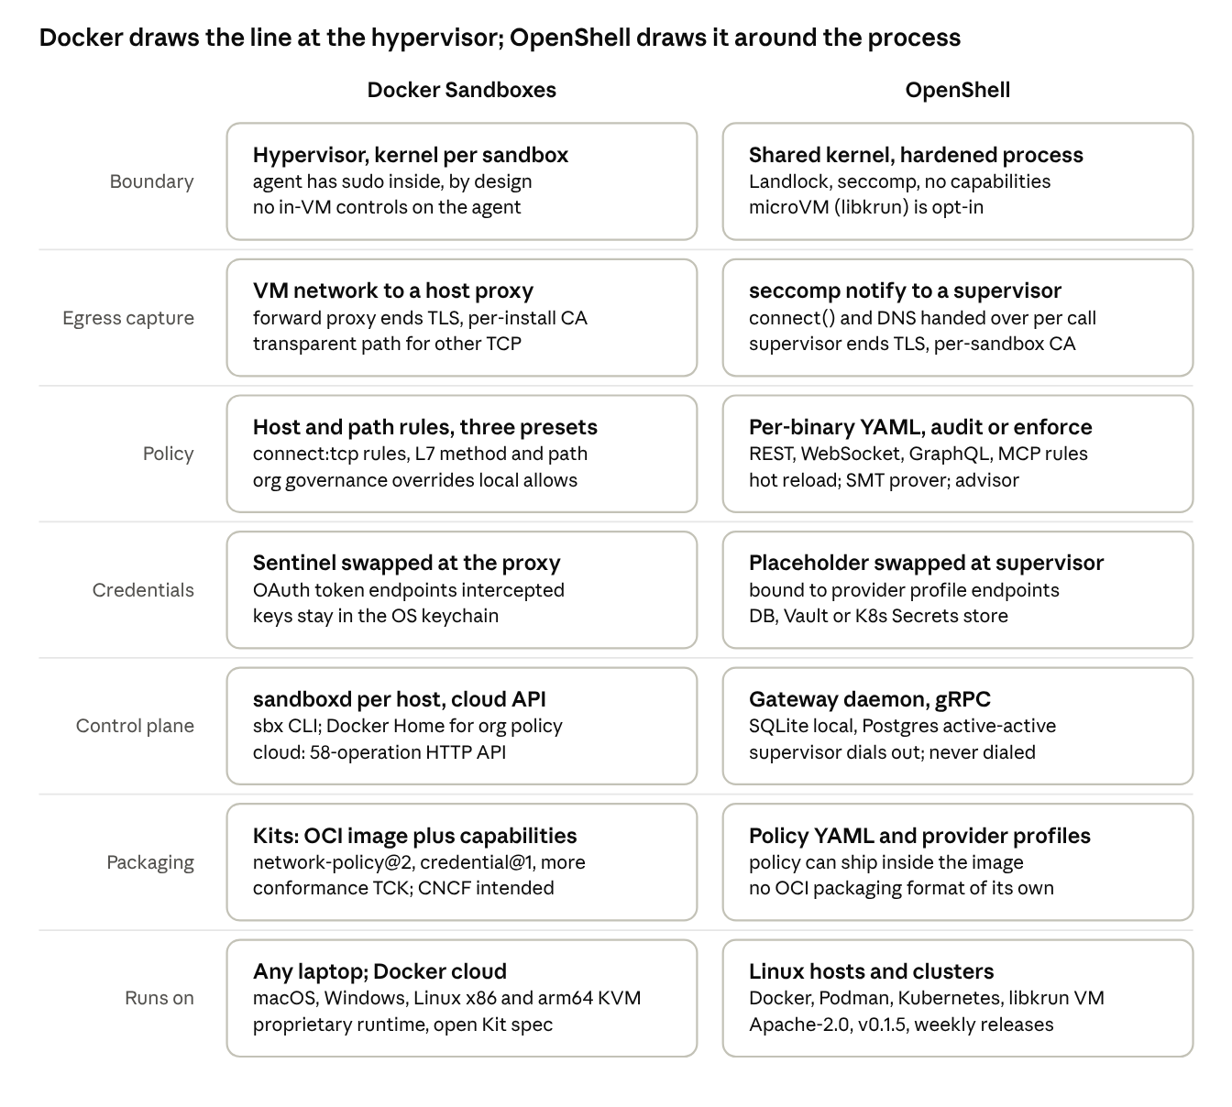
Layer by layer: Docker Sandboxes beside OpenShell 0.1.x
Read across a row and the division of labour is obvious: Docker owns the boundary and the packaging, OpenShell owns the policy and the credentials. The egress and credential rows are where the two would collide if simply stacked.
Dimension | Docker Sandboxes | OpenShell 0.1.x | Consequence for combining them
Isolation boundary | microVM with its own kernel; agent runs with sudo | shared kernel; non-root, Landlock, seccomp, no capabilities; libkrun microVM opt-in | complementary: Docker supplies VM strength, OpenShell supplies in-guest least privilege
Kernel requirements | Docker-built guest kernel, version unpublished | Landlock ABI 3+ (Linux 6.2+), nested seccomp user notification with ADDFD, same-UID /proc/<pid>/mem, SO_BINDTODEVICE; probed at admission, fail closed | the first gating check for running openshell-sandbox inside Docker's guest
Egress capture | guest network stack to a host proxy | seccomp notify per connect() and DNS; the workload has no network device or namespace route at all | two capture points if stacked; one must become a pass-through
TLS | forward proxy terminates with a per-install CA | supervisor terminates with a per-sandbox CA; upstream proxy chaining with proxy_ca_bundle is a driver setting | chain supervisor to Docker proxy and have the supervisor trust Docker's CA, or let one side skip inspection
Policy granularity | host, port, CIDR, L7 method and path; three presets; approvals; cloud is network-only today | per-binary SHA256 identity, host, port, path, REST, WebSocket, GraphQL, MCP and JSON-RPC rules, audit or enforce, SMT prover, advisor | OpenShell is more expressive on TCP and L7; Docker's experimental UDP rules and host-mount policy have no OpenShell equivalent, so a Kit carrying both keeps those on the Docker side
Credentials | sentinel swapped at the host proxy; OAuth token endpoints intercepted | placeholder swapped at the supervisor, bound to provider profile endpoints | pick one injector; the other must pass the real value through untouched
Control plane | sandboxd per host; Docker Home for org policy; cloud API experimental | gateway with gRPC API; SQLite or Postgres active-active; compute drivers are gRPC plugins | a Docker compute driver is a plugin on OpenShell's side, not a fork
Packaging | Kits: OCI image, typed capabilities, conformance TCK, CNCF intent | policy YAML, provider profiles, a slot for policy shipped inside the sandbox image | a Kit capability that carries OpenShell policy is the cleanest bridge
Scale story | cloud fleet on undisclosed Docker-managed compute, linux/arm64 offered | reference architecture on Vera, about one environment per core | NVIDIA's scale story points at Vera; Docker has said nothing about Vera, and neither has announced the other
Licence and status | sbx proprietary, free locally, cloud experimental | Apache-2.0, weekly releases, README still says alpha | a governance mismatch worth naming to Docker early
Where each is stronger: Docker on boundary strength, developer ergonomics (a full daemon inside, workspaces, cloud moves) and distribution (Kits, Hub, a conformance suite); OpenShell on policy expressiveness (per-binary identity, MCP tool rules, hot reload, a prover) and on keeping credentials out of the execution boundary entirely. OpenShell's policy YAML carries no resource limits (they sit in driver config); a Docker Kit can request them through resources@1 (cpu, memory, gpu).

Where they overlap and where they collide
The overlap is philosophical and large: both deny by default, both keep real credentials out of the agent's reach, both enforce from a position the agent cannot modify, both package the environment as an OCI image, both run on Linux arm64 with KVM, and, if the nerdbox inference holds, both sit on libkrun lineage. The collisions are mechanical and specific. Every one of them comes from the same root: each system was built to be the only policy layer between the agent and the network.
Collision | What happens if the two are stacked naively | How it resolves
Two TLS terminators | OpenShell's supervisor ends TLS with its per-sandbox CA, then the upstream leg hits Docker's forward proxy, which ends TLS again with the per-install CA; the supervisor rejects the certificate | the supervisor treats Docker's proxy as a corporate proxy (https_proxy, proxy_ca_bundle, HTTP CONNECT are driver settings already); or Docker's proxy relays the supervisor's flows on its transparent path
Two credential injectors | OpenShell swaps the placeholder for the real key; Docker's proxy has refused since v0.43.0 to forward credentials it did not issue to managed provider hosts, so a request carrying the real key to api.anthropic.com or another managed host is not forwarded | one injector per host: either Docker's proxy becomes a pass-through fence and OpenShell owns credentials, or OpenShell policy allows the endpoint without a credential_binding and the agent carries Docker's sentinel through; the second loses per-binary credential scoping
Two DNS policies | OpenShell answers the agent with placeholder addresses and resolves for real at the supervisor; inside a Docker VM that real resolution hits Docker's resolver, which refuses names without a permitting rule | superset rule: Docker's network policy must allow every host an OpenShell network_policies rule allows, which a Kit can express
Two policy languages | Docker: host, port, CIDR, L7 method and path on the forward path only, network deny as a floor; OpenShell: per-binary identity, protocol-aware L7 rules, deny overrides allow | the semantics agree on deny-wins; only the superset of hosts and ports has to be kept in step, and OpenShell carries the finer grain
Kernel probes inside the guest | openshell-sandbox fails closed without Landlock ABI 3, nested seccomp user notification with ADDFD, same-UID /proc/<pid>/mem and loopback SO_BINDTODEVICE; Docker Desktop's 6.12.54-linuxkit kernel shipped without CONFIG_SECURITY_LANDLOCK (issue #4133) and the Docker Sandboxes guest kernel config is unpublished | a kernel config question for Docker, cheap for Docker to fix and impossible for NVIDIA to work around
The inner Docker daemon | OpenShell constrains the agent's process tree; the agent can still ask the in-VM dockerd to run a container, and that container is outside the tree and reaches the network under Docker's policy, not OpenShell's | for OpenShell-governed sandboxes the daemon is absent, fenced to deny-all, or itself driven by OpenShell (the native pattern, where the workload container has no Docker socket)
Gateway reachability | the supervisor must reach the gateway over TLS verified against the gateway CA, carrying a gateway JWT; from inside a Docker VM that flow would cross Docker's forward proxy, which would re-terminate that TLS with its own CA and be rejected by the supervisor | allow the gateway endpoint on the transparent path, or keep the supervisor outside the VM
Docker Desktop specifics | OpenShell's own Docker driver on Desktop needs host networking enabled or a host.docker.internal endpoint, and its probe fails under ECI (#3880, #4683, PR #4016) | none of this applies to a Docker Sandbox: inside the microVM the inner daemon is native Linux, so host-mode networking and the trusted alias behave as on a server
Two things the public record settles. First, the only documented attempt to nest the NVIDIA stack inside a Docker Sandbox (Ajeet Raina, 23 Apr 2026) got the inner daemon running and the OpenShell gateway image pulled, then died when NemoClaw's k3s kubelet inside that container needed /dev/kmsg, which Docker's guest deliberately withholds; OpenShell's own binaries do not need it, and the attempt predates the 0.1.x split of supervisor and sandbox (write-up). Second, nothing in OpenShell's contract forbids any of this: RFC 0012 says components "may be co-located with the workload or hosted in trusted services, and one component may implement multiple roles", and the Windows MXC driver is the precedent for a driver that owns enforcement without an OpenShell supervisor inside the sandbox.

Integration topologies
There are four workable ways to put the two together. The first two are the loose and native couplings Michael framed; the third is a packaging bridge that makes either cleaner; the fourth is the scale deployment that makes the first three worth doing. The loose pattern is the one OpenShell's maintainers have already asked for in another context: when Docker's Eric Curtin proposed an in-tree OCI driver (PR #2312, closed July 2026), Evan Lezar's answer was "I don't think a first-class in-tree driver is something that we can accept at this stage" and a redirect to an out-of-process extension driver over a Unix socket, support for which merged on 26 Jun 2026 (#1703).
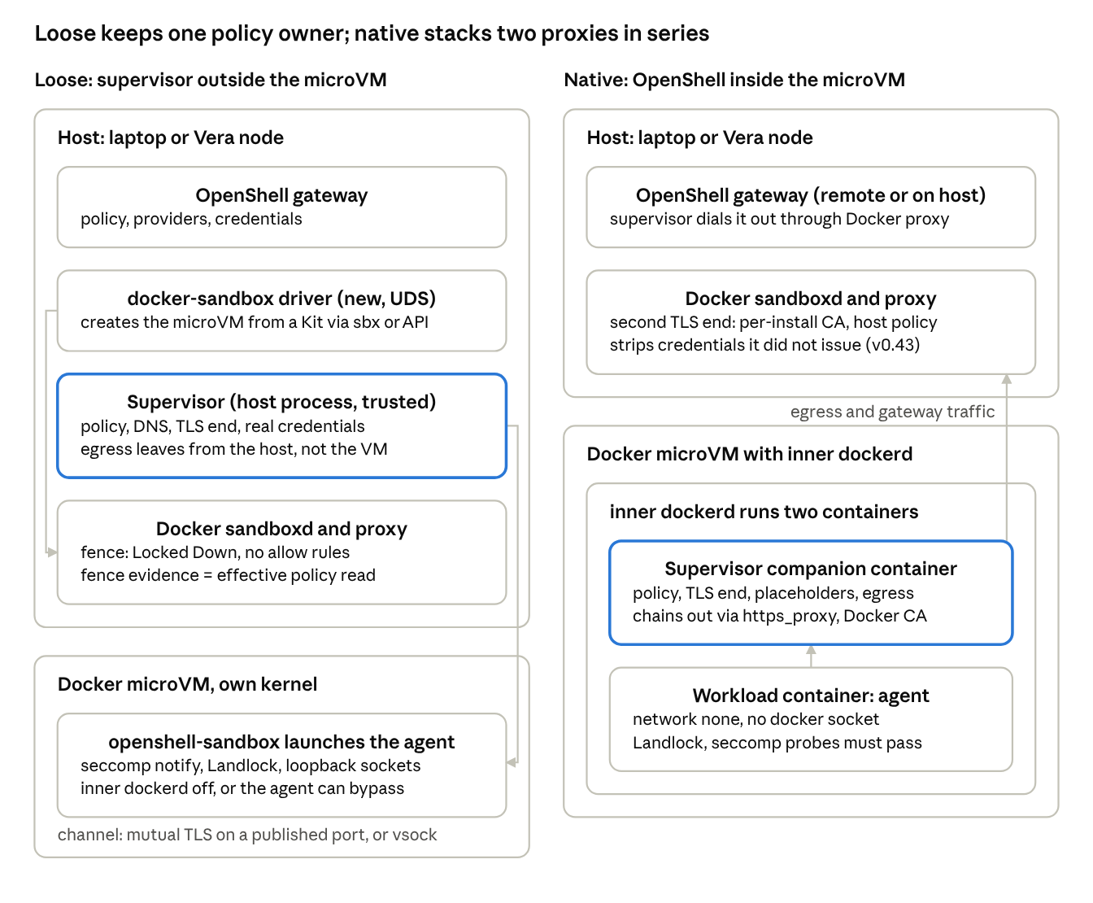
The two couplings Michael asked about, drawn to the same scale
On the left the supervisor never enters the VM, so Docker's proxy is reduced to a fence and there is one TLS terminator and one credential injector. On the right nothing new is written on either side, but every outbound byte passes two inspecting proxies and Docker's proxy currently strips credentials it did not issue.
A. Loose: OpenShell outside, the Docker microVM as a compute target. A new docker-sandbox extension driver on the gateway host implements the 12-RPC ComputeDriver contract over a Unix socket and calls sandboxd locally or the Cloud API remotely to create the VM from a Kit. The Kit makes openshell-sandbox the launcher of the agent process tree, so seccomp notification, Landlock and loopback-only sockets hold inside the guest even though the guest has a NIC. The supervisor runs on the host, exactly as OpenShell's own libkrun driver places it, and reaches the guest over mutual TLS on a port published to host loopback or over vsock if Docker exposes one; the supervisor's upstream connections leave from the host and never touch Docker's proxy. Docker's policy for the sandbox is Locked Down with no allow rules, which is the outer fence RFC 0012 requires, and the driver proves it with an effective-policy read. What Docker has to provide: a guest kernel that passes OpenShell's probes, a launcher hook, a channel, and an API for local sandboxes (today the v1 API is documented for cloud, with Unix-socket access mentioned once). What NVIDIA has to provide: the driver, which touches no gateway code. The one design decision is the inner daemon: off for governed sandboxes, or fenced to deny-all, because a container the agent starts through dockerd is outside OpenShell's process tree.
B. Native: OpenShell inside the microVM. The guest already runs a Docker Engine, so OpenShell's stock Docker driver works unchanged: a workload container with network_mode=none and a supervisor companion on the guest's host network, which is native Linux and free of every Docker Desktop caveat. The gateway is either a per-VM instance or a remote one the supervisor dials through Docker's proxy. Everything that collides in the previous section collides here: the supervisor must chain through Docker's proxy as if it were a corporate proxy with Docker's CA trusted, Docker must stop stripping the credentials OpenShell injects (or OpenShell must pass Docker's sentinel through and give up per-binary credential scoping), and the Kit's network requests must be a superset of the OpenShell policy. It costs two containers per sandbox inside the VM (the workload plus the supervisor companion), and the agent loses the inner daemon unless its socket is mounted, which reopens the bypass. Its virtue is speed: nothing new is written for the spike (pass Docker's sentinel through and accept the double proxy), so it is the right two-week spike to answer the kernel-probe and proxy questions with evidence.
C. Kits carry OpenShell policy. A mixin Kit, or a com.nvidia.openshell/policy@1 capability, ships the OpenShell policy YAML inside the image; OpenShell already reads a policy from the sandbox image as the third source in its precedence order. The same descriptor derives the Docker network-policy@2 requests so Docker's fence is always a superset, and the Kit spec's rule that any widening of the permission surface stops for approval lines up with OpenShell's prover and advisor. The reverse direction matters as much: OpenShell could consume Kits as sandbox images and run the kit-tck conformance suite, which would make NVIDIA the second conforming runtime of a spec Docker is taking to the CNCF, and would put OpenShell's policy schema inside that spec before it is final (target Q4 2026).
D. A Docker Sandboxes fleet on Vera with OpenShell as the governance plane. Docker's Cloud Sandboxes run on undisclosed Docker-managed compute and already offer linux/arm64; the microVM stack is KVM on arm64, which both sbx and OpenShell's libkrun driver support. On Vera bare metal from a CSP NVIDIA already lists (CoreWeave, OCI, Lambda, Nebius, Nscale, Crusoe, Vultr) the fleet would use topology A per node with the gateway in the same cloud, and BlueField-4 Sentry would observe the node's egress out of band from early 2027. Docker's smallest cloud size is 1 vCPU and 2 GiB; a Vera CPU has 88 cores, 176 threads and up to 1.5 TB, about 17 GB per core at the maximum and about 9 GB per core at NVIDIA's recommended 200 TB rack configuration, so NVIDIA's one-environment-per-core figure is bounded by vCPU, not memory; Docker's default cloud size of 2 vCPU and 4 GiB, at one sandbox per two hardware threads, gives the same 88 per CPU. Those are arithmetic from published figures, not a measurement.
Topology | Owns egress and credentials | New work, NVIDIA | New work, Docker | Known blockers | First demo
A. Loose | OpenShell supervisor on the host; Docker proxy is a fence only | extension compute driver (no core changes) | guest kernel flags, launcher hook, channel, local API, Kit | local API undocumented; inner daemon bypass; guest kernel unverified | 4 to 8 weeks
B. Native | OpenShell inside, then Docker proxy in series | none | guest kernel flags, proxy credential trust, Kit for OpenShell | credential stripping (v0.43), double TLS, gateway path | 1 to 2 weeks if the kernel passes
C. Kits bridge | unchanged | Kit consumer in drivers, policy mapping, TCK run | capability or mixin for OpenShell policy | spec still experimental | 2 to 4 weeks
D. Vera fleet | as A, plus Sentry out of band from 2027 | gateway deployment pattern, RA listing | arm64 cloud fleet on Vera, images, kernels | Vera racks quotable, not yet shipping at scale; Sentry early 2027 | a staged demo by 1 Dec is plausible, production is 2027

Landing on Vera
Vera is the agent tier of a three-tier design NVIDIA announced on 21 Oct 2026 at GTC Berlin: models on Vera Rubin NVL72, agent harnesses, tool use and OpenShell on Vera CPUs, and Sentry on BlueField-4 DPUs. Jensen's line was that agents "think on Rubin, act on Vera and be governed on BlueField" (release, technical blog). For Docker the practical reading is simple: a sandbox fleet belongs on the Vera CPU Rack, OpenShell is the software boundary NVIDIA expects to find there, and the DPU layer is optional and not before early 2027.
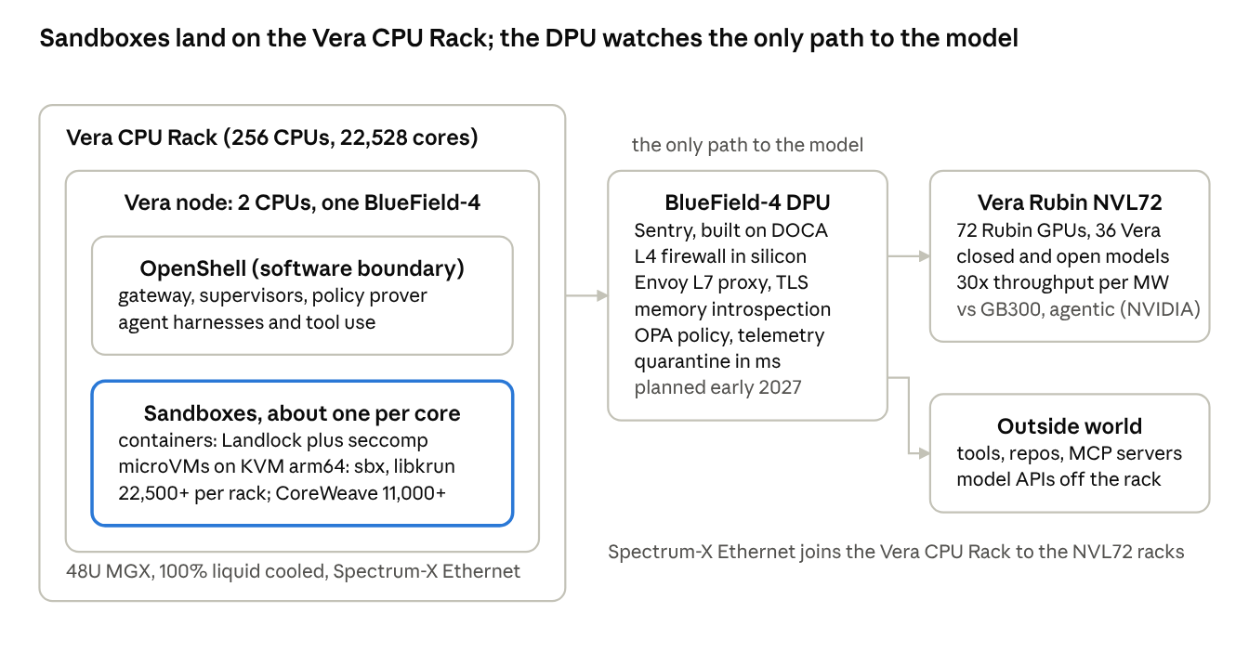
NVIDIA OpenShell Reference Architecture, 21 Oct 2026: Vera CPU Rack, BlueField-4, Vera Rubin
Everything an agent sends, to the model or to the internet, leaves the Vera node through its BlueField-4, which is why NVIDIA can put an independent enforcement point there without touching the host.
The rack. Up to 256 Vera CPUs (88 Olympus cores and 176 threads each, up to 1.5 TB LPDDR5X per CPU at 1.2 TB/s), 22,528 cores and 45,056 threads in a 48U, fully liquid-cooled MGX rack with Spectrum-X Ethernet and BlueField-4 DPUs; DCD and The Register count 64 DPUs per rack (Vera CPU Rack, DCD). NVIDIA's wording is "more than 22,500 concurrent CPU environments" with no footnote; it equals about one environment per physical core, and CoreWeave's 128-CPU rack figure of "more than 11,000" follows the same ratio. The CPU is in full production and first systems were hand-delivered to OCI, Anthropic, OpenAI and SpaceXAI from May, then AWS; the only OEM rack found so far, Supermicro's, became quotable on 22 Oct 2026 with no ship date (Supermicro).
Published sandbox numbers. All vendor-run and unaudited; none names its x86 memory configuration.
Who, when | Claim | Workload and baseline
CoreWeave, 30 Sep 2026 | sandbox startup more than 3x faster; more than 11,000 concurrent environments per 128-CPU rack | agent sandbox startup vs an unnamed x86 CPU, bare metal, one BlueField-4 per 2-socket node
NVIDIA, 21 Oct 2026 | 1.8x geometric mean, up to 2x | 20 Terminal Bench tasks vs "a leading x86 CPU"; repeats CoreWeave's 3x
Modal, 19 Oct 2026 | up to double the task throughput under load, latency equal or lower | 50 Terminal Bench 2.1 oracle tasks in prewarmed Docker containers vs an Intel Granite Rapids box; single node; Modal is all-x86 today and gives no rollout date
Daytona, 7 Oct 2026 | 1,000 sandboxes up in 10.8 s vs 32.3 s (EPYC 9575F) and 88.4 s (EPYC 9755); 13.3 jobs/s peak | coding-agent task across sandbox fleets; no node config published
Perplexity via NVIDIA, 7 Jul 2026 | coding workflow 1.5x, concurrent sandbox start 1.9x | clone, test in sandboxes vs x86
The pattern across all of them is that Vera's advantage shows under concurrency, which matches NVIDIA's positioning of "maximum single-thread performance at full data-center load" and its per-core memory bandwidth argument. Independent testing (Phoronix, May 2026, NVIDIA-approved workloads only) put Vera about 11% ahead of the top EPYC configurations and about 55% ahead of the best single-socket Xeon, a 6980P, on a general geomean as summarised by TweakTown, so the headline multiples are specific to loaded sandbox workloads, not general compute (Phoronix).
Sentry and BlueField-4. Sentry is a DOCA-based framework on the 800 Gb/s BlueField-4 (64 Neoverse V2 cores, 128 GB LPDDR5X): DOCA Flow as a per-agent L4 firewall in silicon, DOCA Tower as an Envoy L7 proxy with accelerated TLS termination, DOCA Argus for agentless memory introspection, an OPA/Rego engine evaluating in under a millisecond, attested telemetry, and millisecond quarantine (Sentry blog). NVIDIA says DOCA Tower "is compatible with OpenShell policies, using OPA" and that signed-policy distribution is an explicit integration requirement, but publishes no export or sync mechanism, and the OpenShell repository contains no Sentry, BlueField or DOCA code. Planned availability is early 2027; NVIDIA's own tech blog and deployment-tier docs call the DPU layer optional. Plan on OpenShell policy in software first and treat Sentry as a later hardware option.
What Arm means for Docker. The stack Docker needs on Vera already exists. Docker Sandboxes officially support Ubuntu 24.04+ on arm64 with KVM (kvm_arm64; nested virtualization inside VMs per Docker's docs; Arm's own guide asks for sbx 0.33 or later on bare metal); Docker's purpose-built VMM uses KVM on Linux; since v0.46.0 (28 Sep 2026) the default allocation on Linux arm64 is capped at 16 CPUs per sandbox; Cloud Sandboxes accept --platform linux/arm64; GPU passthrough is x86_64 only (install, release notes, GPU passthrough). Vera boots mainline Ubuntu and Fedora on Linux 7.1+, and OpenShell's gateway image and libkrun driver are both multi-arch. The remaining work is arm64 guest kernels and images, and that is engineering, not research.
What does not exist yet. Docker has made no public statement about Vera or Grace, and NVIDIA has not named Docker, Modal, E2B or Daytona in the reference architecture; CoreWeave is the only sandbox platform NVIDIA quotes. That is an opening: no developer-tool sandbox vendor has published Vera numbers.
Timing. GTC Washington, D.C. runs 30 Nov to 3 Dec 2026 with the keynote on 1 Dec; its tracks include Agentic AI, AI Infrastructure and AI Safety and Security, and nothing specific is pre-announced.

Assessment: chances of marrying the two
Technically the marriage is straightforward; organisationally it is unproven. The contracts fit, the hardware is ready, and the maintainers have already said which door to use. What does not yet exist is any sign that Docker and NVIDIA have agreed who owns policy.
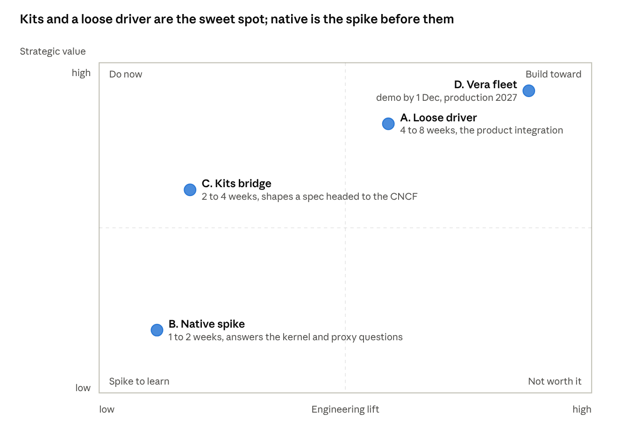
Four topologies placed by engineering lift and strategic value
The sequence that follows from the picture: run B as a two-week spike to get evidence on Docker's guest kernel and proxy behaviour, do C in parallel because it costs little and shapes a spec before it freezes, build A as the real integration, and treat D as the joint story to tell when Vera racks ship.
Why the technical odds are high.
- OpenShell's contract was rewritten in September to allow exactly this: RFC 0012 separates placement, enforcement and decisions, lets components live "co-located with the workload or hosted in trusted services", and supports vsock and TLS channels for a supervisor that is not on the same kernel as the workload. Out-of-process compute drivers have been supported since 26 Jun 2026.
- The two runtimes share a lineage. OpenShell's microVM driver is libkrun; the evidence says Docker's VMM is libkrun through containerd's nerdbox. The same host-process supervisor and vsock pattern NVIDIA uses for its own VMs maps onto Docker's VM with no conceptual change.
- Arm is a non-issue: sbx supports arm64 Linux with KVM, Cloud Sandboxes offer linux/arm64, OpenShell is multi-arch, and Vera runs mainline Ubuntu.
- Both products already share a philosophy: deny by default, credentials never inside the boundary, enforcement where the agent cannot reach. Policy translation is lossy mainly in the direction that does not matter; the exceptions are Docker's UDP and host-mount rules, which OpenShell cannot express.
Why the organisational odds are only fair.
- Docker's upstream presence in OpenShell is one engineer, Eric Curtin, with 45 small merged commits and two architectural PRs closed unmerged in July. No Docker-authored driver, provider profile or RFC exists in the tree. The "Docker agent provider for Docker Hub and Model Runner" mentioned in the earlier brief could not be found in OpenShell or NemoClaw and should be treated as unconfirmed.
- Docker is absent from the 100-plus partner lists of 28 Sep and 21 Oct, despite being named an inaugural Open Secure AI Alliance member on 27 Jul 2026, with its own post on 30 Jul (Docker blog). No joint statement on sandboxes or OpenShell exists in either direction.
- The products overlap on the valuable part. Both sell policy and credential brokering; Docker wants Kits to be the industry's permission format and is taking it to the CNCF, NVIDIA wants OpenShell policy to be the runtime's language. sbx is proprietary; OpenShell is Apache-2.0 with Red Hat maintainers.
- Docker's own channel to enterprises is Docker Home governance and a cloud with an experimental API; OpenShell's is a gateway on NVIDIA infrastructure. Each will reasonably ask why the other layer is needed.
The split that works. Docker owns the boundary, the packaging and the developer's laptop; OpenShell owns runtime policy, credentials and fleet governance on NVIDIA infrastructure. That is the division the loose topology produces on its own, and it matches the position of NVIDIA's security team on single-user local setups (internal section). It also gives Docker something it does not have: a seat in the reference architecture and the first developer-tool sandbox numbers on Vera.
Horizon | Realistic outcome
3 months, to late Jan 2027 | B spike reported with kernel-probe and proxy evidence; C policy mapping and a mixin Kit published; A driver prototype against Cloud Sandboxes or a Linux sandboxd; a staged demo for GTC DC on 1 Dec only if both sides commit this week
6 months, to Apr 2027 | A driver in OpenShell's extension catalog with fence evidence; Docker guest kernel passing OpenShell's qualification; an OpenShell capability in Kit spec v3 (Docker's Q4 2026 final may slip)
12 months, to Oct 2027 | D on Vera bare metal at one CSP with the gateway in-cloud; Sentry integration profile once Sentry ships (planned early 2027); Docker named in the reference architecture partner list
Risks worth naming. Docker ships its own per-binary L7 policy and credential scoping and no longer needs OpenShell for the laptop; the Kit spec lands at the CNCF without an OpenShell capability and the policy schemas diverge; Docker's guest kernel lacks Landlock and nobody prioritises the rebuild; the local sandboxd API never becomes public, which confines topology A to the cloud; the Vera racks slip past 2026 and the fleet story loses its date; and the earlier brief's unverified claims (the provider PR, the ECI framing, Daytona's native proposal, which has no public source) get repeated to Docker and cost credibility.

Internal context, NVIDIA only
Remove this section before anything here goes to Docker. It is what the public picture above leaves out. These points come from internal channels and the meeting note, not from the research sources, and were not re-verified for this study.
- NVIDIA already sanctions Docker's sbx internally for autonomous agent runs, so the first-hand operational experience with Docker's boundary is in-house.
- The security team's position is that OpenShell does not plan sbx-style enterprise policy distribution for single-user local setups. That leaves the laptop and the org-governance surface to Docker and the fleet surface to OpenShell, which is the cleanest possible split to propose.
- John Myers, an OpenShell maintainer, called Docker Sandboxes "promising" as a future OpenShell target in April. Nothing has landed in the repo since, and no partner sandbox driver of any kind exists in main as of 22 Oct.
- On 12 Oct an OpenShell engineer complained that Docker's isolation interferes with OpenShell's own. The mechanics in the sections above explain why: two TLS terminators, two credential injectors, and OpenShell's seccomp and Landlock probes running inside Docker's guest.
- Michael's framing for the research is loose versus native coupling: the OpenShell supervisor outside the sandbox treating the Docker microVM as a compute target, or OpenShell running inside the sandbox the way Daytona proposed. Both are drawn and scored above.
- Michael's guidance for the meeting: treat it as an introduction, hear Docker's vision and roadmap, talk about the long-term partnership, and mention the GTC DC opportunity without promising anything; the keynote is Jensen's call.

Questions for Docker
Ordered by how much each answer changes the plan.
- Guest kernel. Does the Docker Sandboxes guest kernel enable Landlock ABI 3 or newer, nested seccomp user notification with SECCOMP_IOCTL_NOTIF_ADDFD, same-UID /proc/<pid>/mem reads and loopback SO_BINDTODEVICE without capabilities? Would Docker share the kernel config or run OpenShell's qualification probe inside a sandbox?
- Launcher hook. Can a Kit or the API make a trusted binary the launcher of the agent process tree, with bootstrap files only that binary can read? Today the host launches the agent (sbx@1); the question is whether that launcher can be openshell-sandbox.
- Channel. Is there a supported way for a host process to open a mutually authenticated channel into the guest that does not traverse the egress proxy: a vsock port from the VMM, or a port published to host loopback?
- Proxy as a fence. Can a sandbox run with the proxy in a pure deny-all mode, with one exception on the transparent path for the OpenShell gateway endpoint? And can the v0.43 rule that strips credentials the proxy did not issue be relaxed for a trusted injector?
- Inner daemon. Is there a profile without the inner Docker Engine, or a way to apply the same policy to containers the agent starts through it?
- Local API. Will sandboxd expose the v1 Sandboxes API on the Unix socket for local sandboxes, not only the cloud, and will network policy become writable through it?
- Kits. Appetite for a capability or mixin that carries OpenShell policy, and for OpenShell to become a second conformant runtime through the kit-tck? What is the real timing of the CNCF submission and the v3 final?
- Vera. Where does the linux/arm64 cloud platform run today, is Vera bare metal from CoreWeave or OCI on the roadmap, and what is the status of arm64 guest kernels, images and GPU passthrough?
- Ownership. Who at Docker owns OpenShell work beyond Eric Curtin, and is Docker willing to build the out-of-process extension driver the maintainers asked for in #2312?
- Governance. How does Docker see its AI Governance product and OpenShell's gateway dividing the enterprise: laptop and organisation on one side, fleet on the other?

Sources
Pages opened for this study, as of 22 Oct 2026. Repository facts were checked against a clone of NVIDIA/OpenShell at commit 07b7a74b (main as of 22 Oct 2026, two days after tag v0.1.5 of 20 Oct 2026).
OpenShell (NVIDIA)
- Architecture, support matrix, sandbox runtimes, policy schema, policies overview, prover, inference, security best practices, upgrade to 0.1.0, drivers, isolation backends
- RFC 0001 core architecture, RFC 0012 isolation backend, RFC 0013 Windows MXC, compute_driver.proto, Docker driver README, VM driver README, Kubernetes driver README, MAINTAINERS, providers/nvidia.yaml
- Docker-related issues and PRs: PR #2312 OCI compute driver, issue #2255, PR #2313, #1703 out-of-tree drivers, PR #2942 supervisor placement, issue #3880, issue #4683, issue #4133, issue #4015, PR #4016, issue #4403, issue #1737
- NemoClaw ecosystem, NVIDIA blog, OpenShell launch, 23 Mar 2026
NVIDIA Vera, BlueField-4, Sentry, reference architecture
- OpenShell Reference Architecture release, 21 Oct 2026, technical blog, Inside NVIDIA Sentry, Open Agent Safety Platform, 28 Sep 2026, Secure Agent Workspace reference design, deployment tiers
- Vera CPU, Vera CPU Rack, Vera launch, 16 Mar 2026, Vera delivery blog, Ian Buck on Vera, Rubin platform, NVL72 efficiency blog, Open Secure AI Alliance
- Partners and press: CoreWeave, 30 Sep 2026, Modal, 19 Oct 2026, Daytona, 7 Oct 2026, Supermicro Vera CPU Rack, 22 Oct 2026, Phoronix Vera review, ServeTheHome on Vera, DCD, HPCwire on BlueField-4, SiliconANGLE on GTC Berlin, The New Stack on OpenShell and Sentry
Docker Sandboxes, Kits, Cloud Sandboxes
- Architecture, isolation layers, install, credentials, governance, GPU passthrough, release notes, local vs cloud, Sandboxes API reference, ECI FAQ
- Why microVMs, 16 Apr 2026, Sandboxes launch, 30 Jan 2026, standalone sbx, 31 Mar 2026, Introducing Cloud Sandboxes, 24 Sep 2026, Kit spec and CNCF, 24 Sep 2026, Docker joins the Open Secure AI Alliance, 30 Jul 2026, Model Runner on DGX Spark
- docker/sandbox-kit-spec, SPEC-v3, network-policy@2, credential@1, docker/sbx-releases, containerd/nerdbox, libkrun
- Third-party: NemoClaw inside Docker Sandboxes, 23 Apr 2026, sandbox comparison matrix, InfoQ on Kits, InfoQ on Cloud Sandboxes, Futurum on the Kit spec

