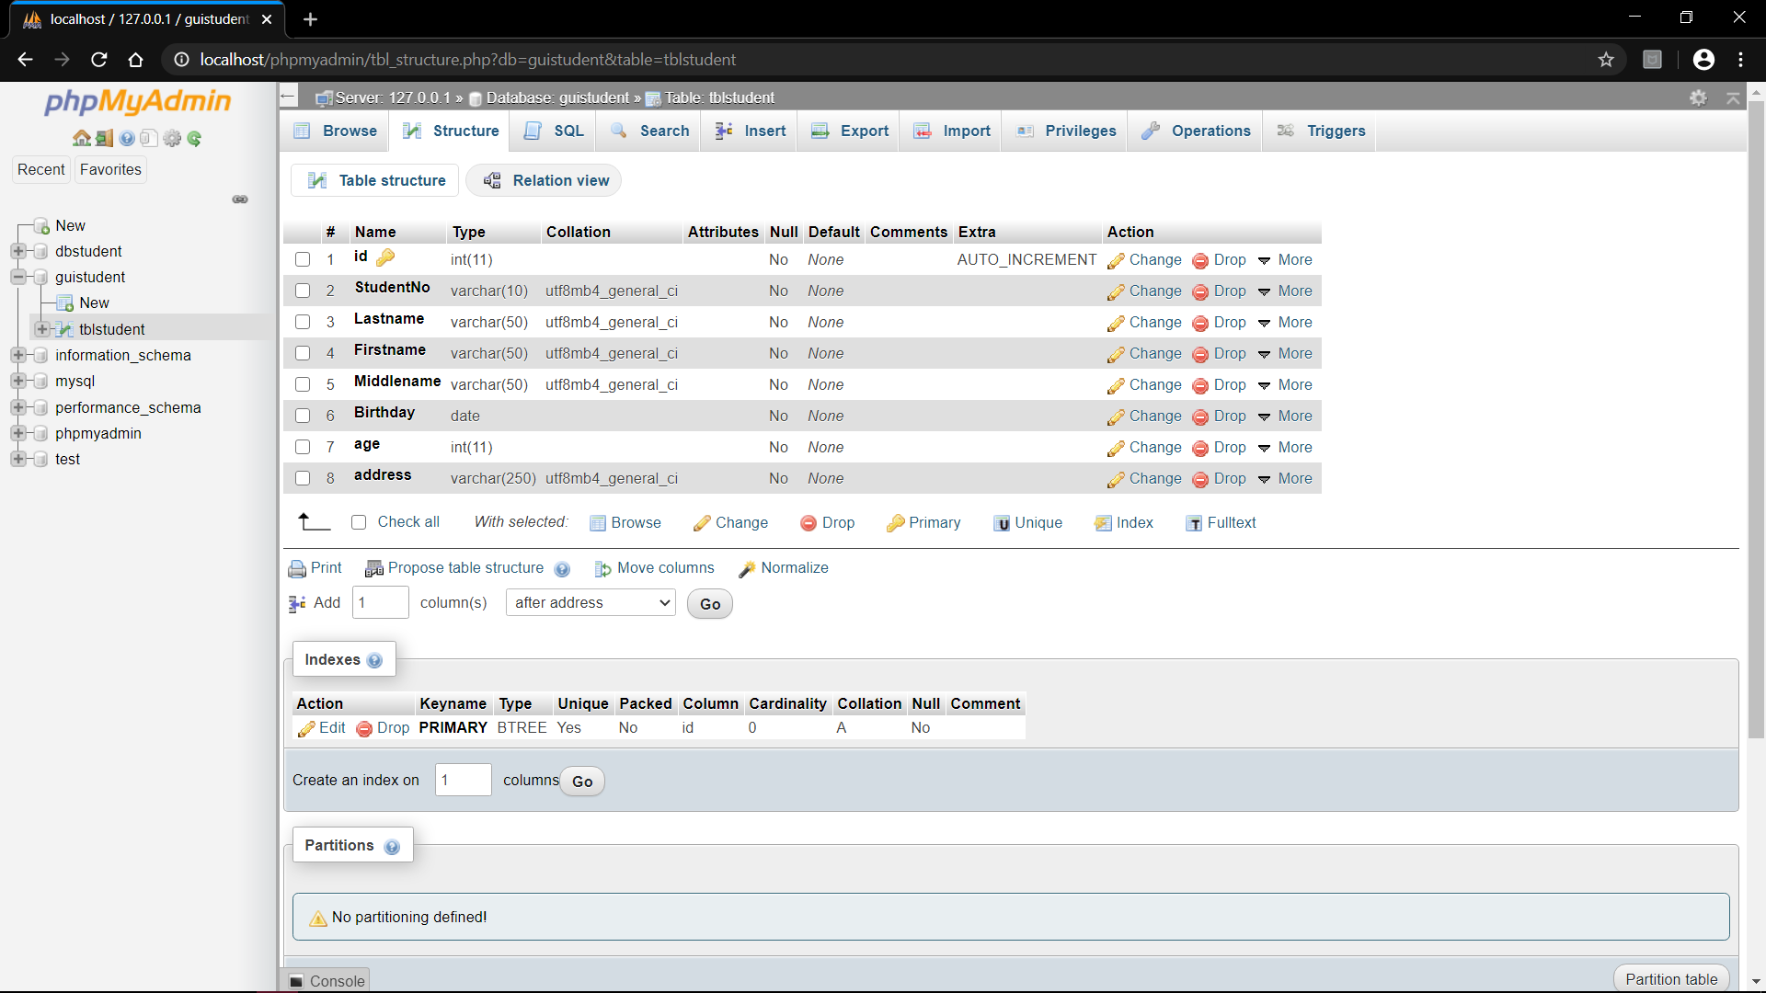

***Table Structure:*** *Table containing the required value names.*

*Data base : guistudent table : tblstudent*

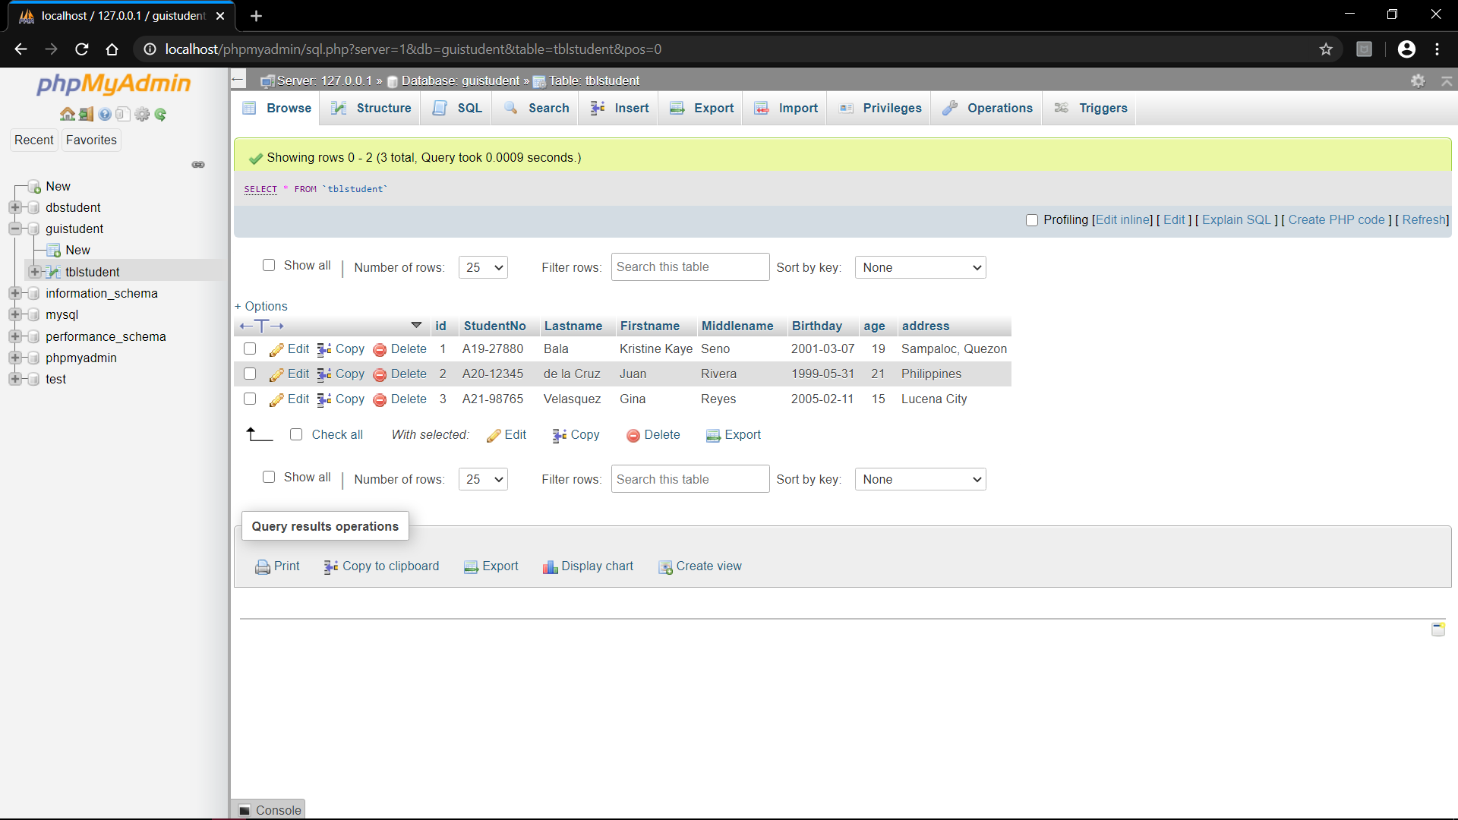

***Table Contents*** *after three user input*

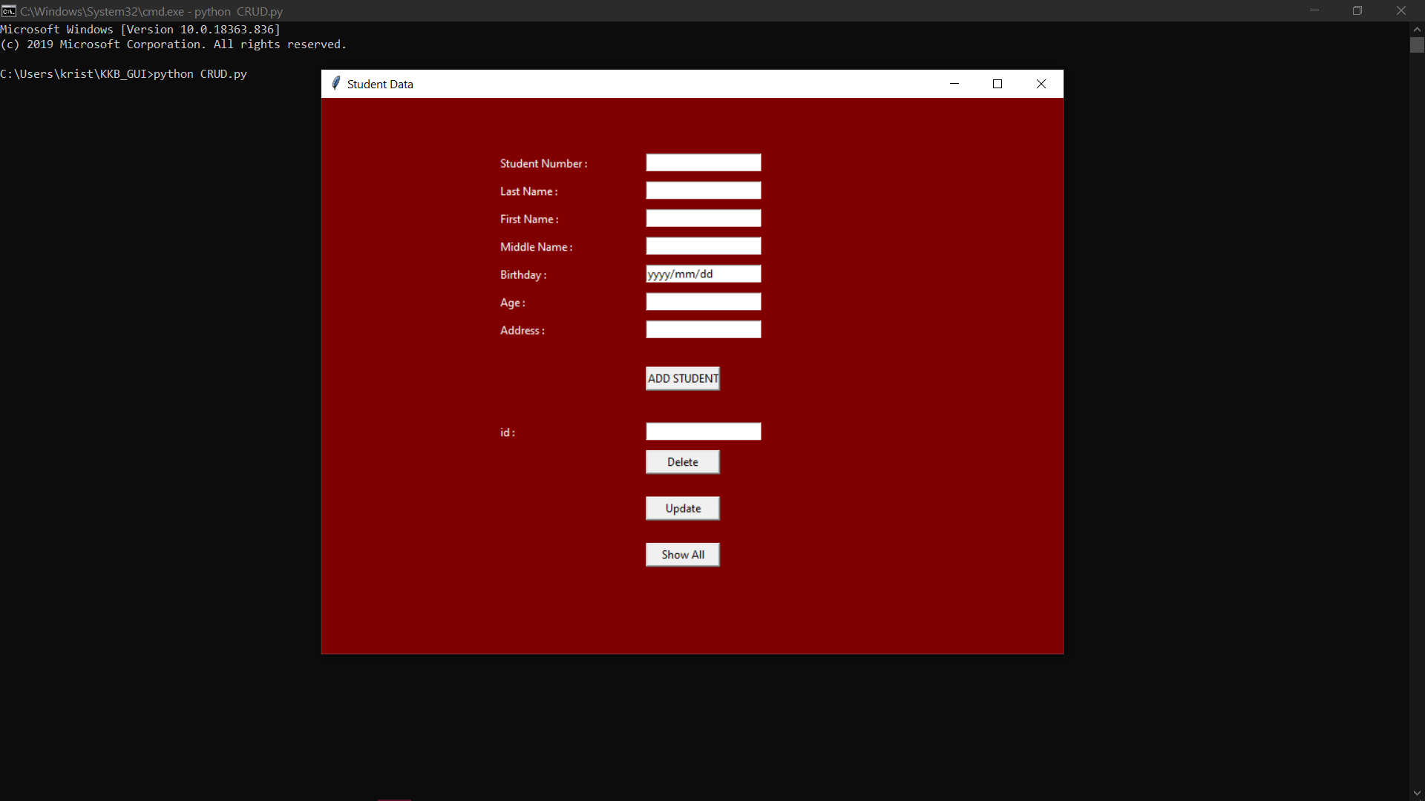

***Run CRUD.py on command prompt.***

*Student Data widget shows. The widget has a variable of root in coding.*

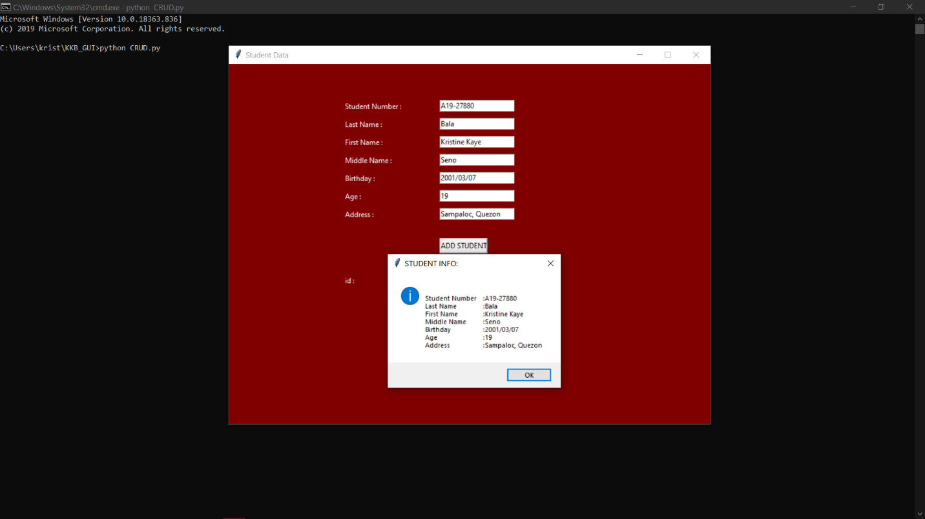

***Add Student.*** *Show a message box containing the user input. The user input is pass through the database*

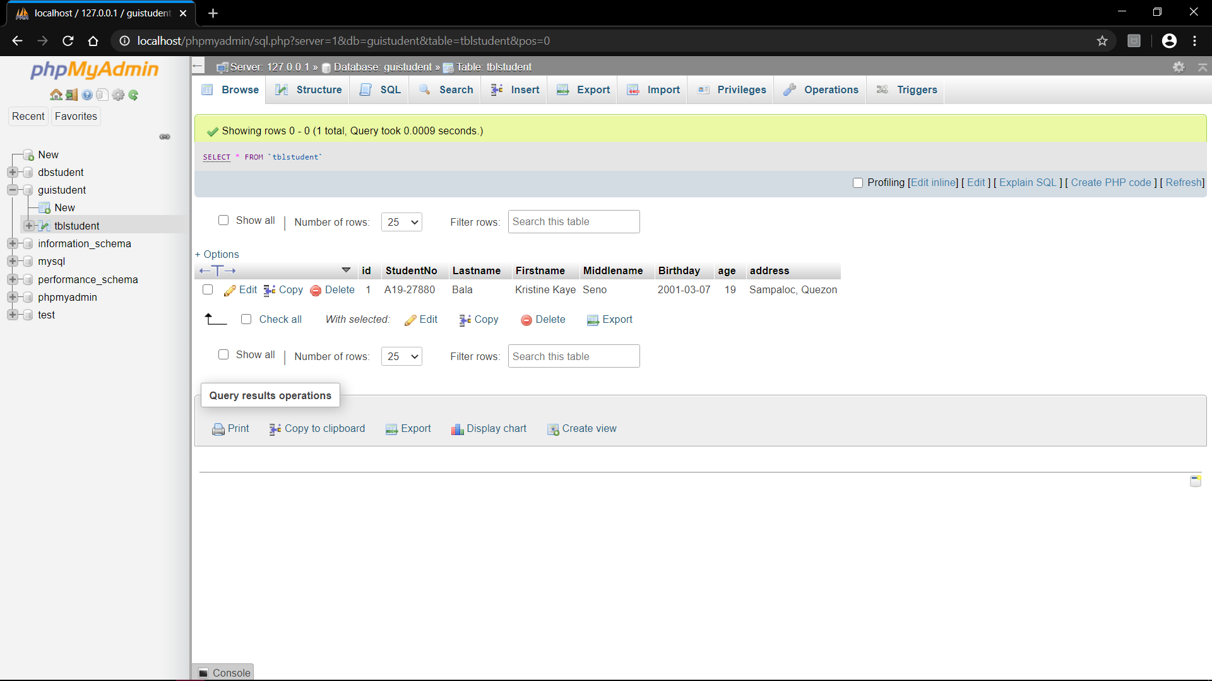

*Data base received the user input.*

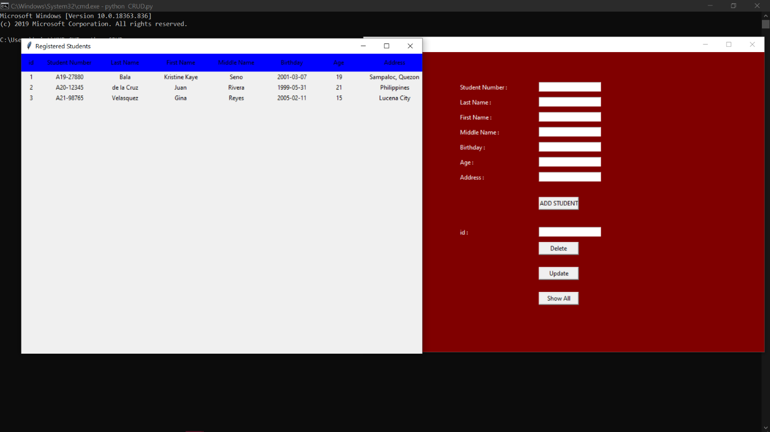

***Show all.*** *Show all the students that has been added in by the user. The content are also in the data base.*

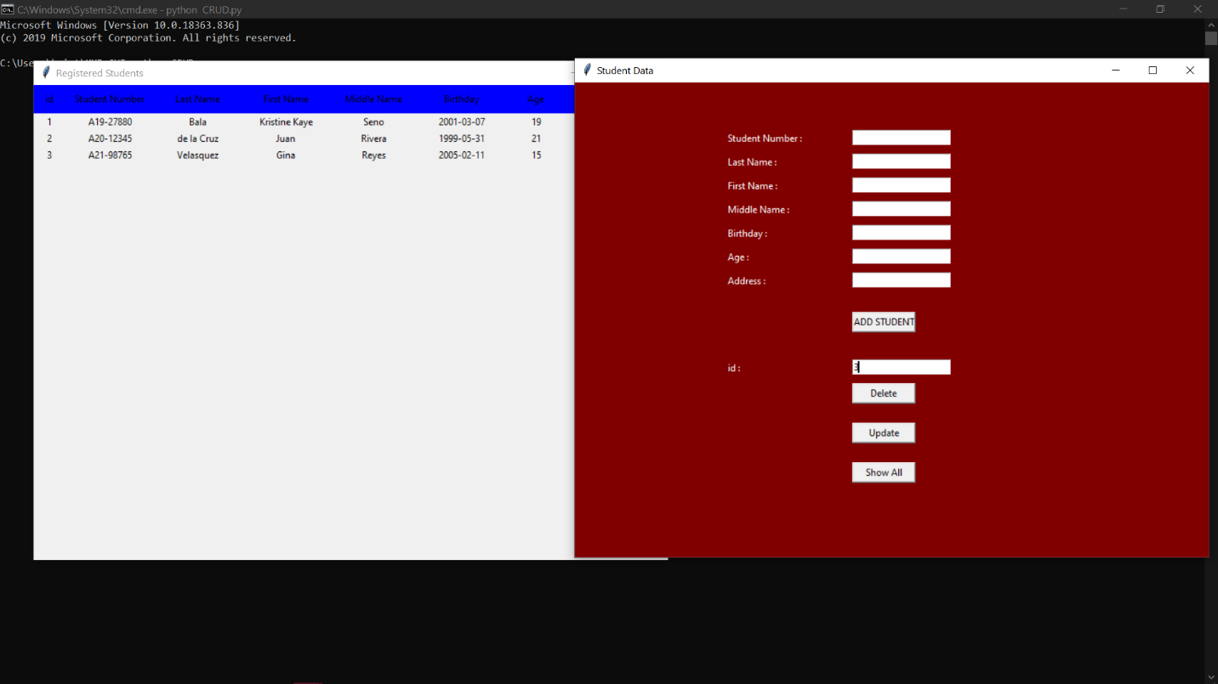

*Input ID to Delete specific student*

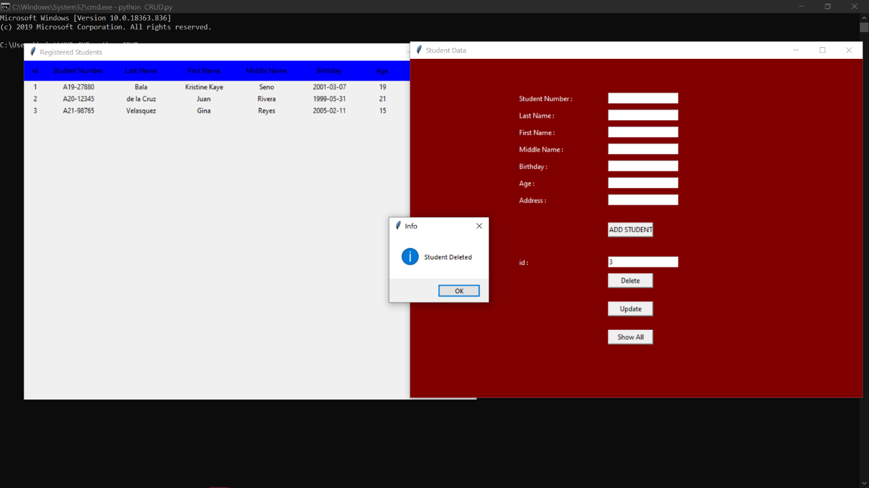

*Message box pop up indicating that the student has been deleted*

*\*The Registered Students widget should be close then reopen again to recognize the changes*

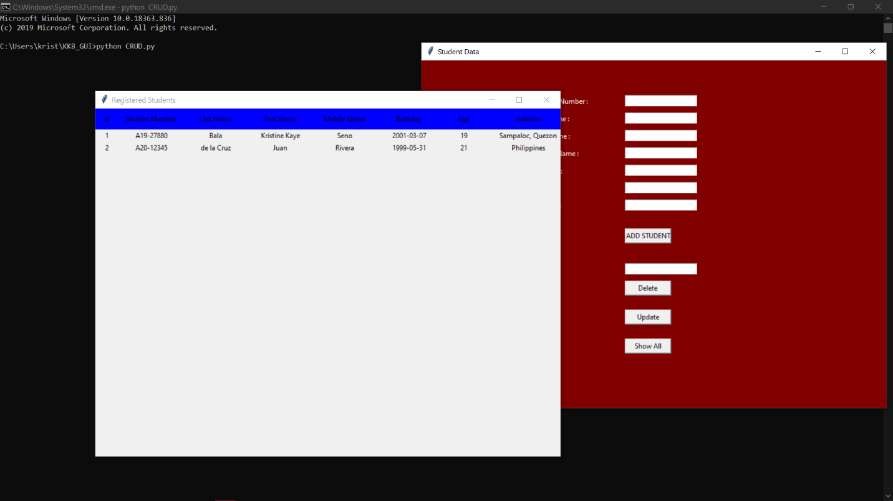

*Registered Student widget recognize the changes*

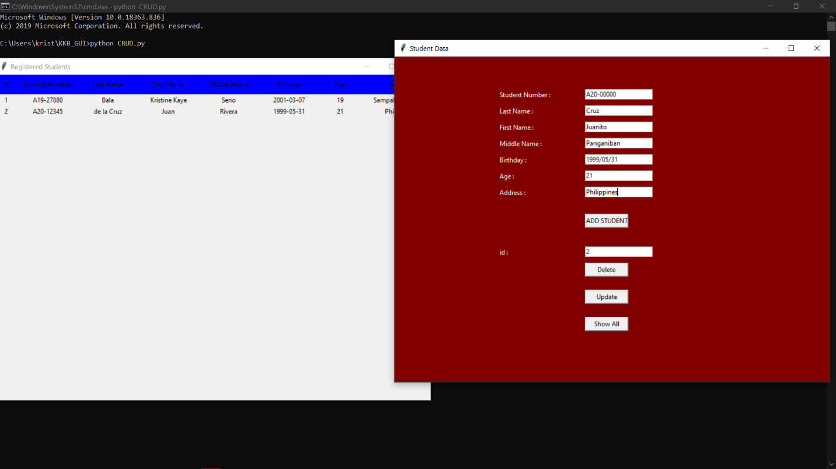

***UPDATE****. Id number 2 will be edited after clicking the update button*

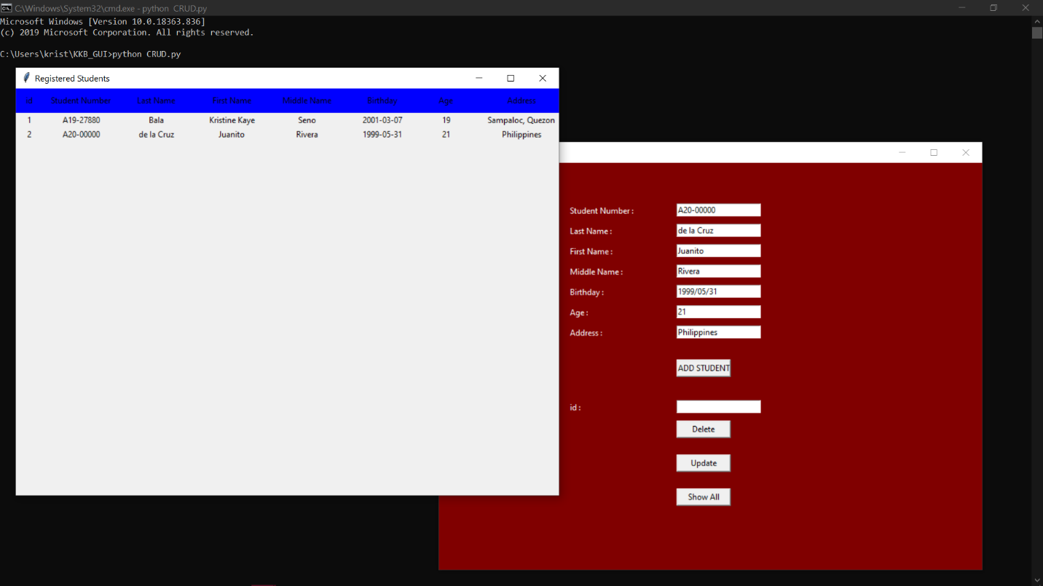

*Register Student widget updated the id 2 data*

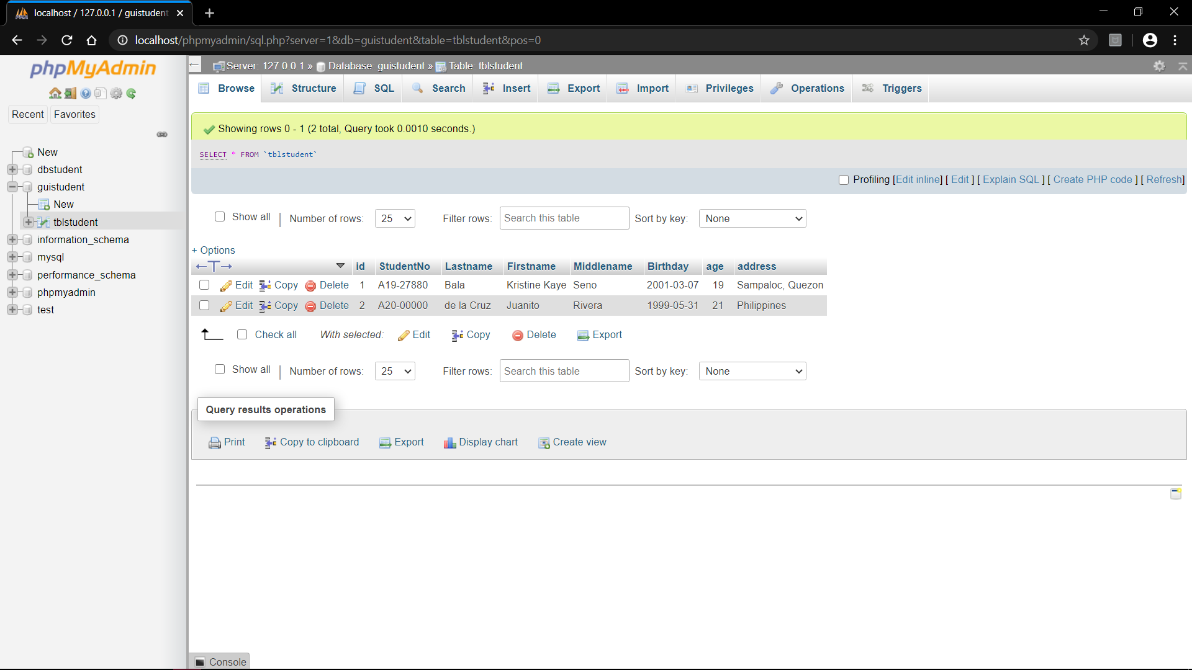

*Data base also update id 2 data*