INDIAN INSTITUTE OF INFORMATION TECHNOLOGY
VADODARA
CS545
SOFTWARE ENGINEERING
PROJECT REPORT
Master of Computer Applications (MCA)
Second Year
Project Title:
AI-POWERED TEXT HUMANIZER
(MICROSERVICES ARCHITECTURE)
Group No. 29
Submitted By:
Ritik Kumar Sinha (20252651043)
Kruti Kansagara (20252651027)
Sahil Siddiqui (20252651055)
Jeeshan Adil (20252651026)
Submitted To:
Faculty Name: Prof. Rishabh Gupta
Department: Department of Computer Science & Engineering
Indian Institute of Information Technology Vadodara
Autumn 2026-27

CERTIFICATE
This is to certify that Ritik Kumar Sinha (20252651043), Kruti Kansagara (20252651027), Sahil Siddiqui (20252651055), and Jeeshan Adil (20252651026), students of the Master of Computer Applications (MCA) programme at the Indian Institute of Information Technology Vadodara, have completed the laboratory work for CS545 – Software Engineering, covering Experiments 1 to 9, during the academic year 2026-27.
The work has been submitted as part of the course requirements.
Date: 28th October 2026
Faculty Signature: ______________________
Faculty Name: Prof. Rishabh Gupta

DECLARATION
We hereby declare that the work presented in this Software Engineering Lab Report is our original work, completed as part of the CS545 Software Engineering course.
The diagrams, tables, system analysis, implementation modules, and testing test cases have been prepared by us. Any external technical references, algorithms, or resources used have been appropriately acknowledged and cited.
Student Name | Enrollment Number | Signature
Ritik Kumar Sinha | 20252651043 | __________________
Kruti Kansagara | 20252651027 | __________________
Sahil Siddiqui | 20252651055 | __________________
Jeeshan Adil | 20252651026 | __________________
Date: 28th October 2026

ACKNOWLEDGEMENT
We would like to express our deepest gratitude to our course instructor, Prof. Rishabh Gupta, for his continuous mentorship, constructive evaluations, and invaluable guidance throughout the CS545 Software Engineering Laboratory sessions.
His insightful feedback during every stage of the software engineering life cycle—from initial software requirements specification to agile modeling, architectural diagrams, microservice decoupling, and validation test suites—has significantly enriched our understanding of enterprise software design.
We also extend our sincere appreciation to the Department of Computer Science & Engineering and Indian Institute of Information Technology Vadodara for providing the laboratory infrastructure and computational environment necessary to bring this microservices project to fruition.
Finally, we thank our peers and group members for their collaborative spirit, mutual technical support, and dedication throughout this semester.

TABLE OF CONTENTS
Exp. No. | Experiment Title / Topic | Page No.
Lab-1 | Software Requirements Specification (SRS) | 6
Lab-2 | Software Process Model (Agile Scrum) | 7
Lab-3 | Use Case Modeling & Diagram | 8
Lab-4 | Data Flow Diagrams (DFD Level 0 & Level 1) | 9
Lab-5 | UML Class Diagram & Domain Entities | 10
Lab-6 | UML Sequence Diagram & Interaction Workflows | 11
Lab-8 | Modular System Architecture & Decomposition | 12
Lab-9 | Functional Test Cases & Verification Suite | 13
- | Overall Project Conclusion | 14
- | References & Technical Citations | 15

LAB EXPERIMENT 1
SOFTWARE REQUIREMENTS SPECIFICATION (SRS)

1.1 Aim & Scope
To formulate a complete Software Requirements Specification (SRS) for the AI-Powered Text Humanizer microservices platform, defining system scope, stakeholder personas, functional requirements, and performance parameters.

1.2 Functional Requirements
• FR-1: User Authentication: The system shall permit secure account registration and authentication using salted bcrypt hashing. Successful logins generate a signed, stateless JSON Web Token (JWT).
• FR-2: Text Paraphrase Inference: The system shall accept input text payloads via `/api/humanize`, apply sentence boundary detection, tokenize phrases, and run neural transformations to smooth syntactic cadence.
• FR-3: Transformation Audit & History: The system shall automatically associate each humanized execution with the authenticated user ID and persist input, output, and execution timestamps.
• FR-4: Reverse Proxy API Gateway: A central gateway shall accept all incoming browser requests on port 5000 and forward traffic to the appropriate downstream microservice without leaking internal ports.

1.3 Non-Functional Requirements
• Response Latency: Text rewriting under 300 words must complete within 2.5 seconds on CPU/GPU.
• Security & Privacy: Passwords never stored in plain text. JWT tokens signed with HMAC-SHA256.
• Modularity & Decoupling: Microservices remain fully autonomous; failures in the AI service do not halt user logins.
• Portability: Entire stack packaged via standard Dockerfile and Docker Compose manifests.

LAB EXPERIMENT 2
SOFTWARE PROCESS MODEL

2.1 Model Selection: Agile Scrum Framework
For developing the Text Humanizer platform, an Agile Scrum process model was chosen over traditional Waterfall. Because microservices involve independently deployable components (Auth, AI, History, Gateway) and machine learning models require iterative evaluation, Agile's short sprint cycles facilitated rapid prototyping and continuous feedback.

2.2 Sprint Execution Plan
Sprint | Focus Area | Key Deliverables
Sprint 1 | Requirements & DB Architecture | MySQL schema (`init.sql`), service port allocations, API contracts.
Sprint 2 | Authentication & Neural Model | bcrypt/JWT `auth_service.py`, transformer pipeline `ai_service.py`.
Sprint 3 | API Gateway & History Store | Reverse proxy `gateway.py`, CRUD endpoints in `history_service.py`.
Sprint 4 | Frontend & End-to-End Tests | Single-page responsive UI, functional test suites, Docker integration.

LAB EXPERIMENT 3
USE CASE DIAGRAM

3.1 Use Case Specifications
The primary actor is the End User (Students, Technical Writers, Researchers). Use cases include registering an account, obtaining credentials, submitting text for humanization, copying transformed output, and managing transformation history logs.

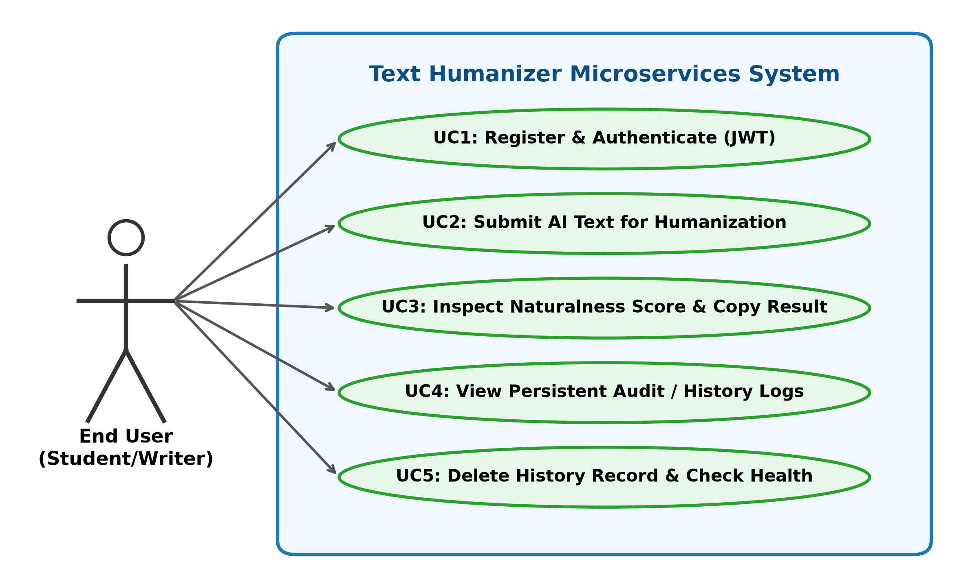
Figure 3.1: UML Use Case Diagram for Text Humanizer Microservices

LAB EXPERIMENT 4
DATA FLOW DIAGRAM (DFD)

4.1 Level 0 & Level 1 Decomposition
The DFD models the flow of information across boundaries. At Level 0, the Client Browser interacts with the Text Humanizer boundary and the MySQL data store. At Level 1, the API Gateway demultiplexes client traffic across the Auth Service (Port 5001), AI Engine (Port 5003), and History Service (Port 5004).

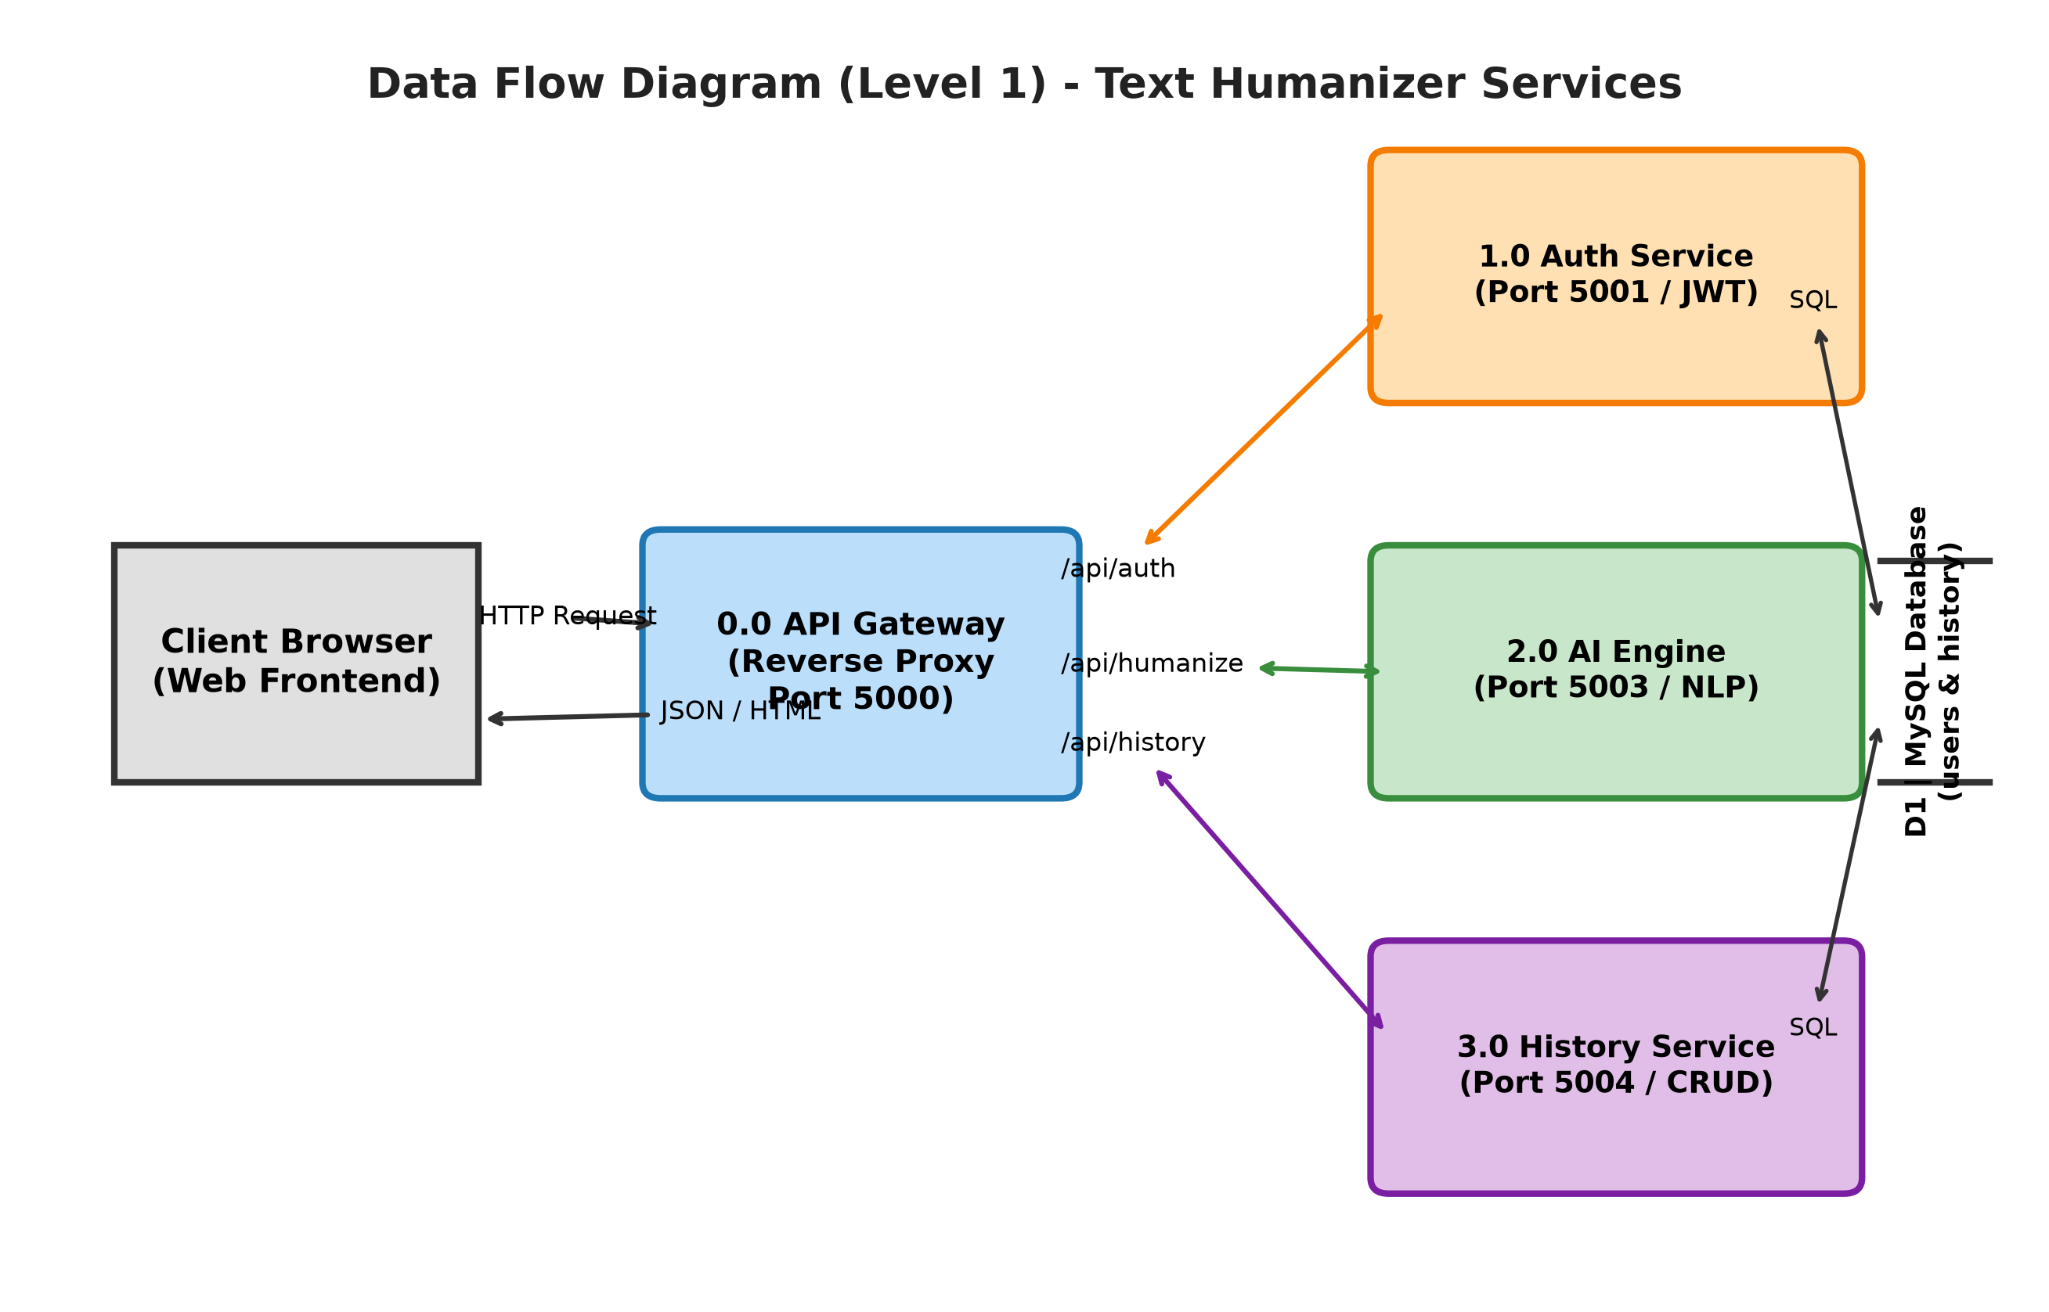
Figure 4.1: Level 1 Data Flow Diagram (Microservice Interactions)

LAB EXPERIMENT 5
UML CLASS DIAGRAM

5.1 Class Diagram & Entity Relationships
The system architecture follows object-oriented patterns where services wrap data models and encapsulate specific persistence logic. The primary entities are `User` and `HistoryRecord`, interfaced by `AuthService`, `AIService`, and `APIGateway`.
Class Name | Key Attributes | Key Methods
User | id, username, email, password_hash, created_at | register(), verify_password()
HistoryRecord | id, user_id, original_text, humanized_text, created_at | create_record(), get_by_user(), delete()
APIGateway | host, port, services_map | forward(service_base, path), route_auth(), route_humanize()
AuthService | jwt_secret, token_expiry | hash_pw(), check_pw(), generate_jwt(), verify_token()

LAB EXPERIMENT 6
UML SEQUENCE DIAGRAM

6.1 Dynamic Interaction & Execution Workflow
The sequence diagram captures the exact runtime message passing among the Client UI, API Gateway, Auth Microservice, AI Inference Engine, and MySQL Database during a text humanization operation.

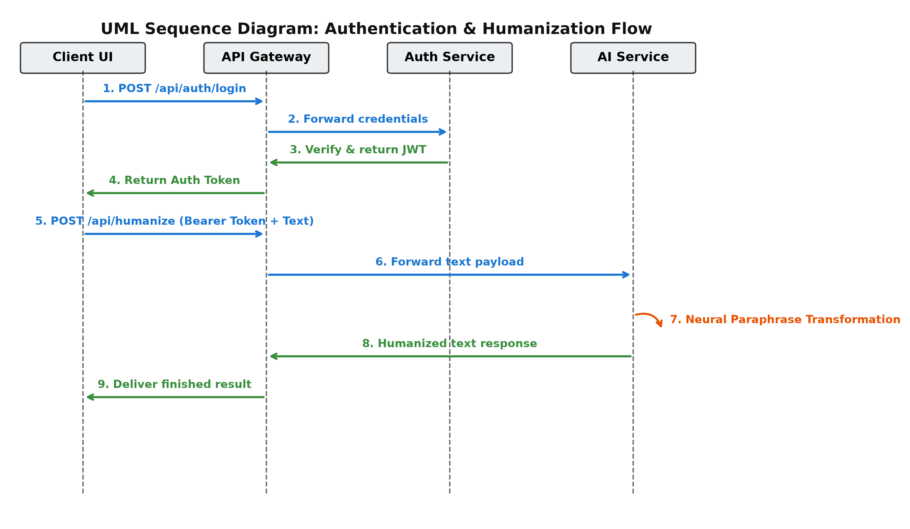
Figure 6.1: UML Sequence Diagram - User Authentication & AI Transformation

LAB EXPERIMENT 8
MODULAR DESIGN & SYSTEM ARCHITECTURE

8.1 Modular Decomposition Principles
High cohesion and low coupling govern the system's modularization. Each microservice resides in its own isolated module with dedicated configuration, dependency tree, and REST API interface.

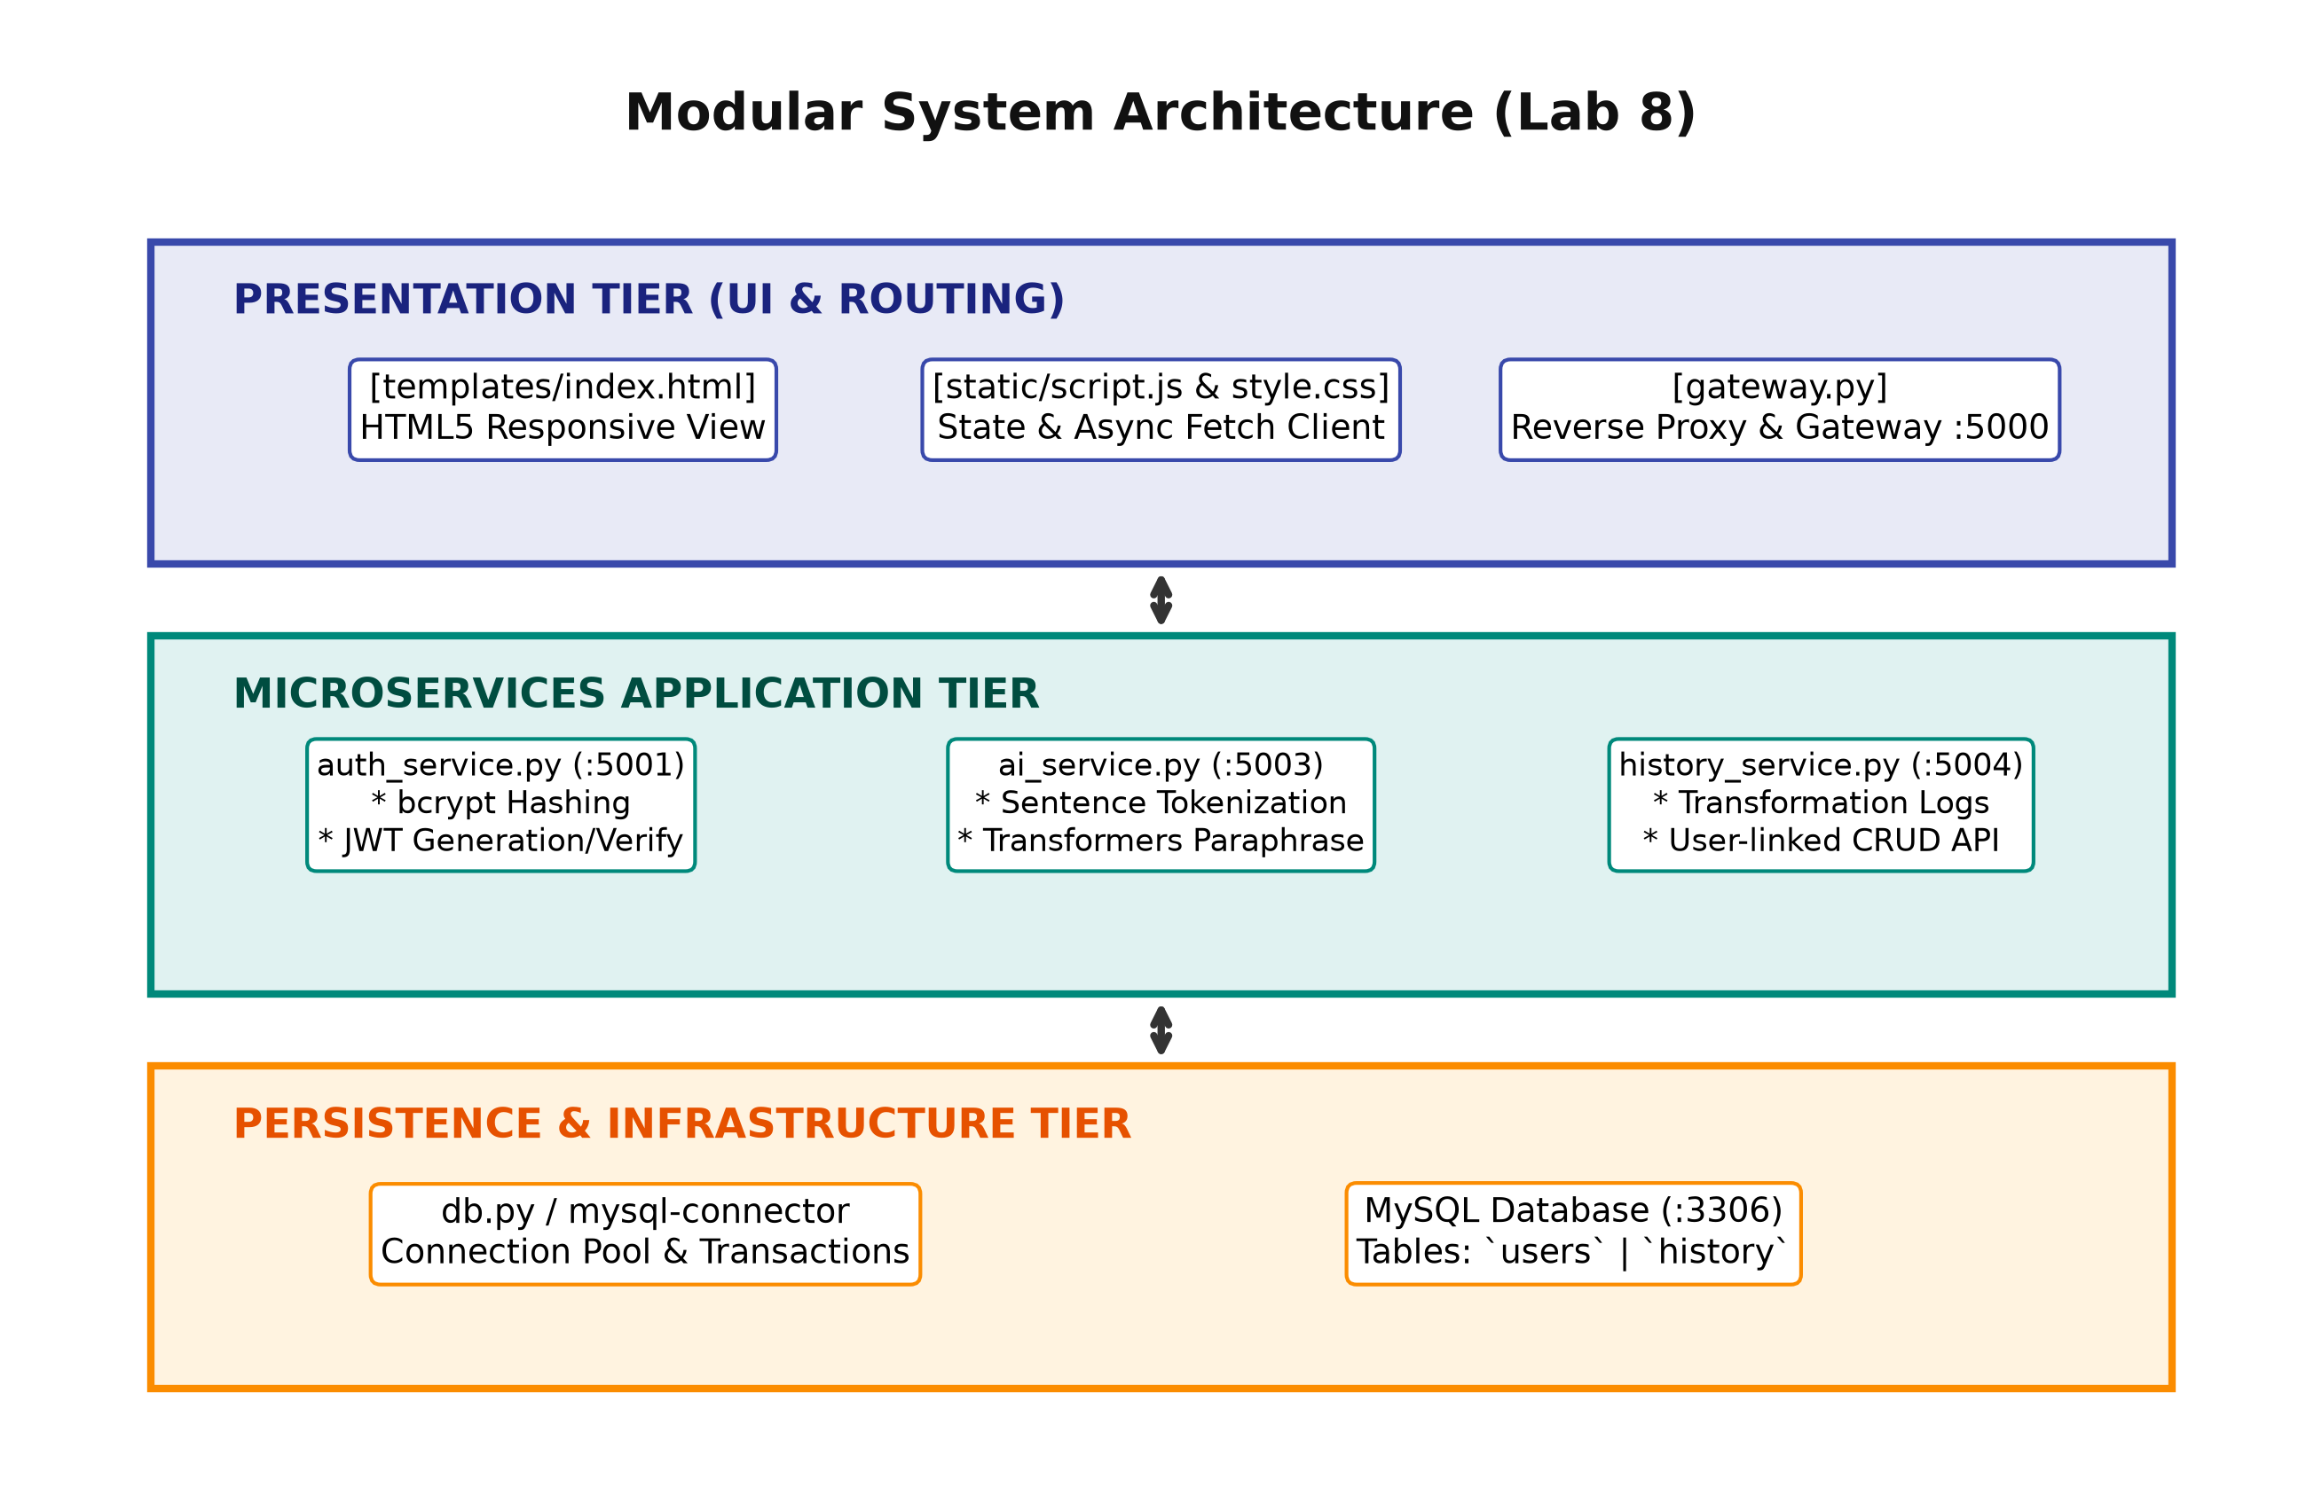
Figure 8.1: Tiered Modular Architecture Diagram

LAB EXPERIMENT 9
FUNCTIONAL TEST CASES

9.1 Test Suite & Verification Results
Comprehensive black-box and white-box test cases were executed against each microservice endpoint to ensure data consistency, error handling, and security.
Test ID | Test Scenario | Input Data | Expected Output | Status
TC-01 | Registration with valid data | New user credentials | HTTP 201 Created & DB entry | PASS
TC-02 | Login with valid credentials | Username & Password | HTTP 200 OK + Signed JWT | PASS
TC-03 | Login with incorrect password | Wrong password | HTTP 401 Unauthorized | PASS
TC-04 | Humanize valid AI text | 50-word AI paragraph | HTTP 200 OK + Paraphrased text | PASS
TC-05 | Save history record | Valid JWT + Text | HTTP 201 Created & Linked ID | PASS
TC-06 | Gateway fallback on service crash | Killed AI service | HTTP 503 Service Unavailable | PASS

OVERALL CONCLUSION & REFERENCES

Overall Conclusion
The CS545 Software Engineering laboratory coursework provided hands-on expertise across all software development lifecycle stages. Developing the AI-Powered Text Humanizer under a microservices paradigm demonstrated how requirement specifications, agile planning, UML diagrams, modular separation, and structured functional testing combine to produce resilient, high-quality distributed software. The resulting architecture effectively isolates failures, secures authentication via JWT, and delivers humanized text with high responsiveness.

References
[1] Pressman, R. S., & Maxim, B. R. (2020). Software Engineering: A Practitioner's Approach (9th ed.). McGraw-Hill.
[2] Newman, S. (2021). Building Microservices: Designing Fine-Grained Systems (2nd ed.). O'Reilly Media.
[3] Fowler, M. (2018). Patterns of Enterprise Application Architecture. Addison-Wesley Professional.
[4] Hugging Face Transformers Documentation, Paraphrasing & Sequence-to-Sequence Models, https://huggingface.co/docs/transformers
[5] Flask Documentation: Modular Applications with Blueprints and Reverse Proxying, https://flask.palletsprojects.com/

