**BUBBLE SORT**

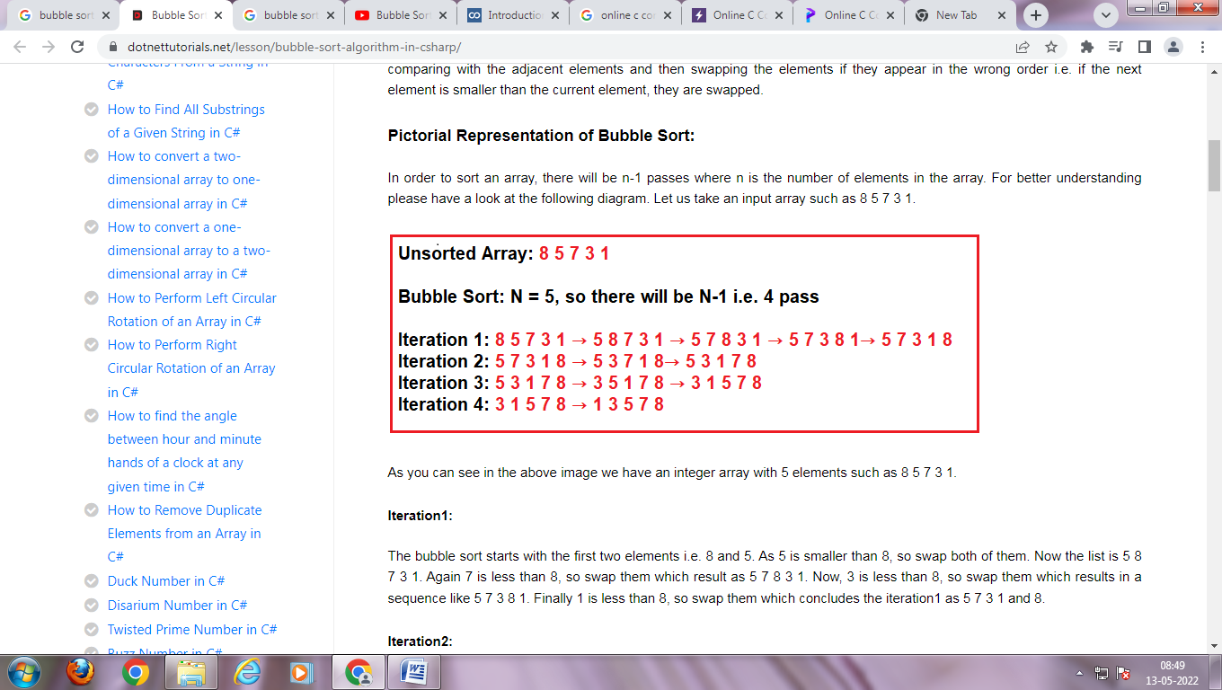



**PROGRAM**

**#include <stdio.h>**

**int main()**

**{**

**int a[50],n,i,j,temp;**

**printf("Enter Size of an Array :");**

**scanf("%d",&n);**

**printf("Values are");**

**for(i=0;i<n;i++)**

**scanf("%d",&a[i]);**

**for(i=0;i<n-1;i++)**

**{**

**for(j=0;j<n-1-i;j++)**

**{**

**if(a[j]>a[j+1])**

**{**

**temp=a[j];**

**a[j]=a[j+1];**

**a[j+1]=temp;**

**}**

**}**

**}**

**printf("Ascending Order Using Bubble Sort \n");**

**for(i=0;i<n;i++)**

**printf("\t %d",a[i]);**

**return 0;**

**}**

**OUTPUT**

**Enter Size of an Array :8**

**Values are**

**25 57 48 37 12 92 86 33**

**Ascending Order Using Bubble Sort 12 25 33 37 48 57 86 92**

**SELECTION SORT**

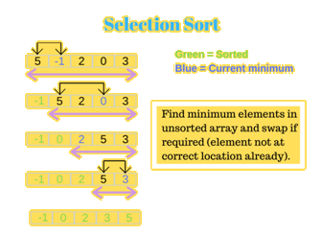

**Selection Sort**

**Algorithm for Selection Sort:**

**Step 1 − Set min to the first location**

**Step 2 − Search the minimum element in the array**

**Step 3 – swap the first location with the minimum value in the array**

**Step 4 – assign the second element as min.**

**Step 5 − Repeat the process until we get a sorted array.**

**#include <stdio.h>**

**int main()**

**{**

**int a[100], n, i, j, min,temp;**

**printf("Enter number of elementsn");**

**scanf("%d", &n);**

**printf("Enter Values");**

**for (i = 0; i < n; i++)**

**scanf("%d", &a[i]);**

**for(i = 0; i < n - 1; i++)**

**{**

**min=i;**

**for(j = i + 1; j < n; j++)**

**{**

**if(a[j]<a[min])**

**min=j;**

**}**

**temp=a[i];**

**a[i]=a[min];**

**a[min]=temp;**

**}**

**printf("Sorted Array:n");**

**for(i = 0; i < n; i++)**

**printf("%d \n", a[i]);**

**return 0;**

**}**