**PROGRAM TO COMPUTE MARKS OF STUDENTS FOR FIVE SUBJECTS USING STRUCTURES**

**AIM**

To write C program for Compute internal marks of students for five different subjects using structures and functions.

**ALGORITHM:**

Step 1.Start the program

Step 2. Read the value of rollno,name,5 subject marks.

Step 3. Enter the number of student using array

Step 4.Calculate total and average of students.

Step 5. Generate mark sheet report.

Step 6.print the result

Step 7.Stop the program

**PROGRAM**

#include<stdio.h>

#include<conio.h>

struct stud

{

int rollno, s1, s2, tot ;

char name[10] ;

float avg ;

} s[10] ;

void main()

{

int i, n ;

clrscr() ;

printf("Enter the number of students : ") ;

scanf("%d", &n) ;

for(i = 0 ; i < n ; i++)

{

printf("\nEnter the roll number : ") ;

scanf("%d", &s[i].rollno) ;

printf("\nEnter the name : ") ;

scanf("%s", s[i].name) ;

printf("\nEnter the marks in 2 subjects : ") ;

scanf("%d %d", &s[i].s1, &s[i].s2) ;

s[i].tot = s[i].s1 + s[i].s2 ;

s[i].avg = s[i].tot / 2.0 ;

}

printf("\nRoll No. Name \t\tSub1\t Sub2\t Total\t Average\n\n") ;

for(i = 0 ; i < n ; i++)

printf("%d \t %s \t\t %d \t %d \t %d \t %.2f \n",s[i].rollno,s[i].name,s[i].s1,s[i].s2,s[i].tot,s[i].avg);

getch() ;

}

**OUTPUT**

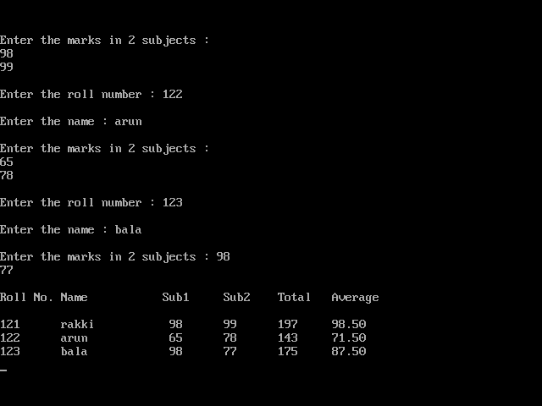

**RESULT**

Thus the C program for Compute internal marks of students for five different subjects using structures and functions is executed successfully and the output is verified.

**PROGRAM TO PRINT STUDENT DETAILS USING SEQUENTIAL ACCESS FILE**

**AIM:**

**To write a c program to print student details using sequential access file.**

**ALGORITHM:**

**Step 1: Start.**

**Step 2: Open a file *fp.**

**Step 3: Create a structure using structure name stud.**

**Step 4: Get the rollno,name and avg, inside the structure.**

**Step 5: write the content into file(student.txt).**

**Step 6: Then Print the student details.**

**Step 7: Stop**

**PROGRAM:**

#include<stdio.h>

#include<conio.h>

struct stud

{

int rollno, s1, s2, tot ;

char name[10] ;

float avg ;

}s[10];

void main()

{

FILE *f;

int i,n;

clrscr();

f=fopen("student.txt","w");

if(f==NULL)

{

printf("\n Error opening student.txt\n\n");

exit(1);

}

printf("Enter the number of students : ") ;

scanf("%d", &n) ;

for(i = 0 ; i < n ; i++)

{

printf("\nEnter the roll number : ") ;

scanf("%d", &s[i].rollno) ;

printf("\nEnter the name : ") ;

scanf("%s", s[i].name) ;

printf("\nEnter the marks in 2 subjects : ") ;

scanf("%d %d", &s[i].s1, &s[i].s2) ;

s[i].tot = s[i].s1 + s[i].s2 ;

s[i].avg = s[i].tot / 2.0 ;

fwrite(&s,sizeof(struct stud),1,f);

}

fclose(f);

f=fopen("student.txt","r");

if(f==NULL)

{

printf("\n Error opening student.txt\n\n");

exit(1);

}

else

{

printf("\n Roll No Name \t Sub1 \t Sub2 \t Total \t Average \n\n") ;

for(i = 0 ; i < n ; i++)

{

fread(&s,sizeof(struct stud),1,f);

printf("%d \t %s \t %d \t %d \t %d \t %.2f \n",s[i].rollno,s[i].name,s[i].s1,s[i].s2,s[i].tot,s[i].avg);

}

}

fclose(f);

getch() ;

}

**OUTPUT:**

**RESULT**

Thus the C program to print the student details using sequential access file is executed successfully and the output is verified.