Solar Cell Characaterization

Solar cells can modeled as a diodes. So to collect data I wired the two solar cells in parallel connected them to the input of the solar controller, connected the output of the solar controller to a battery, and connected the MPPC setting to a voltage source that I could vary the voltage on. The layout is in the following figure

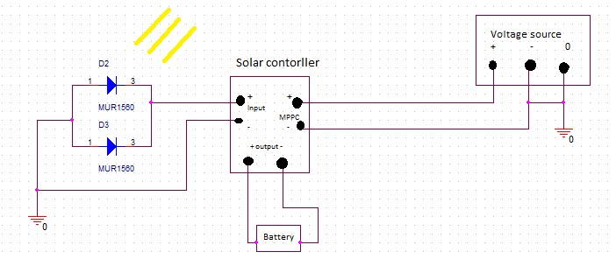

For the collection of data I first used cells 2 cells in parallel and varied the light intensity at MPPC setting that ranged from .5 volts to 4 volts. For each of the MPPC setting used the light intensity was varied from .1 sun to 1.1. After all the data was gathered it was stuck in to Microsoft Excel and sorted out by light intensity to compare the output power and see what MPPC setting had the highest power output for a given MPPC setting. The data in the following tables is what was collected. The tables show the power input vs output at a specific light intensity as the MPPC setting was varied. The yellow highlighted box is MPPC setting for the maximum output power at the that particular light intensity

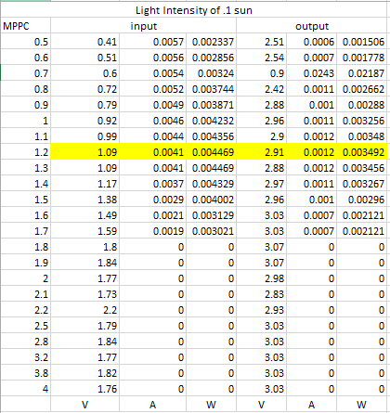 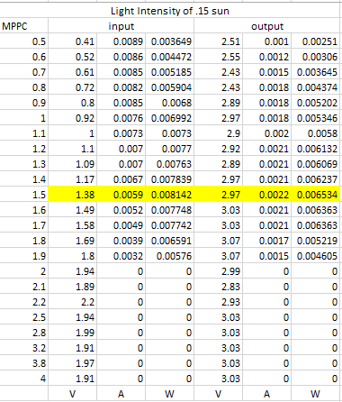

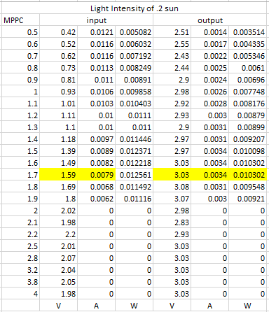 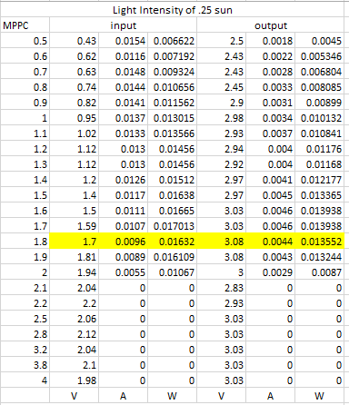

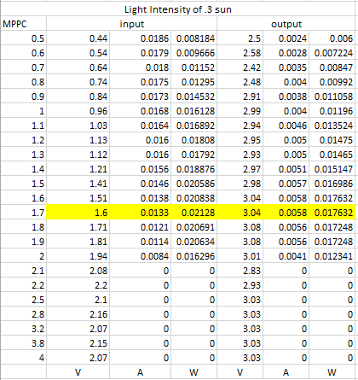 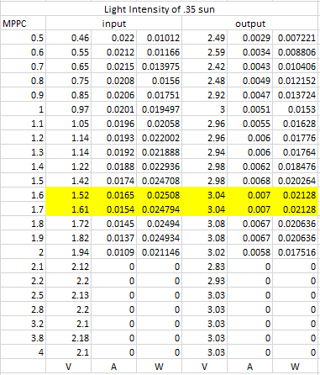

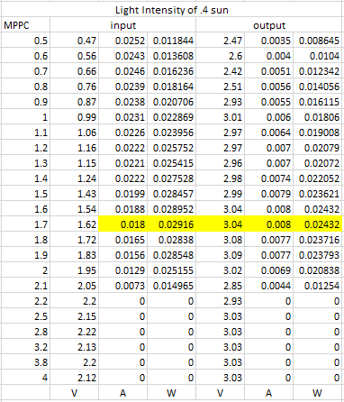 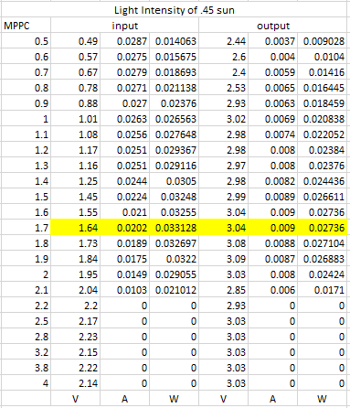

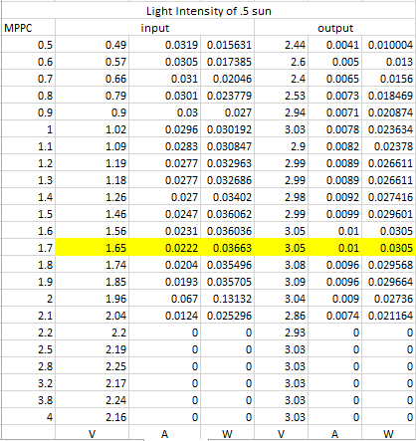 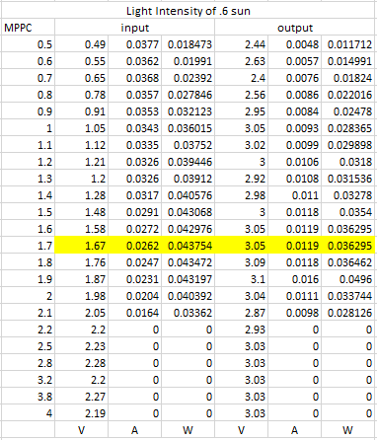

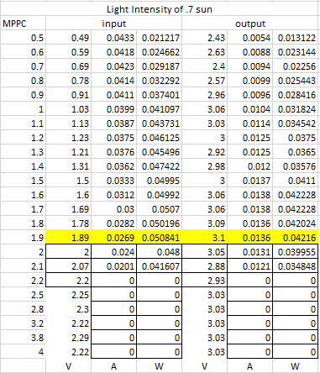 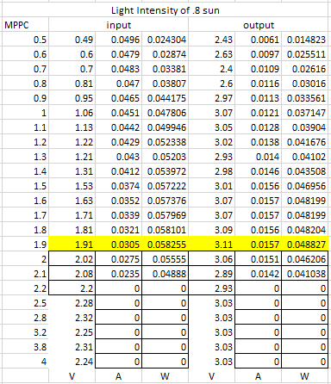

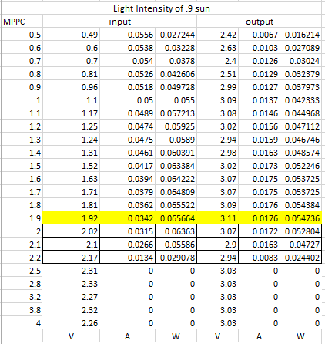 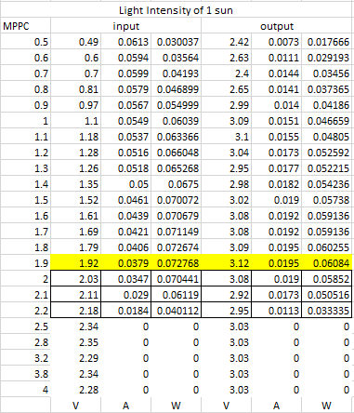

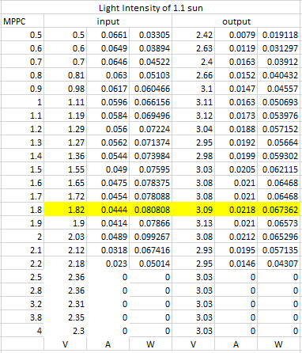

From those tables tables I was able to get a graph of the MPPC setting as a result of the light intensity. The graph is given below

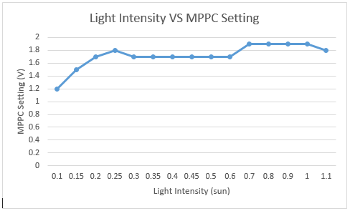

During testing the question whether a bypass diode was needed for the configuration that the cells were in given that some of them would be in direct light, others in partial light and some that would not be given any light at all. The concern being that the shaded cells would overheat and could malfunction as well as damage the circuitry. To test this I mounted 4 more cells on to test PCB boards and wired them all in parallel. I placed one board in the direct light, one board out of the light, to be illuminated by the light of the room to simulate partial illumination, and I placed the 3 board away from the others and covered it with a black piece of construction paper to stop all light. I took the temperature of the cells before beginning and all the temperatures were 23°C (approximately the temperature of the room). I then took all my data again varying the light intensity and the MPPC setting. After 2 hours of collecting data I measured the temperature of the cells. The cells under full illumination had risen to temperature of 39.2°C, the partially lit cells to a temperature of 23.9°C and the temperature of the cells that had no light did not change at all. I could attribute the temperature rise of the fully illuminated cells and the partially illuminated cells to the heat given off from the light machine. Thus indicating that no bypass diode would be needed. The layout for testing the temperature was basically the same as before but more cells in parallel. The following figure lays out how this was done

