SD Card Data Format - Animal Tracking Project

SD Card Organization
SD cards are organized in blocks each of which is 512 bytes. The tracking data will always be written in complete blocks starting from the first one and continuing sequentially. No block will normally be written after an unwritten block. (This latter situation may occur if a write fails leaving a, possibly unusable, block in an unwritten state.)
Each block starts with a 4 byte sequence number between $00000001 and $FFFFFFFE. The bit patterns $00000000 and $FFFFFFFF are not used as either can be used to fill unwritten blocks when the device is erased. Thus a valid sequence number indicates that the block has been written.
The data written to these blocks is organized in segments. Segments do not cross block boundaries. Each segment starts and ends in a single block. At the end of each segment is the segment trailer, a two byte data element which identifies the type of segment that precedes it. Segment trailers always contain the segment type and the length of the segment (excluding the length of the segment trailer itself). Putting them at the end of the segments allows segments to be written as their data accumulates rather than requiring the data to be buffered so that the length can be determined and written to a header before the data is. The end of each block (bytes 510 and 511) will always be a segment trailer. If no valid trailer is found here it indicates that the block is invalid and must be ignored.
Segment Type | Length : 1 - 255
7 6 5 4 3 2 1 0 7 6 5 4 3 2 1 0

Segment Types
There are currently a number of segment types. The most basic is the Padding Segment (segment type $01). It is used to mark the bytes within it as unused. Normally it is found at the end of a block to fill it out to the end. It is placed here when the next segment will not fit in the remains of the block or when the block needs to be immediately written out, even though not yet full.
The Status Segment (segment type $02) contains the status of the system at the time it is written to the block. It contains a two byte version number that identifies the format of the segment. Version 1 segments have the following format:
- 2 Bytes Version Number = $01.
- 2 Bytes Year of Project Compile.
- 1 Bytes Month of Project Compile.
- 1 Bytes Day of Project Compile.
- 9 Bytes FPGA Time. The FPGA time at which the status segment was assembled.
- 9 Bytes Last Accelerometer Sample FPGA Time
- 9 Bytes Last Magnetometer Sample FPGA Time
- 9 Bytes Last Gyroscope Sample FPGA Time
- 9 Bytes Last Temperature Sample FPGA Time
- 9 Bytes Last Audio Sample FPGA Time
- 1 Byte Number of microphones active
The GPS Time Mark Segment (segment type $03) contains time stamp data provided by the UBX TIM_TM2 packet. It contains the following information:
- 9 Bytes GPS Time Stamp. This GPS Time stamp comes from a TIM_TM2 packet where time is separated into week number, milliseconds into week and nanoseconds of millisecond.
- 9 Bytes FPGA Time that GPS Time Stamp is requested.
The GPS Position Segment (segment type $04) contains the position of the tracker at the given time as given by the UBX NAV_SOL packet:
- 1 Byte GPSFix Type
- 12 Bytes Signed XYZ ECEF Coordinates
- 4 Bytes 3D Position Accuracy Estimate
- 2 Bytes Position DOP
- 9 Bytes FPGA Time Associated with this coordinate
The IMU Gyroscope Segment (segment type $05) contains the IMU Gyroscope details of the tracker at the given time:
- 6 Bytes XYZ Gyroscope.
The IMU Accelerometer Segment (segment type $06) contains the IMU Accelerometer details of the tracker at the given time:
- 6 Bytes XYZ Accelerometer.
The IMU Magnetometer Segment (segment type $07) contains the IMU Magnetometer details of the tracker at the given time:
- 6 Bytes XYZ Magnetometer.
The IMU Temperature Segment (segment type $A0) contains the IMU Temperature details of the tracker at the given time:
- 2 Bytes Temperature.
The Audio Segment (segment types $08 - $0F) contains audio sample data acquired continuously. The format is as follows:
- n Bytes Audio Sample Bytes. Collected audio samples are stored here. They may not be multiples of 8 bits each. Consequently, the number of samples in a segment may not use all the bits in its last byte. The lower three bits of the Audio Segment Type indicate how many bits of the last byte are unused. The unused bits will be the top bits of the next byte. Version number 0x01 will use 16bit audio words and thus segment type will be 0x08.
The Event Segment (segment types $0B) contains event types and associated types since last event segment write. The format is as follows:
- n Bytes Event Count Bytes. This segment contains the counts of type event since the last event count segment was formed. Writing an event count segment will clear the event counts. Event count of 1 byte is followed by the event type which is 1 byte.

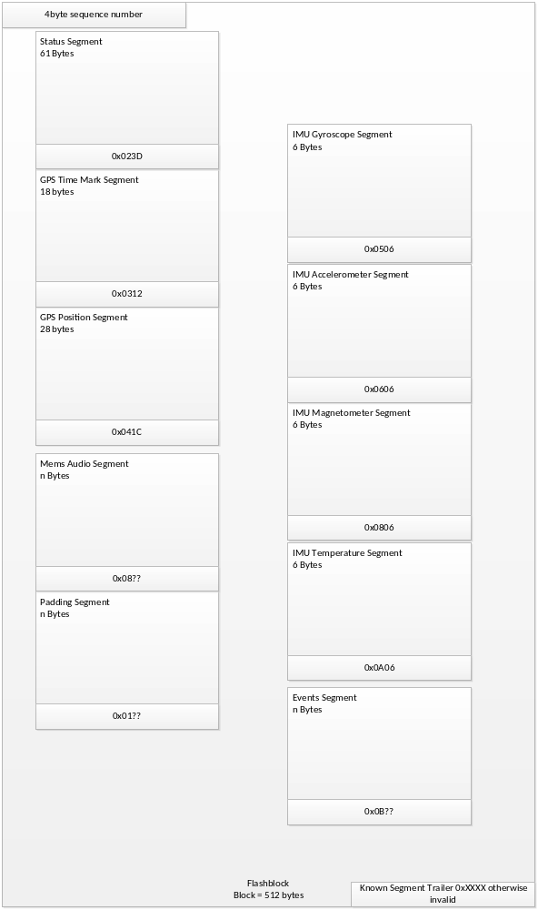

Changes:
Sector terminology changed to blocks exclusively.

