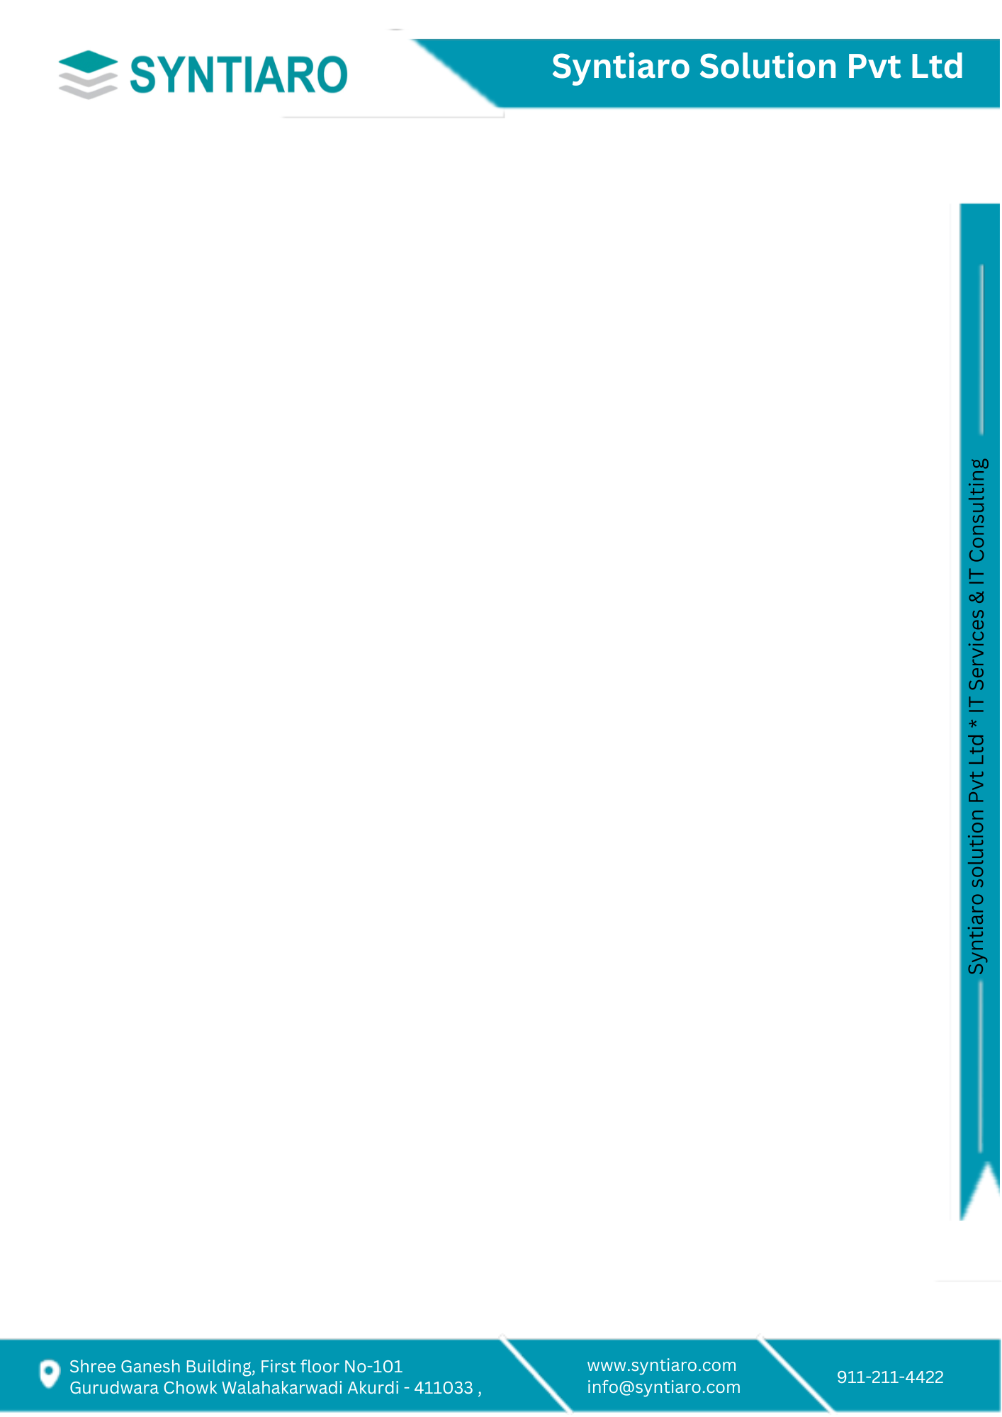

**Certificate**

**TO WHOM IT MAY CONCERN**

This is to certify that **Mr. Aakash Gavali** has successfully completed an internship with Syntiaro Solution Pvt Ltd. as an Digital Marketing Intern in the Department from **01-09-2023** to **30-11-2023.**

He has worked on the **UBSBill** Project under guidance of marketing manager. During the internship, he has gained several learnings such as keyword research & planning, social media ads, Canva graphic design, AI and developed considerable skills.

Besides showing high comprehension capacity, managing assignments and exhibiting maximal efficiency, showcased excellent moral character throughout the internship period.

I hereby certify his overall work as excellent to the best of my knowledge.

Wishing him the best of luck in his future endeavors.

Date: - 26-12-2023

For SYNTIARO,

**Authorized Signatory**