<https://openai.com/blog/image-gpt/>

reference- Andrew ng- courser – deep learning.ai

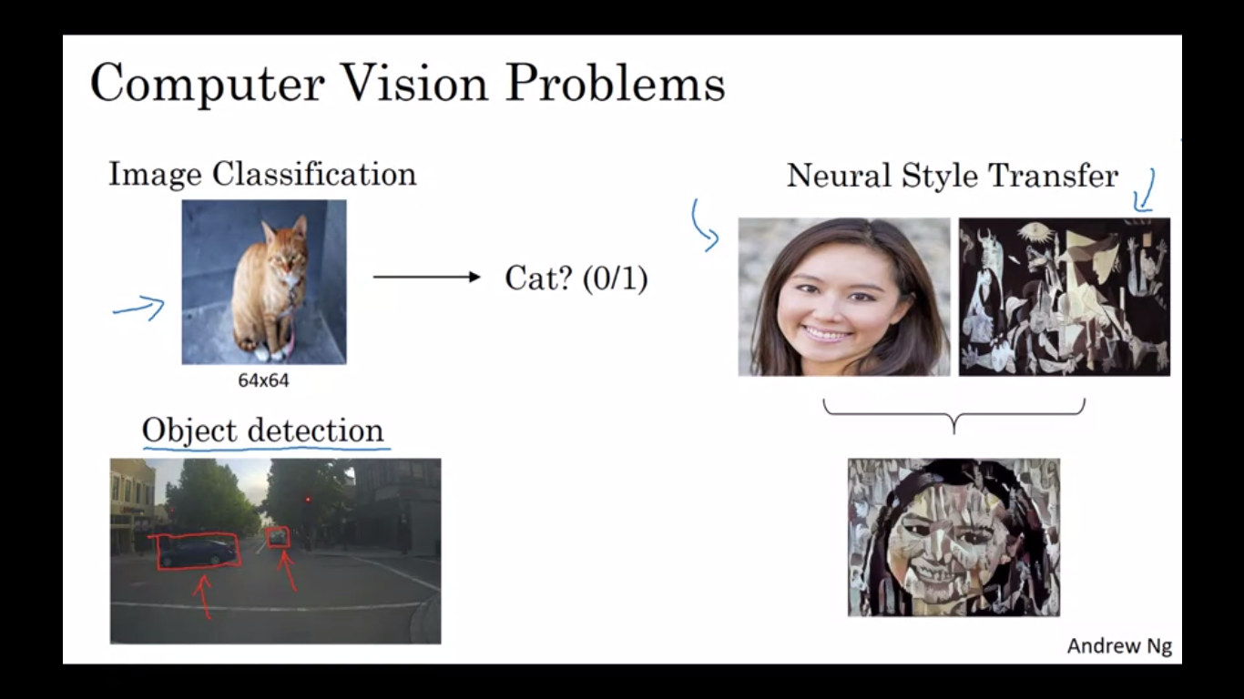

Computer Vision === ALGORITHMS-----

BOLTZMAN MACHINE 🡪> RBMs – Geoffrey Hilton

------- yann leCunn

CNN ----- LeCNN

AlexNet

VGG

Residual Net – ResNets

Inception Model

Generative Models

igpts -- openAI

GANs

[ESRGAN:](https://arxiv.org/abs/1809.00219)

---------------------------------

