Function and it’s derivative

$$f\left(x\right)={3x}^{2 }-3x+4$$

For a power function

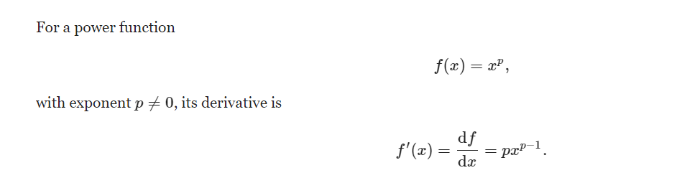

Power rule :-

$\frac{dy}{dx}=2*3*x^{2-1}-3*1*x^{1-1}$

$$\frac{dy}{dx}=6*x^{1}-3*x^{0}$$

$$\frac{dy}{dx}=6x-3$$

$6x= 3$

$$x= \frac{3}{6}$$

$$x= 0.5$$