$$Understanding tf.data.Dataset.interleave()$$

It was hard for me to go over the interleave documentation and understand how it works so I thought of writing of this blog which makes the understanding of interleave API clear. Hope this helps in clearing the doubts.

Let’s follow along the example in the documentation:

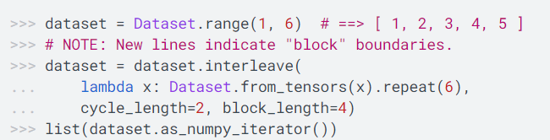

The output of the above program is as follows:

[ 1, 1, 1, 1,

2, 2, 2, 2

1, 1,

2, 2,

3, 3, 3, 3,

4, 4, 4, 4,

3, 3,

4, 4,

5, 5, 5, 5,

5, 5]

* Cycle Length 🡪 2

There will be 2 input elements which will be processed concurrently. In this case element 1 & 2 will be processed at the same time.

* Block Length 🡪 4

The number of consecutive elements to produce from each input element before cycling to another input element, in this case 4 element will be produced from each input element.

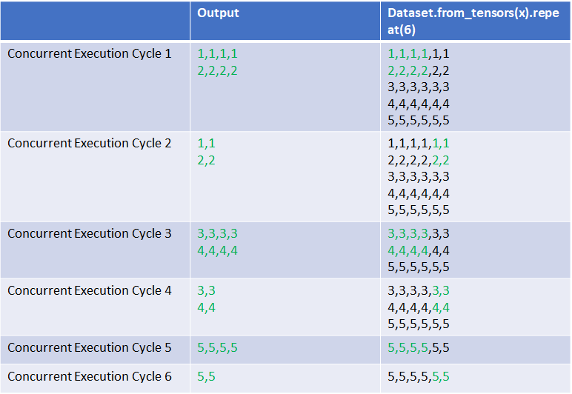

Hope this helps. Let me know if any questions/suggestions.

References:

<https://www.tensorflow.org/api_docs/python/tf/data/Dataset#interleave>