GIT
Git is a version control system.

Let,s see what we can do with it:-

To initialize firs of all we need to download and setup git in our system.
We can download it from git-scm.com

then we install it according to our Oprating system
Guide to install git in your system is avilable here.

Now open bash in the folder in which you have your project and start git here with command-
git init

by this command git will we initialized in that folder. Here you will also get a folder named ‘.git’ in folder. And now we can apply version control on that folder.

Git status:-
This shows which changes you have done within folder.its command is-
git status
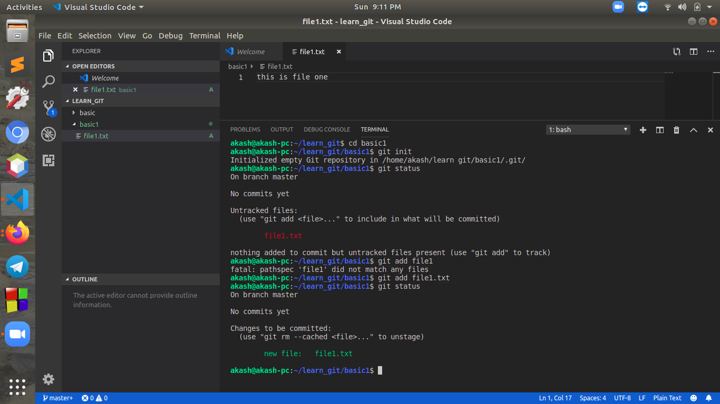
Here we can see first we started git by ‘git init’ command.
Then we run command ‘git status’ we can see it is showing that there is an untracked file.
It is like there exist some files which are not attched with your version control system which is git.

So now add our work in git system. Command for it is
git add <filename>
it will add that file in git. We call it staging. It means that our project is ready to commit as an version, “But still not commited”. One more thing to notice that we need to add exact file name with extension. We can still ustage is and make some changes, becouse it is ready to commit but still not commited. Command for unstaging is as given:
git rm –-cached <filename>
we can also unstage a file using command:
git reset HEAD <filename>
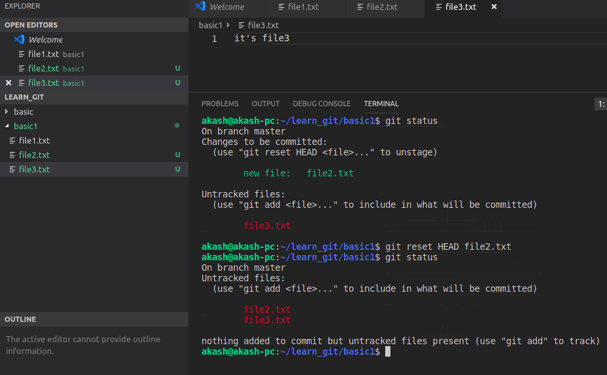
If we are working on a project and there are lots of unadded files so it becomes difficult to add them one by one. Then we can add them all at onne time too with command:
git add.
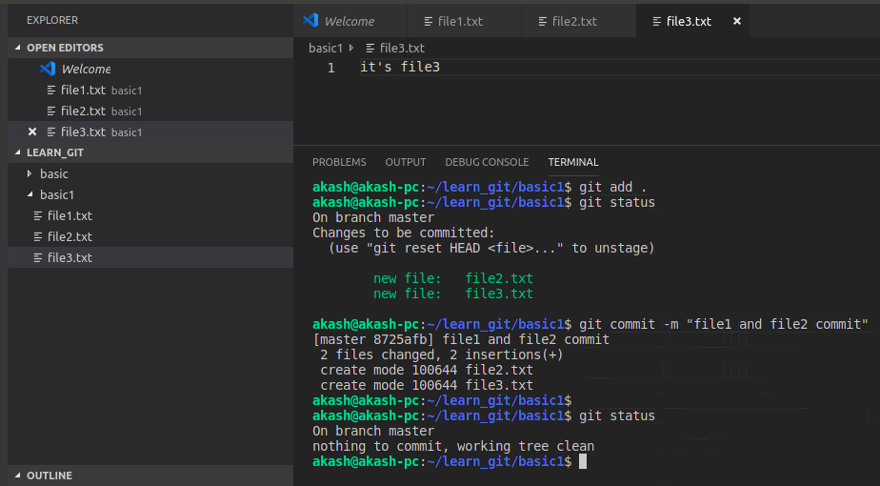
this command will add all un added file in git
By term “commit” it means that you tell git your project as an version. After commit that instance of your project get recorded by git. Command for commit is:
git commit -m “<message>”
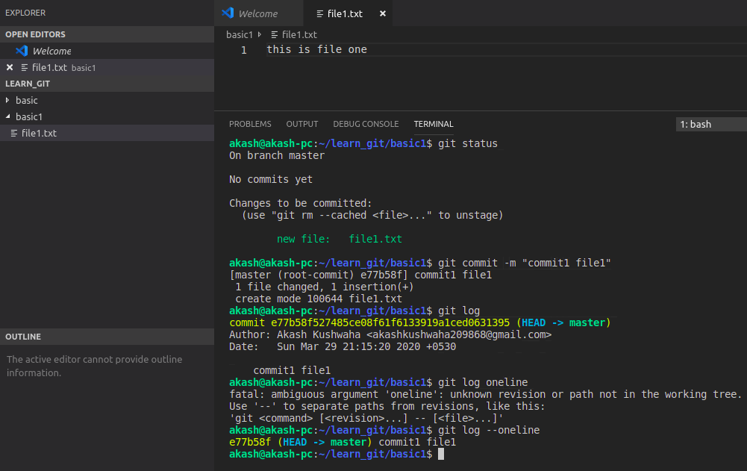
by this command our project get commited to git. And git keeps it as an version. Git issues this version a 40 charector long ID. We call this ID “saw one ID”, this ID is basiclly made by encryting project files and their names. In future when-ever we want we can retrive our data with help of this ID. Another very importent thing is message. While working on a big project there are lots of commits after every improvement we do commit so it gets cofusing to know which change has been done in which commit. So we pass a meaningful message about changes have been done.
To see what about commits there is a command:
git log
with this command we get information about previous commits. Here we get 40 charector of saw one ID(in yellow colour). Then “HEAD”, HEAD indicates where we are currently working. Then it shows info about Author. After that new line it showes the messange we have passed at the time of commit. When there is lots of commits then it become lots of info together. So git also provides us a feature by which we can see thies logs in one line only. The command is:
git log --oneline
It shows only first 7 charector of saw one ID then HEAd and then Massege which you passed at the time of commit.

After a commit if we make chnages in any file but we want to discard them all then we use command:
git checkout -- filename
using this command we can discard all the changes done in file after last commit.
Git also provides us branching facility. While working on a project, sometimes we want to try some other feature. So doing the changes in main code sometimes bring some problems. So we can create a branch of whole project. It provides you all the project and you try thing on it an you do commit. But all these action don’t affect the main code. After doing thing in branch if we feel right then we can murge a branch back to main code. Banching is also used when more then one people work on same project. the The command for creating a branch is:
git branch <branch name>
to know in which braanch we are currently working in we use command:
git branch

by default when we start working with git we get a main branch named “master” main programe remain in master branch. When we we create branch and work in that branch. That branch does not show up in master branch unless we merge that branch back in master. If we want to switch in a branch from another branch. We use command:
git checkout <branch name>

And if want to create a branch and also wnat to switch to it at the sametime, then we use command:
git checkout -b <branch name>
HEAD always reamin on where last commit has been done. If had not done any commit after creating a branch then it HEAD remain in both branches.
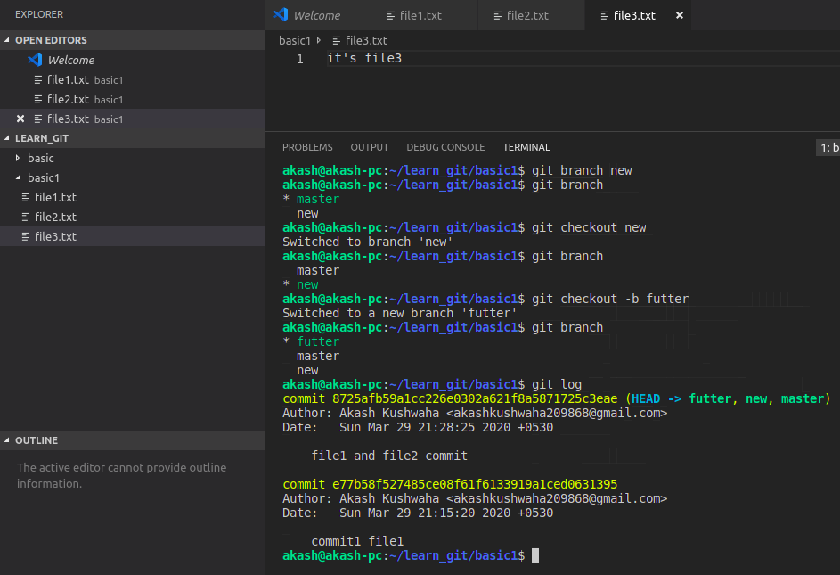
Here examples are given related to all above branch related commands.

Now if we make some changes in any one of file in one branch and commit it. Then it Head goes in that branch. Changes and commits done in this branch does not show up in any other branch.
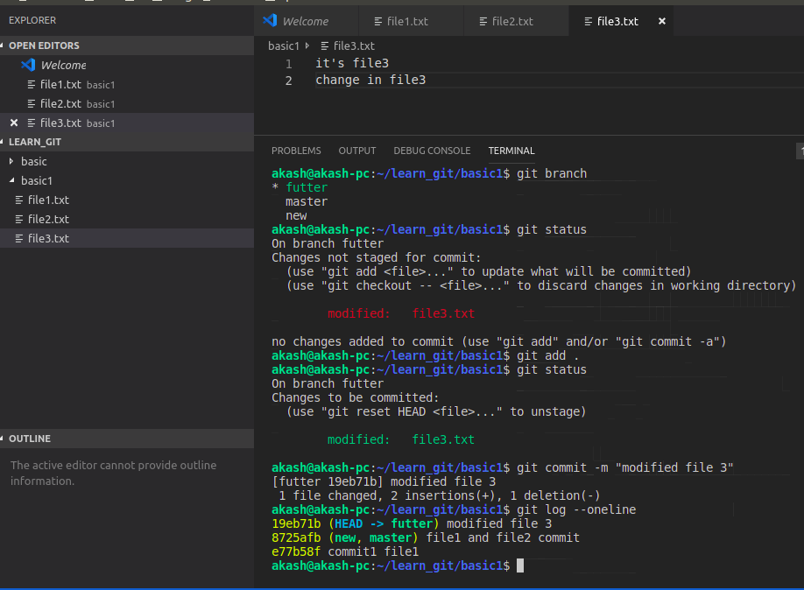
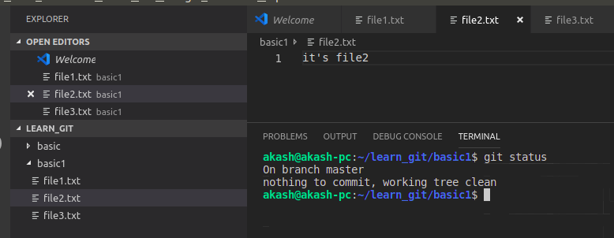
Now if we go to previous branch then we will see that chnages done here won’t reflect in another branch.
Now let’s talk about “.gitignore”.

