**Starting page:**

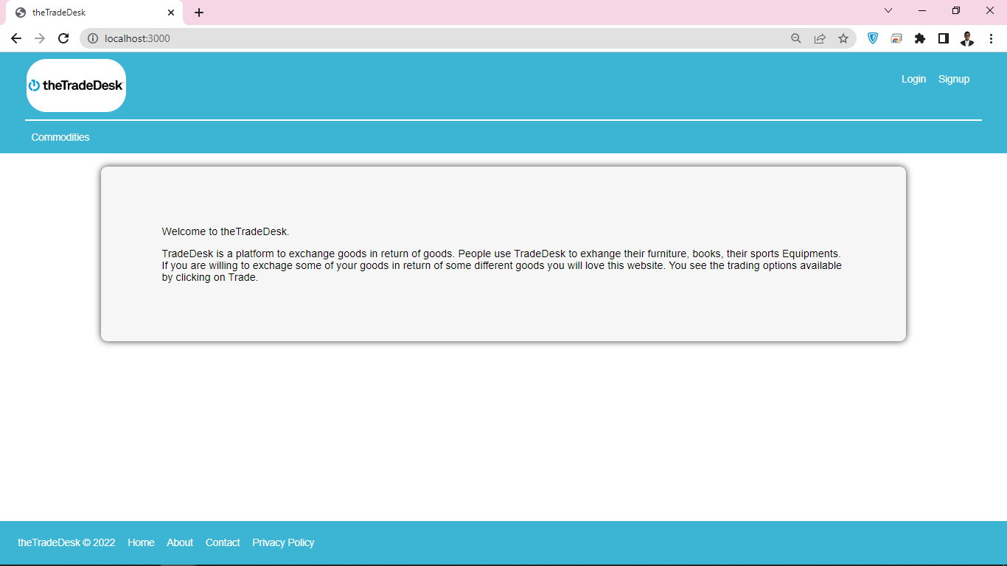

Can view commodities but cannot edit them:

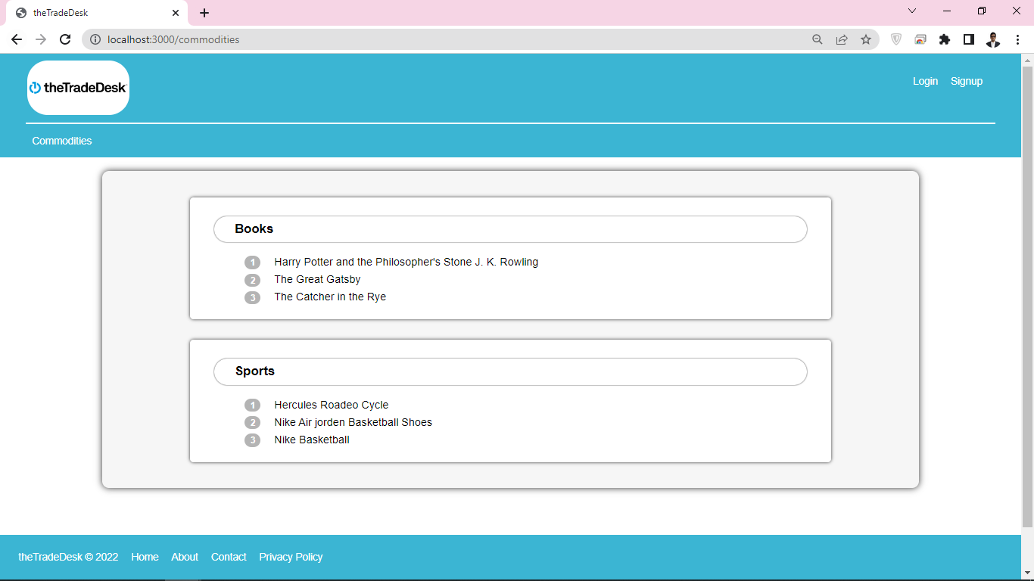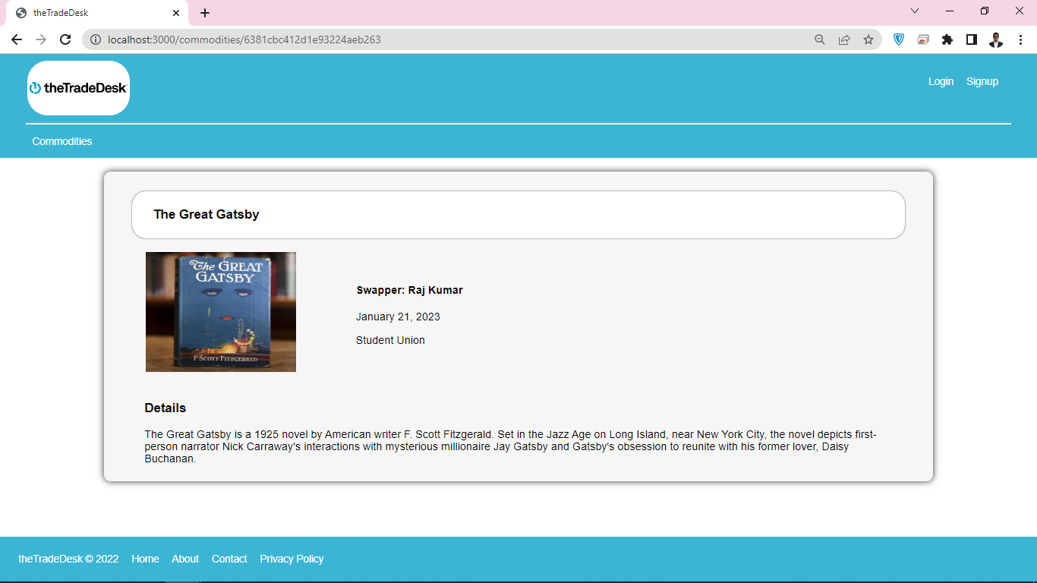

You can see there is no edit or delete button.

**LoginPage :**

If you are a new user you need to Sign up first before logging in.

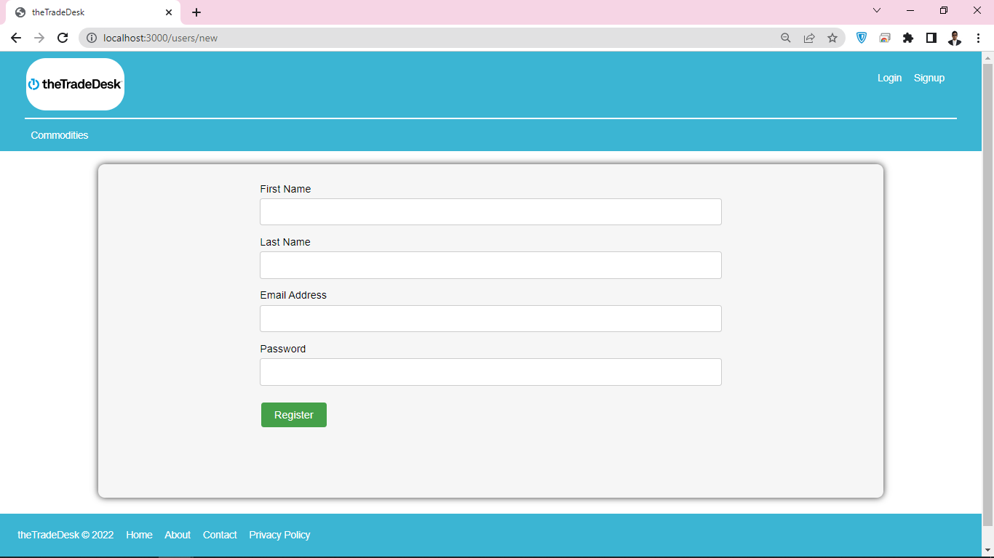

Now trying to logIn:

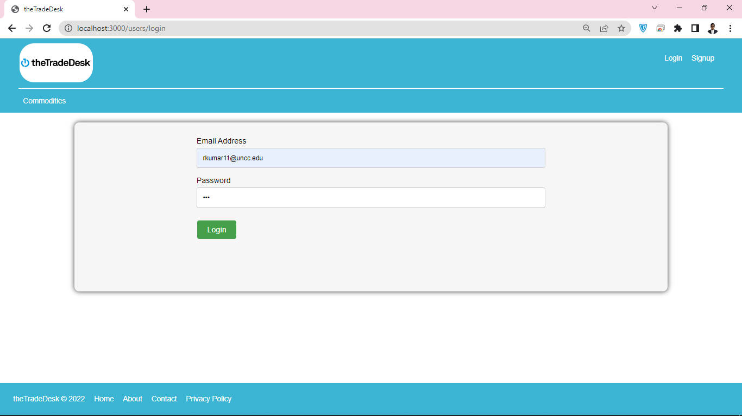if your email id or password is wrong it will display accordingly. As shown in the diagram as follows:

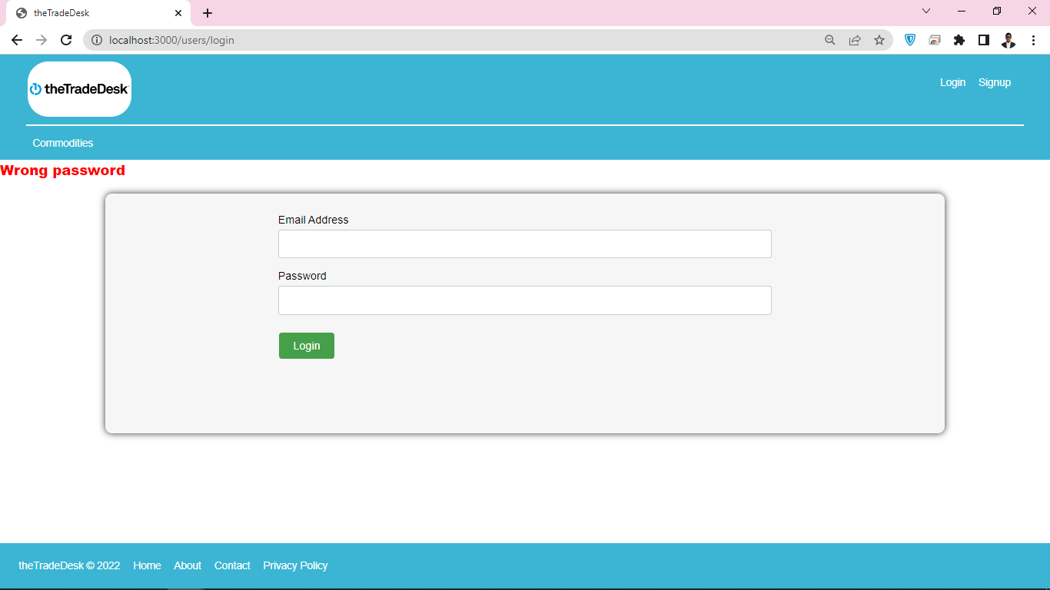

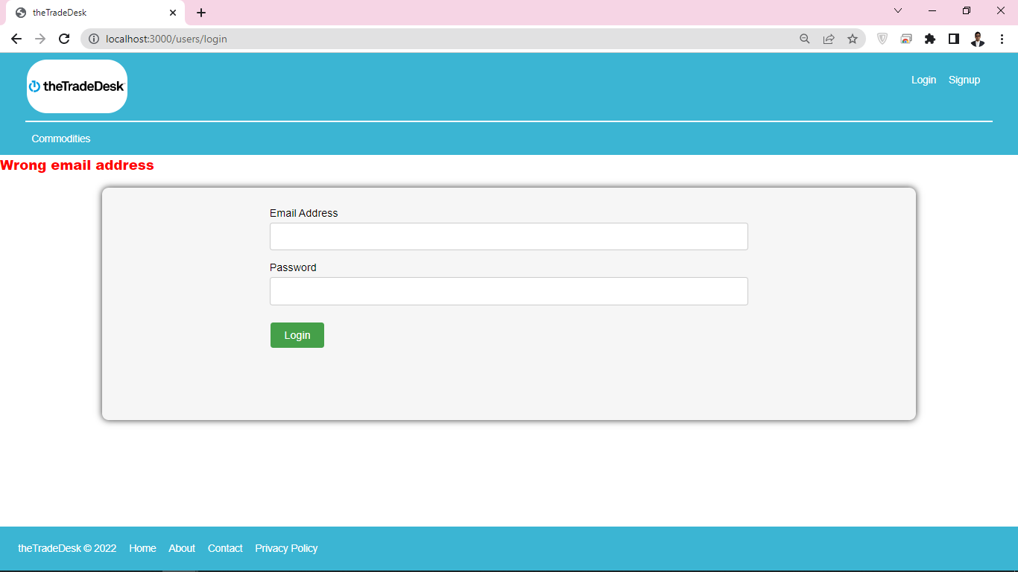

**After Login:**

After successful login, it will show all the trades placed by you, In the profile.

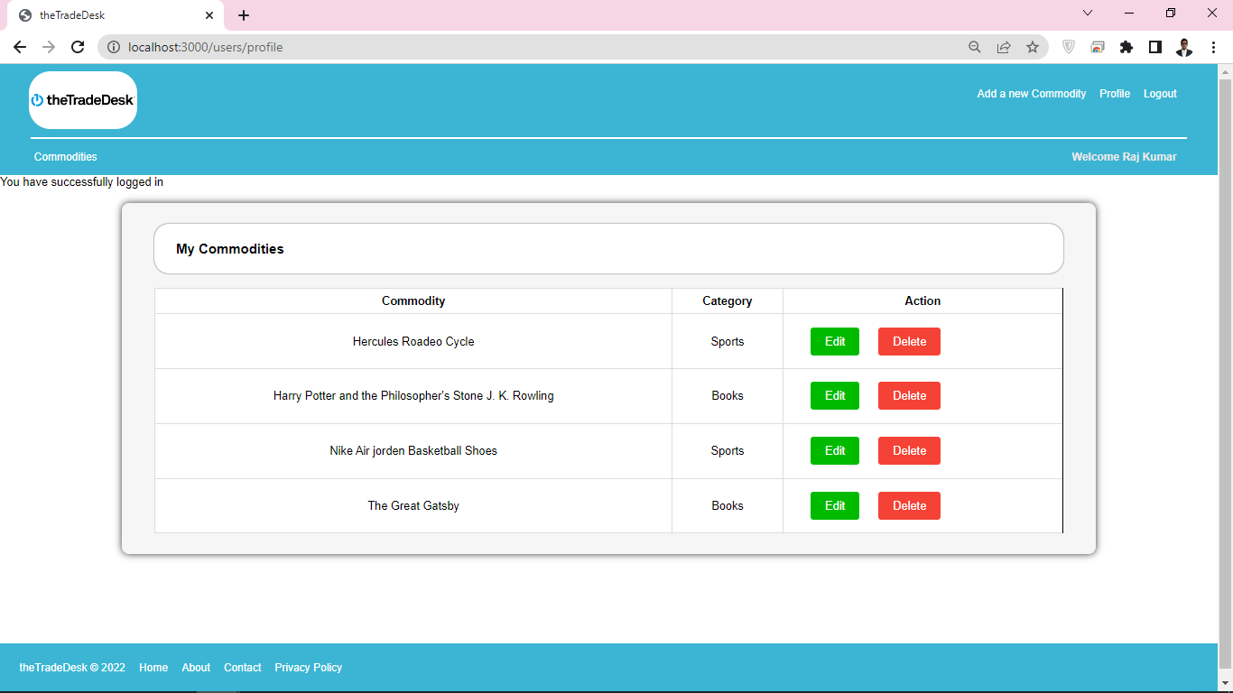

And here you can edit and delete them. And you are only allowed to edit your trade.

The editing page is shown as follows:

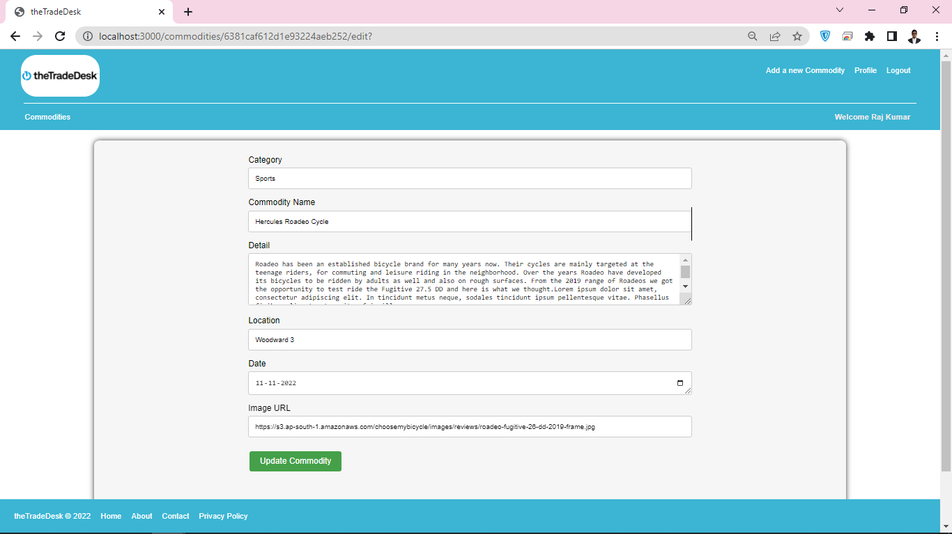

If you will try to edit someone else’s data it will prompt you with 401 ERROR as follows:

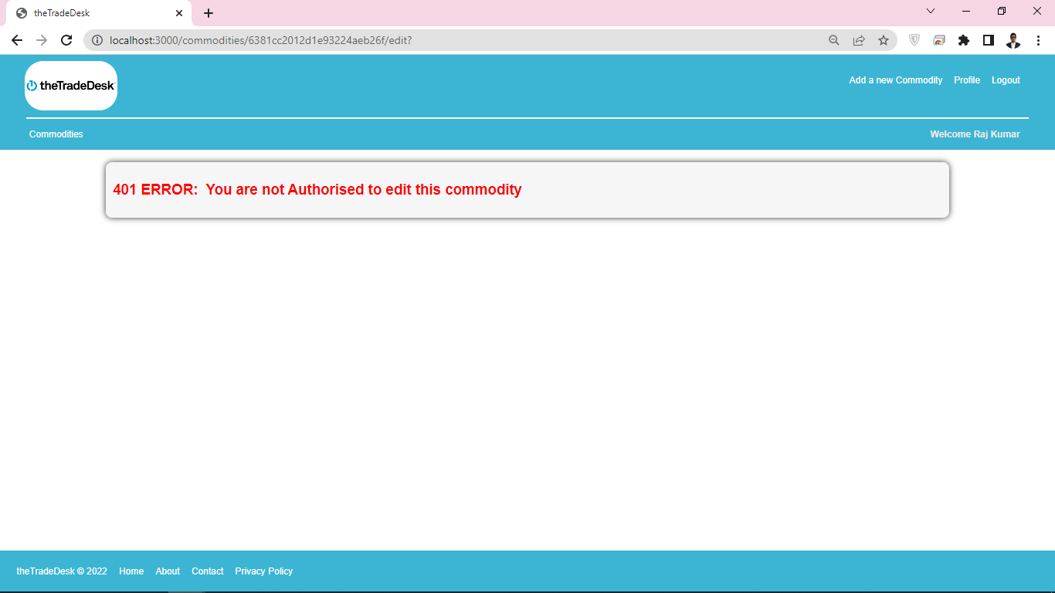

Similarly, if we try to delete the object without authorization we will be prompted with the same error.   
(I tested this using Postman, Since we can not see the delete button anyway for the unauthorized commodities.)

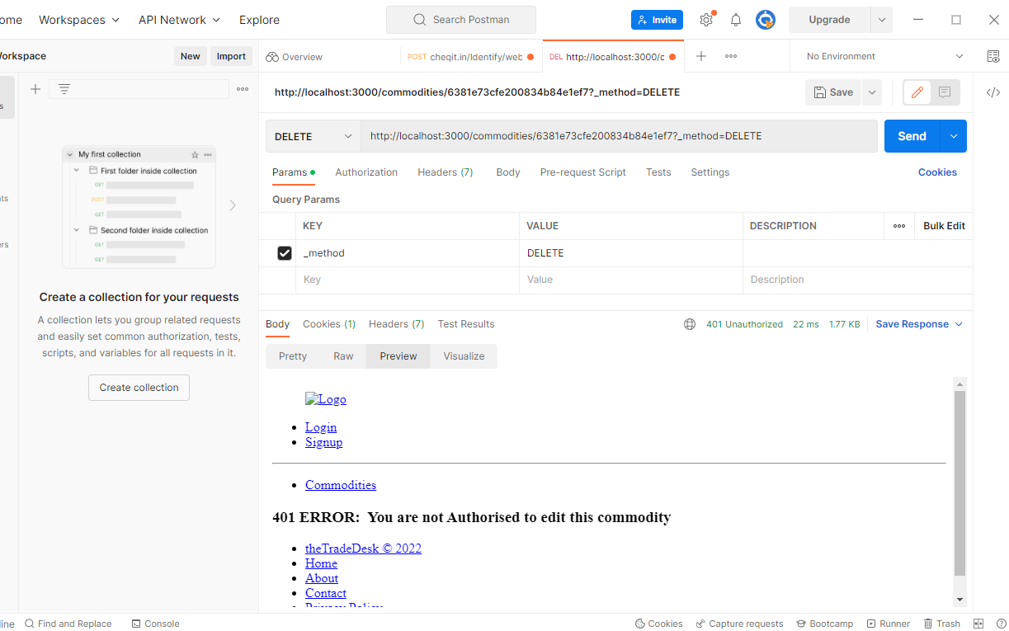

Also, At any point of the application you try to enter any invalid message id it will prompt you as follows: (using middleware)

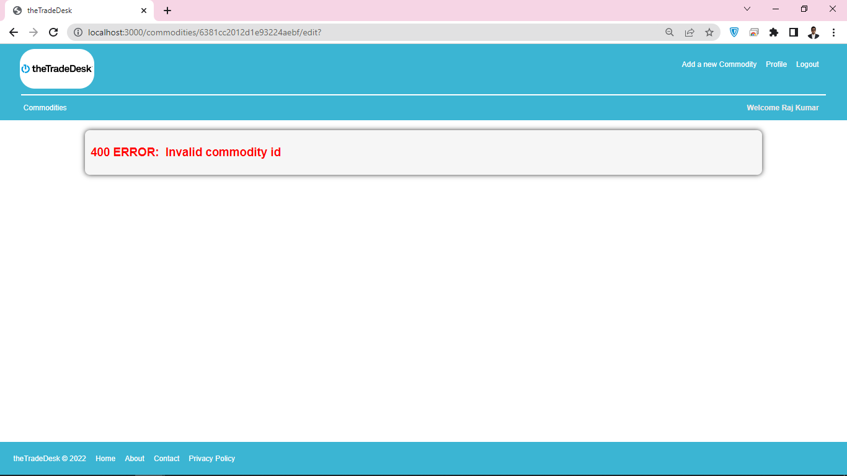

**User-Defined Access:**

You can only edit or delete your own commodity but you are allowed to view other’s commodities:

As you can see in the following screenshot you can’t see any edit or delete button,

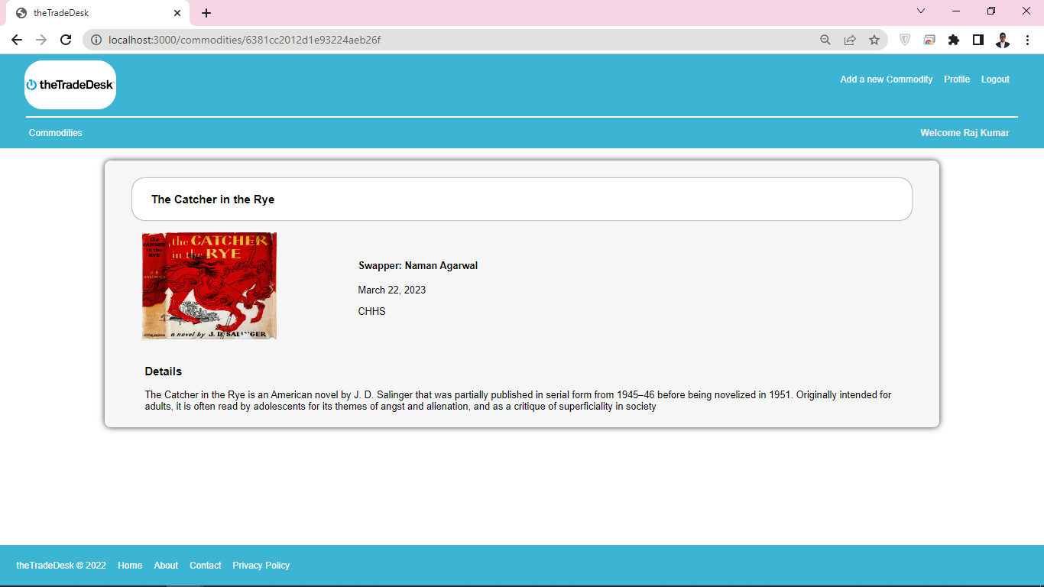

But you can see those buttons in the next screenshot: because they are your own commodities

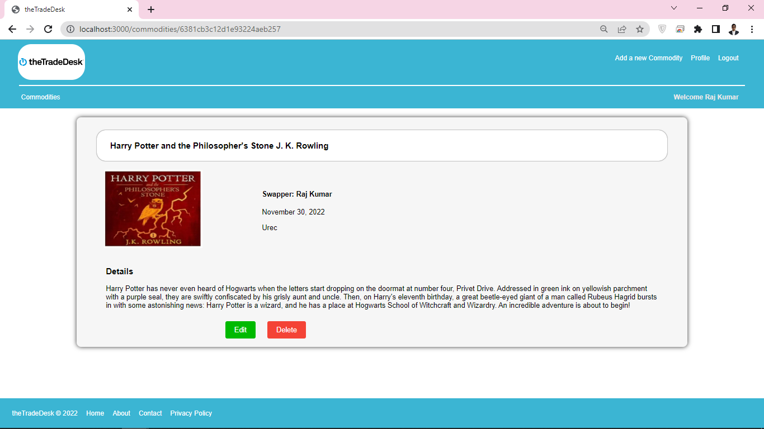

**Adding Commodities:**

You can navigate to the top right corner of the page “Add a Commodity” to add more commodities under your profile. And you need to enter the following details:

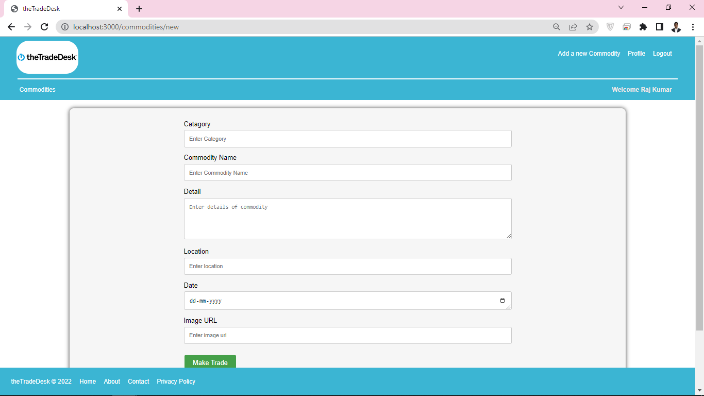

And once you are done with the treading you can sign out. That will close your session.

And It will navigate to the starting page of the application.