This purpose of this exercise is to understand how to import dataset from CVS files for Gephi. We will use highway maps around San Francisco Bay area as an example.

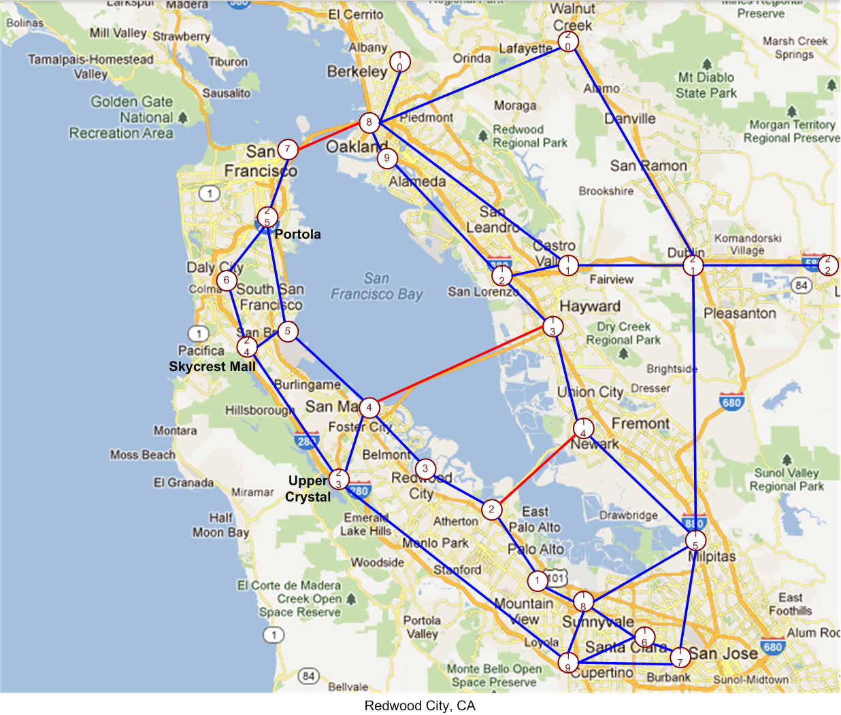

Two CVS files are needed: one for links (SanFranciscoBayGraphEdges.xlsx) and one for nodes (SanFranciscoBayGraphNodes.xlsx). We will use the distance between towns, from Google map, as the weight of link.

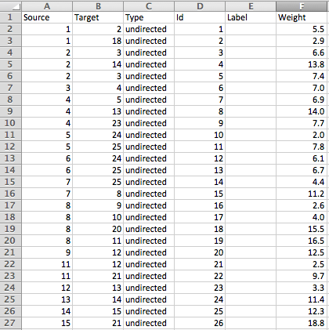 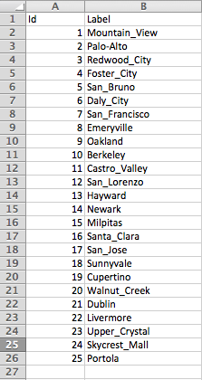

**Figure 1 Partial List of Links and List of Nodes**

Referring to wiki page: <http://wiki.gephi.org/index.php/Import_CSV_Data>

File > New Project > Data Laboratory (1) > Import Spreadsheet (2)

Select CVS file to import (3), Set the table type will be saved (4), **Make sure step-3 and 4 matches.** Then click Next button (5)**.** Select options and click Finish button (6).

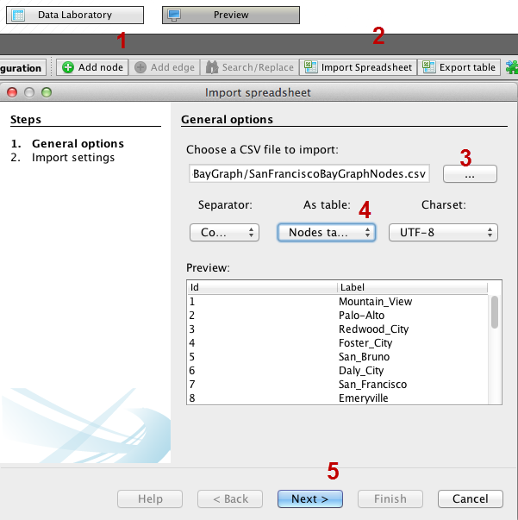 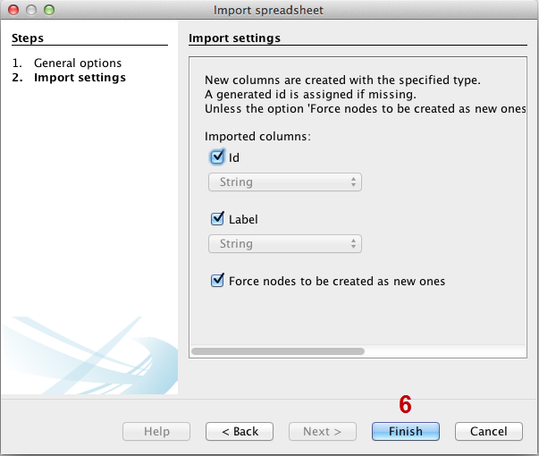

Then we will import CVS file with edge information., step-7 to 10. Make sure step-7 and 8 matches.

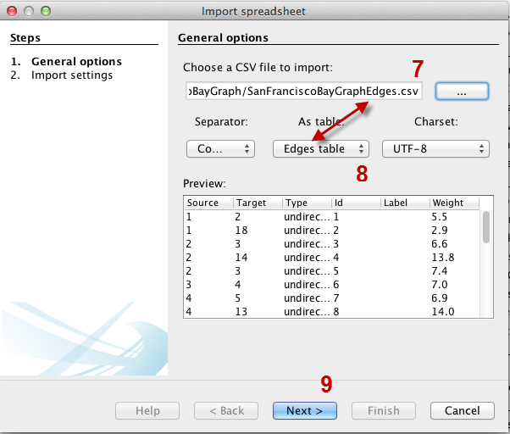 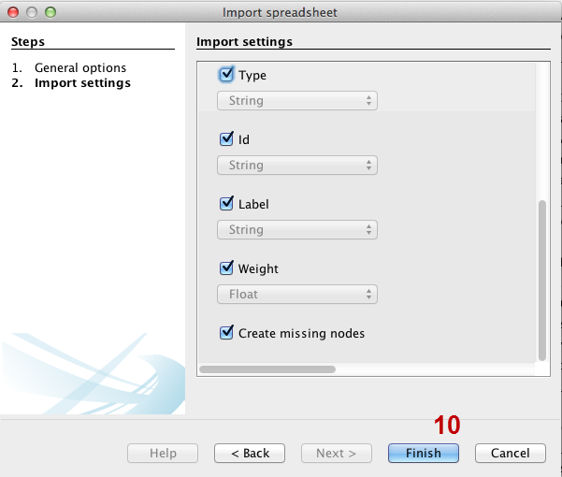

This results a dataset graph as below:



Save file as a gephi file, Run same statistic calculations, set Ranking =Weighted Dimension (1-100), select color for different nodes, and set Layout=Fruchterman Reingold, then Run.

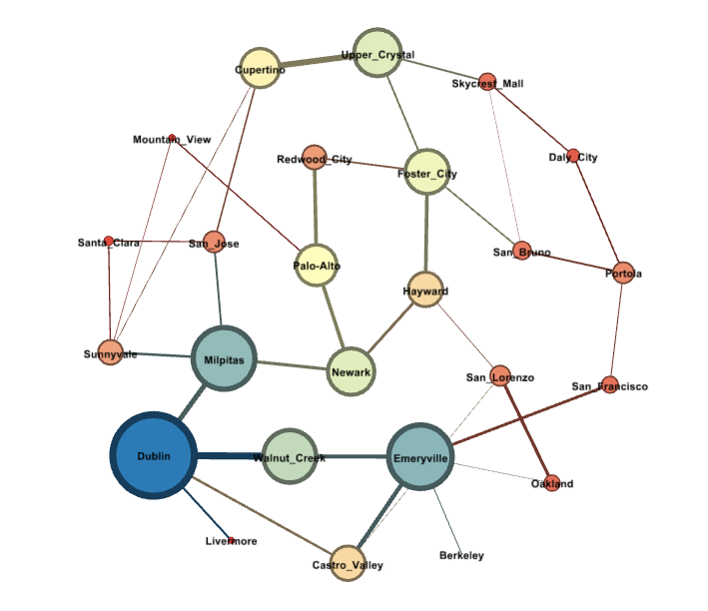

Create Neo4j dataset

File > Neo4j Database > Export > set default = 1

SanFranciscoBayGraphNeo4j. This becomes directory name for Neo4j dataset.

Other dataset examples: <http://example-data.neo4j.org/>