Rebar Ali

SCI5551

Yugyung Lee

Oct. 6, 2013

**IIS_Lab3**

1. I installed and configured IIS on Cloud remote machine. I deployed the service in Tutorial 5 package to my instance as shown in figure below:

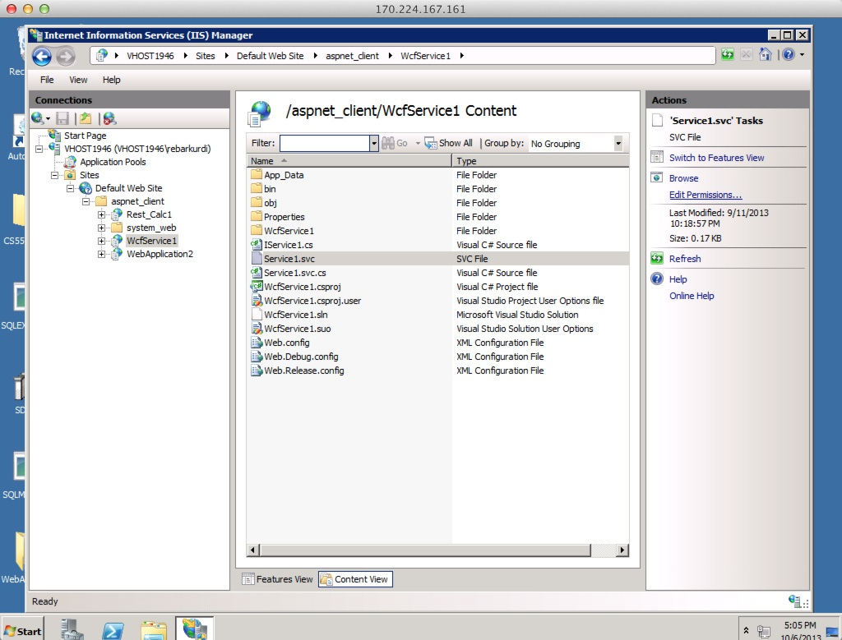

1. I have accessed to the WcfService from my local machine browser to the cloud instance after deployed it as shown in figure below:

