Rebar Ali

CS551

Midterm Exam

**Gift Registry**

1. I have created a login session page in ASP.net.

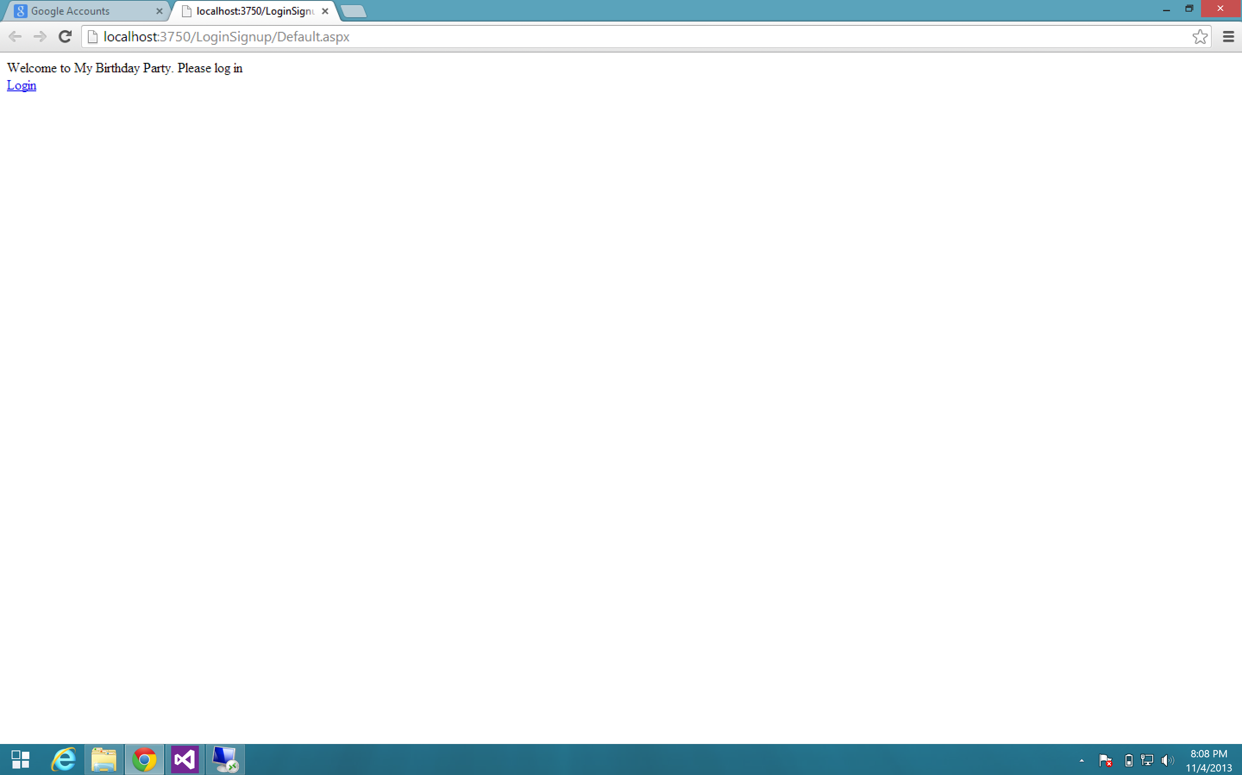

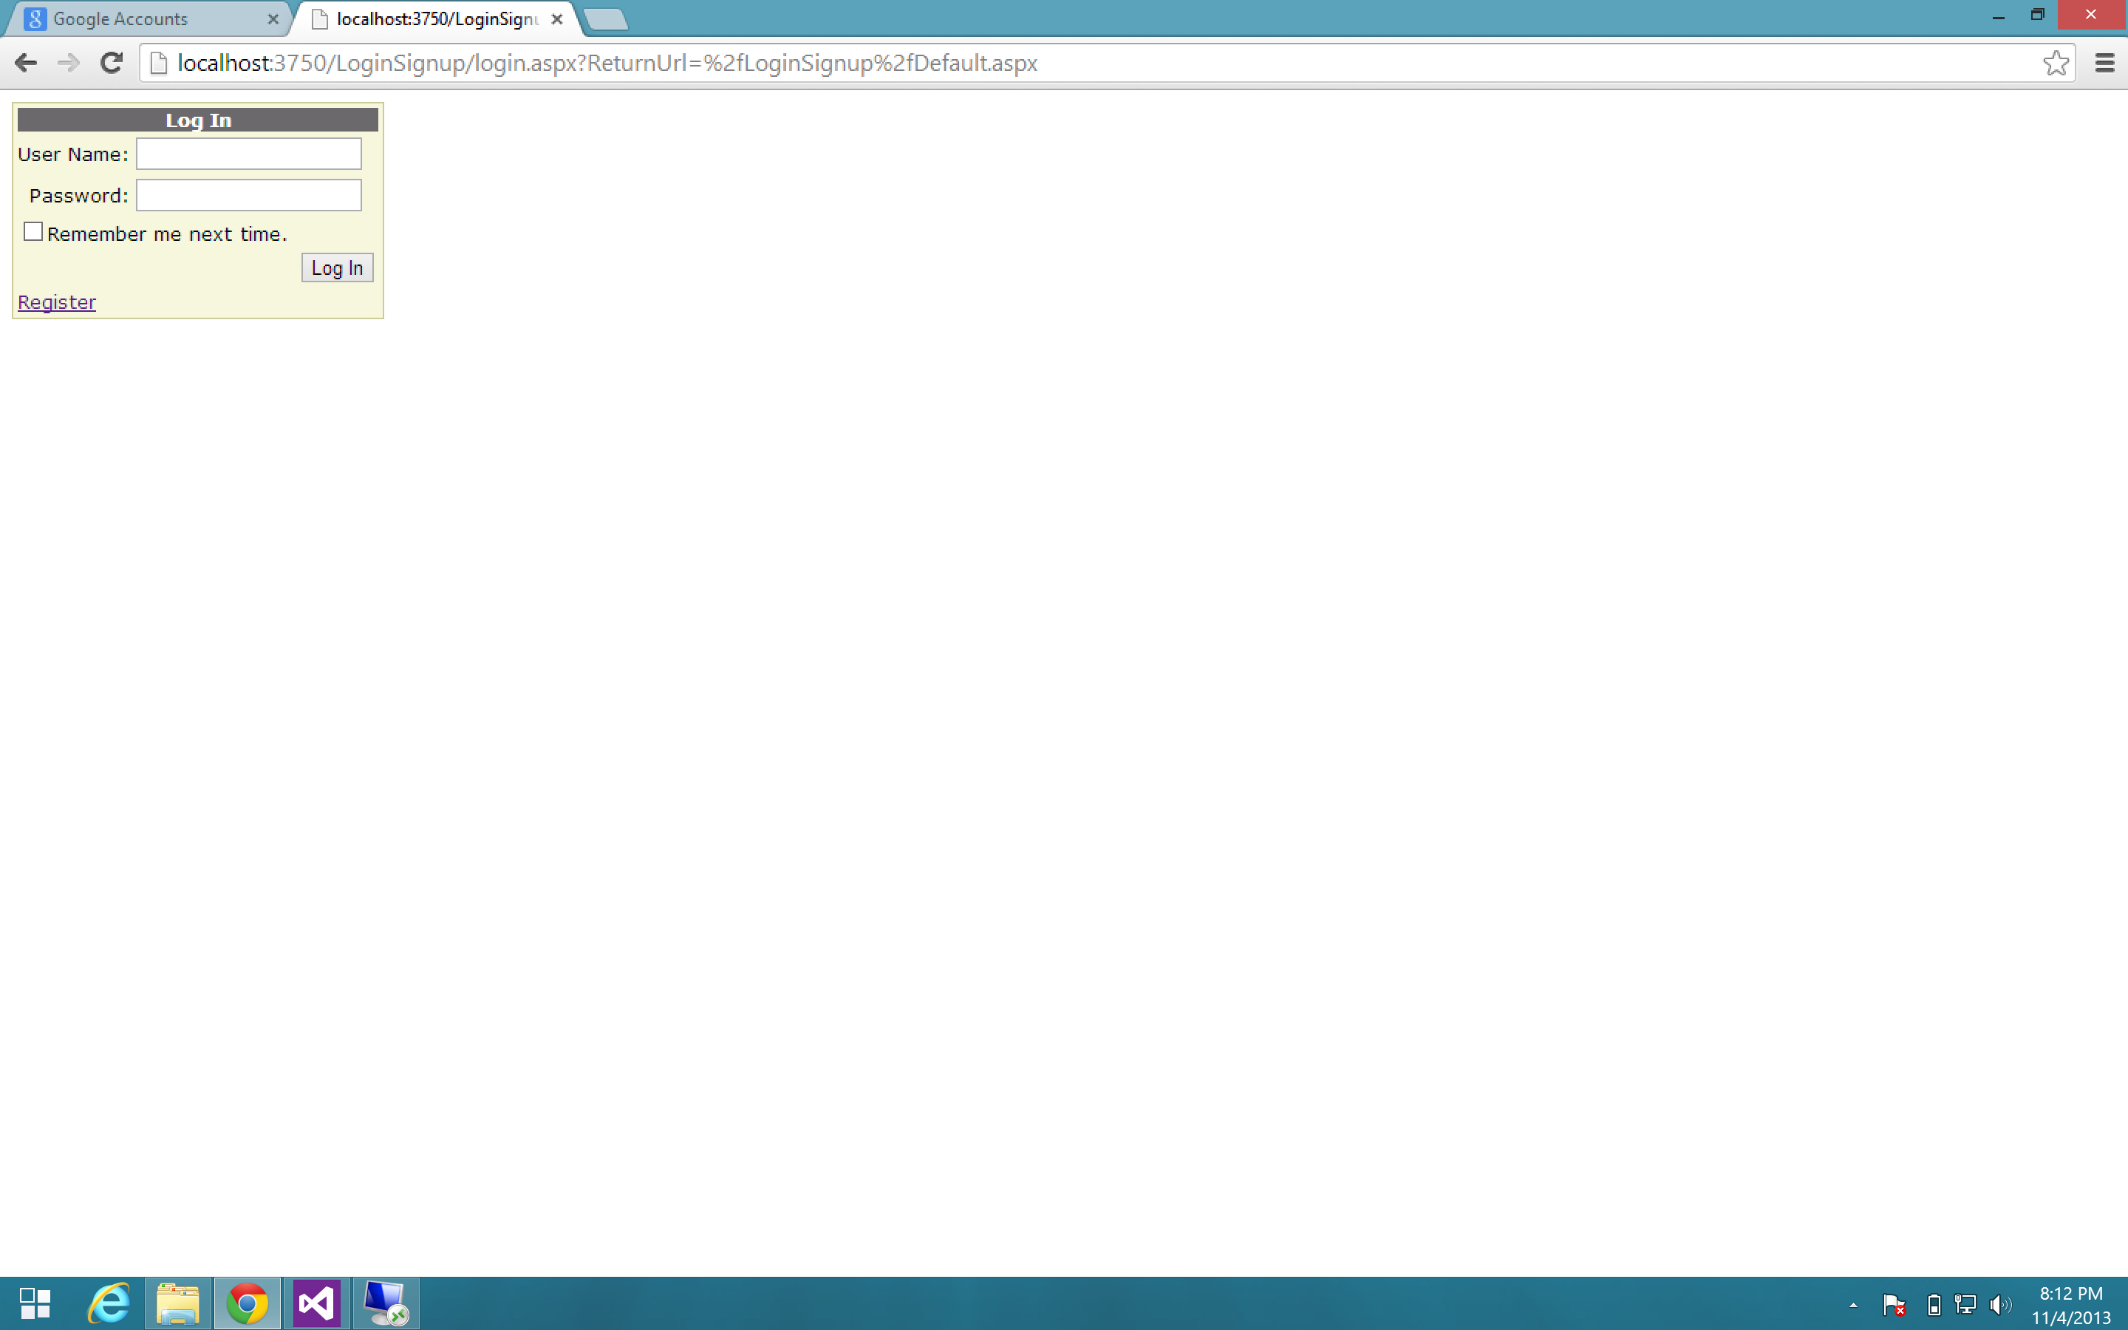

1. 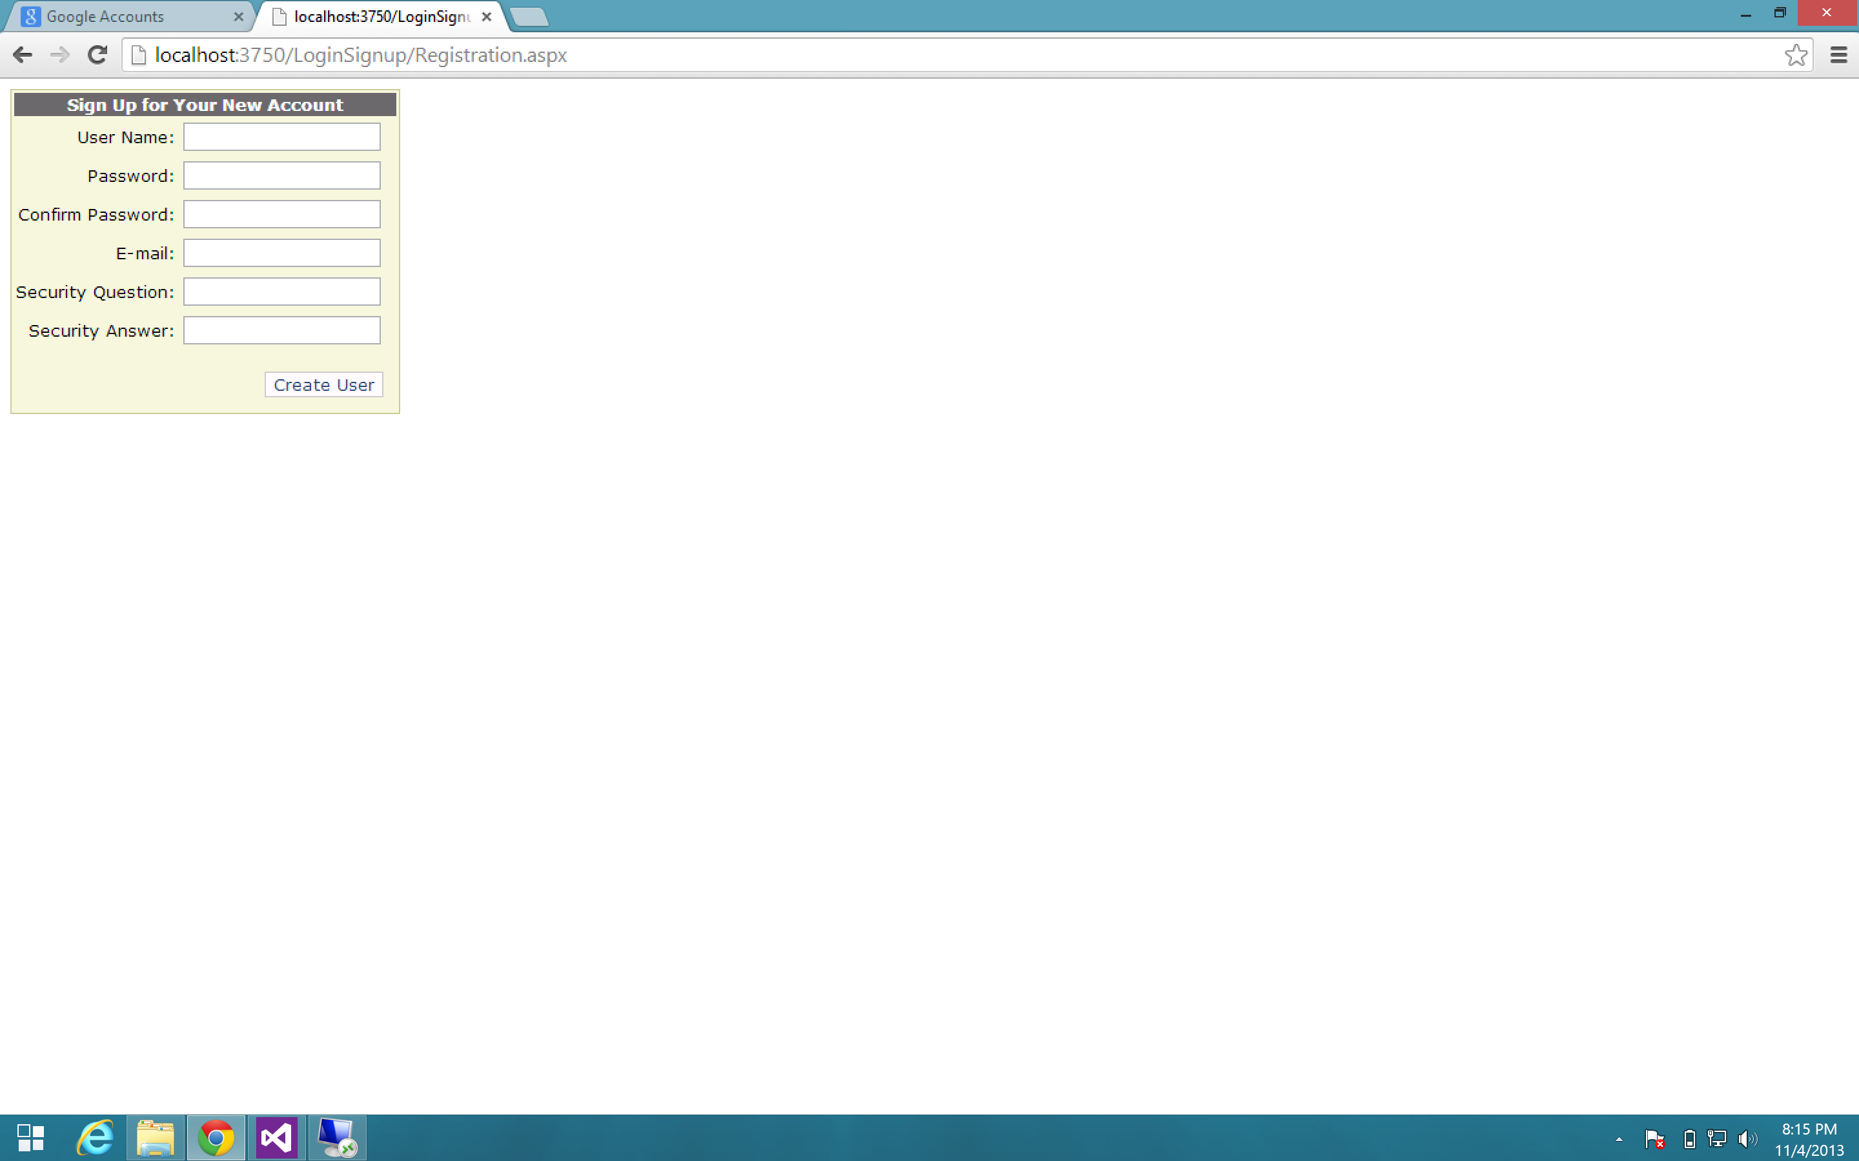After Click on registration link: We have to fill out all fields to be store the account into DB.
2. When registration has been successful, the new page will be open with logout and change password. In this page, we have to have at least to links which are connect with (Checking Gift Registry) and (Adding new products for our gift registry)*.

* I did not do that because I have spent all time with barcode reader, which was unsuccessful.