

A SCOPE OF WORK SUBMITTED TO: The Edwards Aquifer Authority

Reevaluation of estimating recharge into the Edwards Aquifer

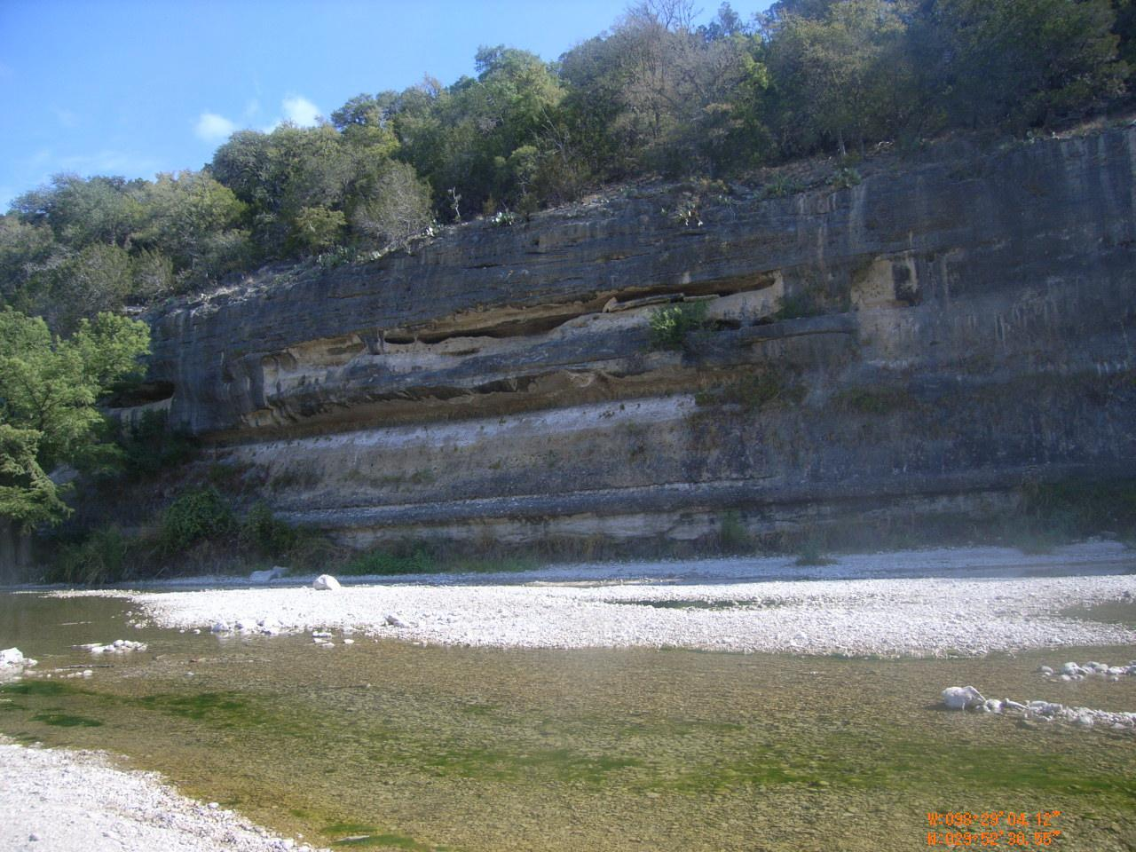

United States Geological Survey

Texas Water Science Center

# Background

The Edwards aquifer is a major source of water for agriculture, industry, and communities in south-central Texas. The United States Geological Survey (USGS) provides yearly estimates to the Edwards Aquifer Authority (EAA) for each watershed basin in the Edwards recharge zone based on the work of Puente (1978). This method has been used to estimate recharge of the aquifer based on historical observations of flooding and draught events, comparing USGS stream gauges from upstream in a watershed to stream gauges downstream and accounting for rainfall.

This study will re-examine the current and past methods for estimating recharge in a watershed while implementing the use of the computer language Python for automation of data processing, analysis, and statistics.

Groundwater flow and storage in the Edwards and Trinity aquifers are largely controlled by the aquifers’ hydrostratigraphy and structure, therefore, understanding these features will aid in anticipating and mitigating issues related to groundwater, environment, and land use. In order for water-resource managers, such as the Edwards Aquifer Authority (EAA), to better manage these resources, a refined understanding of the spatial distribution of the geologic framework and hydrostratigraphic units of the aquifers is needed. Previous studies such as those by the U.S. Geological Survey (USGS) and the Texas Bureau of Economic Geology have mapped the geology, hydrostratigraphy, and structure in these areas at various scales. Examples of previous mapping include Barnes (1963, 1963a, 1965, 1967), Brown and others (1982), Collins (1991), Baumgardner and Collins (1991), Raney and Collins (1991), Hanson and Small (1995), and Clark and others (2009). This study will re-examine the geology, geologic framework, and hydrostratigraphic characteristics of these areas and refine the previous mapping using better access to geologic properties and more accurate mapping tools such as global positioning systems.

**Problem**

The current methods used for estimating groundwater recharge for the Edwards Aquifer have not been updated to modern technology and can be refined to minimize error in the estimations using current advances in the field of computer programing. Detail on this project will help EAA gain further knowledge on the Edwards aquifer to further manage groundwater resources.

# Objectives

The objective of this multi-phase study is to utilize the USGS stream gauge network in the Edwards recharge zone and coupled with Oregon State University’s PRISM climate model, Daly and Bryant (2013), and NASA’s Moderate Resolution Imaging Spectroradiometer (MODIS) evapotranspiration data

and develop new geologic and hydrostratigraphic maps of the Edwards and Trinity aquifers at the 1:24,000 scale in parts of Bexar, Comal, Hays, Blanco, Kendall, Bandera, Medina, Uvalde, Real, Edwards, and Kinney Counties (fig. 1). The scope of this phase of work pertains to geologic mapping of the Edwards and Trinity aquifers in Hays County. Geologic mapping in the remaining counties will be proposed in future scopes of work. The specific objectives of the geologic and hydrostratigraphic mapping project will be to:

1. Refine previously published outcrop maps of the Edwards Group and Georgetown Formation in Hays County for the hydrostratigraphic units (I-VIII) making up the Edwards aquifer (Lindgren and others, 2004) as well as proximate upper confining unit. The geologic units forming the Edwards aquifer are (bottom to top): basal nodular, dolomitic, Kirschburg evaporite, grainstone, regional dense bed, leached and collapsed, cyclic and marine members, and Georgetown Formation. The upper confining units proximal to the Edwards aquifer recharge zone are the Del Rio Clay, Buda Limestone, Eagle Ford Group, Austin Group, and Taylor Group.
2. Geologic and hydrostratigraphic detail will be mapped of the Trinity Group in Hays County for the units composing the upper, middle, and lower (if present) Trinity aquifers. The hydrostratigraphic mapping will be based on recent publications, such as “Key subsurface data to help refine Trinity aquifer hydrostratigraphic units, south-central Texas” (Blome and Clark, 2014) and “Geologic and hydrostratigraphic map of the Anhalt, Fischer, and Spring Branch 7.5-minute quadrangles, Blanco, Comal, and Kendall Counties, Texas” (Clark and Morris, 2015). The geologic units to be mapped in Hays County include (bottom to top) the Hammett Shale, Cow Creek Limestone, Hensell Sand, and lower and upper members of the Glen Rose Limestone.

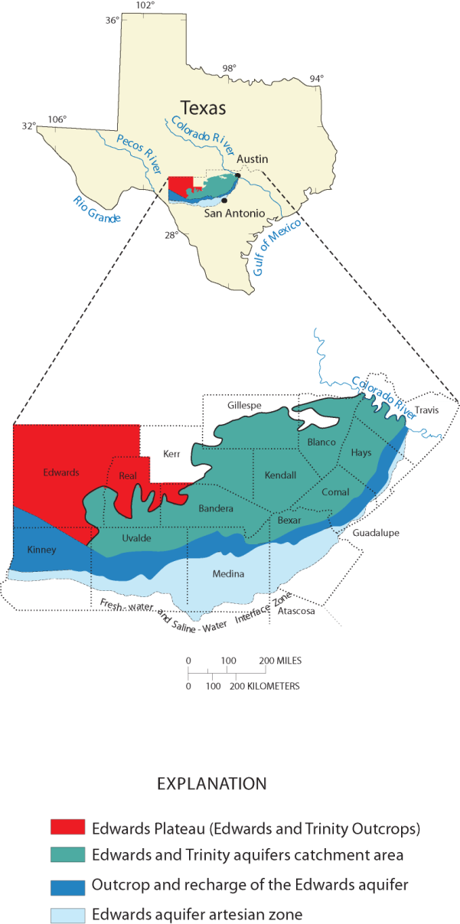

**Figure 1. Location of the proposed study area(s).**

# Approach

Previously unmapped areas, as well as areas of limited access, will be visited. Global Positioning Systems (GPS) technologies will be used to determine the location of geologic contacts, faults, and karst features with a higher degree of accuracy than previously mapped, and modern, more robust data analysis tools will be used to visualize the geologic information. The entire project is expected to take at least 15 years to complete but will be scoped and budgeted on a 3-year phase. Each 3-year phase will include the geologic mapping and reporting of the Edwards and Trinity aquifers in areas of interest in up to 2 counties. Each subsequent 3-year phase will begin during the third year of the previous phase such that new mapping will commence during the report writing phase of the previous mapping effort. Subsequent 3-year phases will require a new scope and budget and completion of a Joint Funding Agreement (JFA). County groupings and prospective study years for each phase of the project are:

1. Bexar and Comal: Beginning of 1st quarter of FY14 to end of 4th quarter FY16
2. Hays: Beginning of 1st quarter FY16 to end of 4th quarter FY18
3. Medina and Uvalde: Beginning of 1st quarter FY18 to end of 4th quarter FY20
4. Kendall and Blanco: Beginning of 1st quarter FY20 to end of 4th quarter FY22
5. Bandera: Beginning of 1st quarter FY22 to end of 4th quarter FY24
6. Real and Kinney: Beginning of 1st quarter FY24 to end of 4th quarter FY26
7. Edwards: Beginning of 1st quarter FY26 to end of 4th quarter FY28

Phase 2 will be to update the geologic and hydrostratigraphic maps developed by the USGS and to add hydrostratigraphic detail to the Trinity Group outcrops. To efficiently organize the mapping project, priorities will be developed by county and by 7.5 minute topographic quadrangle map (“quad sheet”). Quad sheets that cross county lines will be included in the county which most of the quad sheet overlaps. This Phase 2 scope and budget is for mapping the portion of the following quad sheets that are within Hays County. In addition, the USGS National Cooperative Geologic Mapping Program has similar mapping efforts occurring in nearby areas. Together, the quad sheets to be mapped include:

* Hays County (EAA portion): Buda, Devils Backbone, Hunter, Hammetts Crossing, Mountain City, San Marcos South, San Marcos North, and Signal Hill.
* Hays County (USGS Geologic portion): Driftwood, Dripping Springs, Henly, and Wimberley.
* Additional priority areas in Medina and Uvalde Counties (related to Proposition 1) will be mapped upon request from EAA

## Task 1: Data Compilation

Pre-existing geophysical borehole data will be reviewed. Data sources may include files at the USGS Texas Water Science Center South Texas Program Office, the Edwards Aquifer Authority, San Antonio Water Systems, and local groundwater conservation districts. Existing reports, geologic literature, maps, and field mapping investigations of the geology in Hays County will be reviewed to aid in mapping of the hydrostratigraphic subdivisions. Digital orthophoto quadrangles (DOQs), satellite imagery, and other aerial photographs may be used to identify human activities and/or subaerial geologic expressions. Human activities may include road cuts, quarries or gravel pits, land clearings for development, new roads or widening of roads forming new land developments, and excavation of trenches for water lines or pipelines. Subaerial geologic expressions include areas of bare rock or rock ledges. These features are not apparent on topographic maps but might be indicated on remotely sensed imagery. Pre-existing geophysical borehole data will be compiled and correlated with surface mapping, especially in areas where access is restricted or obscured. Geophysical borehole data also will be used to compare similar hydrostratigraphic units identified in the subsurface with the outcrop.

## Task 2: Field Mapping

The Edwards and Trinity aquifers outcropping in the study area will be remapped and hydrostratigraphic units will be based on previous work such as Maclay and Small (1985), Hanson and Small (1995), Clark and others (2009), and Wierman and others (2010). Mapping will include the identification of physical features such as faults. Faults will be located and their displacements approximated by identification of juxtaposed rock units. Faults and fractures, which represent a primary means of recharge to the Edwards and Trinity aquifers, will be located when possible. Types of porosity will be noted, which may aid in future geologic and hydrogeologic investigations. Porosity will be identified on the distinctive porosity type observable in the Edwards and Trinity aquifer outcrop based on the Choquette and Pray (1970) classification of carbonate rock porosity. Pre-existing geophysical borehole data identified in task 1 will be compiled and used to determine the thickness of the hydrostratigraphic units and to assist in determining fault displacement in complexly faulted areas or where rocks are poorly exposed or inaccessible.

The field mapping activities for this project will be focused in Hays County. However, additional properties in the Edwards aquifer recharge zone may also become available, in relation to the City of San Antonio Proposition 1 which authorizes purchase of lands for conservation easement purposes. Up to two weeks of time per year will be allocated for mapping these selected areas as they become available. Depending on the size and scope of the priority areas the timelines may need to be adjusted to accommodate the new identified mapping areas. The priority of mapping these areas will be set in conjunction with EAA.

## Task 3: Analysis and Reporting

A county scale hydrostratigraphic map and an accompanying report-style write-up will be produced as a USGS Scientific Investigations Map (SIM) series. The SIM will show the hydrostratigraphy, faulting, and significant geologic characteristics within the Edwards and Trinity aquifer outcrops in Hays County, Texas. In addition, the 7.5-minute quadrangle [1:24,000 scale] geology data will be housed in a geodatabase and included in the USGS SIM as an online-only appendix. Draft mapping products and progress update maps will be provided to EAA. Additional Edwards Aquifer recharge zone mapping will be incorporated into a future proposed mapping study of the Uvalde and Medina County.

# Quality Assurance Plan

Quality assurance and quality control (QA/QC) measures will be followed to ensure the quality, precision, accuracy, and completeness of the data generated during the study. The quality assurance objectives for the collection and assemblage of data are to provide data that will:

* Withstand scientific scrutiny
* Be obtained by methods appropriate for its intended use, and
* Be of known precision, accuracy, completeness, representative, and comparability.

All data will be reviewed by USGS Texas Water Science Center personnel to ensure proper documentation. The project will be reviewed by USGS management on a quarterly basis to ensure project timelines and objectives are met. All data will follow the Fundamental Science Practices of the USGS which require all data intended for public release are subject to USGS FSP review, approval, and release requirements. Minimum requirements are two reviews that include a technical review and a metadata review followed by Bureau approval[.](http://www.usgs.gov/usgs-manual/im/IM-OSQI-2015-03.html)

# Relevance and Benefits

This study will provide baseline data and mapping products to help resource managers better understand the groundwater resources in south-central Texas. Results from this study will benefit the USGS Strategic Directions Program by characterizing an area where there are critical water-resources issues and adding to the scientific body of knowledge in the region.

**Deliverables**

A county scale hydrostratigraphic map of Hays County and an accompanying report-style write-up will be produced within the structure of the USGS Scientific Investigations Map (SIM) series. The 7.5-minute quadrangle [1:24,000 scale] geology data will be housed in a ArcGIS geodatabase and included in the USGS SIM as an online-only appendix.

**Timeline and Budget**

Phase 2 of the study will begin in the first quarter of FY16 (October 1, 2015) and the USGS SIM will be approved by the end of the fourth quarter of FY18 (September 30, 2018).

|  |  |  |  |  |  |  |  |  |  |  |  |  |
| --- | --- | --- | --- | --- | --- | --- | --- | --- | --- | --- | --- | --- |
|  | FY16 | | | | FY17 | | | | FY18 | | | |
| Q1 | Q2 | Q3 | Q4 | Q1 | Q2 | Q3 | Q4 | Q1 | Q2 | Q3 | Q4 |
| Data compilation |  |  |  |  |  |  |  |  |  |  |  |  |
| Field mapping |  |  |  |  |  |  |  |  |  |  |  |  |
| Analysis and reporting |  |  |  |  |  |  |  |  |  |  |  |  |
| EAA | $118,600 | | | | $126,300 | | | | $83,300 | | | |
| USGS | $30,000 | | | | $30,000 | | | | $30,000 | | | |
| Budget | $148,600 | | | | $156,300 | | | | $113,300 | | | |

# References

Barnes, V.E., 1963, Hammetts Crossing Quadrangle, Blanco, Hays, and Travis Counties, Texas, Map No. 51 Scale 1:24,000; 11-p. text, 1 appendix, 1982.

Barnes, V.E., 1963a, Geology of the Johnson City Quadrangle, Blanco County, Texas. Map No. 25. Scale 1:24,000; 12-p. text, 1963.

Barnes, V.E., 1965, Geology of the Hye Quadrangle, Blanco, Gillespie, and Kendall Counties, Texas, Map No. 27. Scale 1:24,000; 8-p.

Barnes, V.E., 1967, Geology of the Monument Hill Quadrangle, Blanco County, Texas. Map No. 33. Scale 1:24,000; 7-p. text.

Baumgardner, R. W., Jr., and Collins, E. W., 1991, Geologic map of the Hunter 7.5-minute quadrangle, Comal and Hays Counties: The University of Texas at Austin, Bureau of Economic Geology, open-file map prepared for U.S. Geological Survey under cooperative agreement, 1 sheet, scale 1:24,000.

Blome, C.D., and Clark, A.K., 2014, Key subsurface data help to refine Trinity aquifer hydrostratigraphic units, south-central Texas: U.S. Geological Survey Data Series 768, 1 sheet, <http://dx.doi.org/10.3133/ds768>.

Brown, T.E., Waechter, N.B., Rose, R.R., and Barnes, V.E., 1982, Geologic Atlas of Texas, San Antonio sheet: The University of Texas at Austin, Bureau of Economic Geology, Map No. GA0029, 1 sheet, scale 1:250,000.

Choquette, P. W., and Pray, L.C., 1970, Geologic nomenclature and classification of porosity in sedimentary carbonates: American Association of Petroleum Geologists Bulletin, v. 54, no. 2, p. 207-250. Clean Water Action, 2012, conserving water in Central Texas. Accessed April 17, 2012 at <http://www.cleanwater.org/feature/conserving-water-central-texas>.

Clark, A.K., and Morris, R.R., 2015, Geologic and hydrostratigraphic map of the Anhalt, Fischer, and Spring Branch 7.5-minute quadrangles, Blanco, Comal, and Kendall Counties, Texas: U.S. Geological Survey Scientific Investigations Map 3333, 13 p., 1 sheet, scale 1:50,000, <http://dx.doi.org/10.3133/sim3333>.

Clark, A.R., Blome, C.D., and Faith, J.R, 2009, Map showing the geology and hydrostratigraphy of the Edwards aquifer catchment area, northern Bexar County, south-central Texas: U.S. Geological Survey Open-File Report 2009-1008, 24 p., 1 pl.

Collins, E. W., and Hovorka, S. D., 1997, Structure map of the San Antonio segment of the Edwards aquifer and Balcones Fault Zone, south-central Texas: structural framework of a major limestone aquifer: Kinney, Uvalde, Medina, Bexar, Comal, and Hays Counties: The University of Texas at Austin, Bureau of Economic Geology, Miscellaneous Map No. 38, 14-p. text, scale 1:250,000.

Collins, E. W., 1991, Devils Backbone quadrangle﻿, Texas, by E. W. Collins. Oversize geologic map on color topographic base, map scale 1:24,000, with explanatory text

Collins, E. W., Baumgardner, R. W., Jr., and Raney, J. A., 1991, Geologic map of the Wimberley 7.5-minute quadrangle, Hays and Comal Counties, Texas: The University of Texas at Austin, Bureau of Economic Geology, open-file map prepared for U.S. Geological Survey under cooperative agreement, 1 sheet, scale 1:24,000.

Hanson J.A., and Small, T.A., 1995, Geologic framework and hydrogeologic characteristics of the Edwards Aquifer outcrop, Hays County, Texas: U.S. Geological Survey Water-Resources Investigations Report 95-4265, 10 p., 1 pl., scale 1:75,000

Lindgren R.J., Dutton, A.R., . Hovorka, S.D, Worthington, S.R.H., and Painter, S., 2004, Conceptualization and Simulation of the Edwards Aquifer, San Antonio Region, Texas: U.S. Geological Survey Scientific Investigations Report 2004-5277

Maclay, R.W., and Small, T.A., 1976, Progress report on geology of the Edwards aquifer, San Antonio area,Texas, and preliminary interpretation of borehole geophysical and laboratory data on carbonate rocks: U.S. Geological Survey Open-File Report 76–627, 65 p.

Raney, J. A., and Collins, E. W., 1991, Geologic map of the Devils Backbone 7.5-minute quadrangle, Comal and Hays Counties: The University of Texas at Austin, Bureau of Economic Geology, open-file map prepared for U.S. Geological Survey under cooperative agreement, 1 sheet, scale 1:24,000.

US Geological Survey Fundamental Science Practices memo, accessed on July 6, 2015, at http://www.usgs.gov/fsp/faqs_datarelease.asp

Wierman, D.A., Broun, A.S., and Hunt, B.B., 2010, Hydrogeologic Atlas of the Hill Country Trinity Aquifer, Blanco, Hays, and Travis Counties, Central Texas. Prepared by the Hays-Trinity, Barton Springs/Edwards Aquifer, and Blanco Pedernales Groundwater Conservation Districts, July 2010, 17 plates+DVD.