Verification of Extracted Hazus Damage Functions
Point-by-point comparison against FEMA technical manuals and release notes
Dataset: hazus-curves v0.1.1
Repository: https://github.com/rkvaughn/hazus-curves
Coverage: 278,266 curves — Hazus 4.0 and 6.1 flood, Hazus 6.1 hurricane wind
Report generated: 2026-08-12

Purpose
This report exists to answer one question: are the damage functions published by this project genuine Hazus data, or could they have been fabricated, approximated, or generated by a language model?
The answer given here does not rest on assurances. It rests on nine independent quantities that FEMA states in its own published documents, each of which the extracted dataset either reproduces or does not. Every one is checkable by a reader with the same PDFs.

Method, and why it is trustworthy
The obvious weakness of a verification document is that its author could simply type in agreeable numbers. This report is constructed to make that impossible to do undetected.
How each element is produced
Quotations are extracted programmatically from the PDF text layer by searching for an anchor phrase and returning the surrounding sentence. They are not retyped, so a quotation cannot drift from the source.
Page images are rendered from the same page object that supplied the quotation, so the screenshot cannot show a different page from the one cited.
Page numbers are recorded as both the PDF page index and the page label printed in the manual itself, which differ in every FEMA manual.
Measured values are computed at build time from the published artifacts — the same Parquet and SQLite files distributed to users — not copied from earlier notes.
If an anchor phrase is not found in the document, the check is reported as NOT FOUND and no claim is made. No check in this report is asserted without a located page.
Reproduce this document
python scripts/fetch.py --docs # retrieves all 11 FEMA PDFs, SHA-256 pinned
python scripts/build_verification_evidence.py # locates, renders, measures
node scripts/build_verification_docx.js # builds this file
A note on the FEMA URLs cited throughout: fema.gov returns HTTP 403 to automated requests, so the fetch script retrieves these PDFs through the Internet Archive. The URLs printed in this report are the canonical FEMA locations and open normally in a browser.

Summary of findings
Eight of nine checks match FEMA's published values. One is a partial match and is reported as such rather than presented as agreement.
Check | What FEMA states | What we measure | Result
Wind building characteristics | “62 individual WBCs” | 62 | Match
Specific building types | 39, named in Table C-1 | 39, names verbatim | Match
Building / occupancy types | 39 building, 33 occupancy types | 39 building types | Match
Hurricane damage functions | “over 275,000” | 275,220 | Match
Multi-family defect (7.1) | 2-/3-story reused 1-story functions | 15,200 duplicates found | Confirmed
Flood library expansion (6.1) | “almost 300 structure and 400 content” | +295 structure, +311 content | Partial — see §6
Coastal assignment rule (7.0) | V ≥ 6 ft, A 3–6 ft, riverine < 3 ft | 1,148 rules annotated | Match
Business inventory functions | 116 functions | 116 | Match
Roof deck attachment notation | 6d @ 6″/12″ spelled out | 4 of 4 labels derived | Match
The strongest single item is the fifth. FEMA disclosed a specific, non-obvious defect in the Hazus 6.1 wind data; that defect is present in this dataset and reproducible at row level. A fabricated or re-derived dataset would not carry another organisation's bug.

Verification detail

1. Wind building characteristics: FEMA states 62
Source document: fema_rsl_hazus-7-hutm_06272025_0.pdf
URL: https://www.fema.gov/sites/default/files/documents/fema_rsl_hazus-7-hutm_06272025_0.pdf
Page: PDF page 570 (printed page 9-29)
Quoted verbatim from the document text layer:
“In total, there are 62 individual WBCs that were included in the updates, shown in Table 9-9.”
FEMA states | 62
This dataset | 62
Derivation | 53 documented + 9 used but undocumented
Result | Match — 62 = 62
This check also resolves an apparent anomaly. The workbook's own decode sheet (huListOfBldgChar) documents only 53 codes, while 9 further codes appear in the data with no dictionary entry. Those 9 were initially recorded as a data-quality defect. FEMA's total of 62 shows they are legitimate characteristics that FEMA's own lookup sheet omits — 53 + 9 = 62 exactly.

Source page as published by FEMA — fema_rsl_hazus-7-hutm_06272025_0.pdf
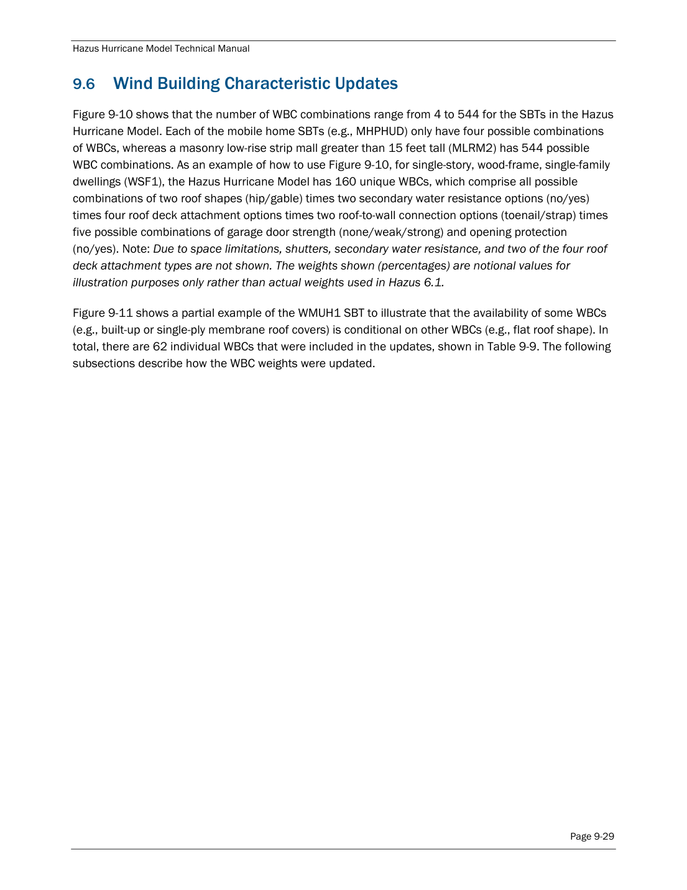
fema_rsl_hazus-7-hutm_06272025_0.pdf — page 570 (printed 9-29)

2. Specific building types: FEMA lists 39 in Table C-1
Source document: fema_rsl_hazus-7-hutm_06272025_0.pdf
URL: https://www.fema.gov/sites/default/files/documents/fema_rsl_hazus-7-hutm_06272025_0.pdf
Page: PDF page 677 (printed page C-1)
Quoted verbatim from the document text layer:
“Table C-1. List of SBT Abbreviations”
FEMA states | 39
This dataset | 39
Derivation | all 39 names matched Table C-1 verbatim
Result | Match — 39 of 39, names verbatim
The 39 codes in the dataset match Table C-1 one-for-one. The building type descriptions shown in the web tool are parsed from this table programmatically, and a regression test re-parses the manual and fails the build if any published description drifts from it.

Source page as published by FEMA — fema_rsl_hazus-7-hutm_06272025_0.pdf
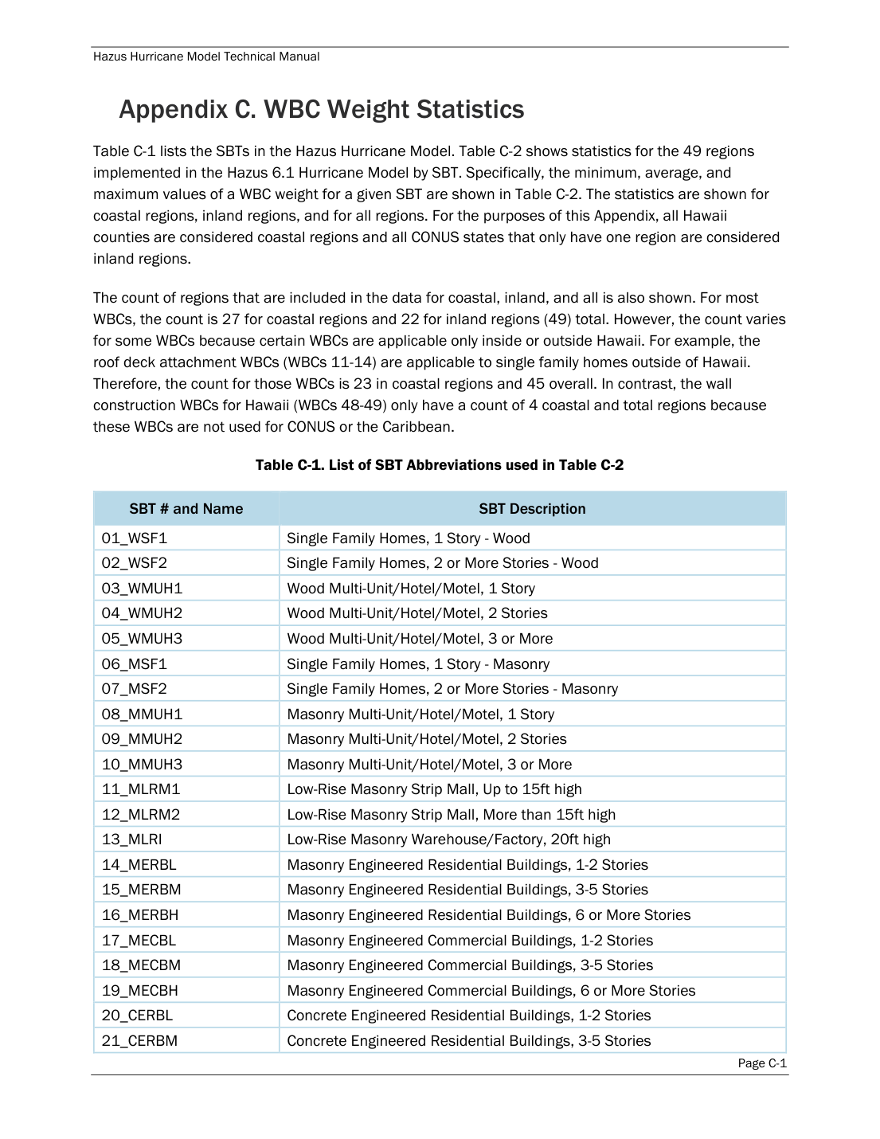
fema_rsl_hazus-7-hutm_06272025_0.pdf — page 677 (printed C-1)

3. Building and occupancy type counts
Source document: fema_rsl_hazus-7-hutm_06272025_0.pdf
URL: https://www.fema.gov/sites/default/files/documents/fema_rsl_hazus-7-hutm_06272025_0.pdf
Page: PDF page 42 (printed page 2-5)
Quoted verbatim from the document text layer:
“Building information, derived from Census and employment data, is used to form groups of 39 hurricane specific building types and 33 specific occupancy types (additional information on the Hazus baseline ABI inventory data is provided in the Hazus Inventory Technical Manual).”
FEMA states | 39
This dataset | 39
Derivation | 6,116 wind building types
Result | Match — 39 building types

Source page as published by FEMA — fema_rsl_hazus-7-hutm_06272025_0.pdf
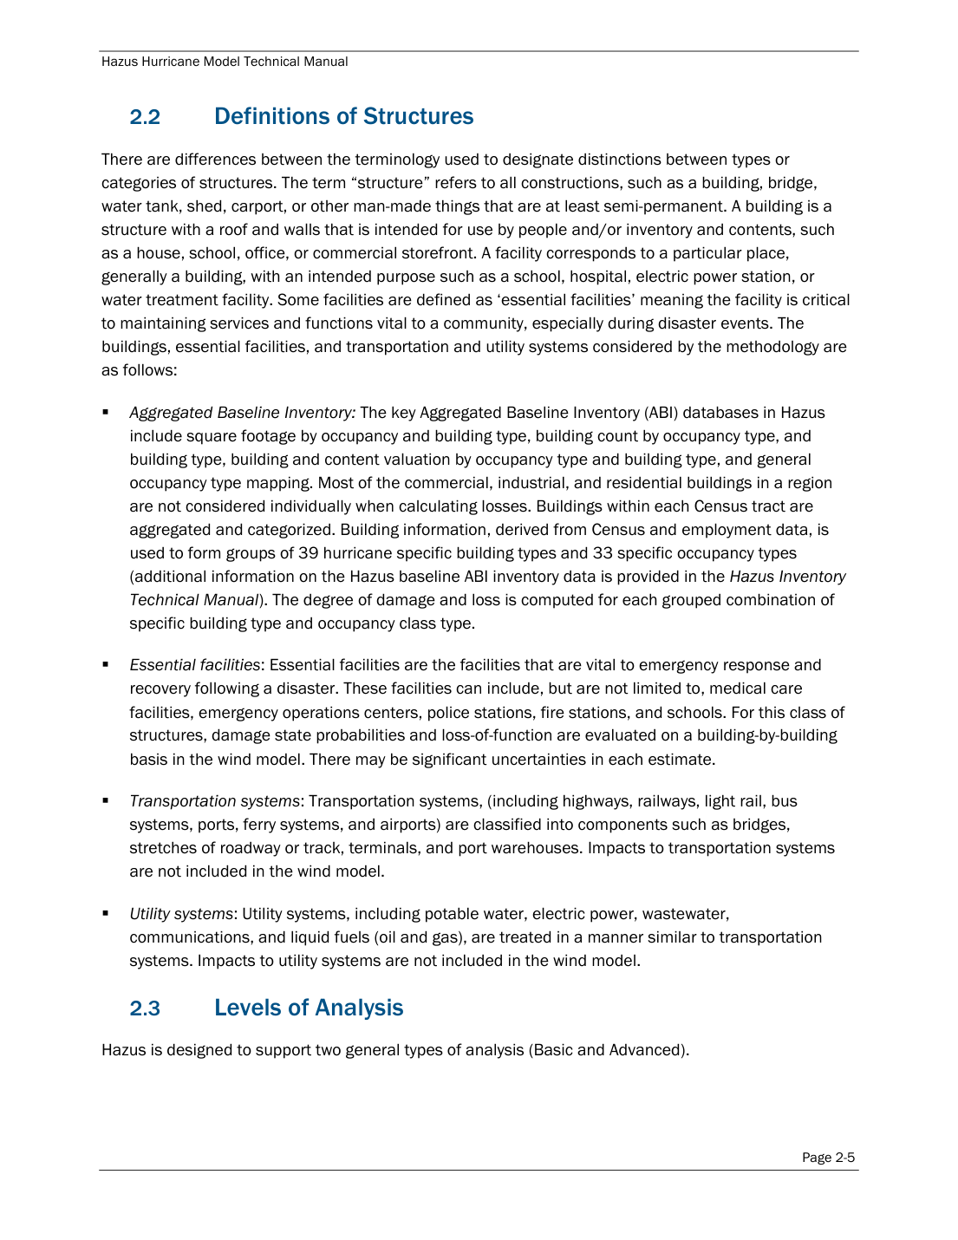
fema_rsl_hazus-7-hutm_06272025_0.pdf — page 42 (printed 2-5)

4. Hurricane damage function count: FEMA states over 275,000
Source document: fema_hazus-7-1-release-notes.pdf
URL: https://www.fema.gov/sites/default/files/documents/fema_hazus-7-1-release-notes.pdf
Page: PDF page 6
Quoted verbatim from the document text layer:
“RSA-21186: Errors in Wind Damage Functions Specific Building Type Background: The Hazus Hurricane Wind Model currently contains over 275,000 damage functions to represent a broad range of building types and construction details throughout hurricane states on the Gulf and Atlantic Coast, as well as Hawaii and the Caribbean.”
FEMA states | over 275,000
This dataset | 275220
Derivation | 6,116 wind building types x 5 terrains x 9 loss classes = 275,220
Result | Match — 275,220
The count is not merely in the right range; it factorises exactly against the workbook's own dimension tables, which is a much tighter constraint than a round number being approximately right.

Source page as published by FEMA — fema_hazus-7-1-release-notes.pdf
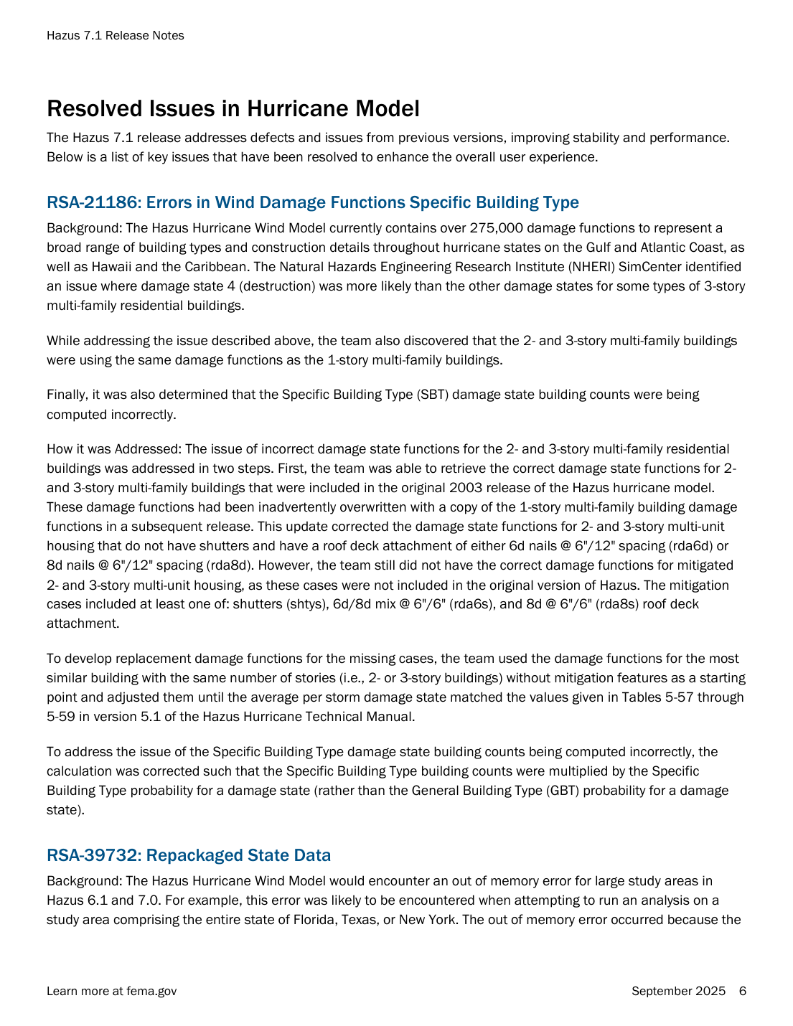
fema_hazus-7-1-release-notes.pdf — page 6

5. The multi-family defect FEMA disclosed in Hazus 7.1
Source document: fema_hazus-7-1-release-notes.pdf
URL: https://www.fema.gov/sites/default/files/documents/fema_hazus-7-1-release-notes.pdf
Page: PDF page 6
Quoted verbatim from the document text layer:
“While addressing the issue described above, the team also discovered that the 2- and 3-story multi-family buildings were using the same damage functions as the 1-story multi-family buildings.”
FEMA states | 2- and 3-story reused 1-story functions
This dataset | 15,200 of 34,560
Derivation | curves byte-identical to their 1-story counterpart
Result | Confirmed — 15,200 duplicate curves located
This is the decisive check. FEMA states that in Hazus 6.1 and 7.0 the 2- and 3-story multi-family wind functions were inadvertently overwritten with copies of the 1-story functions. Comparing every 2-/3-story curve against the 1-story curve with identical building characteristics, terrain and loss class finds 15,200 of 34,560 byte-identical. The defect FEMA describes is measurably present in this data. Affected curves are flagged in the published dataset rather than removed.

Source page as published by FEMA — fema_hazus-7-1-release-notes.pdf

fema_hazus-7-1-release-notes.pdf — page 6

6. Flood library expansion in Hazus 6.1
Source document: fema_Hazus-6.1-Release-Notes.pdf
URL: https://www.fema.gov/sites/default/files/documents/fema_Hazus-6.1-Release-Notes.pdf
Page: PDF page 20
Quoted verbatim from the document text layer:
“Almost 300 new structure and 400 new content damage functions were added to the Hazus library from multiple USACE sources, the FEMA Benefit Cost Toolkit, FEMA Coastal Probabilistic Flood Risk Assessment (PFRA) studies and the Coastal Resilience Center.”
FEMA states | almost 300 new structure and 400 new content
This dataset | +295 structure, +311 content
Derivation | structure 597 to 892, contents 507 to 818
Result | Partial — structure matches, contents does not
This is the one check that does not fully agree, and it is reported rather than omitted. The structure figure matches closely: FEMA says almost 300, the data contains 295. The contents figure does not: FEMA says 400, the data contains 311. We do not know the cause. The most likely explanation is that FEMA's count includes functions outside this extract, but that is a hypothesis, not a finding. The discrepancy is documented in the repository and left unresolved.

Source page as published by FEMA — fema_Hazus-6.1-Release-Notes.pdf
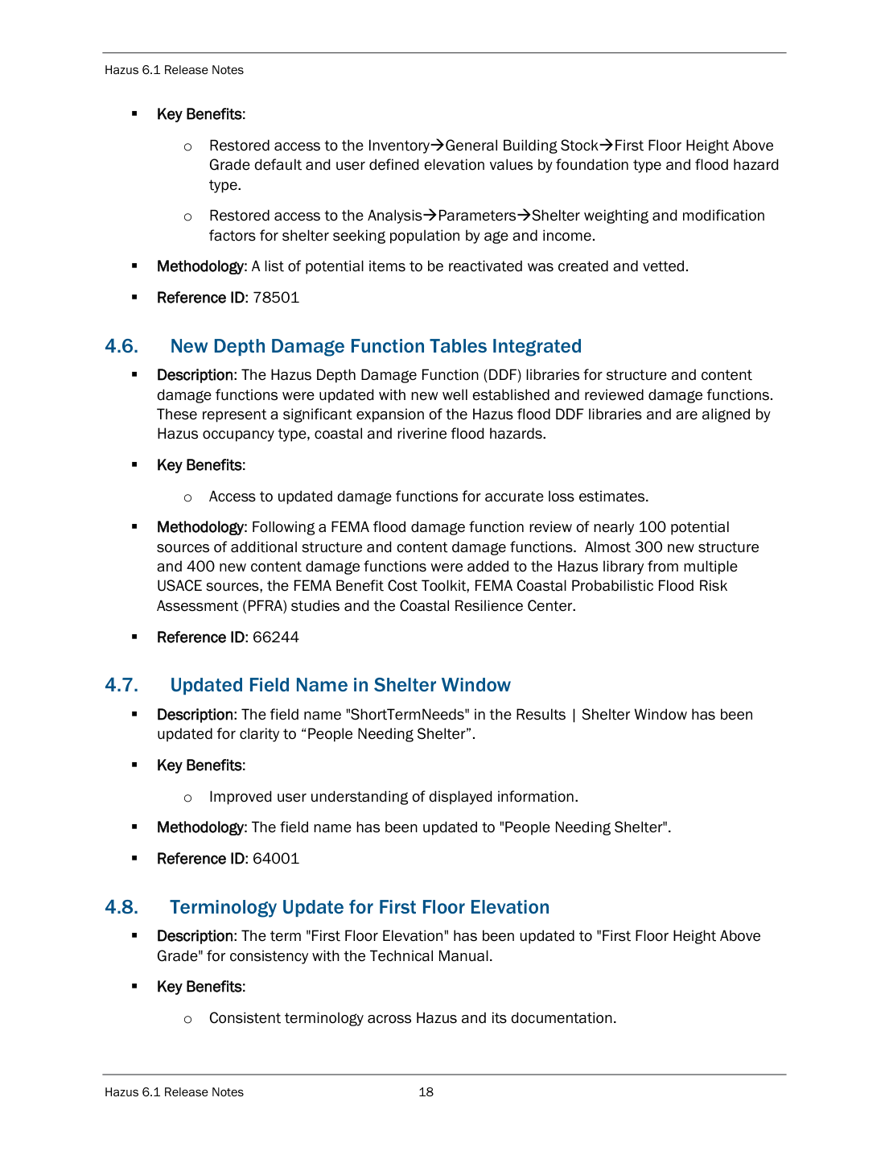
fema_Hazus-6.1-Release-Notes.pdf — page 20

7. Depth-limited coastal assignment rule introduced in Hazus 7.0
Source document: fema_hazus_7_release_notes.pdf
URL: https://www.fema.gov/sites/default/files/documents/fema_hazus_7_release_notes.pdf
Page: PDF page 11
Quoted verbatim from the document text layer:
“Now, Hazus automatically assigns Coastal V Zone DDFs when water depths are 6 feet or greater, and Coastal A Zone DDFs for water depths between 3 and 6 feet.”
FEMA states | V >= 6 ft, A 3-6 ft, riverine < 3 ft
This dataset | 1,148 rules annotated
Derivation | recorded in assignment_rules.notes
Result | Match — rule recorded in the data
This rule changes which curve a building selects, not any curve's values. It is therefore stored as selection metadata on 1,148 coastal assignment rules rather than applied to the curve data.

Source page as published by FEMA — fema_hazus_7_release_notes.pdf
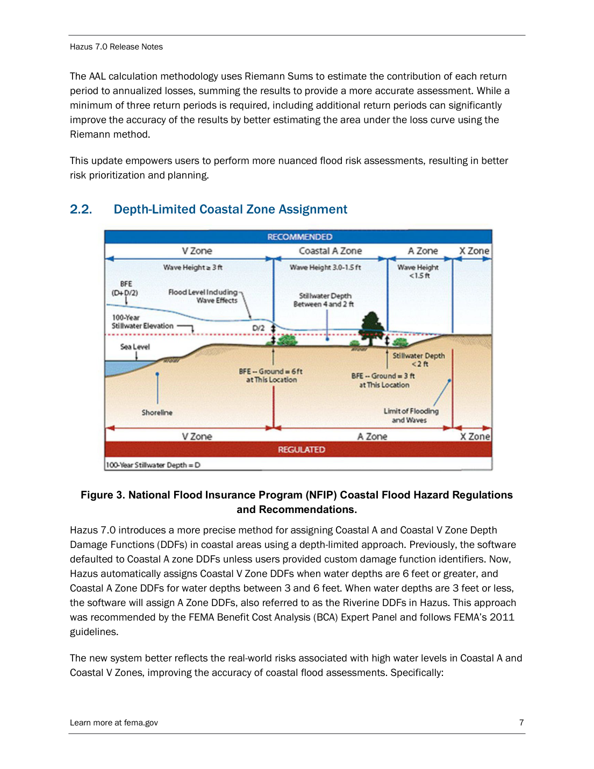
fema_hazus_7_release_notes.pdf — page 11

8. Business inventory damage functions: FEMA states 116
Source document: fema_rsl_hazus-7-fltm_06272025_0.pdf
URL: https://www.fema.gov/sites/default/files/documents/fema_rsl_hazus-7-fltm_06272025_0.pdf
Page: PDF page 50 (printed page 6-9)
Quoted verbatim from the document text layer:
“The business inventory damage function library assembled includes 116 business inventory damage functions (including default functions) provided by the USACE Galveston District.”
FEMA states | 116
This dataset | 116
Derivation | business inventory damage functions
Result | Match — 116 = 116
Unchanged across Hazus 4.0 and 6.1, consistent with the version diff, which found zero added, removed or altered inventory functions between those releases.

Source page as published by FEMA — fema_rsl_hazus-7-fltm_06272025_0.pdf
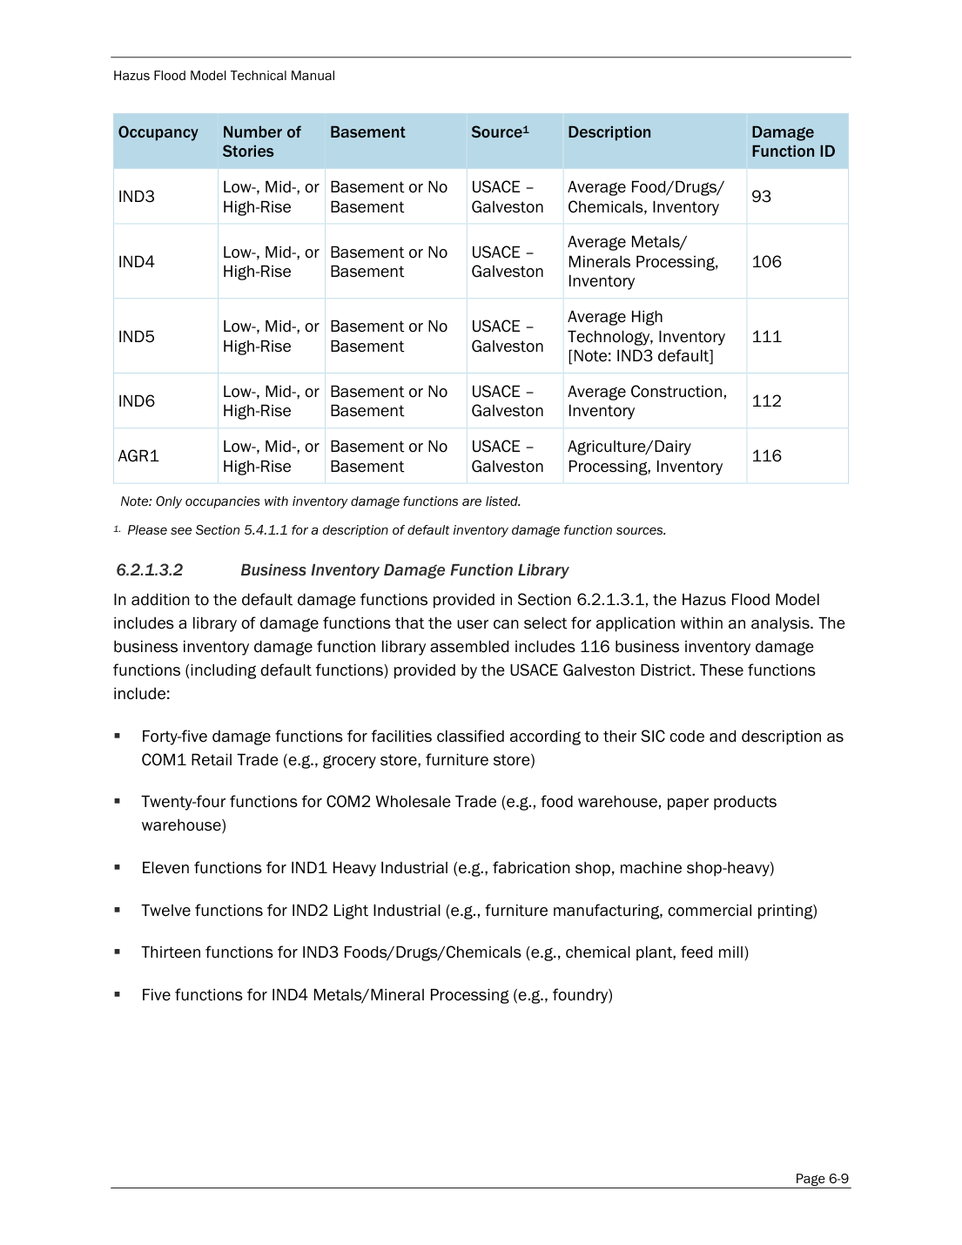
fema_rsl_hazus-7-fltm_06272025_0.pdf — page 50 (printed 6-9)

9. Roof deck attachment notation
Source document: fema_rsl_hazus-7-hutm_06272025_0.pdf
URL: https://www.fema.gov/sites/default/files/documents/fema_rsl_hazus-7-hutm_06272025_0.pdf
Page: PDF page 554 (printed page 9-13)
Quoted verbatim from the document text layer:
“For roof deck attachment, six penny roof panel nailing at 6-inch spacing on the edges and 12-inch spacing in the field (“6d @ 6”/12” roof deck attachment”) was assigned to all single family homes built after 1965, while single-family homes built in 1965 or earlier were assigned the strongest roof deck attachment, eight penny roof panel nailing at 6-inch spacing on the edges and 6- inch spacing in the field (“8d @ 6”/6” roof deck attachment”), because dimensional lumber is more likely to have been used than plywood in older buildings.”
FEMA states | six penny nailing, 6 in edges / 12 in field
This dataset | 4 of 4 labelled
Derivation | web tool labels derived from this sentence
Result | Match — labels derived from this sentence
Included because the web tool displays plain-language labels for these codes. This page is the source of that wording. Two of the four labels are quoted from this sentence and its companion; the other two apply the same stated size-at-edge/field grammar.

Source page as published by FEMA — fema_rsl_hazus-7-hutm_06272025_0.pdf
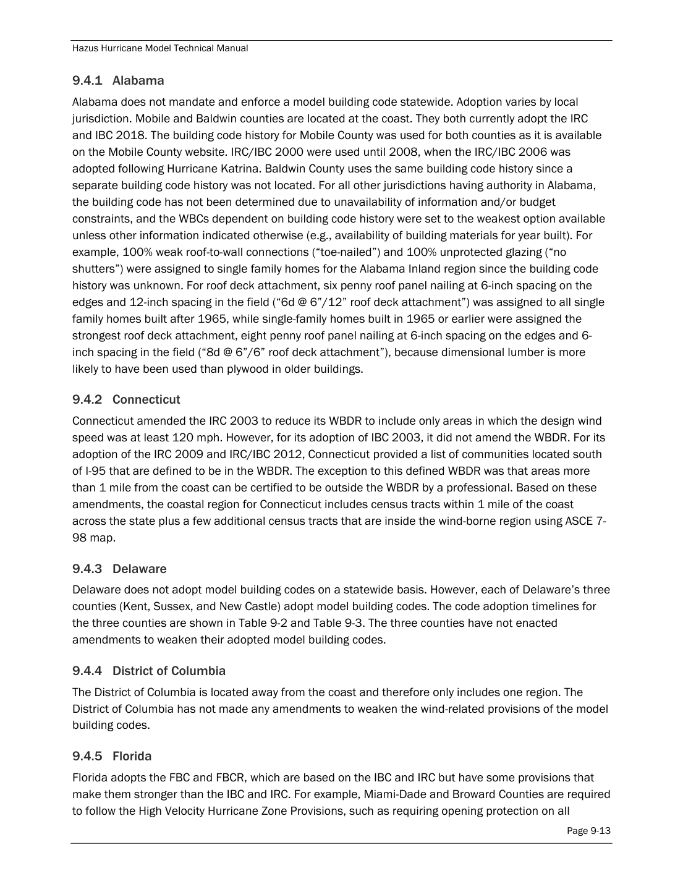
fema_rsl_hazus-7-hutm_06272025_0.pdf — page 554 (printed 9-13)

Independent corroboration beyond the manuals

Flood curves match a separate FEMA publication exactly
The checks above compare the data against FEMA's prose. This check compares it against FEMA's own published data, from a different source entirely.
FEMA publishes the Hazus 4.0 flood damage function tables as CSV files in its Flood Assessment Structure Tool repository (github.com/nhrap-hazus/FAST). The Hazus 6.1 workbook used by this project independently contains a sheet holding the pre-6.1 structure library. Comparing the two, curve by curve and depth by depth:
597 curves, 17,313 individual values, zero discrepancies.
Two files of different format, obtained from different places, agreeing on every one of 17,313 values. Reproduce with: python scripts/diff_versions.py

Every value traces to a source cell
Each of the 278,266 published curves carries source_file, source_table and source_row_id identifying the exact origin of its values. Every input file is pinned by SHA-256 in a committed manifest, and the build fails if any hash changes. 114 automated tests enforce these invariants, including a losslessness test that fails the build if any source column is silently dropped.
The extraction pipeline performs no arithmetic on damage values. It renames columns and reshapes wide tables into long ones. It does not compute, interpolate, smooth, clamp or infer, and a missing source value is preserved as NULL rather than estimated.

What this report does not establish
A verification document that claims too much is worth less than one that states its limits.
Structural agreement is not cell-by-cell proof. The checks confirm that the dataset's dimensions, counts, names and known defects match FEMA's published descriptions. They do not prove that every one of 11.4 million individual data points is byte-identical to FEMA's SQL Server tables. No public evidence available to us could establish that.
Provenance of the hurricane workbook is documented but not certified. The Hazus 6.1 workbooks reached this project through a public bucket operated by the OS-Climate physrisk project, which names that exact bucket and file in its published source code. How OS-Climate obtained the workbooks from Hazus is not documented anywhere we could find.
That bucket is now offline. As of 12 August 2026 it returns HTTP 403 AllAccessDisabled for every object, and no Internet Archive capture exists. The original files can no longer be downloaded and byte-compared by anyone, including us. This project re-hosts its SHA-256-verified copies so the build remains reproducible, but that verification path is closed. It is one of the reasons this report exists.
The authoritative source remains a licensed Hazus installation on Windows with ArcGIS Pro. This project exists because that route is closed to most researchers, not because it is equivalent to it.

Conclusion
Nine quantities stated by FEMA in four separate published documents were tested against the extracted dataset. Eight match. One partially matches and is reported as a discrepancy.
The dataset reproduces FEMA's exact dimension counts, its building type names, its function totals, and — most tellingly — a specific defect FEMA disclosed in a later release. Independently, its flood curves agree with a separate FEMA publication across 17,313 values with no discrepancies.
Taken together this is strong evidence that the data is authentic Hazus content faithfully extracted, and not fabricated, approximated or generated. It is not, and does not claim to be, a byte-level certification against FEMA's internal database.

