**Sherlock Module Test Flow with RT5812 HW**

1. **Test Environment Setup**
2. HW Setup as below.

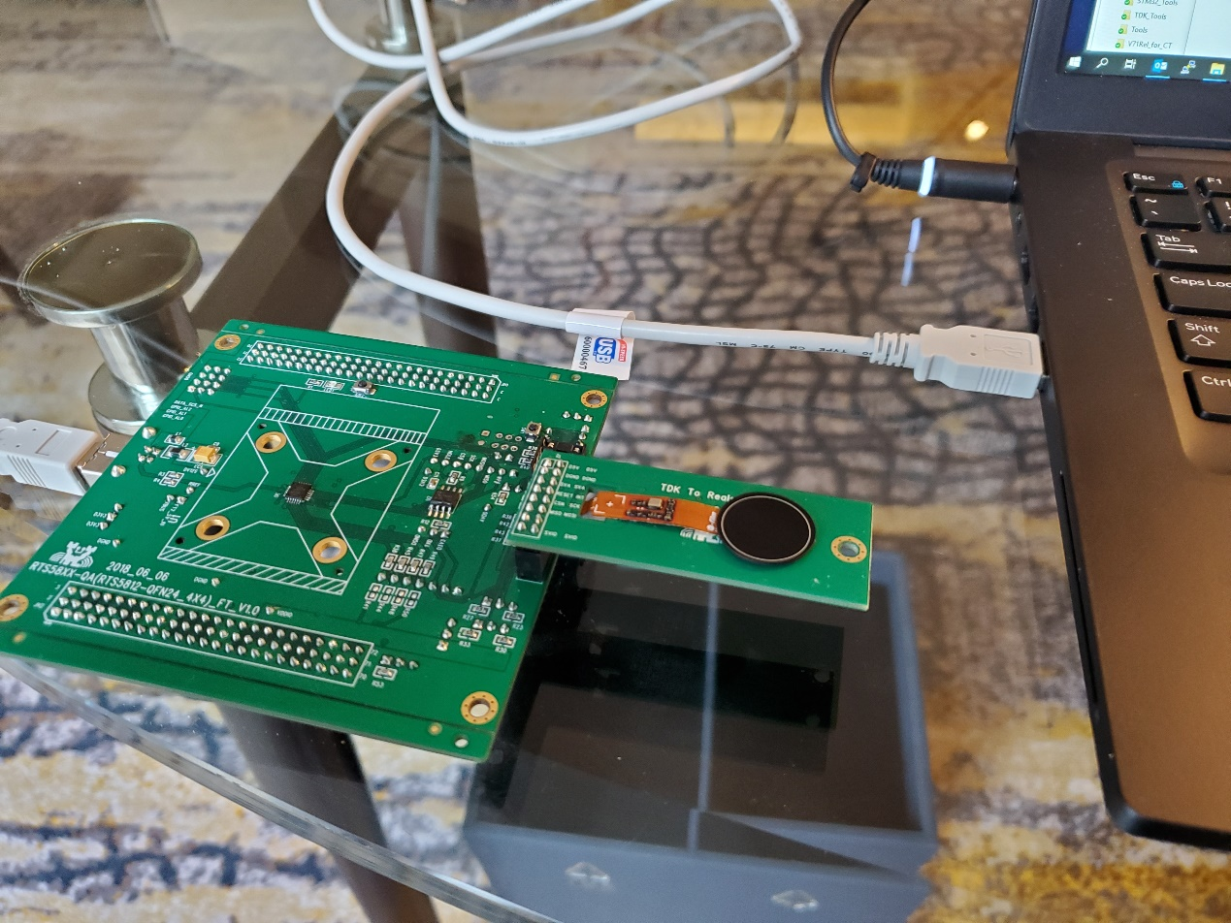

1. SW Setup

For launching the SLK_ModuleTest_NP_Rev1.0\Release\SLK_ModuleTets_Rev1.exe,

there are two .txt files that would need to be preset under the SLK_ModuleTest_NP_Rev1.0\Release folder before running the SW.

1. CfgPathInfo.txt

This is to store the location of the .cfg files for the different test stations to be used.

Current default setting is:-

C:\Users\rkwan\Downloads\ModuleTest\SLK_ModuleTest_NP_Rev1.0_RT5812\SLK_ModuleTest_NP_Rev1.0\fpsys_python

And this should be updated to reflect correctly where the \fpsys_python\*.cfg are actually stored first.

1. CurTestNo.txt

This file is to store the test station number to be run.

Current default setting is:-

2

And this can be modified between 1 and 5.

**OR**

If launching from the project execution under SLK_ModuleTest_NP_Rev1.0\SLK_ModuleTest_Rev1.sln with VS 2017 Professional version,

Please update the CfgPathInfo.txt and CurTestNo.txt under the SLK_ModuleTest_NP_Rev1.0\SLK_ModuleTest_Rev1 folder instead.

This is because the VS settings may not be able to look up the ones in \Release folder.

1. **Initial Test Setup Inside MT SW**
2. Initialize / Open DLL
3. (Power off DUT in case it was not shut down properly)

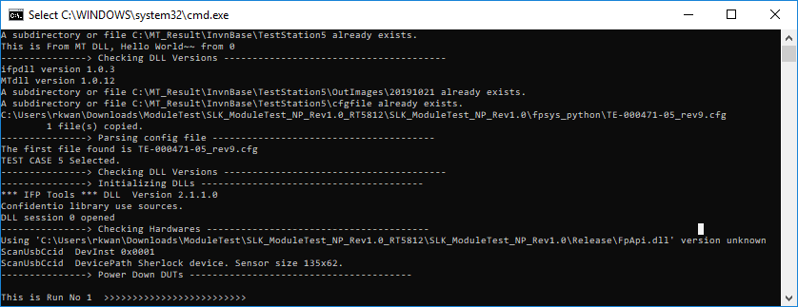

1. **Main Test Loop Inside MT SW**
2. Initialize log file
3. Power on DUTs
4. Check SPI communication (Disable DUTs that are not responding)
5. Check ASIC ID information (DieID, LotID, WaferID etc.)
6. Load DMP
7. Check Power rail currents
8. Calibrate DUTs / Load Trim values from OTP
9. Get Gain Only Images

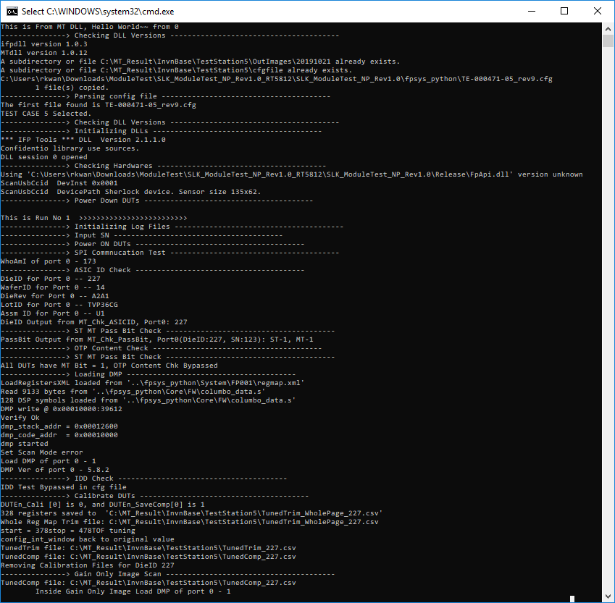

1. Get Air Images
2. Check CMOS temperature

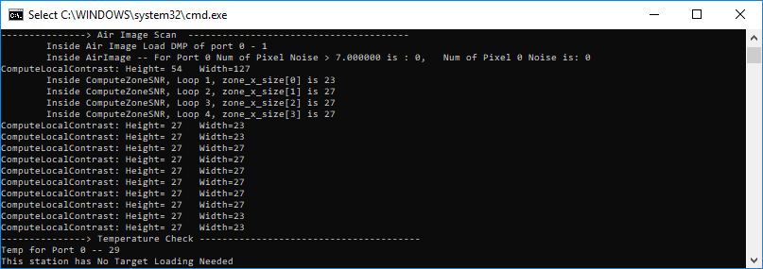

1. Prompt User to Load Target (for Test Station #4 Only, no need for Test Station #5)

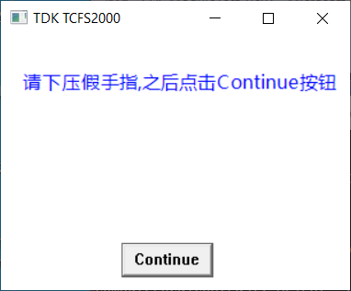

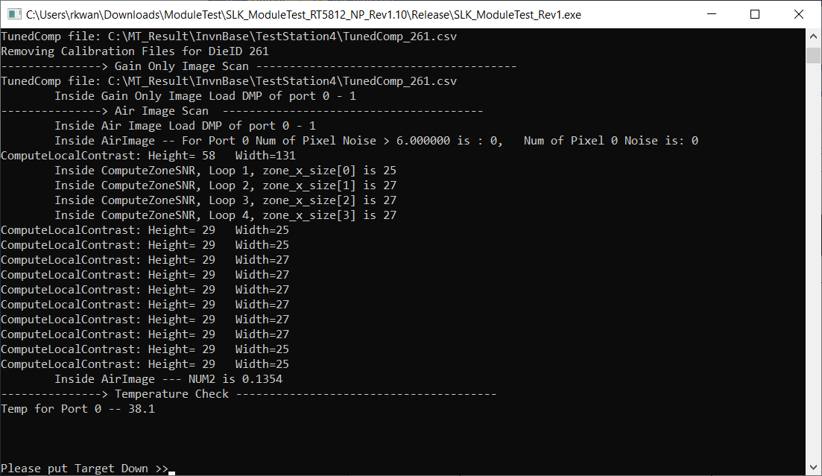

Then it will pop up the fingerprint image BMP file captured in the log folder

and test continues running in the background. No need to press “Continue” button anymore.

**Note:**

For Test Station 2 Only, Air Image GUI window would pop up for viewing and it would be closed automatically at the end of the test.

1. Get Target Images and calculate image related values (for Test Station #4)

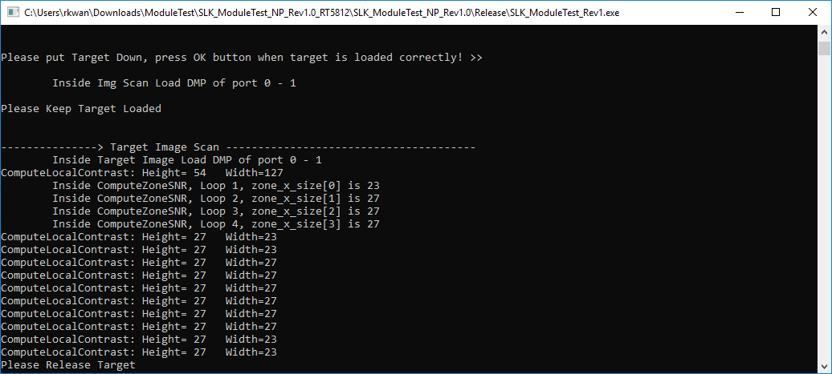

1. Write OTP (Only when OTP_Write is enabled and All Test Passed for Test Station #4 only)

If the module is already OTP-ed, it will show like:-



1. Power off DUT
2. Return PassFail information for this run so user has access to it
3. Display result in command line
4. Write this run’s information to log file

If Pass OK, it would show:-

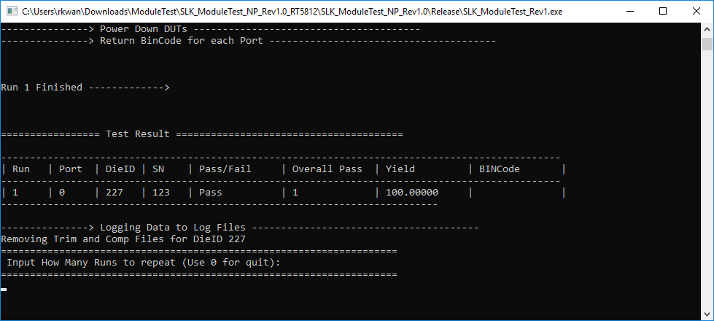

If Fail somwhere, it would show the BIN Code error Information:-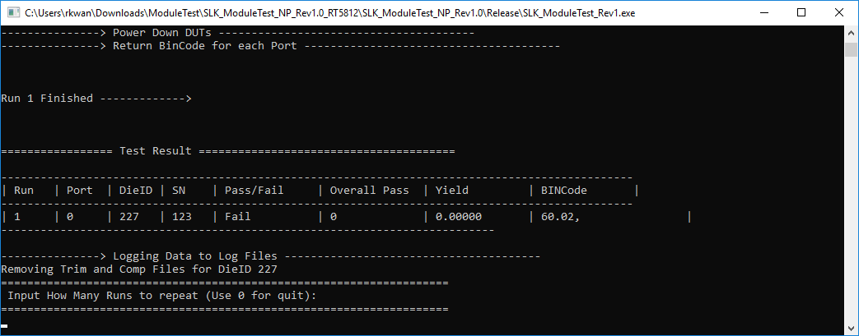

1. **Clean up (after all main loop runs are complete)**
2. Finalized / Close DLL