Questions 1, 2, 3, 4, 5

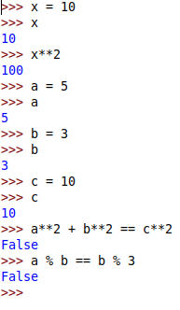

Questions 6, 7, 8, 9, 10, 11, 12, 13, 14, 15, 16, 17, 18, 19

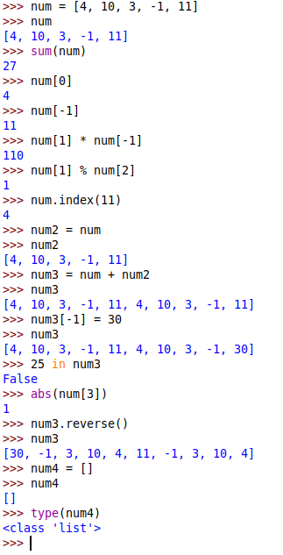

Questions 20, 21, 22, 23

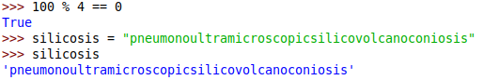

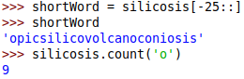

Question 24



a. The operation was not successful because a string index is immutable. You can’t change the value of an certain part of the string, instead you must change the value of the whole string.

Questions 25, 26

