**Linux Exercises Part 1: Name: Ryan Kyger**

Software Carpentry lessons with background material can be found here.

<http://swcarpentry.github.io/shell-novice/02-filedir/index.html>

**Part I:**

1. What is a Graphical User Interface (GUI) and how does that differ from the Command Line Interface (CLI)?

A GUI allows the user to interact with a computer by clicking on buttons and pull-down menus. In contrast, with a CLI, there are no graphical elements to click, as a CLI is a text-based user interface.

1. What does the shell do?

The Linux/UNIX Shell is a CLI that allows the user to execute text-based commands to run scripts and programs.

1. What is the command used for listing things in a directory?

ls

1. What is the command used for changing directories?

cd

1. What command would you use to get your current working directory?

pwd

1. How do you get the manual for these commands?

You can type ‘man’ followed by ‘ls’, ‘cd’, or ‘pwd’.

1. What does the shell prompt look like?

rkyger@DESKTOP-NUEPJTJ:

1. How would you list things in a directory in chronological order?

ls -lhtr

1. Name two ways to get to the ‘home’ or ‘root’ directory.

cd ~ or cd

1. What is the difference between an absolute path and a relative path?

The absolute path is the path that specifies the location of a file or directory from the root directory. Whereas, the relative path is the path that specifies the location of a file or directory relative to the current working directory.

1. What are the two relative path directories we talked about and what do they mean?

Current directory: cd .

Go up one directory: cd ..

**Part II:**

1. As part of this exercise please open the shell and practice moving around into different files. Best practice is to try a little bit every day. Try to challenge yourself by not using the mouse.
2. Open the shell and change directories to the Desktop. List
   1. Paste here the path to the desktop

/mnt/c/Users/Ryan/Desktop/

* 1. List the contents on the desktop paste them here.

IGV.lnk data-shell desktop.ini

1. Draw the file structure from the root directory into one of the folders on the desktop. Select three locations and type the commands for changing directories to those locations use a combination of absolute and relative paths.

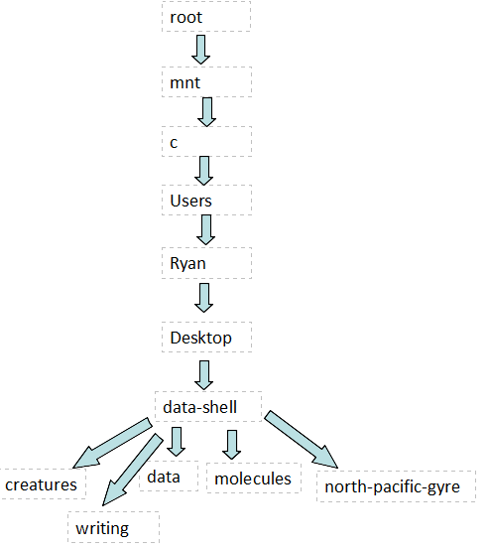

Go to creatures folder from Desktop: cd data-shell/creatures/

Go from creatures folder to data folder: cd ../data/

Go from root to molecules folder: /mnt/c/Users/Ryan/Desktop/data-shell/molecules