Name: Rakyan Satrya Adhikara

Unit Code: SIT124 (Exploring IT)

LinkedIn profile: <https://www.linkedin.com/in/rakyan-satrya-adhikara-b75a99173/>

WordPress Link: <https://rkynrkyn.wordpress.com/>

HOME PAGE:

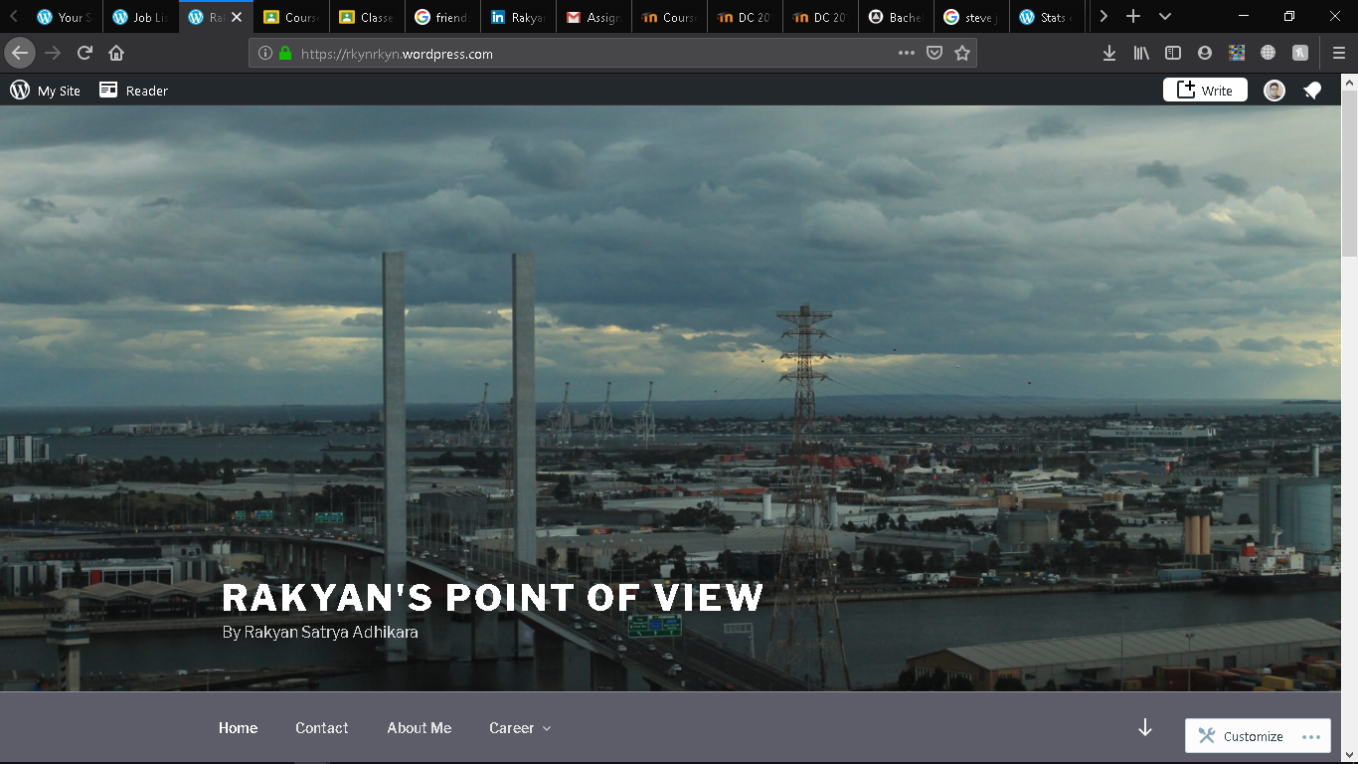

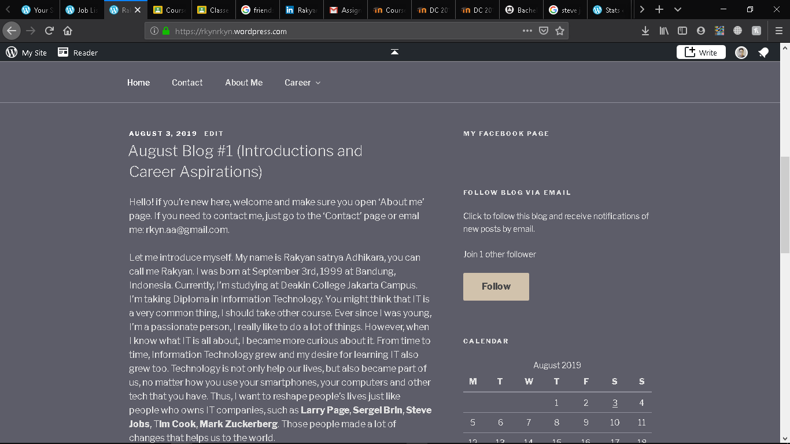

CONTACT PAGE:

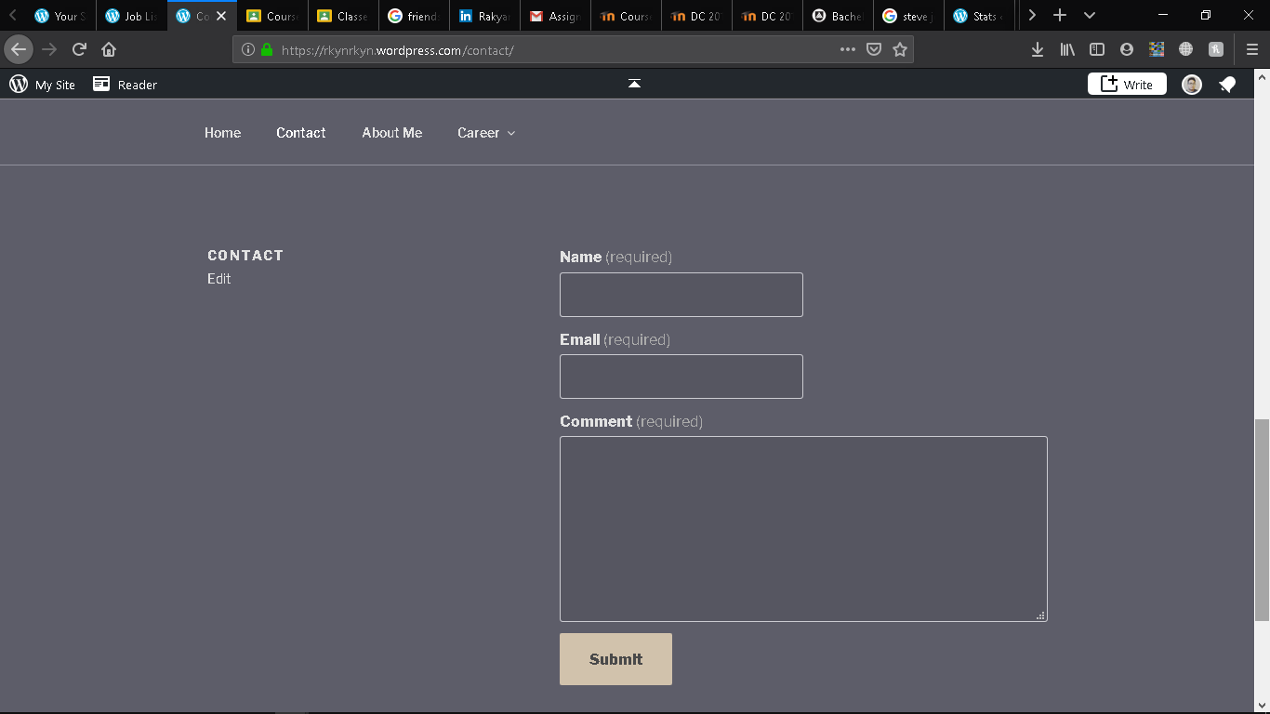

ABOUT ME PAGE:

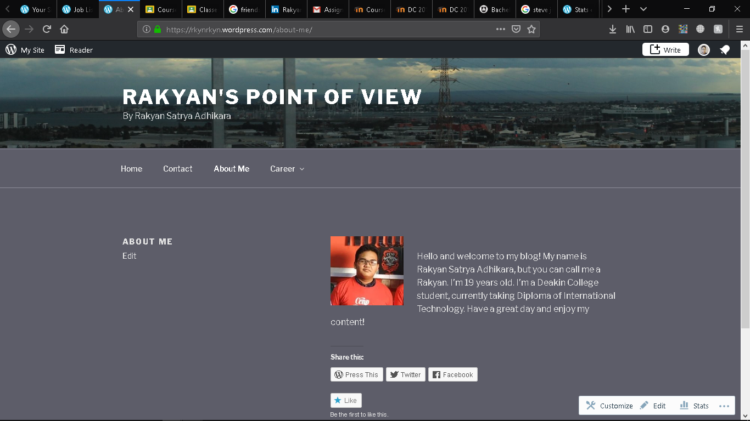

CAREER PAGE:

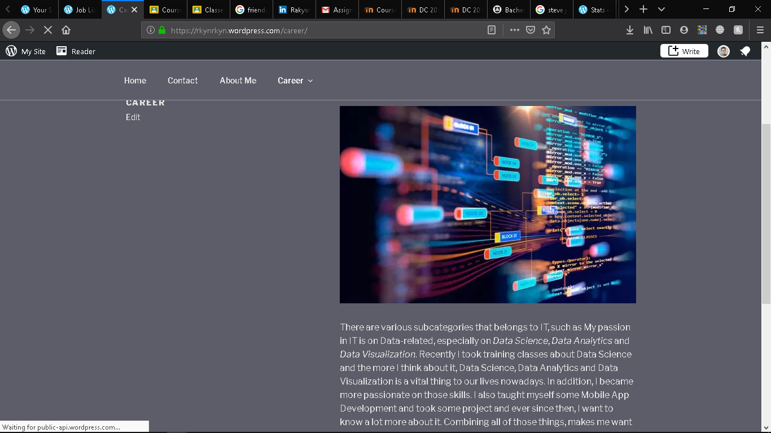

SKILLS PAGE:

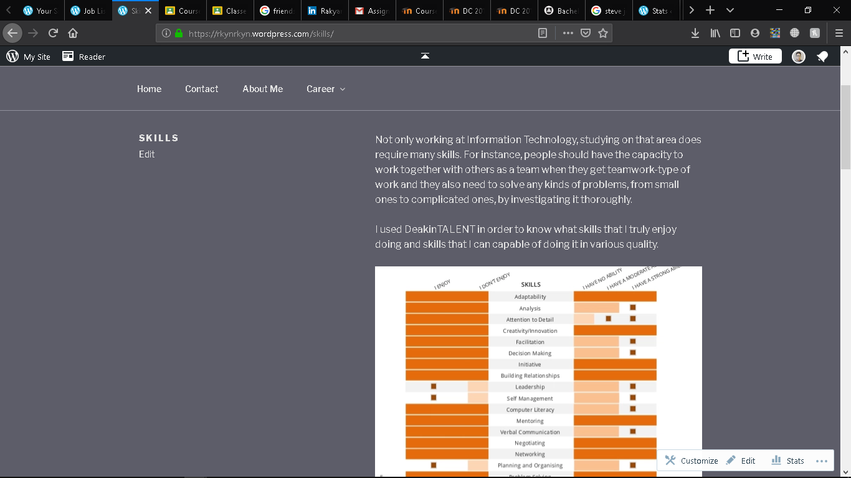

JOB LIST PAGE;

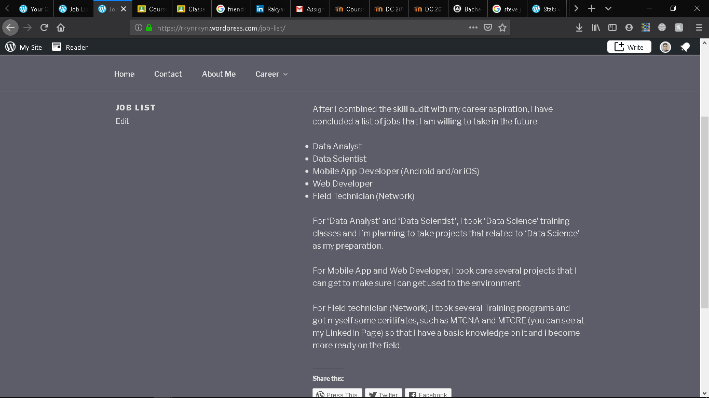

LINKEDIN PAGE:

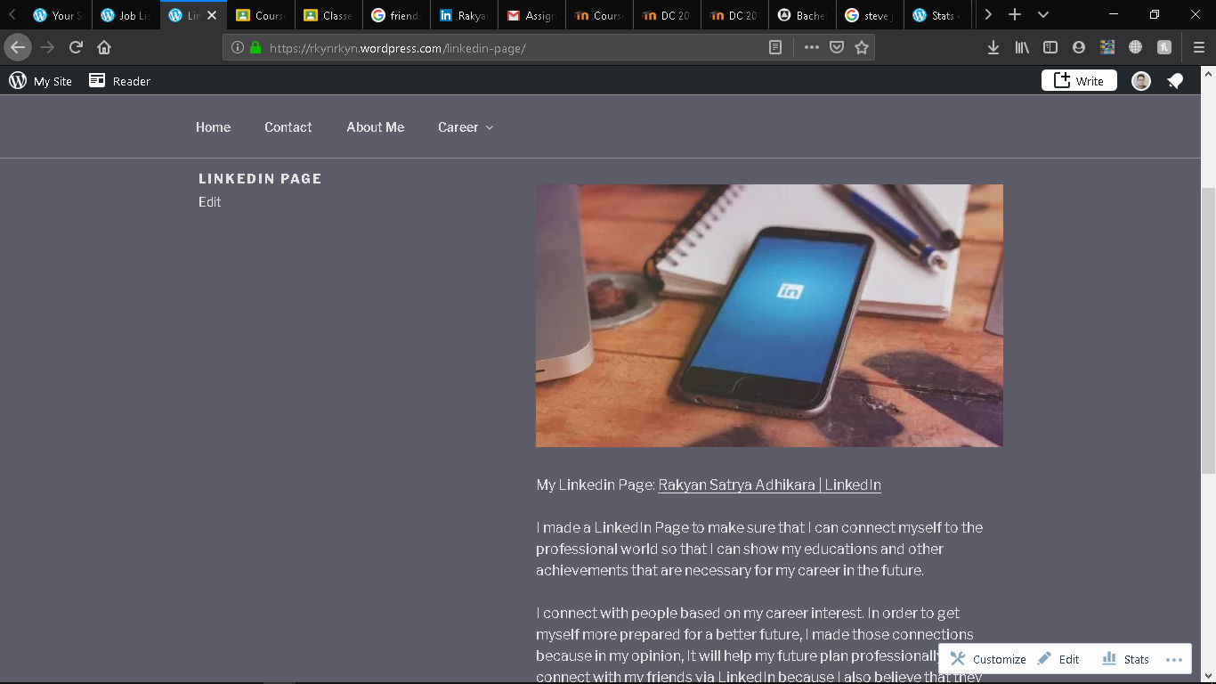

CAREER VIDEO:

