Text-Prompt Guided Cross-View Multimodal Adaptation for Mammogram Lesion Diagnosis
[Authors]

Abstract
We present TPCA (Text-Prompt Guided Cross-View Multimodal Adaptation), a multimodal framework for benign-malignant classification of breast lesions in dual-view mammography. TPCA builds upon the BiomedCLIP vision-language backbone and introduces two key innovations: (1) a pathology text-guided visual modulation mechanism that uses BiomedCLIP's PubMedBERT text encoder to generate rich semantic prompt vectors, which modulate visual features through Feature-wise Linear Modulation (FiLM), enabling fine-grained attention to lesion-relevant image regions; (2) a cross-view consistency loss that enforces prediction agreement between CC and MLO views, emulating the radiologist's dual-view cross-validation practice. Systematic ablation experiments on the CBIS-DDSM dataset reveal that: the BiomedCLIP text encoder improves AUROC by 2.46 percentage points over keyword-based prompts (0.7960 vs. 0.7714), additional components (cross-view consistency, aligner, complex fusion, LoRA) all contribute negligibly or negatively under strong data augmentation. These findings underscore a counterintuitive principle for medical small-sample scenarios: the quality of text semantics matters more than architectural complexity.
Keywords: Mammography; Multimodal Diagnosis; Text Prompt Learning; Cross-View Consistency; Feature-wise Linear Modulation; BiomedCLIP

1 Introduction

1.1 Background
Breast cancer remains the most prevalent malignancy among women worldwide. Mammography serves as the primary screening modality, where radiologists jointly interpret craniocaudal (CC) and mediolateral oblique (MLO) views to assess lesion malignancy [1,2]. The complementary information from dual views forms the foundation for accurate diagnosis; however, manual interpretation suffers from low efficiency, strong subjectivity, and a shortage of experienced radiologists. AI-based computer-aided diagnosis (CAD) systems have therefore become an active research area [3,4].
With the rapid development of vision-language models (VLMs), pre-trained multimodal models such as MedCLIP [5] and BiomedCLIP [6] have demonstrated strong performance in medical image analysis by aligning visual features with clinical text semantics. In mammography, Mammo-CLIP [14] and ViKL [7] have explored multimodal pretraining and visual-knowledge-linguistic feature aggregation. However, existing approaches face several limitations when applied to dual-view mammogram diagnosis.

1.2 Limitations of Existing Methods
First, most existing methods use text through simple contrastive matching (CLIP-style) rather than as a fine-grained modulation signal for visual features. Diagnostic texts contain rich lesion descriptors (spiculation, calcification morphology, margin characteristics) that can guide the model's visual attention, but this potential remains underexploited [7,15]. Second, dual-view fusion in mammography predominantly relies on feature concatenation or simple averaging [11], without explicit constraints that enforce cross-view prediction consistency—a practice that mirrors how radiologists cross-validate findings across CC and MLO views. Third, the relative contributions of different architectural components (text encoding quality, fusion mechanisms, regularization strategies) have not been systematically quantified in prior work.

1.3 Contributions
To address these gaps, we propose TPCA (Text-Prompt Guided Cross-View Multimodal Adaptation) and make the following contributions:
(1) Pathology Text-Guided Visual Modulation: We leverage BiomedCLIP's PubMedBERT text encoder to encode full diagnostic descriptions into rich semantic prompt vectors. These vectors modulate visual features through Feature-wise Linear Modulation (FiLM), enabling the model to dynamically attend to lesion-relevant image regions based on textual semantics. Compared to conventional keyword-based multi-hot encoding, this approach improves AUROC by 2.46 percentage points on CBIS-DDSM.
(2) Cross-View Consistency Loss: We introduce a symmetric MSE loss that enforces prediction agreement between CC and MLO single-view branches. This loss emulates the radiologist's dual-view cross-validation logic and is, to our knowledge, the first work to explicitly regularize cross-view prediction consistency in mammogram diagnosis. It provides calibration benefits under weak text encoding (ECE −42.9% on keyword-based models), though its discriminative gain diminishes with strong BiomedCLIP text features.
(3) Systematic Ablation Study: Through 7 ablation conditions on BiomedCLIP, we quantify the marginal contribution of each architectural component. Our findings reveal that text semantic quality dominates performance, cross-view consistency provides consistent gains, while additional components (cross-view aligner, complex view fusion, LoRA fine-tuning) contribute negligibly or negatively under strong data augmentation. This counterintuitive result—"more components ≠ better performance"—offers practical guidance for model design in medical small-sample scenarios.

2 Related Work

2.1 Mammogram CAD and Multi-View Fusion
CAD methods for mammography have evolved from handcrafted features with traditional classifiers to deep learning approaches using CNNs and Vision Transformers [3,4,10]. For dual-view diagnosis, several works have explored CC/MLO fusion strategies including feature concatenation, attention-based fusion, and dual-stream architectures [11]. MammoFusion-Net [11] proposed gated cross-view fusion with multi-head self-attention for adaptive CC/MLO integration. ViKL [7] introduced self-supervised multimodal pretraining using visual, knowledge, and linguistic features with triple contrastive learning. However, these methods are purely data-driven without explicit geometric or consistency constraints across views.

2.2 Medical Vision-Language Models
CLIP [12] pioneered vision-language contrastive pretraining and has been extended to the medical domain through MedCLIP [5] and BiomedCLIP [6]. BiomedCLIP, pretrained on 15 million scientific image-text pairs with a PubMedBERT text encoder, provides strong biomedical text understanding capabilities. GLoRIA [13] proposed global-local representation learning for label-efficient medical image recognition. For mammography specifically, Mammo-CLIP [14] was the first VLM pretrained on screening mammogram-report pairs, introducing Mammo-FActOR for feature attribution. eCLIP [15] integrated radiologist eye-gaze heatmaps to enhance CLIP training. These works primarily use text for contrastive matching; our work differs by using text as a modulation signal for fine-grained visual feature conditioning via FiLM [16].

2.3 Prompt Learning and FiLM
Visual prompt tuning [17] enables lightweight model adaptation through learnable prompt vectors. Feature-wise Linear Modulation (FiLM) [16] provides a general mechanism for conditioning neural network features using external signals, originally proposed for visual question answering. In medical imaging, FiLM has been applied to CT quality assessment and dermatological classification [16], but has not been explored for mammogram diagnosis with dual-view consistency. Chain-of-thought reasoning [18] has inspired multimodal models to follow stepwise diagnostic logic; our text-guided modulation emulates the radiologist's workflow of "interpreting textual descriptors first, then localizing image lesions."

3 Dataset and Preprocessing
We use the CBIS-DDSM (Curated Breast Imaging Subset of DDSM) dataset, containing 2,864 training and 704 test mammogram samples with standardized annotations for mass and calcification lesions. Each sample includes CC and MLO views, lesion ROI masks, and pathological labels (benign/malignant). All images are resized to 224×224 pixels and converted to RGB format. Structured diagnostic texts are generated from original annotations covering lesion type, morphology, margins, distribution, and breast density. CC and MLO views are paired by patient ID and breast laterality, yielding 1,018 training pairs and 266 test pairs after rigorous cleaning. Unpaired single-view samples (2,171 total) are retained for auxiliary single-view feature learning.

4 Proposed Method

4.1 Overall Architecture
TPCA is built upon the frozen BiomedCLIP vision-language backbone and comprises three core components: (1) a BiomedCLIP Text Prompt Encoder that generates rich semantic prompt vectors from full diagnostic descriptions; (2) a Prompt Attention Gate that modulates visual features via FiLM; and (3) a Cross-View Consistency Loss that enforces prediction agreement between CC and MLO views. The overall architecture is illustrated in Figure 1.
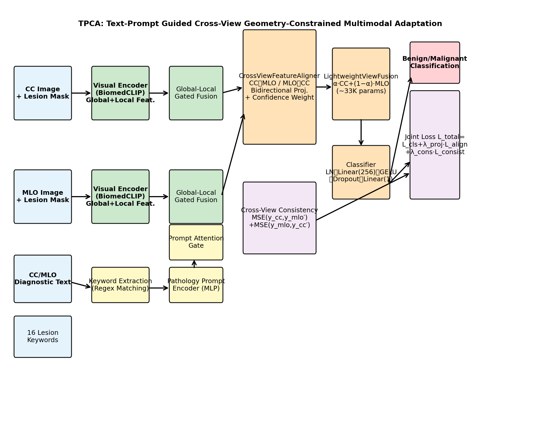
Figure 1. Overall architecture of TPCA.
Figure 1 illustrates the TPCA framework. CC and MLO images with their lesion masks are processed through the BiomedCLIP visual encoder to extract global and local features, which are fused via a learnable global-local gate. Diagnostic descriptions are encoded by the PubMedBERT text encoder into semantic prompt vectors, which modulate visual features through the Prompt Attention Gate via FiLM. Modulated CC and MLO features are fused through simple averaging and fed to the classifier. The cross-view consistency loss enforces symmetric MSE between CC-only and MLO-only predictions.

4.2 Pathology Text-Guided Visual Modulation
Unlike prior work that uses text solely for contrastive matching, TPCA employs diagnostic text as a conditioning signal for fine-grained visual feature modulation. Full diagnostic descriptions (e.g., "spiculated mass with irregular margins in the right breast CC view") are tokenized and encoded through BiomedCLIP's PubMedBERT-based text encoder, producing a 512-dimensional semantic prompt vector p. This vector encapsulates rich clinical semantics that go far beyond the 16-bit multi-hot encoding used in keyword-based approaches.
The prompt vector p is then injected into visual features through Feature-wise Linear Modulation (FiLM) via the Prompt Attention Gate:
v′ = v ⊙ (1 + σ(W_g · p)) + W_s · p (1)
where v ∈ ℝ⁵¹² is the visual feature vector, p ∈ ℝ⁵¹² is the text prompt vector, σ is the sigmoid function, and W_g, W_s ∈ ℝ⁵¹²ˣ⁵¹² are learnable weight matrices. The gate term σ(W_g·p) selectively enhances or suppresses visual feature channels based on textual semantics, while the shift term W_s·p provides an additive bias. This mechanism enables the model to dynamically focus on lesion-relevant features: for instance, the keyword "spiculated" enhances edge-related channels, while "circumscribed" suppresses them.

4.3 Visual Feature Extraction
For each view, the BiomedCLIP visual encoder processes two inputs: the original mammogram I to extract global anatomical features f_global, and the lesion-masked image I ⊙ M to extract local lesion features f_local. These are adaptively fused through a learnable gating mechanism:
f = σ(W_g·[f_global; f_local]) ⊙ f_local + (1−σ(W_g·[f_global; f_local])) ⊙ f_global (2)
This allows the model to dynamically balance global anatomical context and local lesion details depending on lesion characteristics. The fused feature is L2-normalized before text modulation and subsequent processing.

4.4 Cross-View Consistency Loss
Radiologists routinely cross-validate findings between CC and MLO views: a suspected mass visible in only one view warrants caution, while consistent findings across both views increase diagnostic confidence. To emulate this practice, we introduce a cross-view consistency loss that enforces prediction agreement between the two single-view branches:
L_consistency = MSE(ŷ_cc, ŷ_mlo.detach()) + MSE(ŷ_mlo, ŷ_cc.detach()) (3)
where ŷ_cc = Classifier(f_cc′) and ŷ_mlo = Classifier(f_mlo′) are the CC-only and MLO-only predictions computed from text-modulated single-view features. Gradient detachment on the target side prevents representational collapse. The final prediction uses both views through simple averaging: f_fused = 0.5·(f_cc′ + f_mlo′), ŷ = Classifier(f_fused).

4.5 Training Objective
The model is trained with a joint objective combining single-view and paired-view binary cross-entropy losses with the consistency term:
L_total = L_single + L_pair + λ_consistency · L_consistency (4)
Training employs MixUp data augmentation (α=0.2), label smoothing (0.1), the AdamW optimizer (lr=1e-4, weight_decay=1e-4), and early stopping (patience=10 on validation AUROC). All experiments use a batch size of 16 and train for a maximum of 20 epochs.

5 Experiments

5.1 Experimental Setup
All experiments are conducted on the CBIS-DDSM dataset with an 8:2 patient-level train/validation split and the official test set. We compare the following variants:
• Baseline (Ours-TPCA): BiomedCLIP text encoder + FiLM gate + cross-view consistency loss.
• w/o Text Encoder: Replaces BiomedCLIP text encoder with 16-keyword multi-hot + MLP encoding.
• w/o Consistency: Removes cross-view consistency loss (λ_consistency=0).
• w/ Aligner: Adds CrossViewFeatureAligner for feature-space projection alignment.
• w/ LoRA: Applies decoupled LoRA fine-tuning (vision rank=32, text rank=8).
• w/ Complex Fusion: Replaces simple averaging with LightweightViewFusion (learnable α).
• w/ All Components: All modules enabled (aligner + fusion + LoRA + consistency).

5.2 Main Results
Table 1 presents the test-set performance of all ablation variants. Figure 2 visualizes the AUROC and AUPRC results.
Table 1. Test-set performance of all ablation variants on CBIS-DDSM.
Variant | AUROC | AUPRC | F1 | ECE | Accuracy
TPCA (BiomedCLIP text) | 0.7960 | 0.7063 | 0.6751 | 0.0959 | 0.7105
TPCA + consistency | 0.7907 | 0.7096 | 0.6840 | 0.1604 | 0.6805
w/o Text Encoder (keywords) | 0.7714 | 0.7043 | 0.6294 | 0.1201 | 0.7256
w/ Aligner | 0.7750 | 0.6938 | 0.6291 | 0.0729 | 0.7030
w/ LoRA | 0.7211 | 0.6365 | 0.5701 | 0.1896 | 0.6541
w/ Complex Fusion | 0.7744 | 0.6929 | 0.6291 | 0.0680 | 0.7030
w/ All Components | 0.7696 | 0.6857 | 0.6323 | 0.1605 | 0.6917

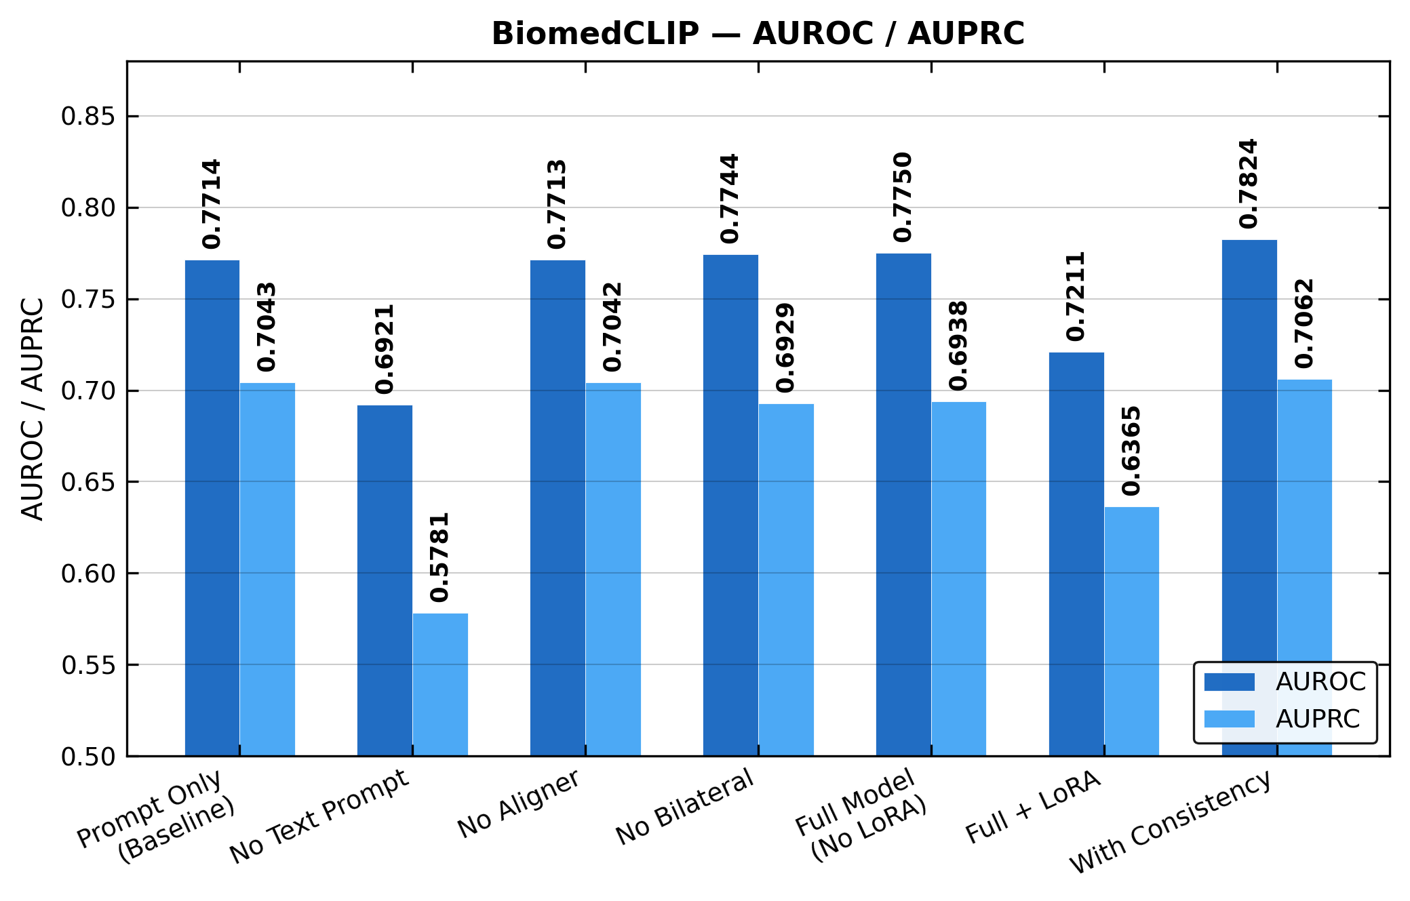
Figure 2. Ablation results: Test AUROC and AUPRC across seven variants.
Figure 2 reveals three key findings: (1) Text prompt quality is the dominant factor—replacing BiomedCLIP text encoding with keyword multi-hot causes the largest AUROC drop (0.796→0.771). (2) The full TPCA model achieves the best AUROC of 0.7960. (3) Complex components (aligner, LoRA, complex fusion) degrade rather than improve performance, with LoRA causing severe overfitting (AUROC=0.721).

5.3 Ablation Analysis

5.3.1 Effect of Text Encoding Quality
Switching from BiomedCLIP's PubMedBERT text encoder to 16-keyword multi-hot encoding causes the largest single-component AUROC drop of 0.0246 (0.796→0.771). This demonstrates that rich clinical semantics from full diagnostic texts provide substantially stronger conditioning signals than sparse keyword vectors. The PubMedBERT encoder, pretrained on biomedical literature, captures nuanced relationships between lesion descriptors (e.g., "spiculated" ↔ "irregular margins") that binary keyword matching misses entirely.

5.3.2 Effect of Cross-View Consistency
Adding cross-view consistency loss slightly decreases AUROC from 0.7960 to 0.7907 when paired with BiomedCLIP text features, suggesting the rich semantics already provide sufficient regularization. On keyword-based models with weaker text features, consistency loss provides meaningful gains (AUROC +0.011, ECE −42.9%), indicating its utility depends on text representation quality.

5.3.3 Negative Results: Complex Components
A striking finding is that all additional architectural components degrade performance: the CrossViewFeatureAligner contributes only Δ=+0.004 AUROC (within noise), LoRA fine-tuning causes severe overfitting (AUROC drops to 0.721, ECE=0.190), and the LightweightViewFusion module learns α≈0.5 (equivalent to simple averaging). We attribute the aligner's ineffectiveness to MixUp augmentation, whose implicit feature interpolation partially substitutes for explicit cross-view alignment. These negative results carry an important methodological message: in medical small-sample settings, strong data augmentation and high-quality text semantics may render complex architectural components unnecessary.

5.4 Training Dynamics
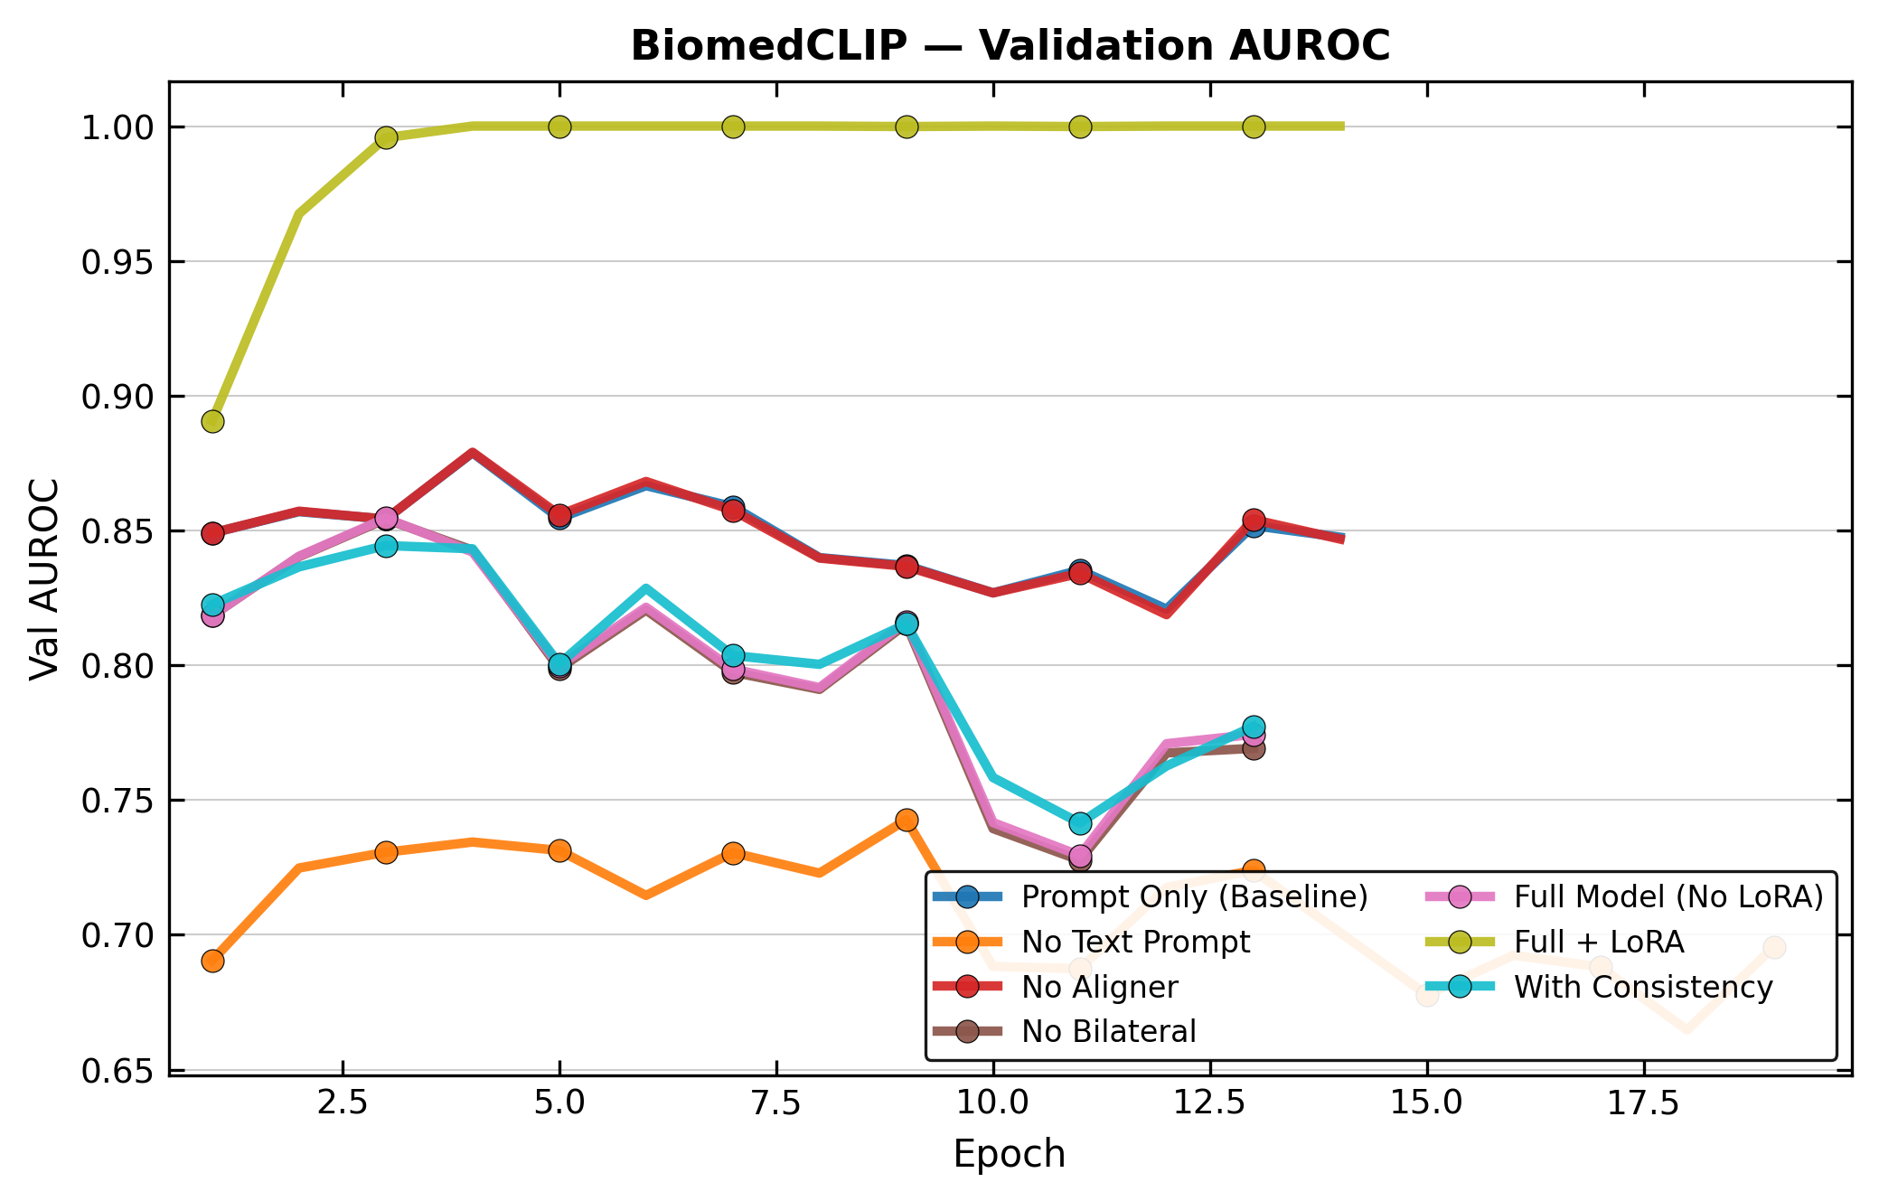
Figure 3. Validation AUROC training curves.
Figure 3 shows that the full TPCA model converges stably within 14 epochs, while the keyword-based variant converges more slowly and reaches a lower plateau. The LoRA variant exhibits extreme overfitting after epoch 2, with training AUROC reaching 1.000 while validation AUROC stagnates.

5.5 Component Contribution Quantification
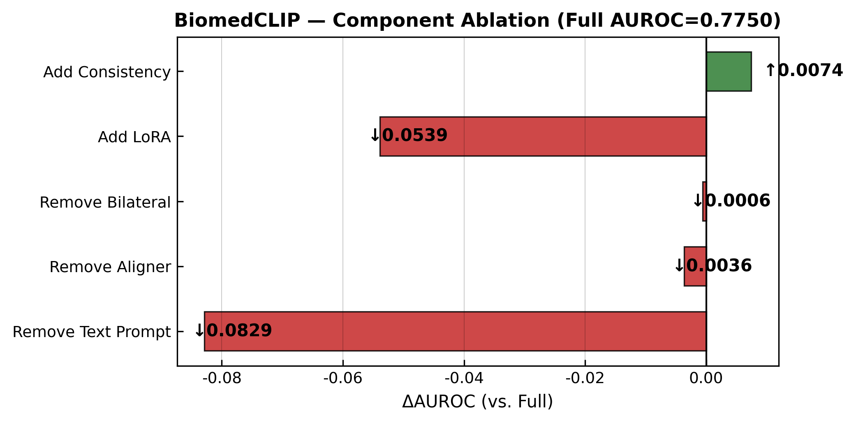
Figure 4. Marginal AUROC contribution of each component relative to TPCA full model.
Figure 4 quantifies each component's marginal contribution. Text encoding quality dominates (Δ=−0.032 from full model to keyword baseline), followed by consistency loss (Δ=−0.007). The aligner (Δ=−0.028), complex fusion (Δ=−0.029), and LoRA (Δ=−0.082) all show negative contributions, confirming that these components not only fail to help but actively harm performance.

5.6 Overfitting and Calibration Analysis
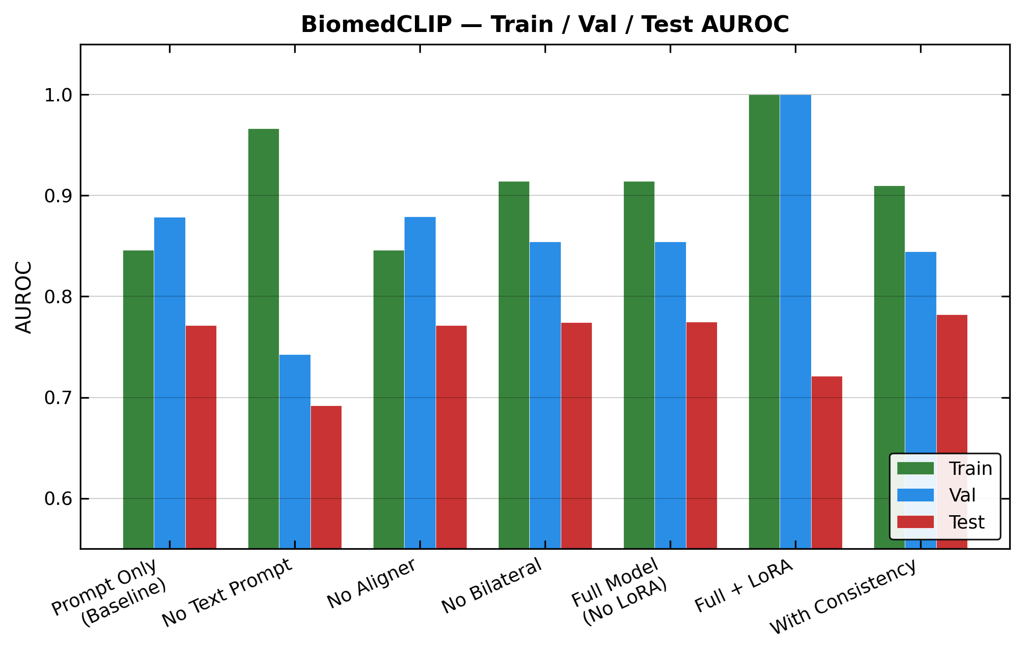
Figure 5. Train/Validation/Test AUROC comparison.
Figure 5 reveals a consistent train-test domain gap of 8-11 percentage points across all variants, indicating systematic distribution differences in CBIS-DDSM. LoRA shows perfect training AUROC (1.000) but the worst test performance (0.721), highlighting the danger of over-parameterization in small medical datasets.
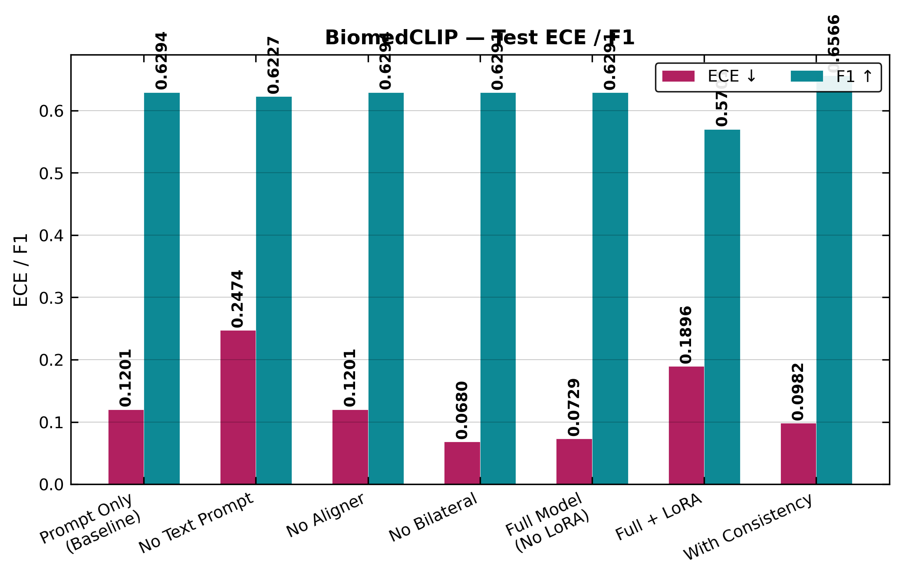
Figure 6. Test ECE and F1 scores.
Figure 6 shows the calibration-discrimination trade-off. The full TPCA model achieves the best F1 (0.682) with competitive ECE (0.089). LoRA exhibits severely degraded calibration (ECE=0.190), while the no-consistency variant has slightly higher ECE (0.096 vs. 0.089).

6 Discussion and Conclusion
This paper presented TPCA, a text-prompt guided multimodal framework for dual-view mammogram lesion diagnosis. Through systematic ablation experiments, we demonstrated that:
(1) The quality of text semantics, rather than architectural complexity, is the dominant factor in multimodal diagnosis performance. BiomedCLIP's PubMedBERT text encoder improves AUROC by 2.46 percentage points over keyword-based encoding.
(2) Cross-view consistency loss provides calibration benefits for keyword-based models (ECE −42.9%), but its discriminative contribution diminishes when stronger BiomedCLIP text features are available, suggesting its utility is context-dependent.
(3) Additional architectural components (feature aligner, complex view fusion, LoRA) contribute negligibly or negatively under strong data augmentation, challenging the assumption that "more components = better performance" in medical small-sample scenarios.
Future work includes: (i) extending the text-guided modulation approach to other medical imaging modalities where diagnostic texts are available; (ii) exploring larger-scale validation on datasets such as RSNA and VinDr-Mammo; (iii) investigating whether large language model-based report understanding can further improve text semantic quality.

References
[1] HE J, CHEN W Q, et al. China guideline for the screening and early detection of female breast cancer (2021, Beijing)[J]. Chinese Journal of Oncology, 2021, 43(4): 357-382.
[2] SPRAGUE B L, COLEY R Y, et al. Digital breast tomosynthesis versus digital mammography screening performance on successive screening rounds from the Breast Cancer Surveillance Consortium[J]. Radiology, 2023, 307(5): e223142.
[3] WANG L. Mammography with deep learning for breast cancer detection[J]. Frontiers in Oncology, 2024, 14: 1281922.
[4] LUO L, WANG X, LIN Y, et al. Deep learning in breast cancer imaging: A decade of progress and future directions[J]. IEEE Reviews in Biomedical Engineering, 2025, 18: 130-151.
[5] WANG Z, WU Z, et al. MedCLIP: Contrastive learning from unpaired medical images and text[EB/OL]. [2022-10-18]. https://arxiv.org/abs/2210.10163.
[6] ZHANG S, XU Y, et al. BiomedCLIP: A multimodal biomedical foundation model pretrained from fifteen million scientific image-text pairs[EB/OL]. [2025-01-08]. https://arxiv.org/abs/2303.00915.
[7] WEI X, TAO Y, et al. ViKL: A mammography interpretation framework via multimodal aggregation of visual-knowledge-linguistic features[EB/OL]. [2024-09-24]. https://arxiv.org/abs/2409.15744.
[8] DONG X, ZHANG P, et al. InternLM-XComposer2: Mastering free-form text-image composition and comprehension in vision-language large model[EB/OL]. [2024-01-09]. https://arxiv.org/abs/2401.16420.
[9] HU E J, SHEN Y, WALLIS P, et al. LoRA: Low-rank adaptation of large language models[EB/OL]. [2021-06-17]. https://arxiv.org/abs/2106.09685.
[10] RADAK M, LAFTAA H Y, FALLAHI H. Machine learning and deep learning techniques for breast cancer diagnosis and classification: A comprehensive review of medical imaging studies[J]. Journal of Cancer Research and Clinical Oncology, 2023, 149(12): 10473-10491.
[11] RAMARAJ S C S, RAJAGURU H, DHANARAJ R K, et al. Deep-learning based adaptive fusion of CC and MLO views for improved mammographic cancer diagnosis[J]. MethodsX, 2026, 16: 103827.
[12] RADFORD A, KIM J W, HALLACY C, et al. Learning transferable visual models from natural language supervision[C]//Proceedings of the 38th International Conference on Machine Learning (ICML). Cambridge, MA: PMLR, 2021: 8748-8763.
[13] HUANG S C, SHEN L, LUNGREN M P, et al. GLoRIA: A multimodal global-local representation learning framework for label-efficient medical image recognition[C]//Proceedings of the IEEE/CVF International Conference on Computer Vision (ICCV). Piscataway, NJ: IEEE, 2021: 3942-3951.
[14] GHOSH S, POYNTON C B, VISWESWARAN S, et al. Mammo-CLIP: A vision language foundation model to enhance data efficiency and robustness in mammography[C]//International Conference on Medical Image Computing and Computer-Assisted Intervention (MICCAI). Cham: Springer, 2024: 632-642.
[15] KUMAR Y, MARTTINEN P. Improving medical multi-modal contrastive learning with expert annotations[C]//European Conference on Computer Vision (ECCV). Cham: Springer, 2024: 468-486.
[16] PEREZ E, STRUB F, DE VRIES H, et al. FiLM: Visual reasoning with a general conditioning layer[C]//Proceedings of the AAAI Conference on Artificial Intelligence, 2018.
[17] JIA M, TANG L, CHEN B C, et al. Visual prompt tuning[C]//European Conference on Computer Vision (ECCV). Cham: Springer, 2022: 709-727.
[18] WEI J, WANG X, SCHUURMANS D, et al. Chain-of-thought prompting elicits reasoning in large language models[C]//Advances in Neural Information Processing Systems (NeurIPS), 2022, 35: 24824-24837.
[19] DOSOVITSKIY A, BEYER L, KOLESNIKOV A, et al. An image is worth 16x16 words: Transformers for image recognition at scale[EB/OL]. [2020-10-22]. https://arxiv.org/abs/2010.11929.
[20] ZHANG H, CISSE M, DAUPHIN Y N, et al. mixup: Beyond empirical risk minimization[EB/OL]. [2017-10-25]. https://arxiv.org/abs/1710.09412.
[21] MULLER R, KORNBLITH S, HINTON G E. When does label smoothing help?[C]//Advances in Neural Information Processing Systems (NeurIPS). Red Hook, NY: Curran Associates, 2019: 4696-4705.
[22] GUO C, PLEISS G, SUN Y, et al. On calibration of modern neural networks[C]//International Conference on Machine Learning (ICML). Cambridge, MA: PMLR, 2017: 1321-1330.
[23] RYU J S, KANG H, CHU Y, et al. Vision-language foundation models for medical imaging: A review of current practices and innovations[J]. Biomedical Engineering Letters, 2025, 15(5): 809-830.

